

**Name:** Ashna Wasif

**Roll Number:** 2791

**Class:** BSCS 7B (Morning)

**Subject:** Computer Graphics

**Submitted To:** Mam Sabina Irum

**Date:** 11th May, 2025

**Question:**

1. Create a Simple Car Dashboard Scene (Top View):

Use rectangles to draw:

* Dashboard
* A basic steering wheel (just a circle)
* A keyboard with 5 rectangular keys placed horizontally

1. Add Non-Parameterized Animation:

When the user presses a specific key on the actual keyboard (e.g., 'A', 'B', 'C', 'D', 'E'):

* Change the color of the corresponding key on the screen (e.g., from gray to green for 1 second)
* Use glutKeyboardFunc() or a similar function for key detection
* Use a fixed duration for the color change (hardcoded logic, no parameters)

**Bonus (Optional for Extra Marks):**

* Add a small screen above the keyboard that displays a static message like “Welcome” or “Car System Active”.

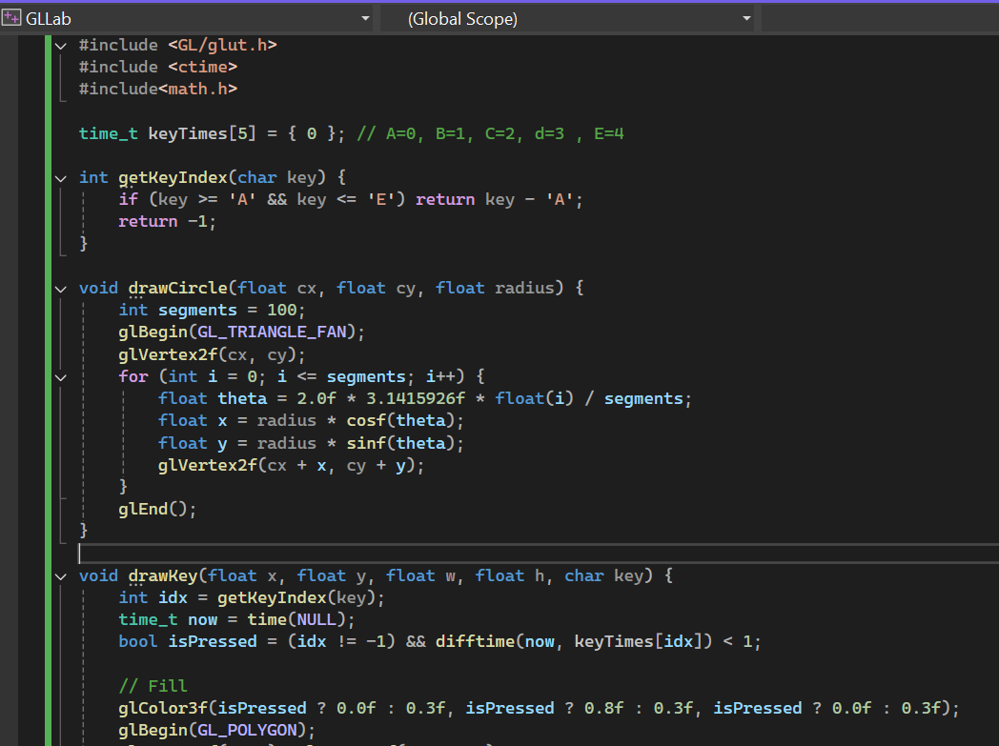**Solution:**

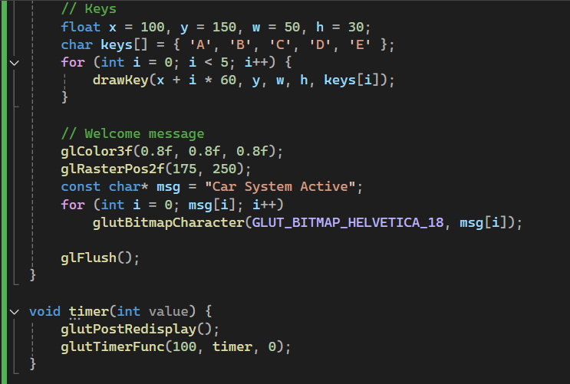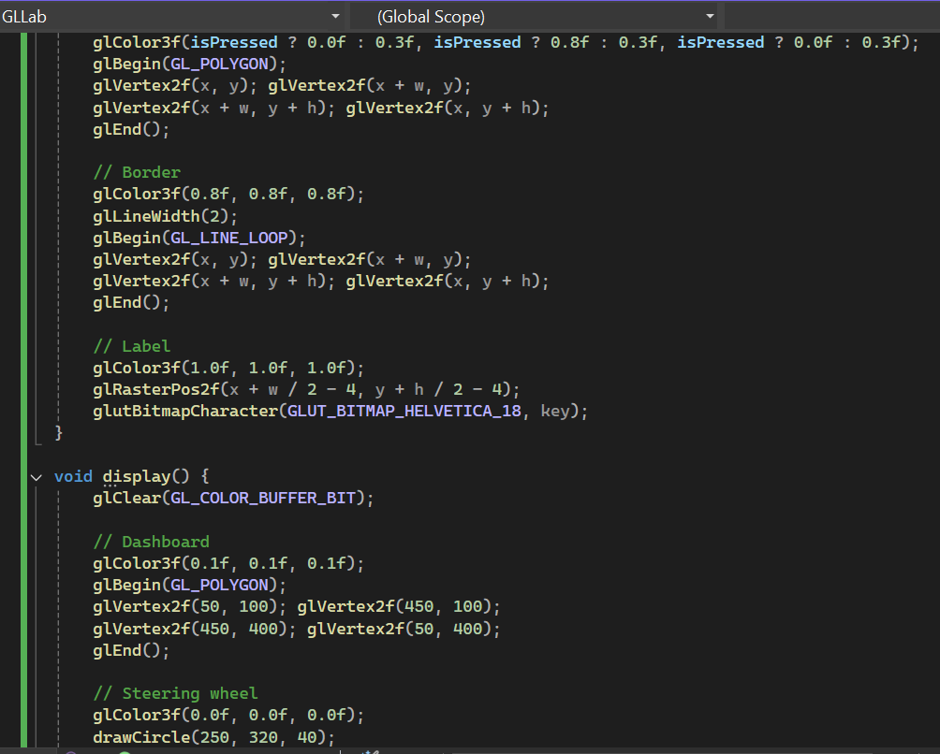

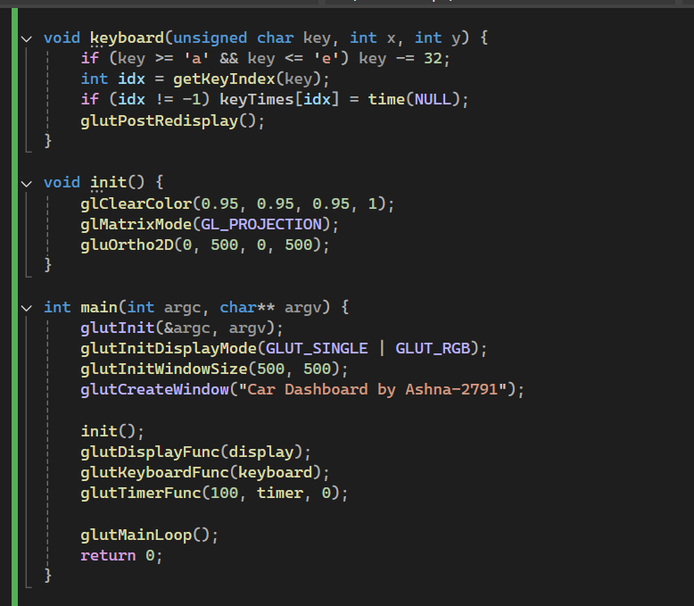

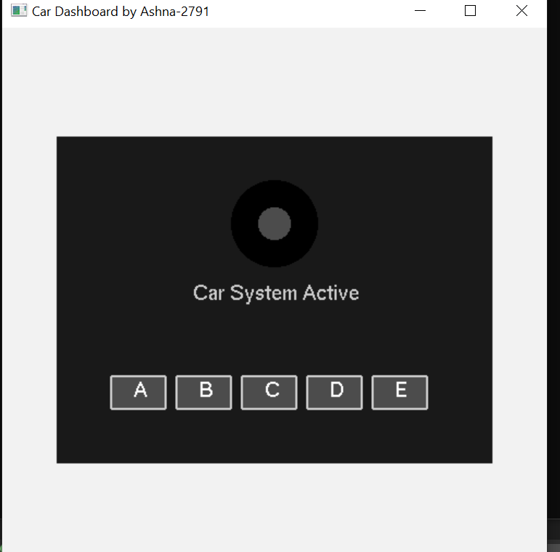**Output:**

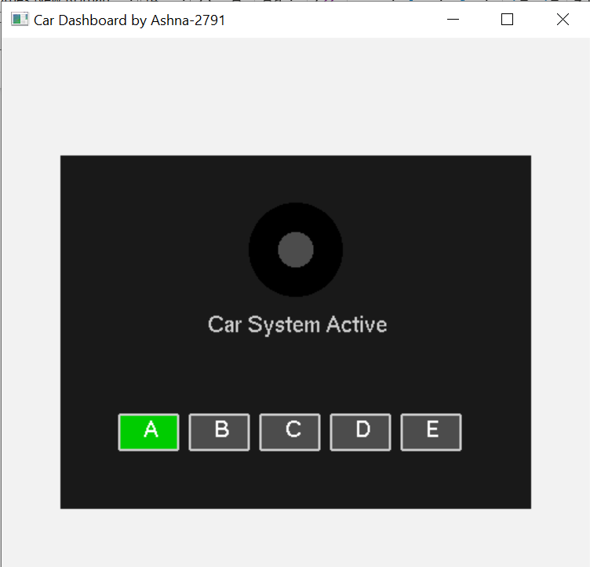On pressing Keys:

