****Objective:****On Day 05, my goal is to enhance and optimize the website, ensuring it is ready for real-world deployment. I will focus on thoroughly testing all components, refining backend integrations, improving performance, and implementing robust error handling. Additionally, I will work on enhancing the user experience to ensure the platform can efficiently handle customer-facing traffic.

**Error Handlings:**  
**Error API Failures:**  
• Addressed API failures and unexpected errors using try-catch blocks.  
• Display fallback UI elements when data is unavailable (e.g., "No products found").  
• Used try catch syntax.  
**Performance Testing:**• Identify bottlenecks using tools like Lighthouse.  
• Optimize images, minimize JavaScript and CSS, and implement caching strategies.

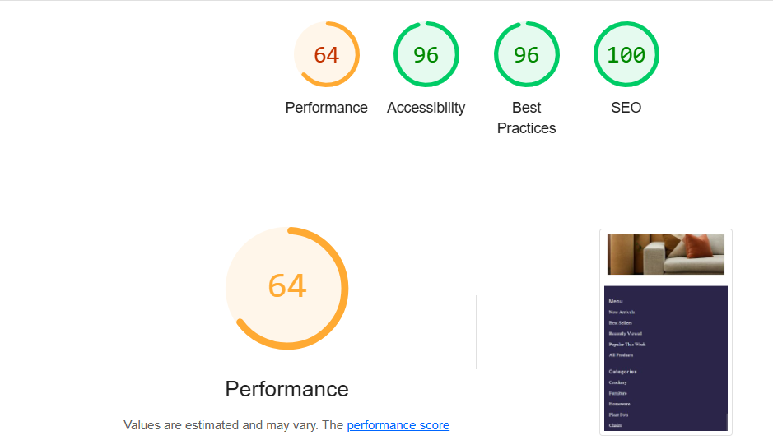

****Test Case Validation Chart****

| **Test Case ID** | **Feature Being Tested** | **Execution Steps** | **Expected Outcome** | **Status** |
| --- | --- | --- | --- | --- |
| TC-UI-014 | Product Card Rendering | Render a ProductCard component with sample data | Product details (name, price, image) should display correctly | In Progress |
| TC-UI-019 | Dynamic Product Grid | Populate ProductGrid with an array of products | All products should render as individual cards | Initial Failure, then Pending |
| TC-FILTER-003 | Category-based Filtering | Choose a category in the Filters component | Products dynamically update based on selection | Passed |
| TC-RESP-011 | Responsive UI Testing | Test UI on mobile, tablet, and desktop screens | Layout should adjust correctly for all sizes | Passed |