**Guide for 3rd Semester (CSE)**

**Disclaimer:** This semester is gonna be hectic, be prepared to face a lot of things to cover. Make sure you manage your time well and try to give equal priority to each course because the syllabus of most of the courses will be heavy.

In our batch many students gave up on the courses and ended up scoring a cgpa which was not so decent, so make sure you don’t become one of those.

It will be tough but take it as a challenge and try to be more systematic in this semester.

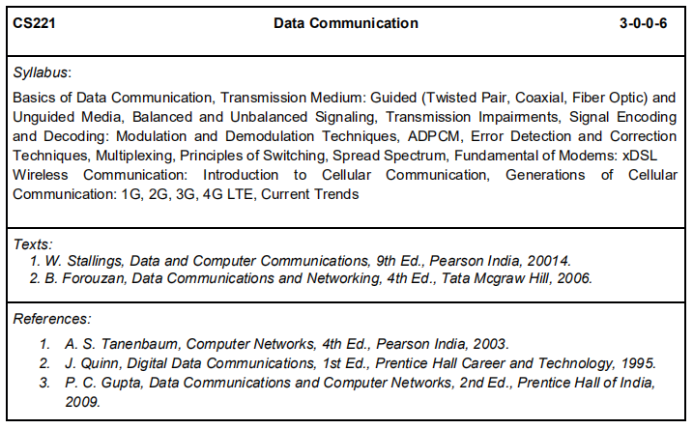

This will be the worst course you will face in this semester. The syllabus is huge but don’t worry about it because most of the questions will be asked from the exercises from the textbooks that you will follow.

Even for us Profs themselves provided a list of questions for practice.

Tip : Many of you will stop attending classes for this course, but that will be a mistake.

Try to maintain the pace with the teacher otherwise you would end up with 500-600 slides left to read on the last day of exam. BEWARE ! Try to ask teachers what can be asked from a definite topic just after he/she finishes teaching that to you.

We suggest you to treat this as the main text book because we witnessed many questions from the exercises of this book - <https://amzn.to/2K1tAm9>

This book will be secondary one and practise from this too - <https://amzn.to/3b4Ux4t>

Link to both the pdf format of both the text books [here](https://drive.google.com/open?id=1HUMzSKwAJYYZOnE8EStoCkLR1xTkT7dE)

I personally think that if you are successful in understanding at least 50% of the course that has been taught then you will score an amazing grade.

Tip (Kushagra) : Just attend the fucking classes . Don’t miss them. Don’t waste your time at hostel on this subject just attend the classes and it will all be more than fine.

Link to the slides of the course - <https://drive.google.com/open?id=1TFcMfm4RN51S82u2d3CbmAh4QOAvvnX7>

Link to our class tests and few important questions that came in our exams – (the questions are from 9th and 10th edition of William Stallings) <https://drive.google.com/open?id=1kEyCl-EHDkoYk_RN6eipuAWlFUAyplsN>

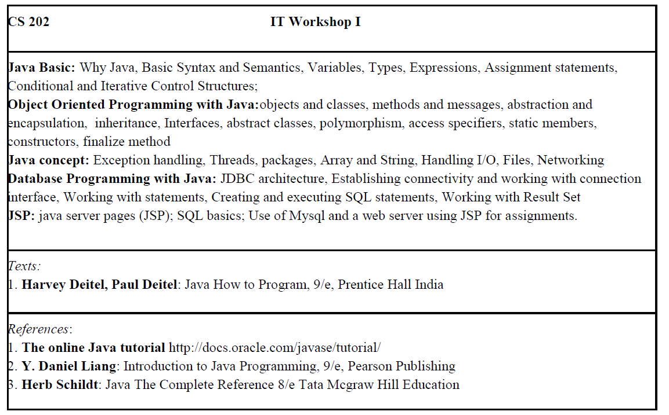

You will have only one tutorial and one lab for this course per week. So, this will be a fast-paced course. You never know when the course starts and you reach strings in the second or third class itself. Make sure you utilise the time at home and start learning JAVA. The questions will be mostly from diverse topics. You need to have a good command in theory of the course so that you can score good.

The MCQs will be confusing but if your concepts are right you can score well. I’ll list down few websites from where you can prepare for the theory. Lab is mainly on either JDBC or socket programming.

Websites to refer:

<https://www.javatpoint.com/>

<https://www.geeksforgeeks.org/java/>

<https://www.tutorialspoint.com/java/java_overview.htm>

Go through the theory in detail and practise previous year question papers. We’ll try to send previous year papers as soon as possible.

YouTube channels to refer for lab:

<https://www.youtube.com/playlist?list=PLEAQNNR8IlB4R7NfqBY1frapYo97L6fOQ>

You need to have an idea about MySQL too before you start with JDBC, practise MySQL from hackerrank or refer to any tutorial on MySQL it would suffice.

Refer to this link to get your MySQL basics right .

<https://www.mysqltutorial.org/basic-mysql-tutorial.aspx>

<https://www.youtube.com/playlist?list=PLoW9ZoLJX39Xcdaa4Dn5WLREHblolbji4>

Socket programming is essential for your Lab exam. Make sure you understand how it works and you’ll do fine.

Tip : Just keep in mind Socket is nothing physical .

Here is the link to the slides we were given by Sanjay Moulik Sir:

<https://drive.google.com/drive/folders/1_oTnun6zzu9BDYuR5nsaZsLvr3V3SY02?usp=sharing>

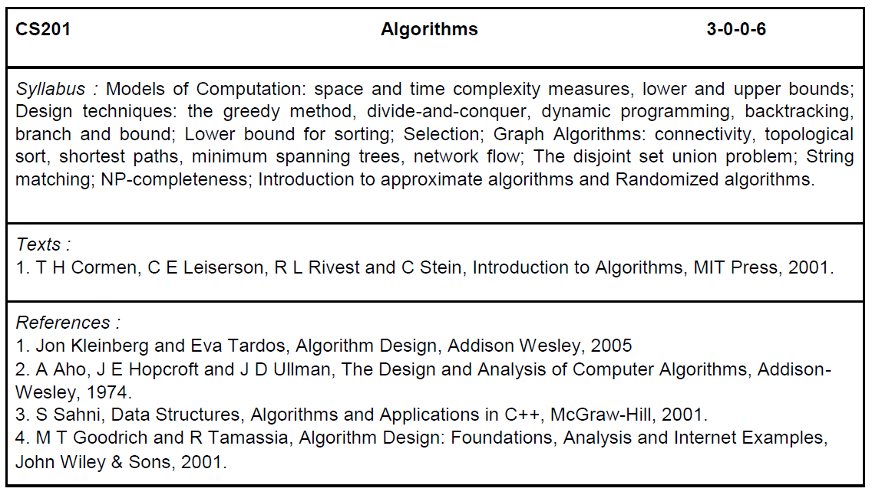

This course is interesting if you really try to understand the story behind every algorithm. All you need to do is follow your class properly and try to implement the algorithms in the lab. Learn the topics beforehand so that you have a better understanding while listening it in the class.

Abdul Bari’s Playlist on algorithms: <https://www.youtube.com/playlist?list=PLDN4rrl48XKpZkf03iYFl-O29szjTrs_O>

This is the most comprehensive course available online. Follow his lectures and you will understand everything.

<https://www.youtube.com/playlist?list=PLBF3763AF2E1C572F>

<https://www.youtube.com/channel/UCliJsnOQEU9ZkWEE7Vtryng/videos> - I found this playlist really helpful when I missed my classes. He explains with examples and just like Sumit sir taught, so it was easy to cover the topics while following this channel.

If you are thorough with the algorithms it will be handy for you to solve the Lab assignments. Be well versed with either C++ or JAVA before you come back to college. Know how the library functions work, and understand the code behind it. It will help you comprehend the problems easily.

Tip : Try to implement as many algorithms as you can because this is what is going you will be doing in your placement season. Don’t neglect this course at any cost. I (Kushagra) did it and I regret about it.

I know while teaching some of the algorithms will feel like they are impossible to implement but most of them are. So go out and try implementing them , It will be of great help.

**BOOKS TO BUY**

**Introduction to Algorithms, 3rd edition**- This is the bible for Algorithms, I strongly suggest you to have this book and follow it thoroughly. This will even help you before your interviews. You can find everything you need in this book so don’t neglect this. It is very ESSENTIAL. You can get this book [here](https://amzn.to/3gPv9CX) I know this book is costly, but it is worth the money. Or download from [here](https://drive.google.com/file/d/0Bxt-YEfIWVhaRkFJNnZqQjBqYk9WVS1RanFYQmZxMXZ1YzRJ/view?usp=sharing).

Even Sumit sir told us to come to class after reading certain topics from this book.

**Data Structures And Algorithm Analysis In C++ by Allen Weiss –** The next best alternative to the book above is this. You can even get this if you’d like to. [Here](https://amzn.to/3cyW4PT) is the link to it.

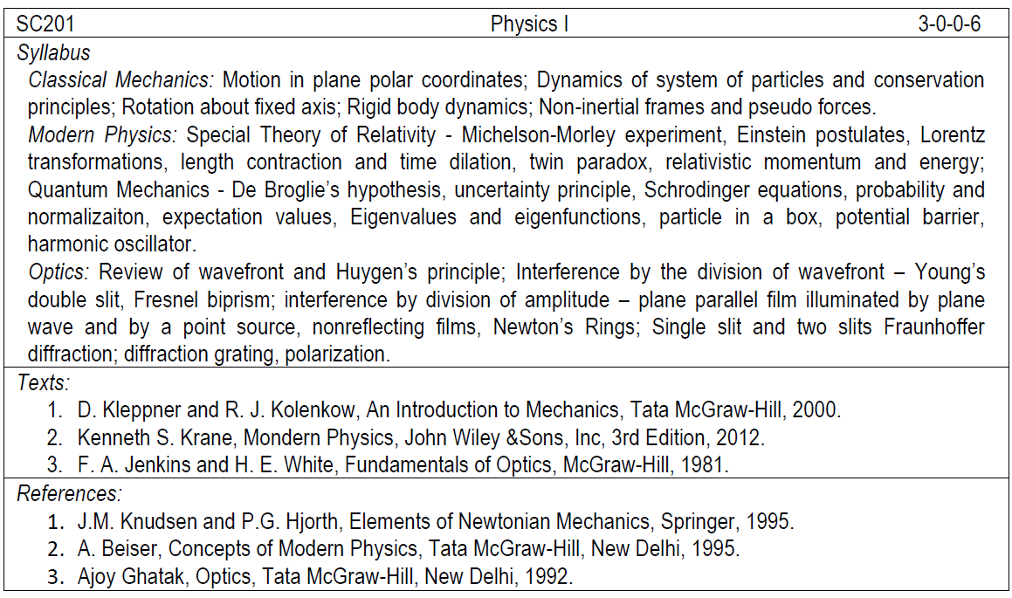

This is the course where you can score the most. Most of the questions will be from previous year papers so you don’t have to worry about it. We will send the papers ASAP. The part till midsem will be from mechanics and later will be Quantum mechanics & modern physics.

You just need to attend classes, solve the problems mam mentions in the class and previous year papers. Easiest way to score 10 pointer in a course.

This will save your SPI so don’t mess this up. Most probably attendance will not be mandatory in this course but try to attend the classes because this the course where you can complete everything in the class itself and can boost up you SPI.

***Things to remember:***

1. Make notes! Mam won’t give you slides for most of the chapters because she asks the stuff from it. Make as clear and informative as possible. She is stone hearted. *sad emoji*
2. Don’t miss your classes. Best way to score 10 in this course is attend every class, you never know when she gives out questions that will appear on the exam. ATTEND ALL CLASSES, especially before your exams.
3. Solve the problem given behind the book. Gateway to an amazing score.

Don’t stress about solving the problems , just be regular with the class and you will score well.

See she mainly teaches the stuff which is exactly same as it is given in the book, so many students think that class is wastage of time and they can read the stuff by themselves but mostly you end up wasting that time. And to your surprise the text in the book is in too depth that you will get lost reading about a particular topic. So I would suggest try making the notes and attending the classes , it will be a huge time saver for you.

This is the link to the e-copy of the Mechanics Book - <https://drive.google.com/file/d/1f9t-A3790LBaWraH1QyPnHs4DhzJOjR9/view?usp=sharing>

You can get the book for Modern Physics here - <http://93.174.95.29/main/1DF4788031072F1E6F3DDAF519504D70>

Link to the optics book, this is a different edition though - <http://93.174.95.29/main/111000/f80b5be97e6140d3ef8b34d04b082b09/Francis%20Jenkins%2C%20Harvey%20White%20-%20Fundamentals%20of%20optics-McGraw-Hill%20Science_Engineering_Math%20%282001%29.pdf>

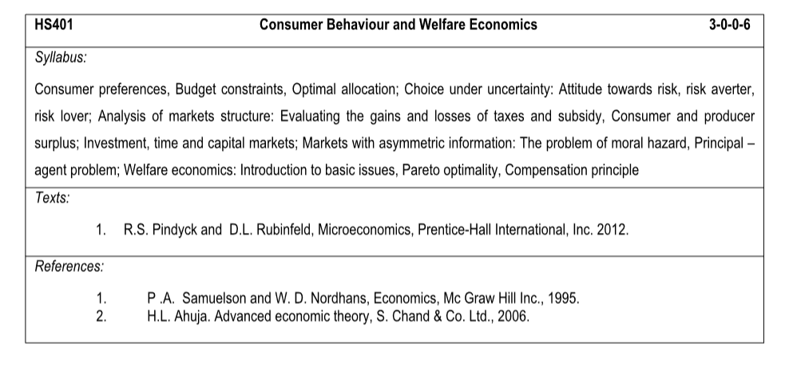

This course is pretty simple. Half of it will be the revision of previous semester’s course and just an addition of few additional topics will be there. Attend every class and take proper notes. Theory questions will mostly be asked from previous year’s paper. You have to work on important topics like the graphs, theories and laws sir explains. Most of the questions come from there.

Resources:

1. <https://drive.google.com/drive/folders/1wUgHPVOVipiJxiwANB8YGU7GR67kI--T?usp=sharing> – We’ve compiled some PDFs that might be helpful
2. <https://drive.google.com/drive/folders/12mBa0CEAIU4Ev_h1es43Hu7ZisTioXeC?usp=sharing> – These are direct chapters from the Textbook we followed. You don’t need to buy any book unless you are interested.

Tip : Just go to class , sit in front because he is not at all audible at the back, hear to what he says, try to understand , make notes , discuss with him if you are stuck and BOOM! You will definitely get a AB(9) by just doing this.

While learning Economics think like you are going to start a business in future , and you will start getting interest in the subject.

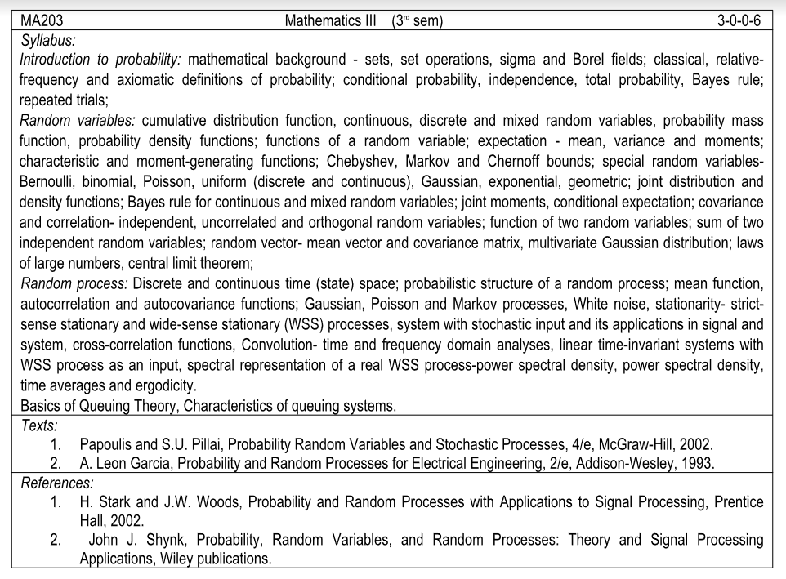

This course will be very lengthy. All we can say is that attend every class and make good notes. You will be given tutorials after each topic and solve them as soon as you can. Clarify your doubts, don’t drag it till exams. The course isn’t difficult but you gotta keep patience till the end. The only tip is solve all the tutorials and read your notes properly.

Here is a compilation of all the tutorials we received: <https://drive.google.com/drive/folders/1BqAcbKDRdZ-arudG1dV8ihLxzG7iSWTF?usp=sharing>

Books to refer:

<https://drive.google.com/file/d/1ylf1ixTneR1JkhvugnfTOcSbSK2wtLaP/view?usp=sharing>

<https://drive.google.com/file/d/1TvWe9Q4SYyZd-F7HfmeqCer0MICpQdx0/view?usp=sharing>

Some random resources so that you can solve your tutorials:

<https://maths4uem.files.wordpress.com/2015/12/prob.pdf>

<https://mrcet.com/downloads/digital_notes/ECE/II%20Year/PROBABILITY%20THEORY%20AND%20STOCHASTIC%20PROCESS-18.pdf>

<https://drive.google.com/drive/folders/1Yvy7ArE-Kw0QnYCQgqLWACvYTPcq-e_3?usp=sharing> .

Kushagra : I would have fucked up this course if I did not had Priya to teach me . So if you are weak in maths try finding someone who can help you in this course. This is such a lengthy course. It’s a complete mess .

This course is such a mess that even Kalita sir used to get confused while solving a particular problem on board. Only thing which can save is you , attend all the classes for this course and try to communicate and discuss with the teacher as much as possible , otherwise toh. you know!

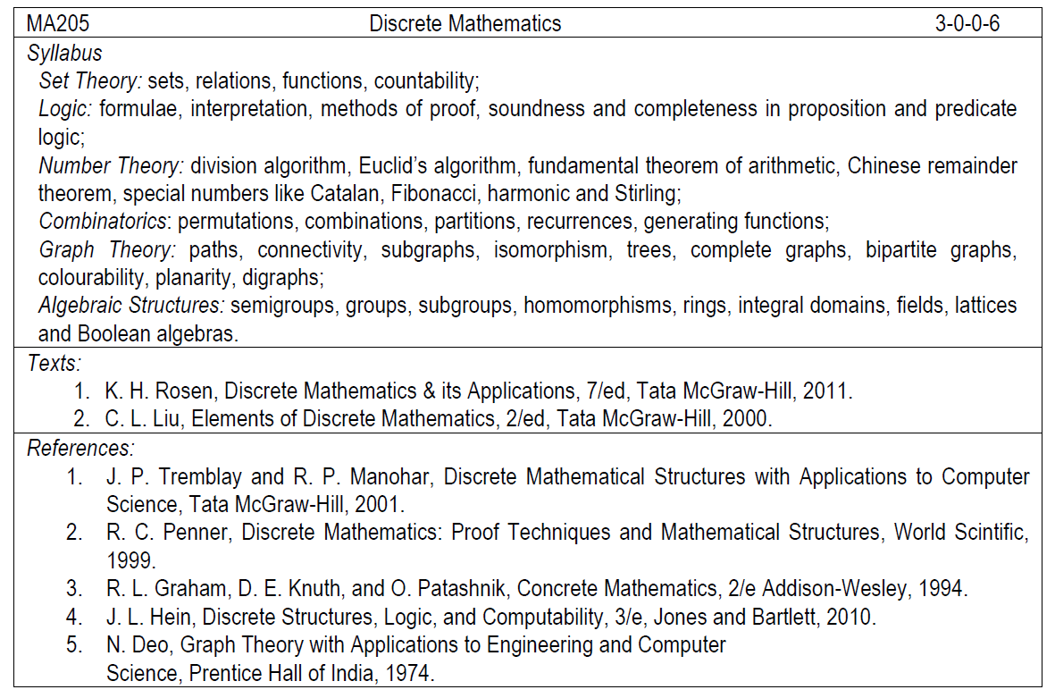

This is a very logical course, nothing much to cram about. Rather than solving tutorials, it is important to solve the questions and in in-text solved examples. There are many theorems and proofs that you need to concentrate on in this course. As always it is a must to attend every class. You can follow the course easily, you won’t have problem understanding it.

Book for DM: <https://drive.google.com/file/d/18DtJq20qZZbcFITdcu2SfiqfKg4TeAKB/view?usp=sharing>

This drive link consists of all the resources you need like: Tutorials, random resources to learn more, slides - <https://drive.google.com/drive/folders/13F5XQOV5ZBZDmMW6Cb7kgtlxukRESbFz?usp=sharing>

Tip : This course is pretty interesting and Saranya Mam make it even more interesting. Our friend Ishan attended all the classes for the course because he had peculiar interest in both of them. He scored a 10 pointer in the course so I think it might be very clear what you have to do to score a 10 pointer in this course . *tongue emoji*