1. Install and run elasticsearch.bat file in terminal.(v7.17.0)
2. Run elastic_db_final.py.
3. POST request to specify file name to be read by the instance.
4. 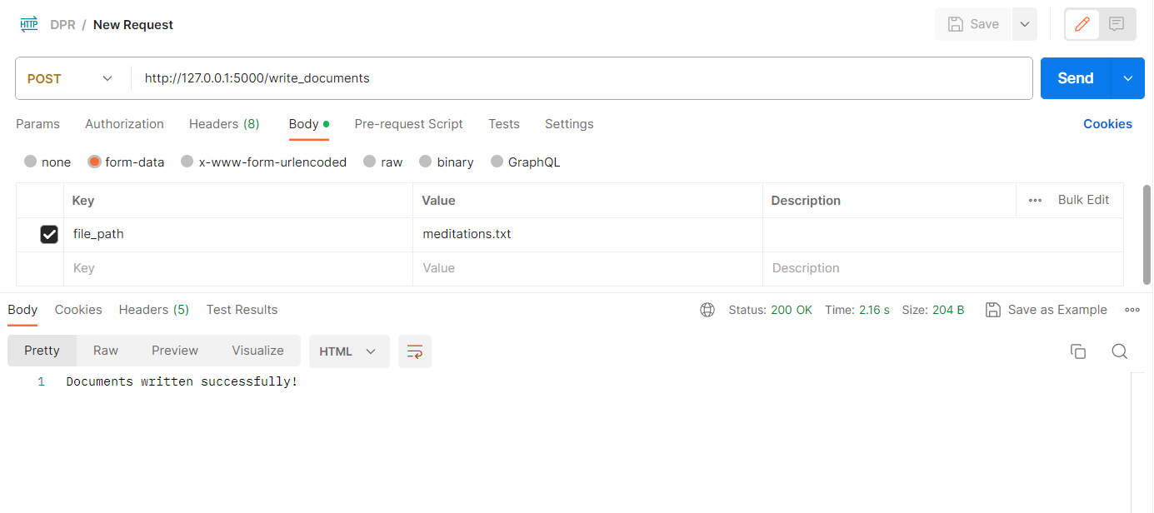
5. Now run the api.py file using uvicorn api:app –reload command.