**Cloud Application Development**

**Phase 5: Project Documentation & Submission**

**Project title: Machine learning model deployment with IBM Cloud Watson studio.**

**Problem statement:**

Become a wizard of predictive analytics with IBM Cloud Watson Studio. Train machine learning models to predict outcomes in real-time. Deploy the models as web services and integrate them into your applications. Unlock the magic of data-driven insights and make informed decisions like never before!

**Problem definition:**

The project involves training a machine learning model using IBM Cloud Watson Studio and deploying it as a web service. The goal is to become proficient in predictive analytics by creating a model that can predict outcomes in real-time. The project encompasses defining the predictive use case, selecting a suitable dataset, training a machine learning model, deploying the model as a web service, and integrating it into applications.

**PROJECT OBJECTIVE:**

A cloud-based predictive analytics solution has been designed using IBM Cloud Watson Studio that empowers users to train, deploy, and integrate machine learning models into their applications. The goal is to harness the power of data-driven insights, enabling users to make informed decisions in real-time and unlocking the magic of predictive analytics.

**Design thinking Process**

Empathize:Understand the target users or audience who want to become wizards of predictive analytics.

Define:Clearly define the problem you're solving, considering the users' perspective.

Ideate:Brainstorm creative solutions to address the defined problem.

Prototype:Create a prototype or mockup of the cloud application that will help users become predictive analytics wizards.

Test:Gather feedback from potential users by allowing them to interact with the prototype.

Implement:Develop the cloud application based on the refined prototype.

Deploy:Deploy the application on a cloud platform, such as IBM Cloud, for accessibility and scalability.

Iterate:Continuously gather user feedback and make improvements to the application.

**Design thinking is a human-centered approach to solving problems and creating innovative solutions. To address the problem statement of becoming a wizard of predictive analytics with IBM Cloud Watson Studio, you can follow a design thinking process with the following steps:**

**Predictive use case :**

Description:

PMML is an XML based language used to represent predictive models  created as the result of the predictive modeling process. It allows for predictive  models to be easily shared between applications.

Key Components:

● Data Collection

● Data Preprocessing

● Model Selection

● Model Training

● Validation and Evaluation

● Fine-tuning

**Datasetselection: (“house-price-prediction”)**

Data collection for a dataset with labels is a critical step in building a machine learning model for tasks like classification or prediction

The "House Price Prediction" dataset contains information about residential properties and their sale prices. It's used to build predictive models for estimating house prices, with features like bedrooms, bathrooms, and square footage. Data scientists use it for regression practice, and it has applications in real estate, finance, and urban planning. Various versions of this dataset may focus on specific regions or property types.

**Model Training:**

The decision tree algorithm is a machine learning method used for "House Price Prediction" dataset in Scikit-Learn (sklearn). It works by recursively splitting data based on features to create a tree structure that predicts house prices. Scikit-Learn's implementation allows users to easily build, train, and evaluate decision tree models for predicting house prices from dataset features.

**Model Deployment and Integration:**

Deploying a trained Faster Decision Tree Algorithm model as a web service on IBM Cloud Watson Studio typically involves the following steps:

1. Prepare the Model

2. Create a Watson Machine Learning (WML) Instance

3. Package Dependencies

4. Deployment Configuration

5. Deploy the Model

6. Endpoint Testing

The deployed model has to be integrated into web applications or other systems that need to use the object detection service. We can make HTTP requests to the endpoint to get predictions for new images.

**DEVELOPMENT PHASE :**

**STEP 1:: Set Up IBM Watson Studio**

1. Create an IBM Cloud Account:

If we don't already have an IBM Cloud account, we'll need to create one. Visit the IBM Cloud website (https://cloud.ibm.com) and sign up for a free accoun

2. Access IBM Watson Studio: After creating our IBM Cloud account, log in to IBM Cloud

3. Create a New Project

i. Once logged in, navigate to the IBM Watson Studio service.

ii. Create a new project within Watson Studio to organize your work. Give your project a name and, if applicable, a description.

4. Define the Project Type

5. Configure the Project:

6. Invite Collaborators

7. Data Import

**Step 2:Data Collection and Preparation:**

**Data Collection:**

• Identify Data Sources: Determine where our data will come

from. It can be internal databases, external sources, or a

combination of both. Identify the specific data needed to address

your predictive analytics problem.

• Data Retrieval: Obtain the data from the identified sources.

Depending on the source, we may need to use SQL queries, web

scraping, APIs, or other methods to retrieve the data.

• Data Import: Import the collected data into your IBM Watson

Studio project. We can typically do this via the project interface

or using programming languages like Python or R.

**Data Preparation:**

Data Inspection:

o Explore the imported data to understand its structure. Use

basic commands and tools to check the data's dimensions,

data types, and an initial sample of records.

Data Cleaning:

o Address missing data: Identify and handle missing values

using techniques like imputation, removal, or

interpolation.

o Remove duplicates: Check for and eliminate duplicate

records from the dataset.

o Outlier detection and handling: Identify outliers and

decide whether to remove, transform, or keep them based

on their impact on the analysis.

o Data normalization: If your data contains features with

different scales, apply scaling techniques like Min-Max

scaling or standardization.

Data Splitting:

Split our data into training, validation, and test sets. The

training set is used for model training, the validation set

for model tuning, and the test set for final model

evaluation.

Data Preprocessing:

Apply any further data preprocessing steps such as

standardization, dimensionality reduction, or other

techniques that can improve the model's performance.

Data Export:

Save the cleaned and pre-processed data in a format that is

easy to work with for building machine learning models.

Common formats include CSV, Excel, or database tables.

The quality and preparation of our data play a significant role in the

success of our predictive analytics project. By completing this step

effectively, we ensure that your data is ready for model development

and that the models can learn meaningful patterns and make accurate

predictions.

**Step 3: Model Building:**

1. Select Appropriate Algorithms: Choose machine learning

algorithms that are suitable for our specific predictive analytics

problem. Common choices include linear regression, decision trees,

random forests, support vector machines, or neural networks.

2)Data Preparation: Ensure our data is prepared and cleaned, as

discussed in the earlier steps. This involves handling missing values,

encoding categorical data, and scaling or normalizing features.

3)Split Data: Divide our dataset into three sets: a training set, a

validation set, and a test set. The training set is used to train the

model, the validation set is for tuning hyperparameters, and the test

set is for final model evaluation.

4)Model Training: Train our chosen machine learning model on the

training data. Watson Studio provides an integrated environment to do

this using popular libraries like scikit-learn or TensorFlow.

**Step 4: Model Deployment :**

Model deployment is a critical step in our project for becoming

proficient in predictive analytics with IBM Cloud Watson Studio.

This step involves making your trained machine learning models

accessible to applications through web services. Here's a guide on

how to deploy your models:

1. Select the Model: Choose the best-performing machine learning

model that you want to deploy. This should be the model that we have

thoroughly trained and evaluated.

2. Preprocessing and Transformation: Ensure that any preprocessing

steps (e.g., feature scaling or one-hot encoding) used during model

training are replicated during deployment. This ensures that incoming

data to the deployed model is processed correctly.

3. Create a Deployment Space:

 - In IBM Watson Studio, navigate to the model deployment section.

 - Create a deployment space or project where you can manage your

deployment assets.

4.Model Deployment:

 - In the deployment space, select the model we want to deploy.

 - Follow the prompts to deploy the model. We may be asked to

specify the deployment environment and configuration settings.

Watson Studio makes this process user-friendly.

5. API Endpoint: Once deployed, our model will have a unique API

endpoint that can be used to make predictions. This endpoint is

typically a URL that accepts input data and returns predictions.

6. Scalability and Load Balancing: Depending on our use case,

consider setting up load balancing and ensuring the deployed model

can handle a scalable number of requests.

7. Security and Access Control: Implement appropriate security

measures to protect our API endpoint. Ensure that only authorized

applications or users can access and use the model.

8. Documentation: Create documentation for the API endpoint.

Include details about the expected input format, response format, and

any required authentication or API keys.

9. Testing: Before integrating the model into applications, test the API

endpoint to ensure it's functioning as expected. Use sample data to

validate that it returns accurate predictions.

 Model deployment in IBM Cloud Watson Studio is designed

to be user-friendly and efficient. By following these steps, you ensure

that your trained models are accessible and capable of making realtime predictions, which is a fundamental part of unlocking datadriven insights for informed decision-making.

**Step 5: Integration with Applications:**

In this step, we'll seamlessly incorporate the deployed machine

learning models into your existing or new software applications, such

as web apps, mobile apps, or backend services. Integration enables

these applications to utilize the predictive power of your models in

real-time, which, in turn, empowers data-driven decision-making.

1. API Integration: Our deployed models typically expose an API

endpoint that applications can communicate with. These APIs allow

applications to send input data to the model and receive predictions as

responses. Integration usually involves making HTTP requests to this

API.

2. Data Input and Output Formats: Ensure that our applications

understand the expected input data format for the model. This might

involve converting user inputs into a format suitable for the model,

and then processing the model's predictions.

3. Security: Implement security measures, including authentication

and authorization, to ensure that only authorized applications can

access and utilize your model's API. This helps protect sensitive data

and the integrity of our predictive analytics.

4. Scalability: Consider the scalability of your application and model

integration. Ensure that our applications can handle a high volume of

requests and that our deployment infrastructure can scale accordingly.

5. Error Handling: Implement robust error-handling mechanisms in

our applications to deal with scenarios where the model may fail to

make predictions or encounters unexpected input data.

6. Testing: Rigorously test the integration of the model within our

applications using a variety of input data and scenarios. Verify that

the predictions align with your expectations and are used

appropriately.

 By successfully integrating your predictive analytics models

with our applications, we enable them to provide data-driven insights

and real-time decision support to users. This is a pivotal step in

making informed decisions, as outlined in your problem statement,

and harnessing the magic of data-driven insights in a practical and

actionable way.

**Step 6: Monitoring and Maintenance:**

To become proficient in predictive analytics with IBM Cloud Watson

Studio, monitoring and maintenance are essential for ensuring that our

predictive models consistently deliver accurate and valuable insights.

 • Metric Tracking: Use specific performance metrics

relevant to our problem. For instance, if we're predicting customer

churn, track metrics like accuracy, precision, recall, or F1-score to

evaluate the model's performance.

 • Continuous Performance Evaluation: Regularly assess the

performance of your deployed machine learning models. This

involves measuring how well they make predictions and checking if

they're still accurate.

 • Alert Systems: Set up automated alerts or notifications that

signal potential issues with your models. These alerts act as early

warning systems, similar to smoke detectors in a house.

 • Data Updates: If the data your models were trained on

becomes outdated, consider updating it. New data ensures that your

models remain relevant and effective, just like updating a map with

new roads.

 • Periodic Retraining: Depending on how rapidly your data

evolves, periodic retraining of your models might be necessary. This

process involves using fresh data to fine-tune the models for

improved accuracy, akin to studying to improve your knowledge.

 • Documentation Updates: Keep your documentation

current. This documentation acts as a guide for anyone who manages

or interacts with your models.

 By the above steps, we can ensure that our predictive

analytics capabilities remain up-to-date, accurate, and secure.

Regular monitoring and maintenance are essential to unlock the full

potential of data-driven insights and informed decision-making with

IBM Cloud Watson Studio.

**Real-Time Insights:**

By deploying and integrating predictive

models, we can gain access to real-time insights based on data. These

insights help us to understand what's happening right now.

**Step wise process for the House Price Prediction Analysis Machine learning model deployment.**

**Step 1:** Login to IBM cloud

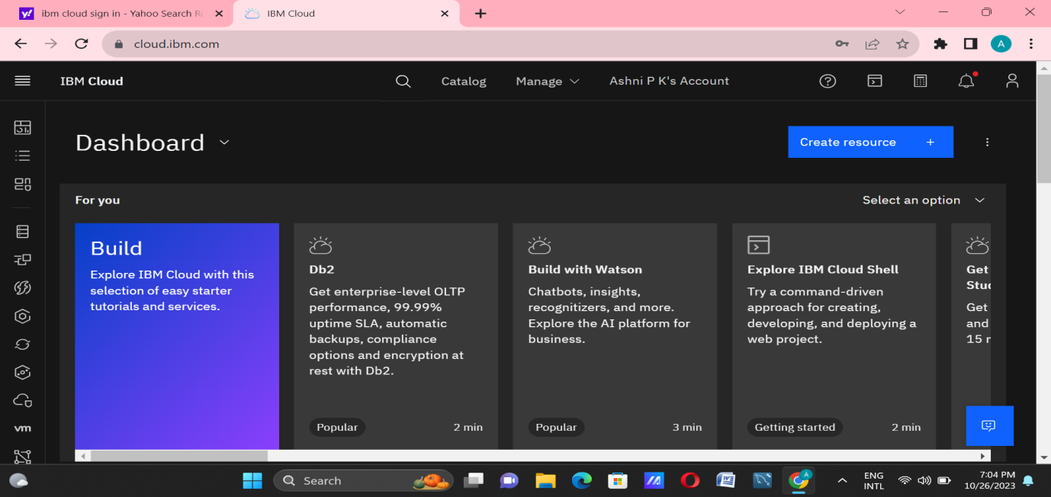

**Step 2:** Go to catalog and create a Watson Studio service in AI category.

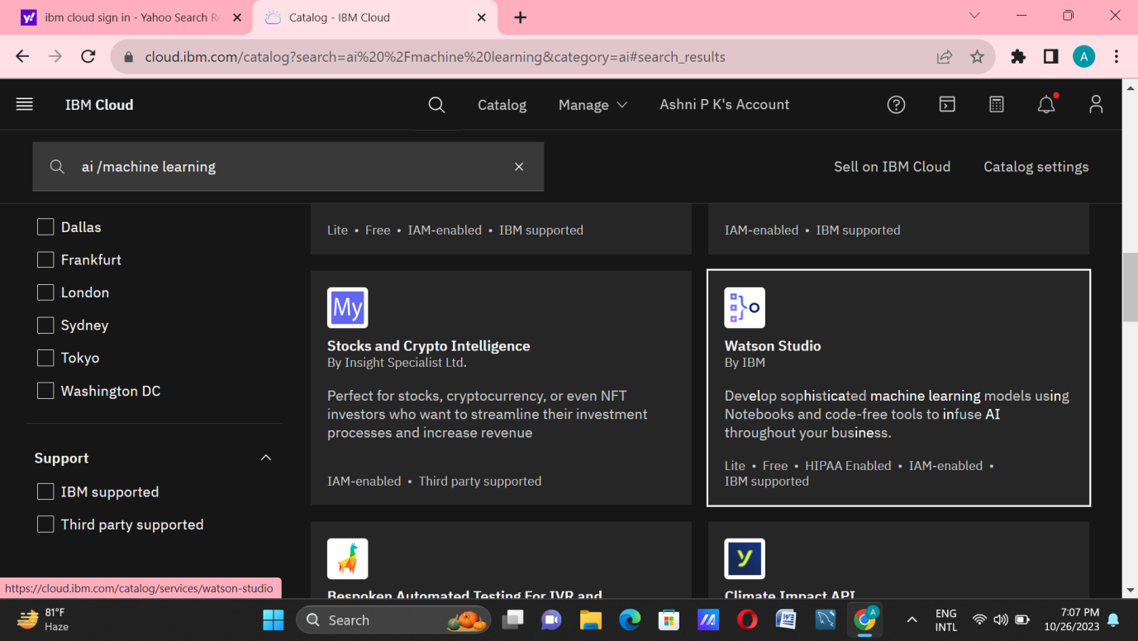

**Step 3:** Get started to launch Watson Studio Dashboard.

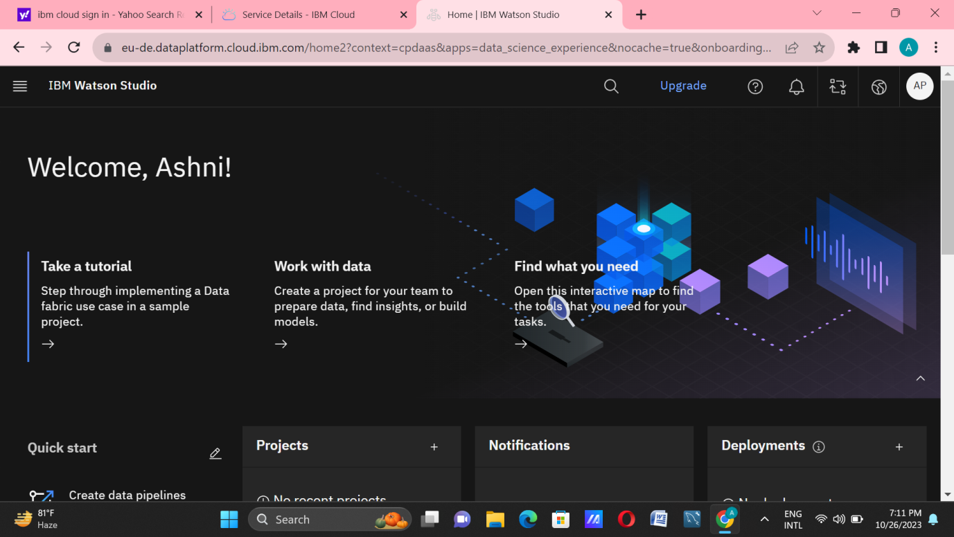

IBM Watson Studio is an IDE to build ,run and manage AI models.The platform consists of a workspace that includes multiple collaboration and open-source tools for use in data science.

**Step 4:** Create a project in IBM Watson Studio in IBM Cloud and assign a Cloud object storage to manage datasets.

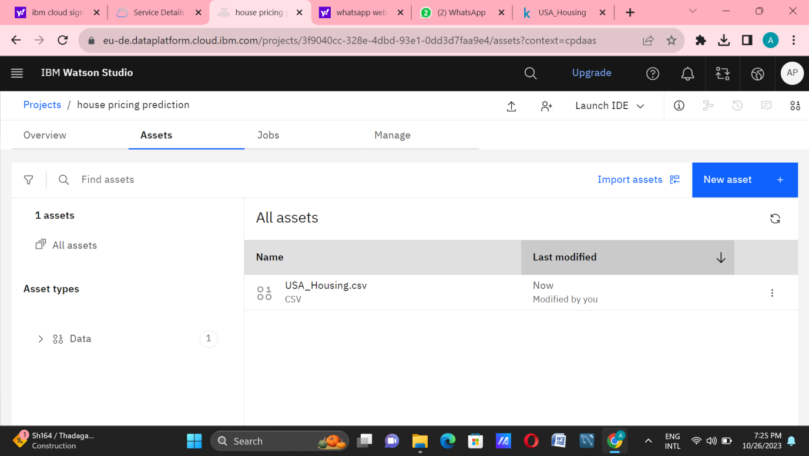

Cloud Object Storage is a storage service in IBM Cloud. IBMCloud Object Storage is a highly scalable,designrd for high durability,resiliency and security.We use this service to manage our datasets for training the ML Model and store required files.

**Step 5:** Add a jupyter notebook instance in your project to Develop and Deploy Machine Learning Model.

1. Import necessary library packages.

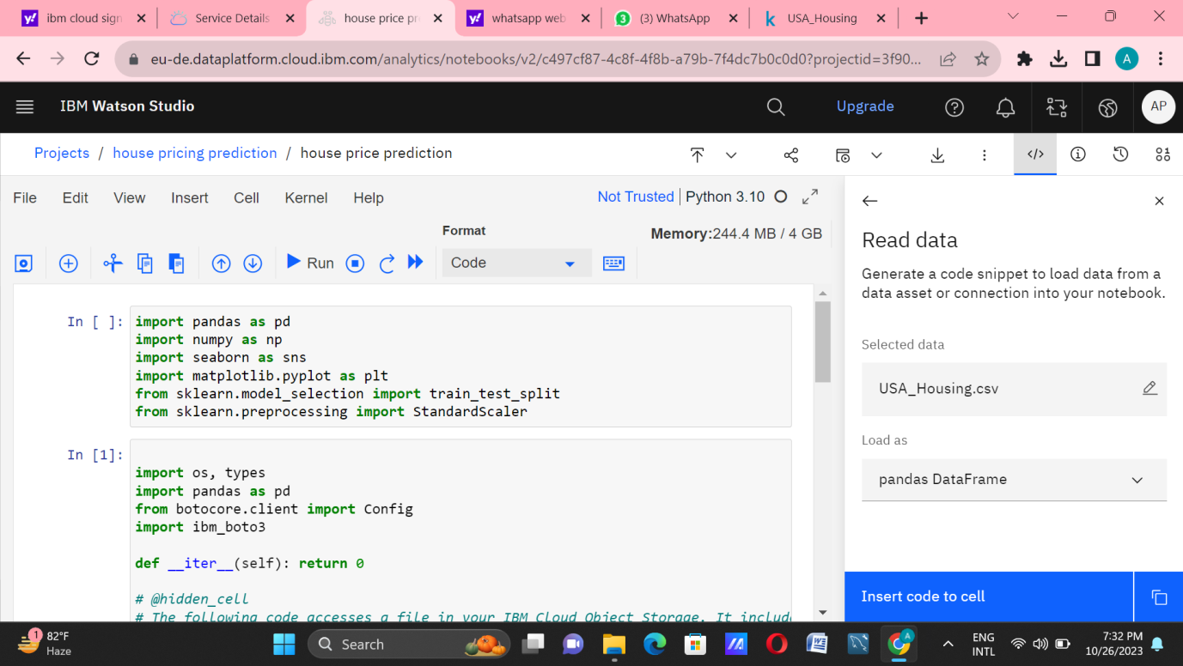

1. Import dataset and proceed further with pre-processing steps and build the model.

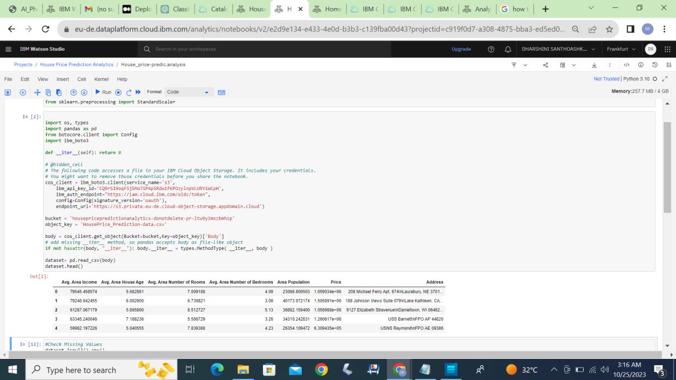

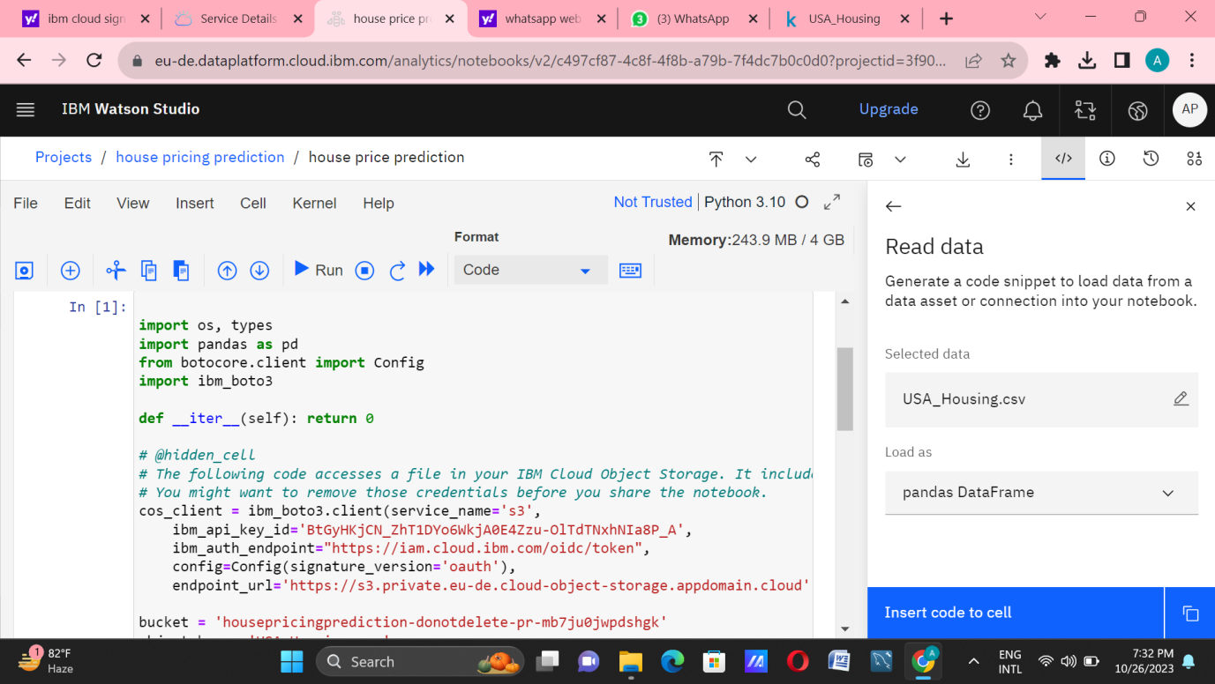**Step 6:** Train the build model and evaluate them.

Model was build trained and tested.

**Deployment of machine learning model and creation of web application for our machine learning model**

**Step:1**

Install ibm_watson_machine_learning by the command

**#pip install ibm_watson_machine_learning**

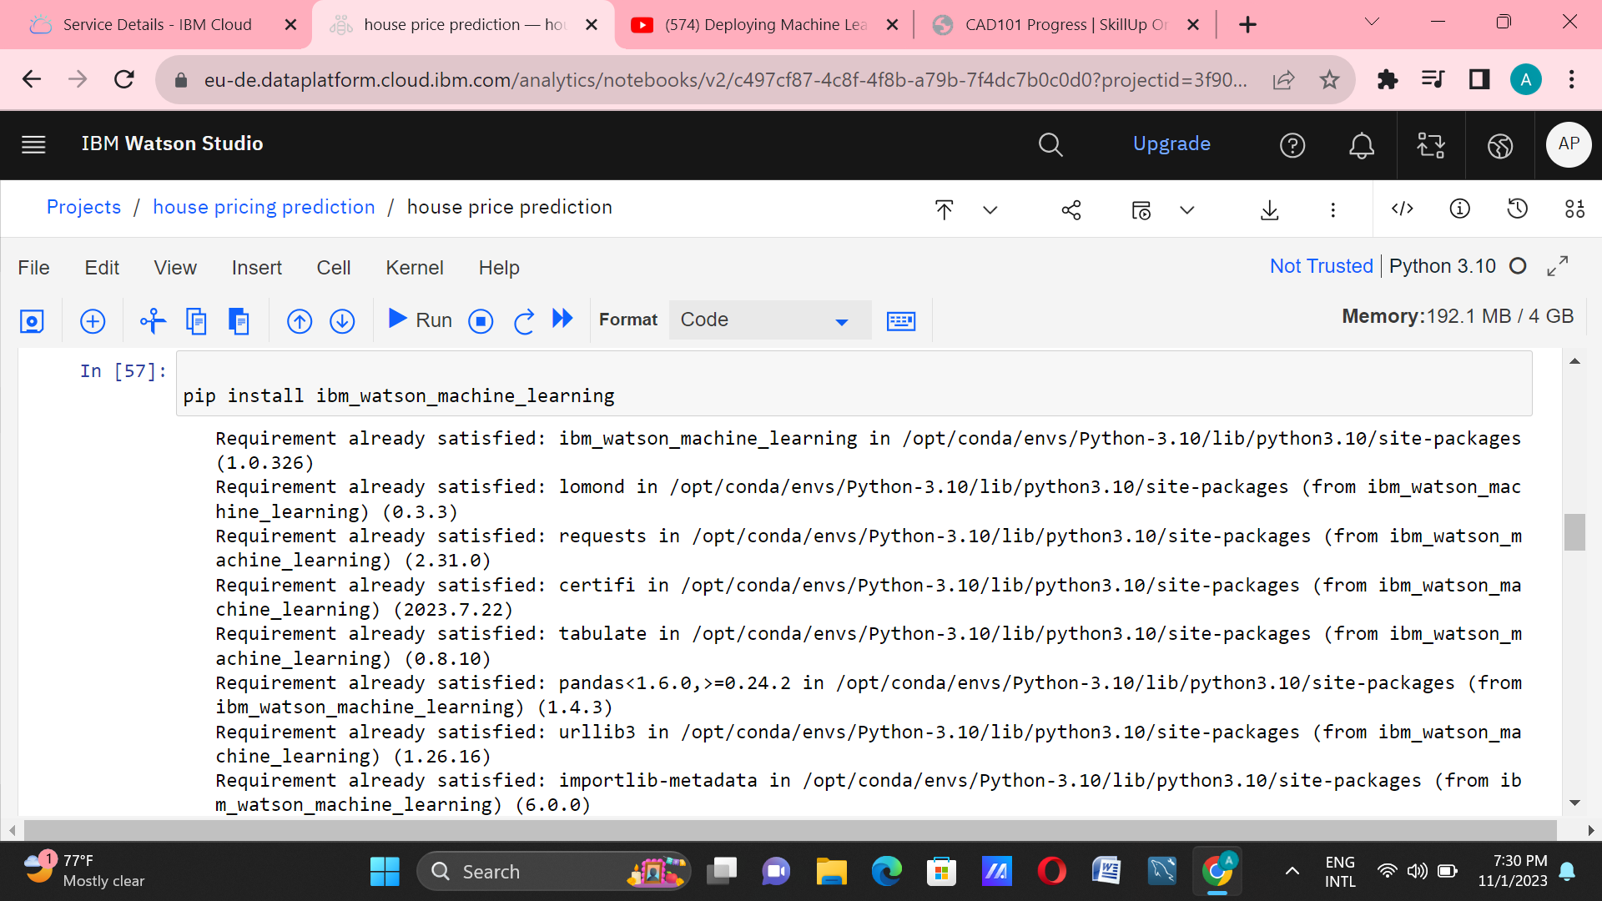**Step 2:** Import **WatsonMachineLearningAPIClient**library. Watson studio uses Watson Machine Learning service credentials to access WML service, so paste the credentials.

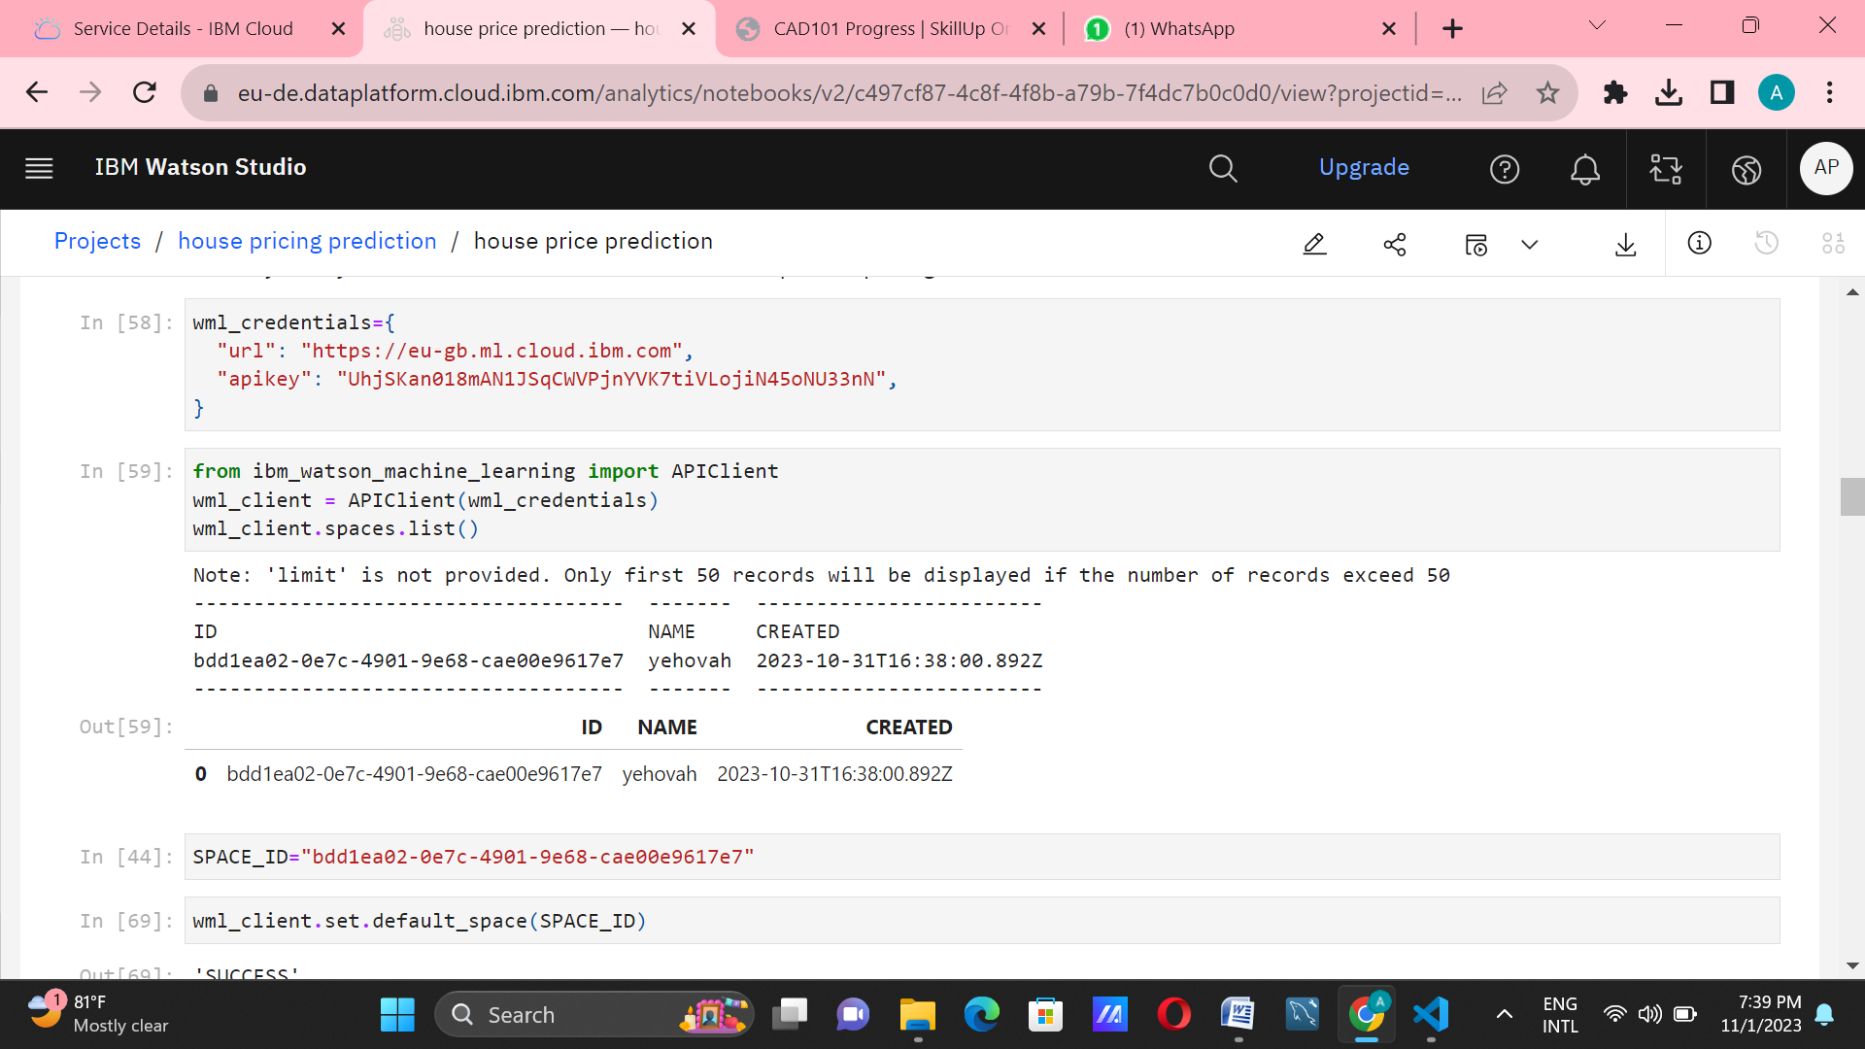

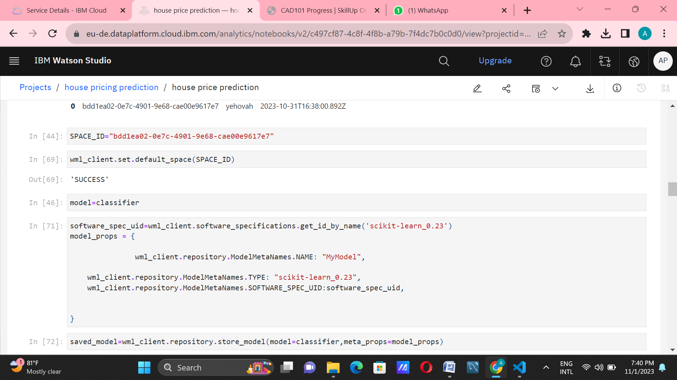**Step-3:**In this step we have to specify our machine learning model properties and store the model in WML repository.

**Step :4**

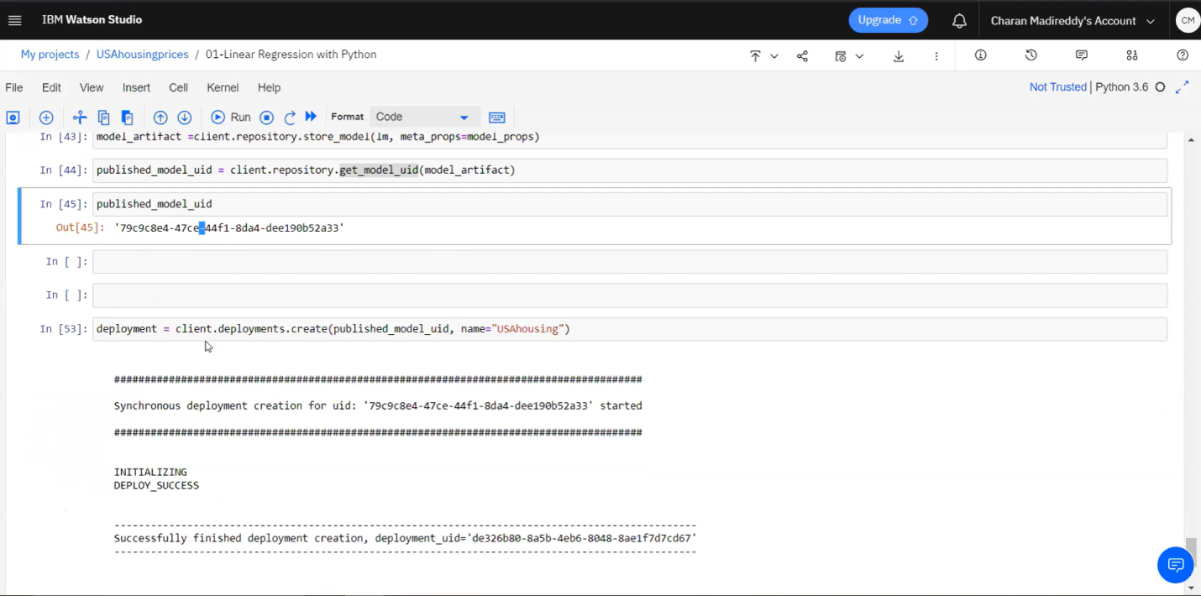Successfully we have deployed our model in IBM Watson Studio.

**Step 5:** Now we have deployed our machine learning model as a Web service. Once the model is deployed ,it can be used to make predictions or provide other intelligent services to web users.

