

# AICTE Activity Points Program

Date:

Team Details

|  |  |  |
| --- | --- | --- |
| Sl No | USN | Name |
| 1 | 3VC19CS065 | LAVANYA.K |
| 2 | 3VC19CS001 | MADHURI.A |
| 3 | 3VC19CS119 | REKHA.M |
| 4 | 3VC19CS067 | AKSHITHA.M |

# Name of the Activity: Plantation

Activity Description:

Plantation drives combat many environmental issues like deforestation, erosion of soil, desertification in semi-arid areas, global warming and hence enhancing the beauty and balance of the environment. Trees absorb harmful gases and emit oxygen resulting in an increase in oxygen supply. They provide us oxygen, filter carbon dioxide, prevent soilerosion, maintain the ecological balance and many more. Also, they provideus food, shelter and many useful things. Trees create jobs, provide flowers, fruit, fodder and fuel to communities and living creatures, offer shade to nomads and their livestock, give shelter to birds and animals, prevent soil erosion and flooding, improve water catchment, generate oxygen, reduce pollution. Planting more trees would not only help humans but it will support the whole biodiversity. Planting trees makes the environment immediately more beautiful. Trees help prevent soil erosion. They also absorb different pollutants and thus make the air-water and earth cleaner.



**Name of the Activity: All lead kind activities**

Activity Description:

We have participated and all activities which where conducted in lead and we learnt many things in that , and this helps student to over come from stage fear , and learn many things and bulid up confidence and grow the knowledge.

**Name of the Activity: Clean Campus**

Activity Description:

Keeping the environment clean is important to being healthy. Many disease-causing germs exist in dirty environments, such as the ones that cause diarrhoea and worm infections. This means that many diseases can be prevented through good personal hygiene, and by keeping the environment clean. Cleanliness is important, for it builds up a healthy environment that facilitates physical and mental well-being and growth. Therefore, its individual, as well as collective importance cannot be denied. Cleaning the environment is the key to the existence and survival of life on planet earth. Maintaining a clean environment reduces pollution, preserves our biosphere, protects endangered species, and helps preserve the earth’s natural resources. In society, the state of cleanliness represents the mindset of its inhabitants.

**Name of the Activity: Corona paper presentation**

Activity Description:

1. Common symptoms of Covid-19 virus
2. Reduce the risk of Infection



1. Protect yourself and others from getting sick The COVID-19 pandemic has affected the world in unprecedented ways, and it's essential to take precautions to help prevent the spread of the virus. Here are some precautions and awareness tips to keep in mind:
   * Wash your hands frequently with soap and water for at least 20 seconds or use a hand sanitizer that contains at least 60% alcohol.
   * Wear a mask when you're in public or around others who don't live with you.
   * Practice social distancing by staying at least 6 feet away from others.
   * Avoid large gatherings, especially indoors.
   * Cover your mouth and nose with a tissue or your elbow when you cough or sneeze.
   * Stay home if you're feeling sick or have symptoms of COVID-19.



# Activity Snapshots:

1. Plantation

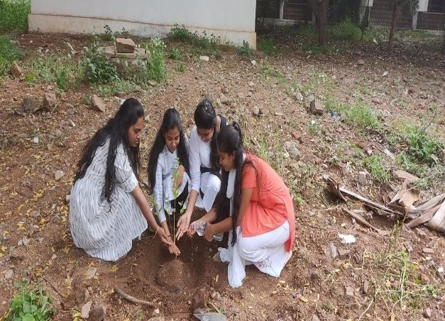

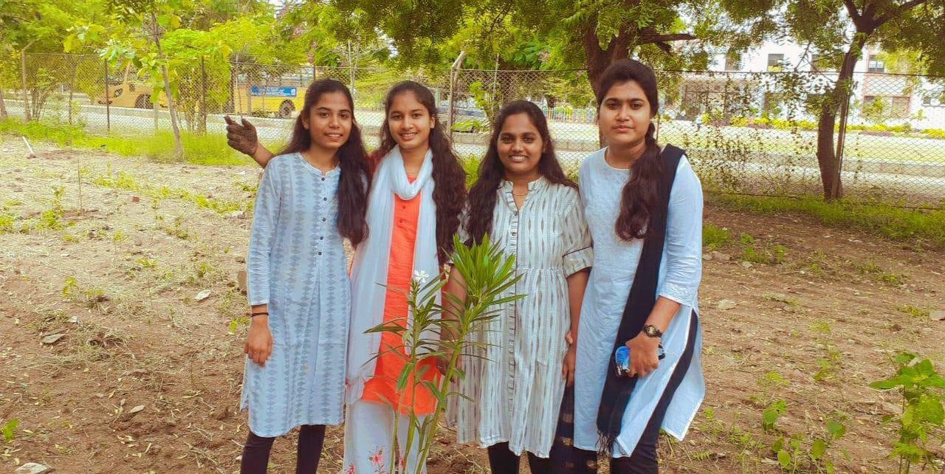



1. Corona drive https://[www.instagram.com/tv/CO4zac0HbVT/?igshid=NTc4MTIwNjQ2YQ==](http://www.instagram.com/tv/CO4zac0HbVT/?igshid=NTc4MTIwNjQ2YQ%3D%3D)

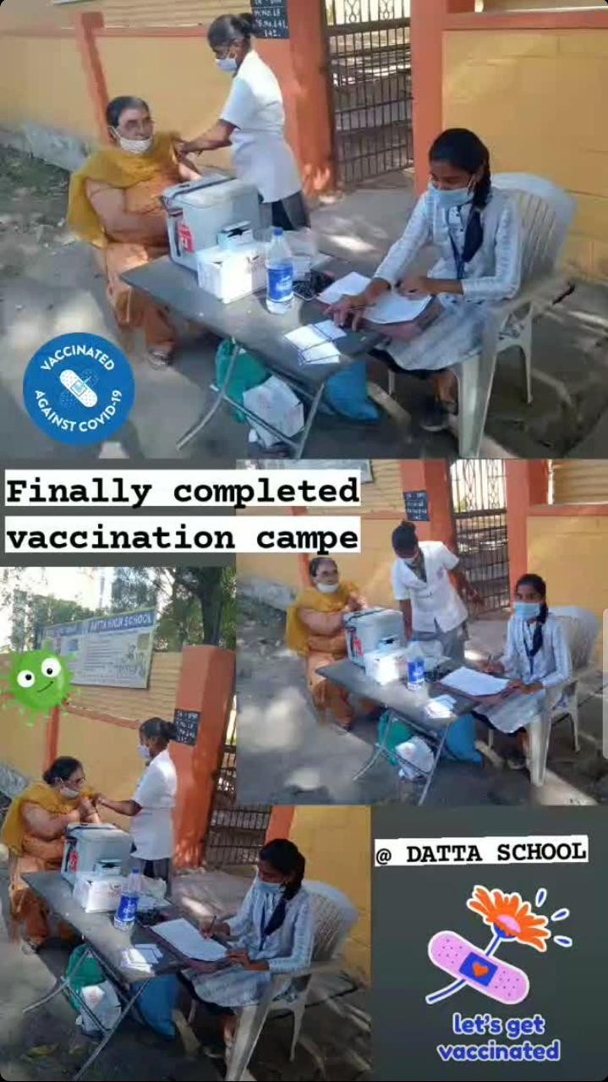



1. Lead activities

**Team Details:**

Activity Description: CM Event, Rakshabandhan Event, anna dan, seva dan, pustak dan, campus clean.

