1. First take a backup of your assignments & projects. This is required because due to incorrect GIT operation you may lose your files.
2. Create an empty directory ‘Assignments’ & cd to ‘Assignments’.
3. Create a file README.txt inside ‘Assignments’ & write few lines about the contents of ‘Assignments’ folder.
4. Commit README.txt file.

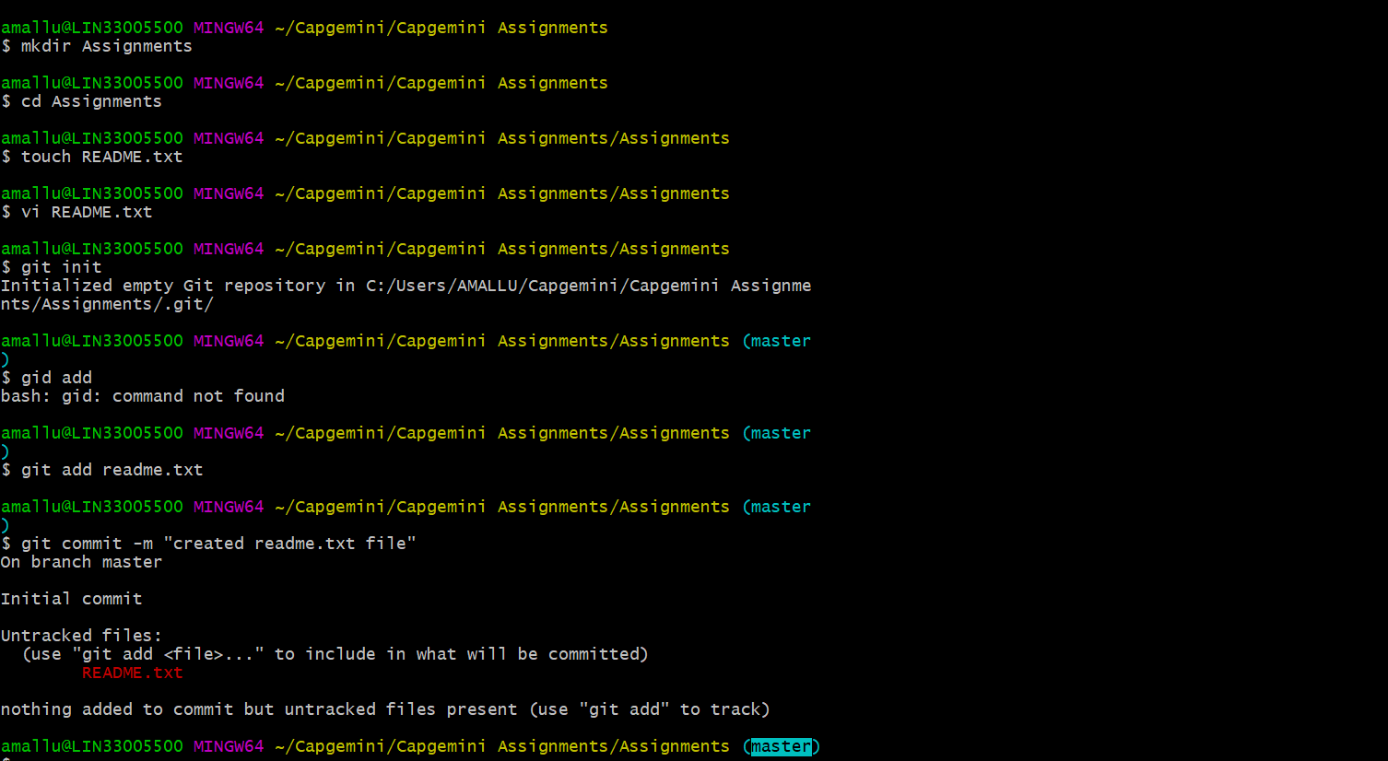

1. Now create a new branch ‘html-assignments’.
2. Switch to ‘html-assignments’ branch.
3. Copy all HTML assignments inside ‘Assignments’ folder.
4. Commit HTML assignments into ‘html-assignments’ branch.
5. Make minor changes into few files belonging to ‘html-assignments’ branch.
6. Commit those changed files.

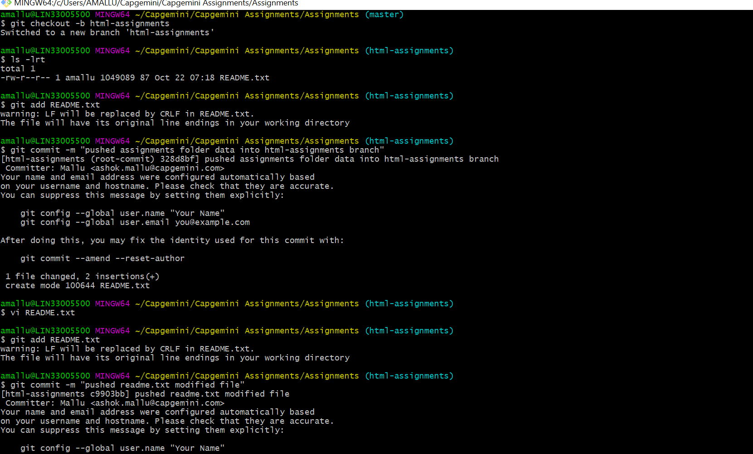

1. Switch to master branch.
2. Make minor changes into README.txt file & commit those changes into master.
3. Again switch to ‘html-assignments’ branch.
4. Make minor changes into few files belonging to ‘html-assignments’ branch.
5. Commit those changes.

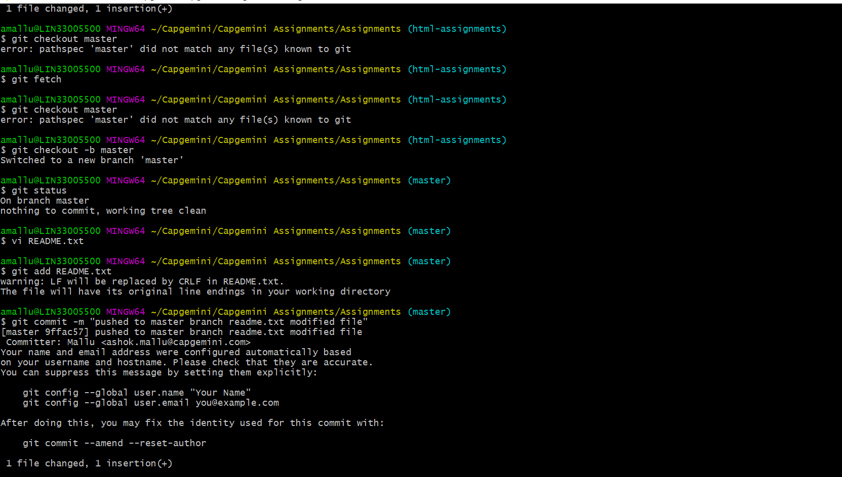

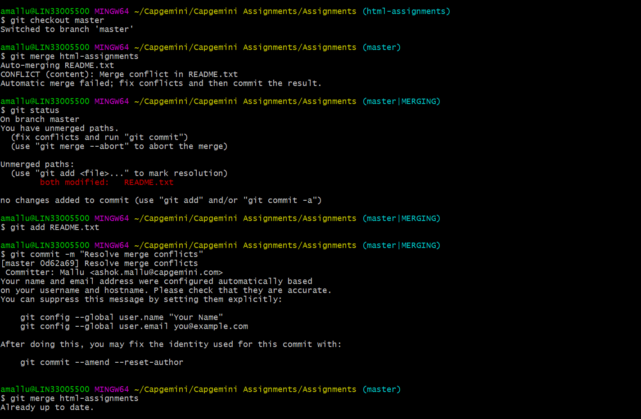

1. Switch to master.
2. Merge ‘html-assignments’ branch into master. Confirm all html assignments are shown in master.
3. Finally delete the ‘html-assignments’ branch.

