TASK/SEAP/2026/Sep/5800 / Note file No: Dt: 09/09/2026
Name of the Trainer: - Rama krishna Talluri Emp Id: - 5800
Designation: - Trainer Department/Location: - SEAP
Name of the College(s): - MJPTCWRDC_KMM
Course Title: - Tally ACE With GST
District: - Khammam Travel Date: - 01.09.2026

Sub: Reimbursement of expenditure for an amount of Rs. (1,080/-) Reg. Ref: Training Calendar.
*****
As per the reference and subject cited above, a training was scheduled at the below mentioned colleges / Reginal Center.
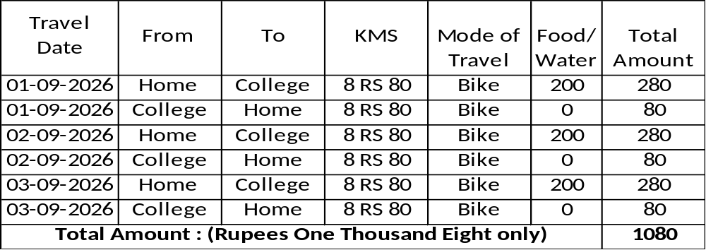

In this regard, I, (Rama krishna Talluri), Emp Id (5800) spent an amount of Rs. 1,080 /- (Rupees One Thousand Eight Only)

Hence, I request you to reimburse the expenditure incurred by me.

Submitted for Kind Approval.

Initiator Coordinator Supervisor

Manager Accounts COO

Chief Executive Officer

