Use-case-4

Technical Details:

1. Regions- Mumbai
2. Vpc
3. Two public subnets
4. Internet Gateway
5. Routing tables
6. Security Groups
7. Alb
8. Lister rules
9. EC2

Installed docker, git and docker compose on my EC2 instance by using below script.

yum update -y

              yum install -y docker git

              systemctl start docker

              systemctl enable docker

              git clone https://github.com/Ashok-yaddala/use-case-4.git

              cd use-case-4

              curl -SL https://github.com/docker/compose/releases/download/v2.33.1/docker-compose-linux-x86_64 -o /usr/local/bin/docker-compose

              chmod +x /usr/local/bin/docker-compose

              ln -s /usr/local/bin/docker-compose /usr/bin/docker-compose

              docker-compose up -d

After launching executing below terraform commands, we could see that our configured infra has been created.

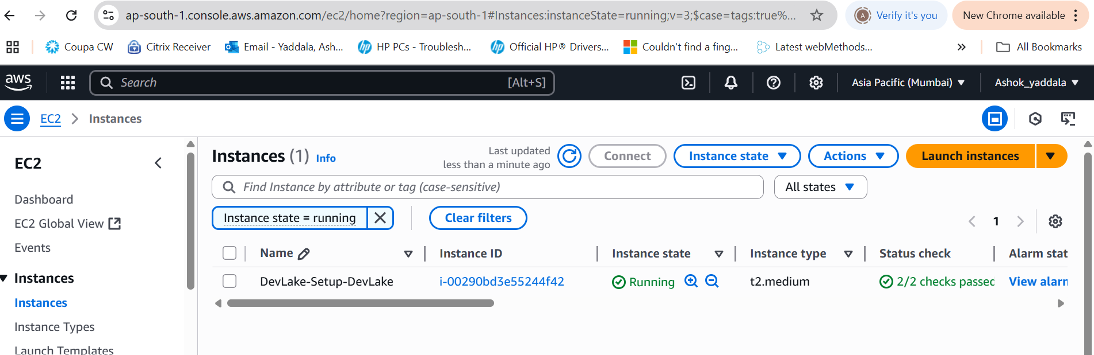

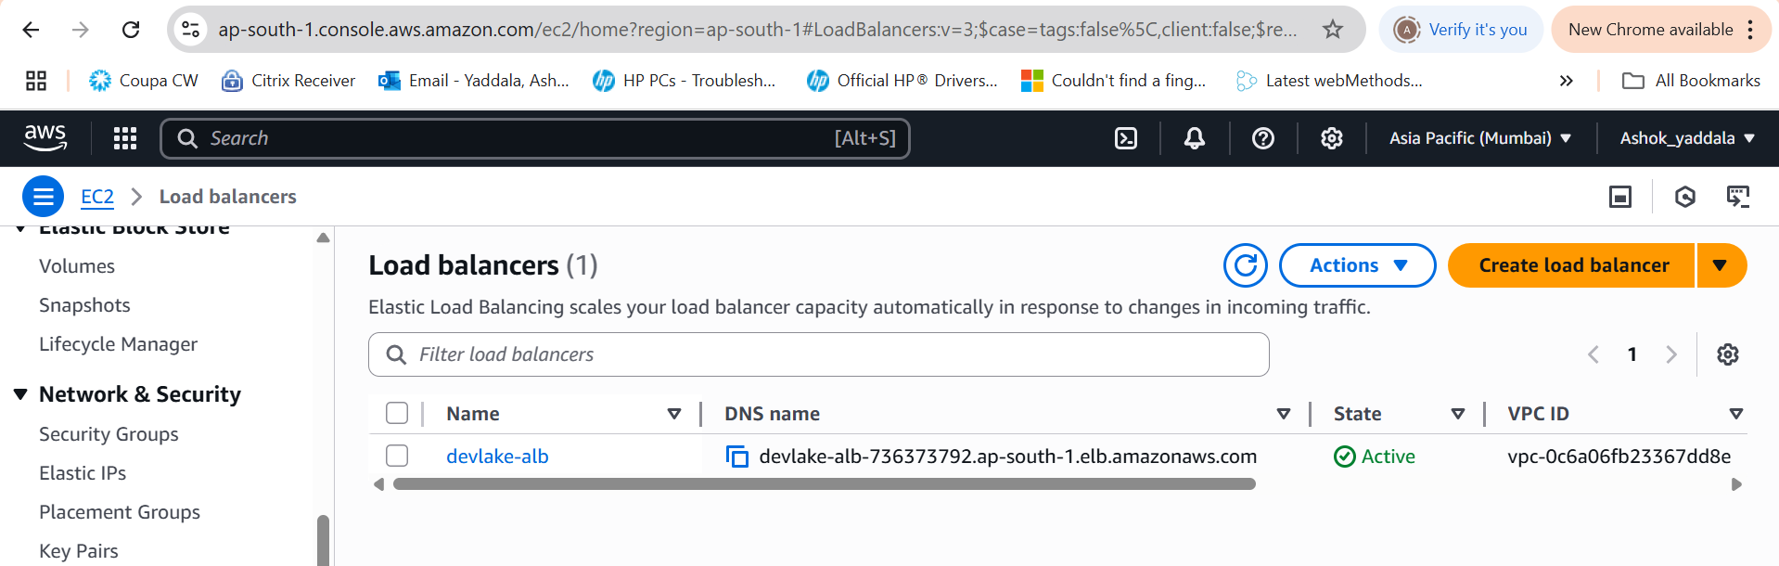

Tested the application by using load balancer url and able to get the response from the application

