Use-case-3

Technical Details:

1. Regions- Mumbai
2. Vpc
3. Two public subnets
4. Internet Gateway
5. Routing tables
6. Security Groups
7. Alb
8. Lister rules
9. EC2

I’ve installed the open project using docker on AWS EC2 instance by using below commands.

 user_data = <<-EOT

              #!/bin/bash

              sudo

              yum update -y

              yum install docker -y

              service docker start

              systemctl enable docker

              sleep 60

              docker run -d -p 80:80 -e OPENPROJECT_SECRET_KEY_BASE=secret -e OPENPROJECT_HOST__NAME=0.0.0.0:80 -e OPENPROJECT_HTTPS=false openproject/community:12

              EOT

When apply terraform commands:

terraform init

terraform plan

terraform apply

I was able to launch the AWS infrastructure successfully.

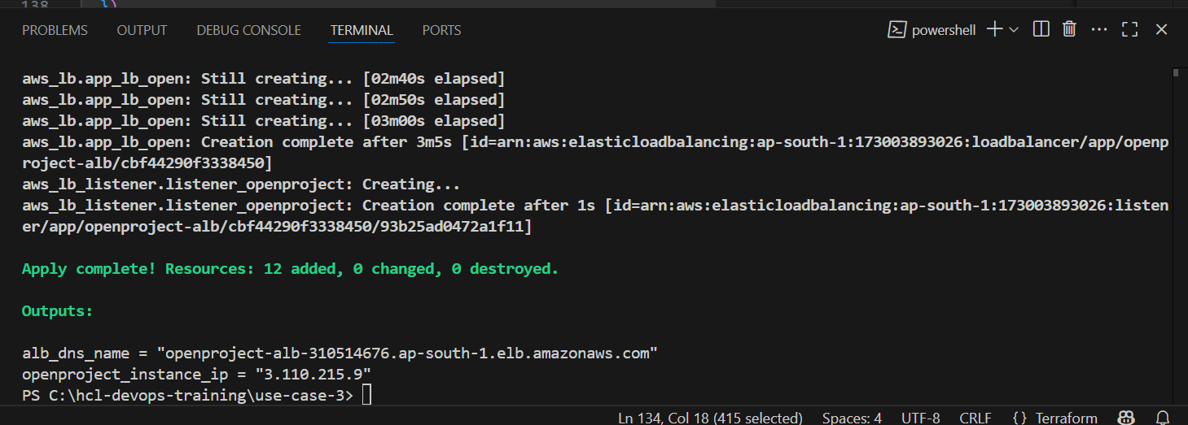

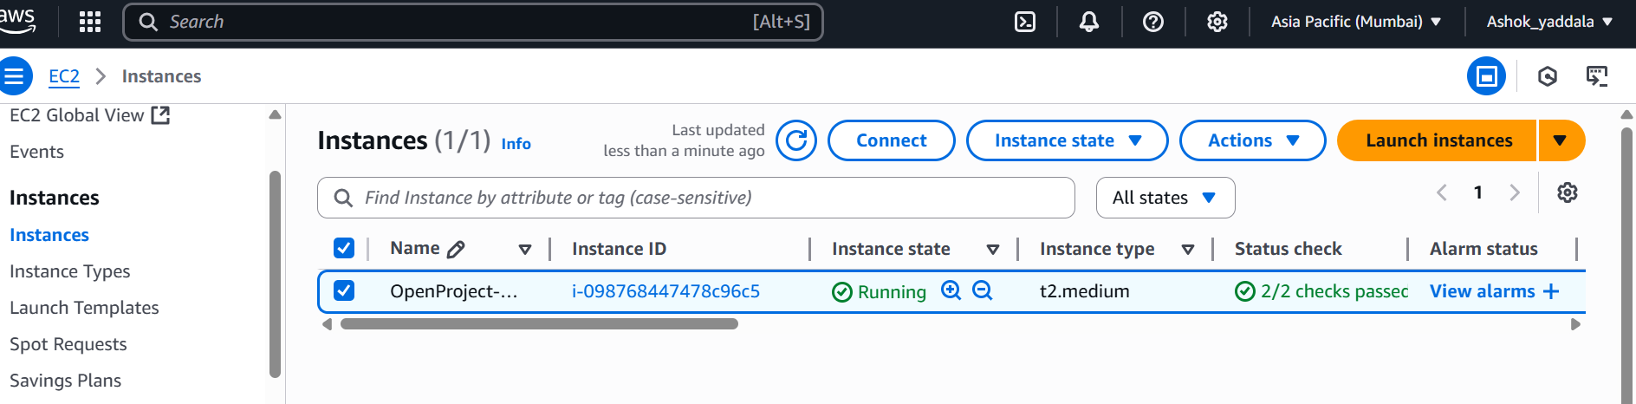

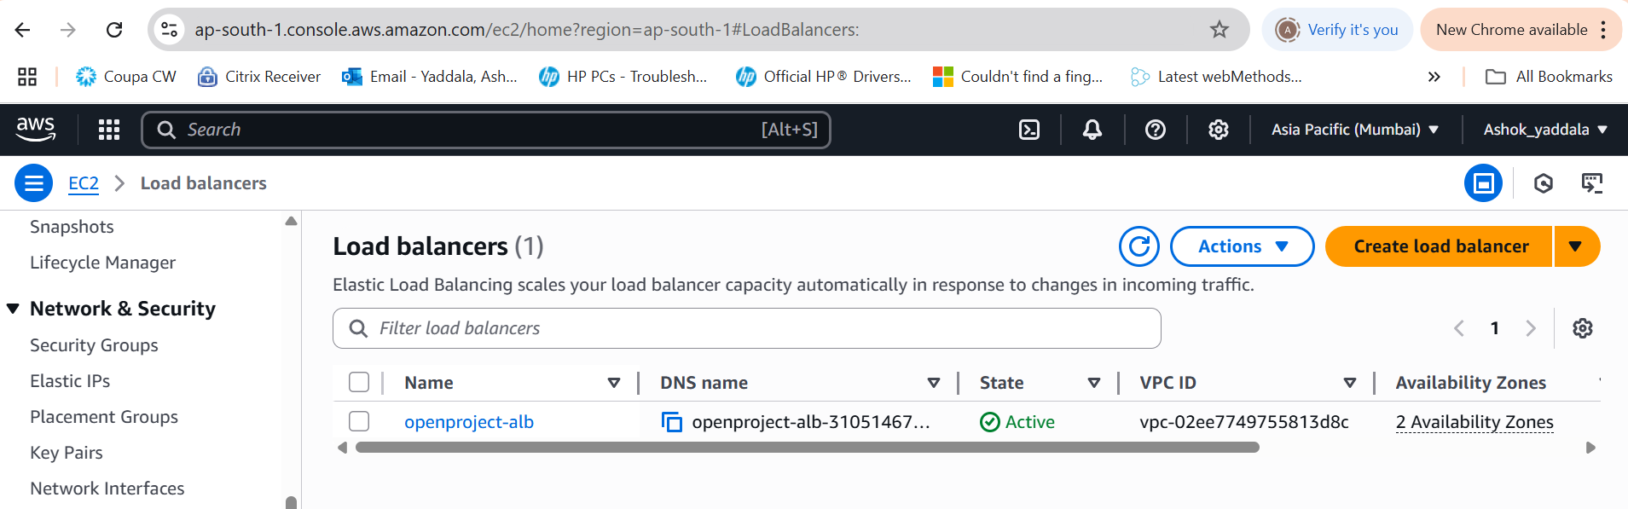

Tested the application by using load balancer url and able to get the response from the application.

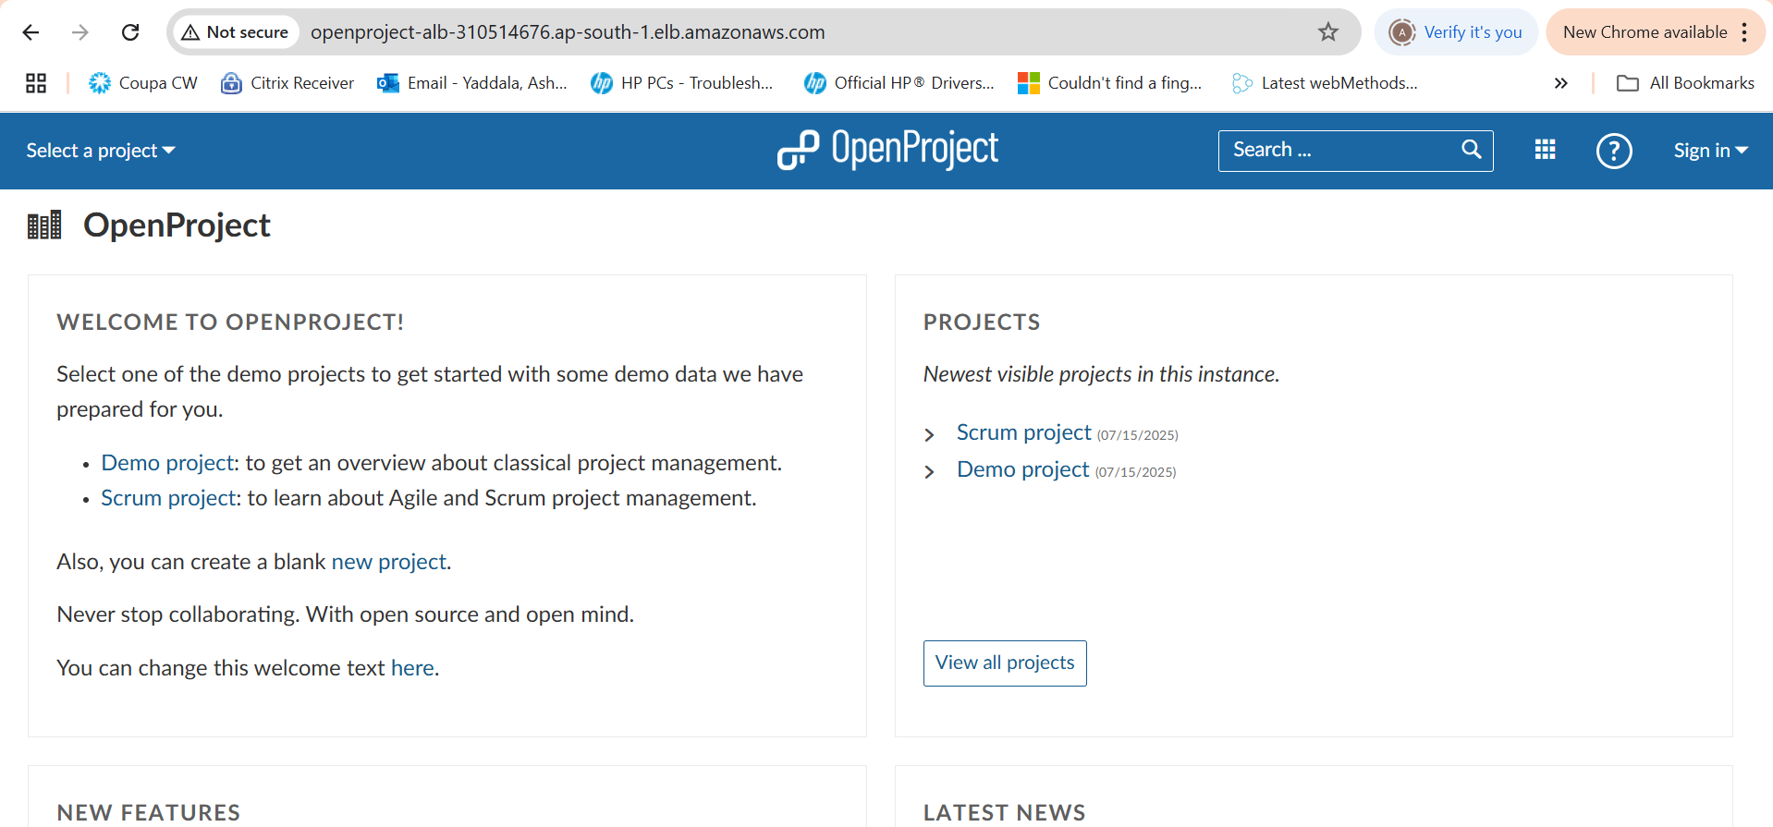

Implemented the github actions CI pipeline and tflint was implemented as part of terraform best practice.

