**US YouTube dataset Exploratory Data Analysis**

***Import necessary libraries and US YouTube Dataset into jupyter notebook***

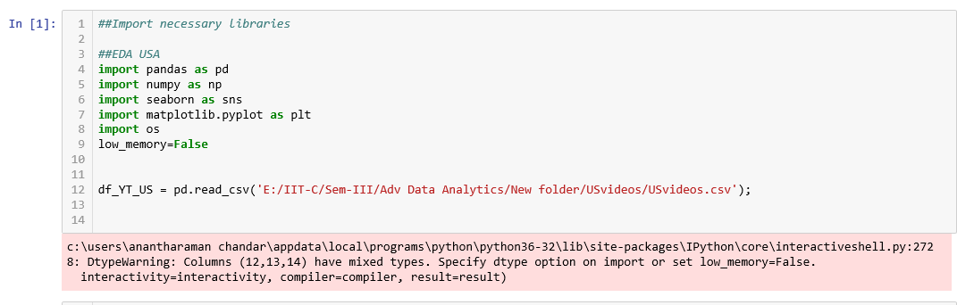

***Get the basic information of rows and columns from the US YouTube Dataset***

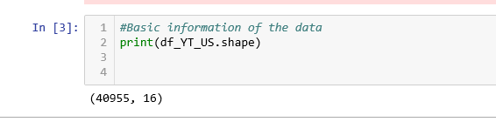

***Get the uniqueness of each column from the US YouTube dataset***

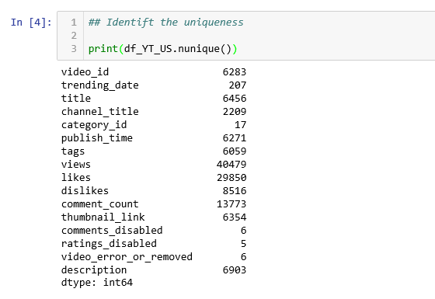

***Display the no of nulls in each column from the US YouTube Dataset***

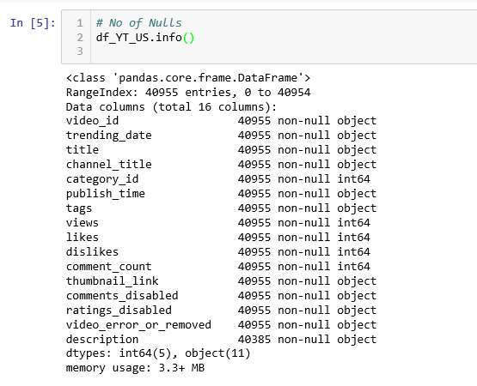

***Display the distribution of Views/Comments/Dislikes/likes from the US YouTube Dataset***

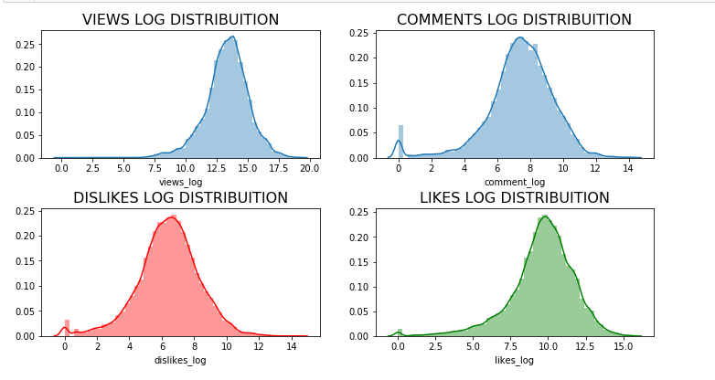

***Display the total number of records based on the category from the US YouTube dataset***

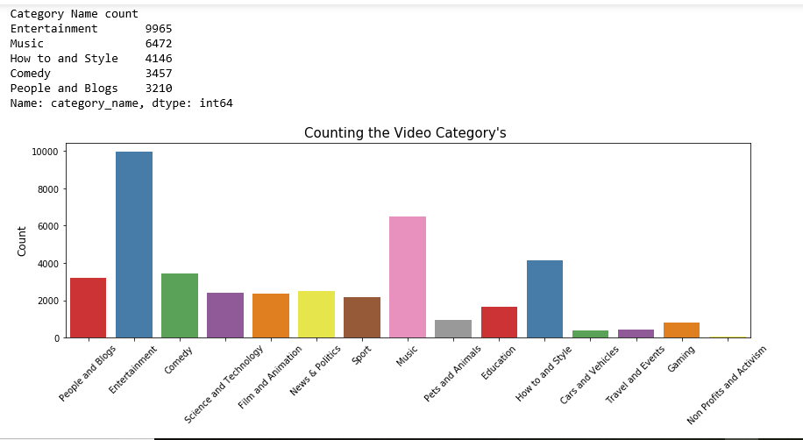

**Canada YouTube dataset Exploratory Data Analysis:**

***Import necessary libraries and CA YouTube Dataset into jupyter notebook***

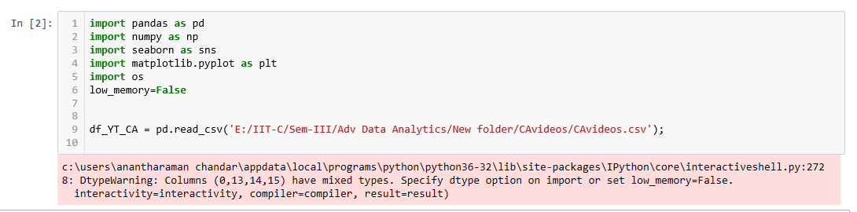

***Get the basic information of rows and columns from the CA YouTube Dataset***

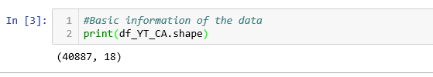

***Get the uniqueness of each column from the CA YouTube dataset***

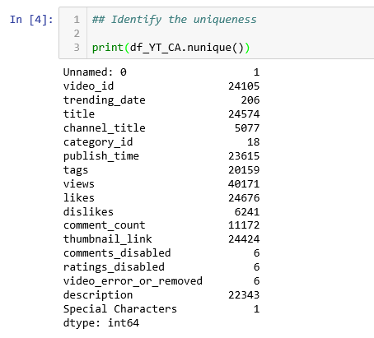

***Display the no of nulls in each column from the CA YouTube Dataset***

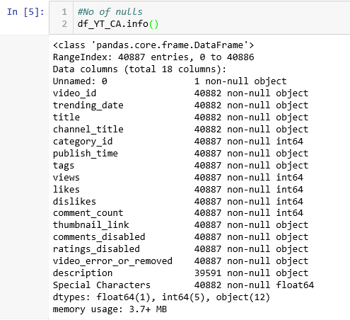

***Display the distribution of Views/Comments/Dislikes/likes from the CA YouTube Dataset***

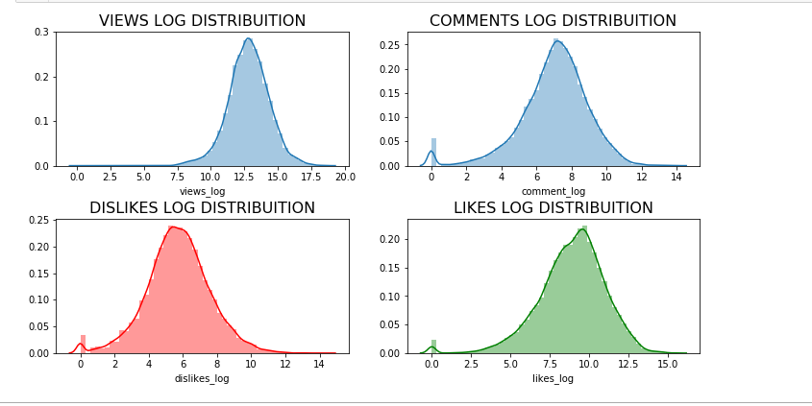

***Display the total number of records based on the category from the CA YouTube dataset***

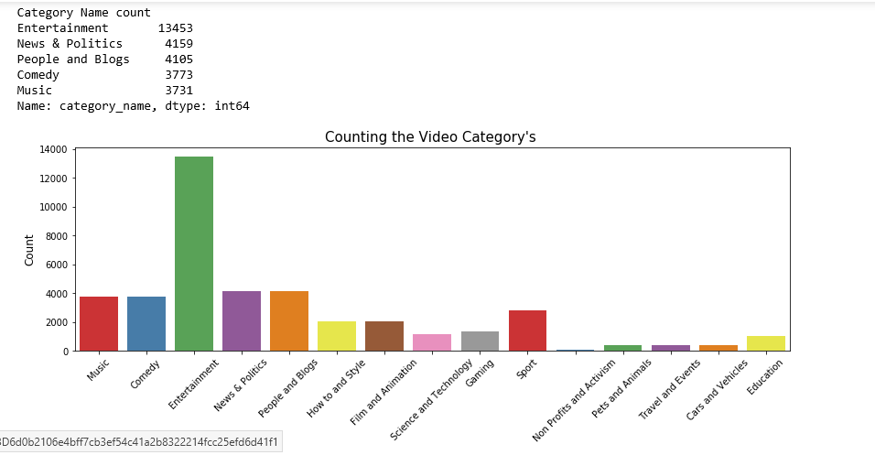

**France YouTube dataset Exploratory Data Analysis:**

***Import necessary libraries and FR YouTube Dataset into jupyter notebook***

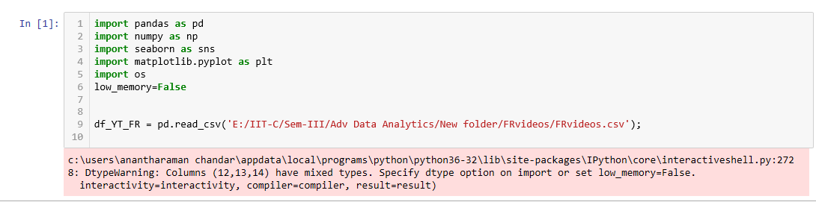

***Get the basic information of rows and columns from the FR YouTube Dataset***

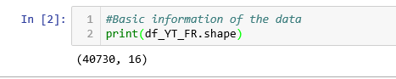

***Get the uniqueness of each column from the FR YouTube dataset***

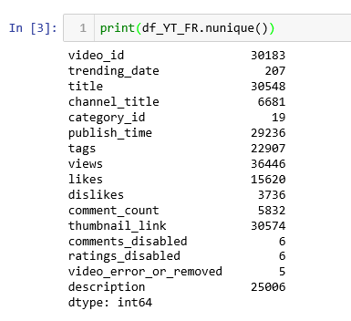

***Display the no of nulls in each column from the FR YouTube Dataset***

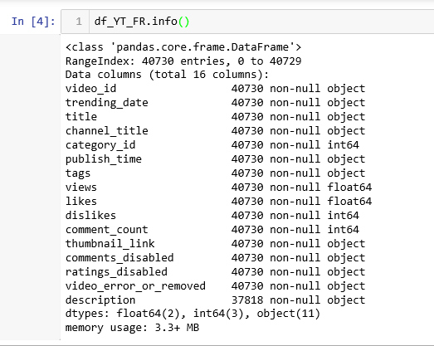

***Display the distribution of Views/Comments/Dislikes/likes from the FR YouTube Dataset***

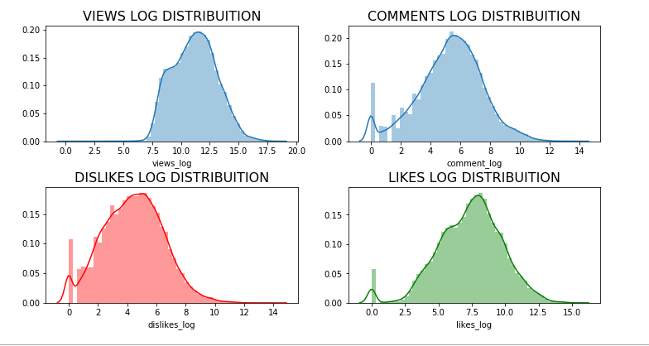

***Display the total number of records based on the category from the FR YouTube dataset***

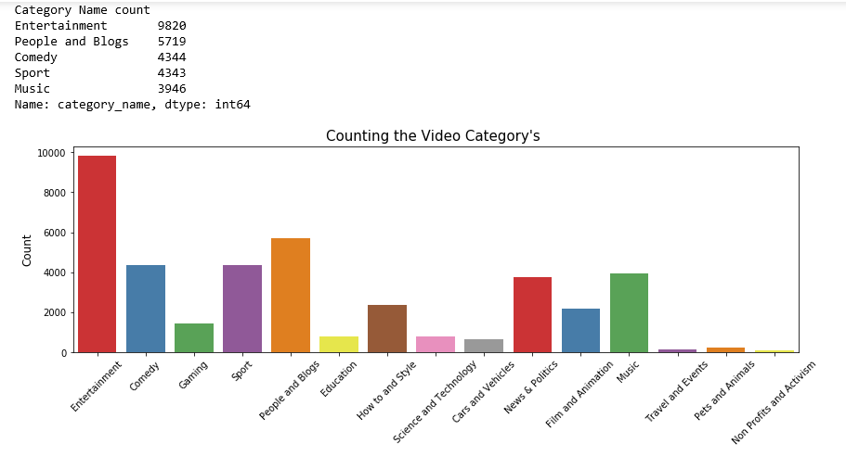

**Great Britain YouTube dataset Exploratory Data Analysis:**

***Import necessary libraries and GB YouTube Dataset into jupyter notebook***

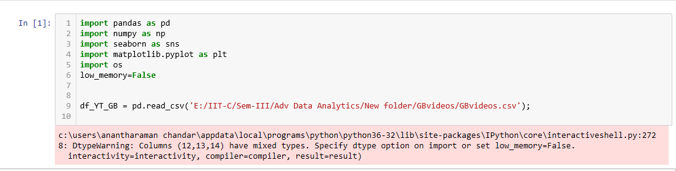

***Get the basic information of rows and columns from the GB YouTube Dataset***

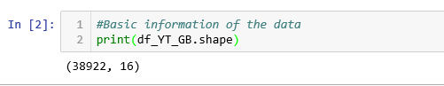

***Get the uniqueness of each column from the GB YouTube dataset***

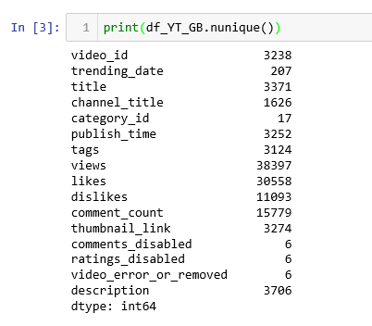

***Display the no of nulls in each column from the GB YouTube Dataset***

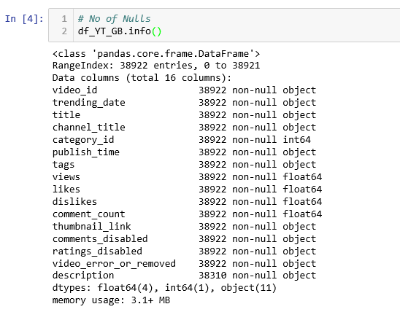

***Display the distribution of Views/Comments/Dislikes/likes from the GB YouTube Dataset***

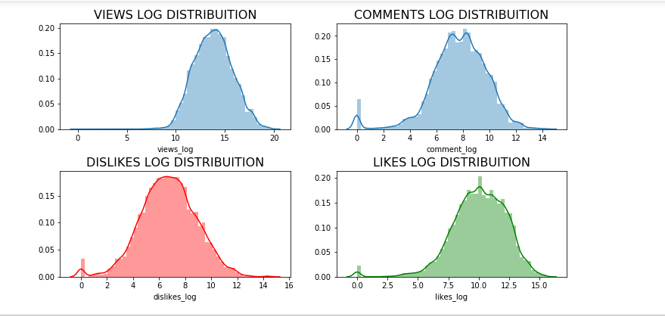

***Display the total number of records based on the category from the GB YouTube dataset***

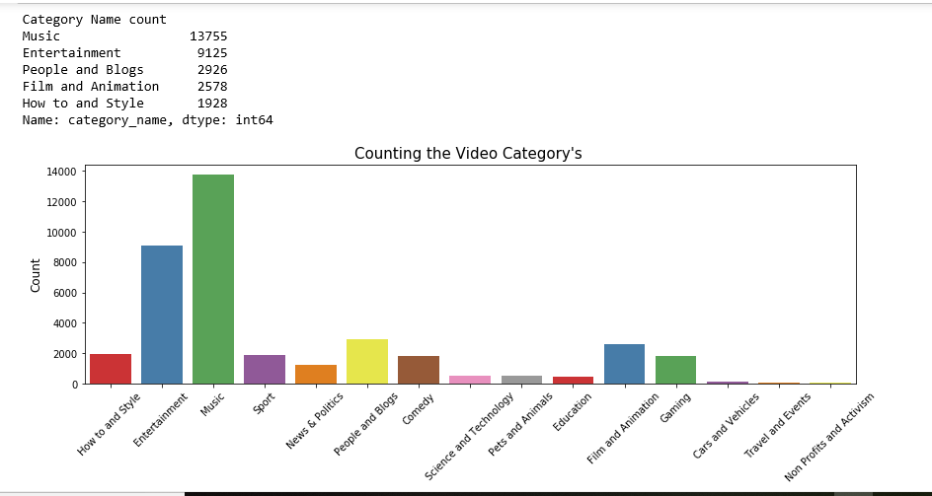

**Germany YouTube dataset Exploratory Data Analysis:**

***Import necessary libraries and DE YouTube Dataset into jupyter notebook***

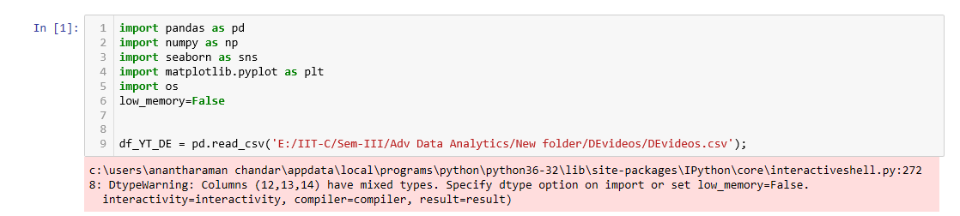

***Get the basic information of rows and columns from the DE YouTube Dataset***

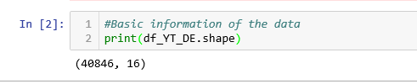

***Get the uniqueness of each column from the DE YouTube dataset***

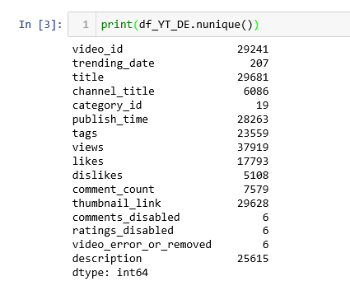

***Display the no of nulls in each column from the DE YouTube Dataset***

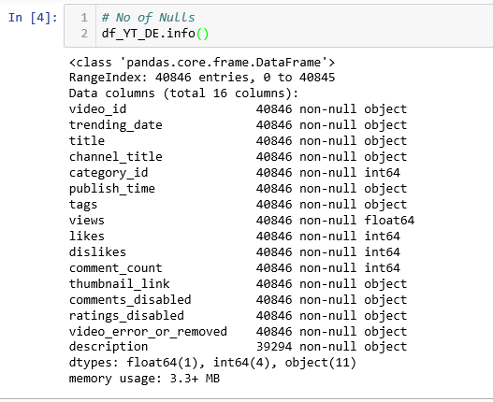

***Display the distribution of Views/Comments/Dislikes/likes from the DE YouTube Dataset***

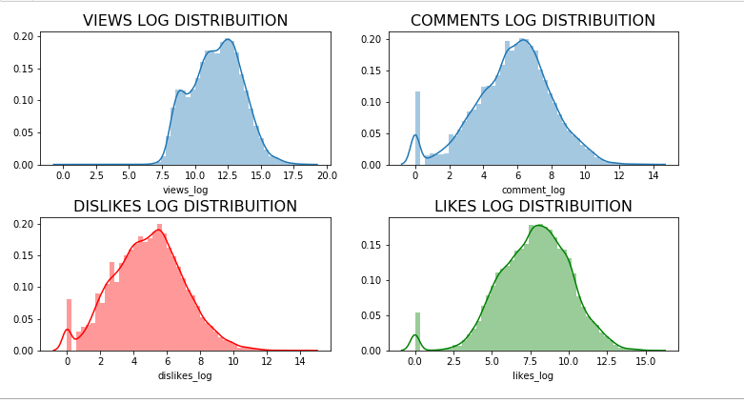

***Display the total number of records based on the category from the DE YouTube dataset***

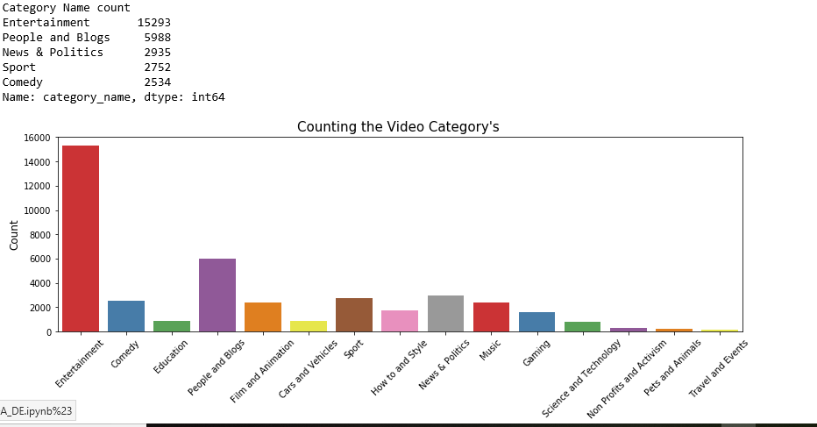

**US YouTube dataset Clustering and Segmentation Analysis**

***Import necessary libraries and US YouTube Dataset into jupyter notebook***

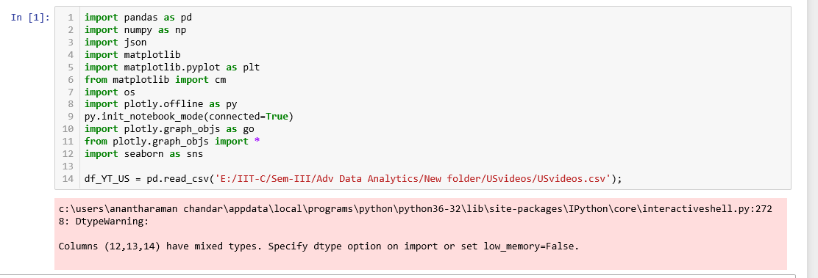

***Display the total number of frequency of US YouTube data based on the category***

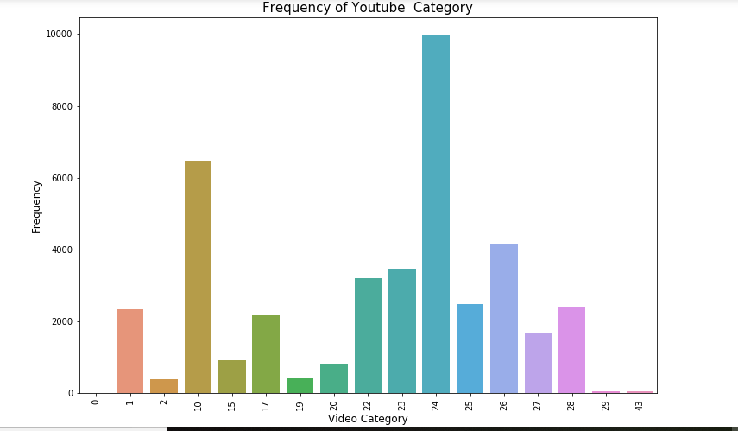

***Analyzing No.of Clusters before normalizing US YouTube dataset***

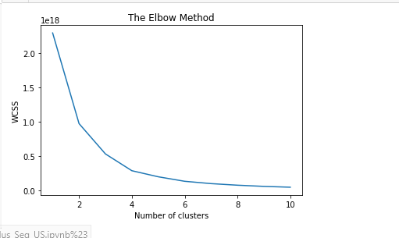

***Analyzing No.of Clusters after normalizing US YouTube dataset. Below diagram shows that 5 clusters will be good to carry on the data analysis.***

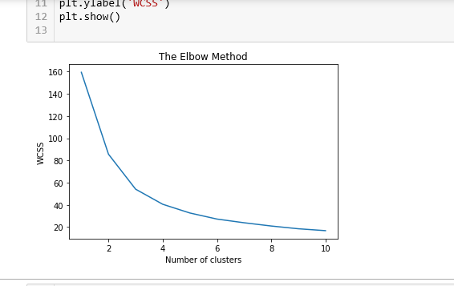

***Map Likes/Comments/Views in a 3D graph to show data distribution.***

***No of Clusters taken: 5***

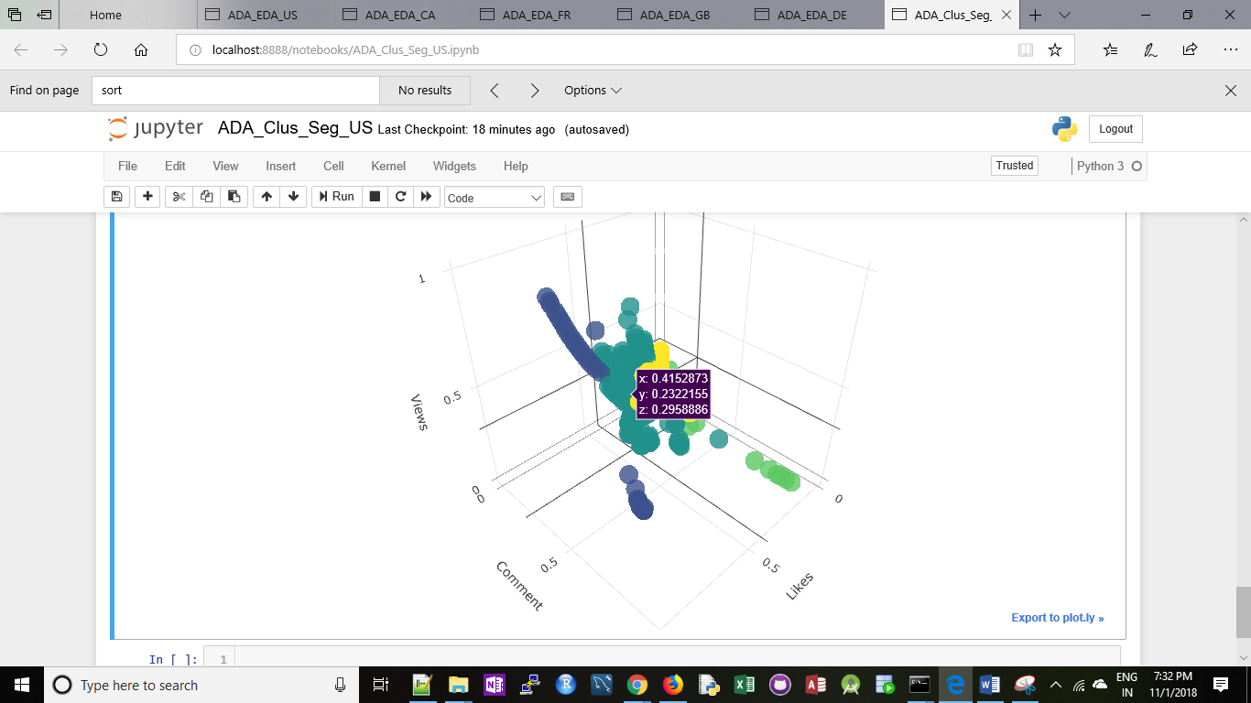

**Canada YouTube dataset Clustering and Segmentation Analysis**

***Import necessary libraries and CA YouTube Dataset into jupyter notebook***

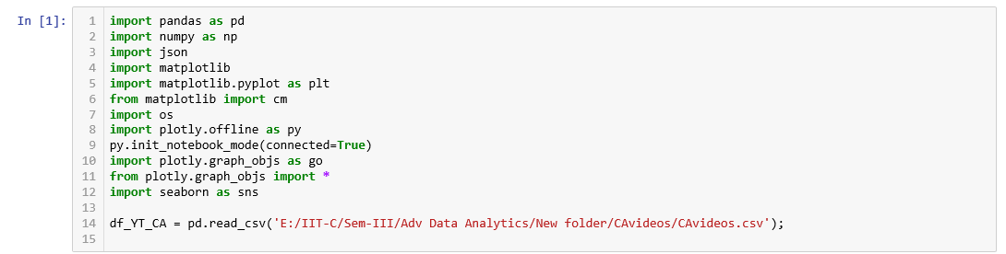

***Display the total number of frequency of CA YouTube data based on the category***

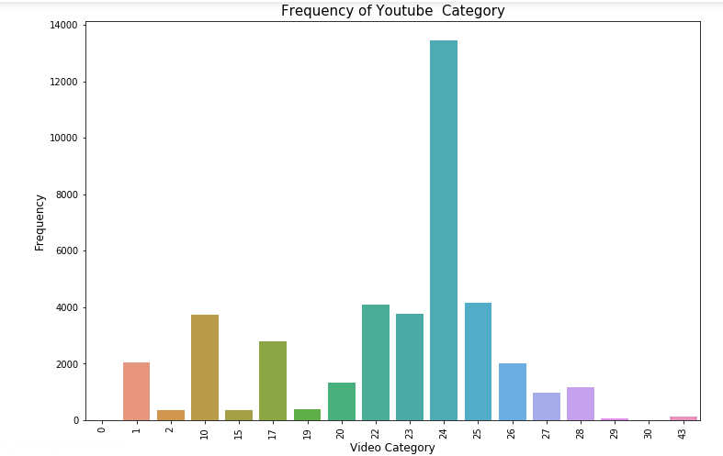

***Analyzing No.of Clusters before normalizing CA YouTube dataset***

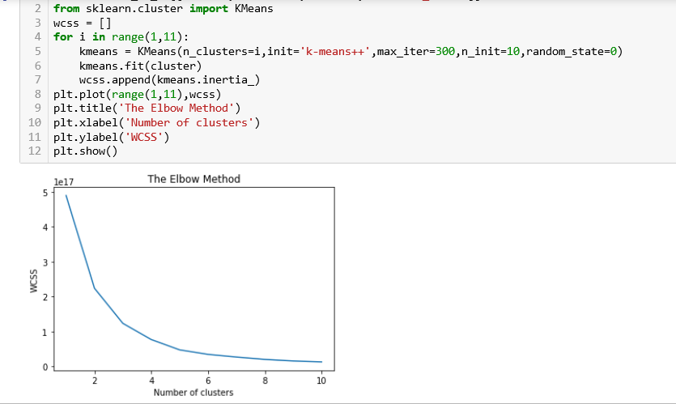

***Analyzing No.of Clusters after normalizing CA YouTube dataset. Below diagram shows that 5 clusters will be good to carry on the data analysis.***

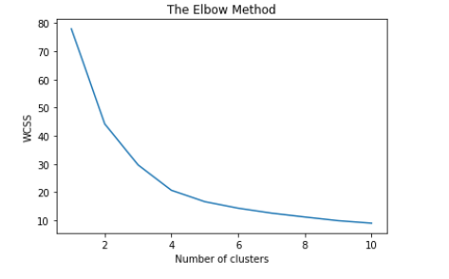

***Map Likes/Comments/Views in a 3D graph to show data distribution.***

***No of Clusters Taken: 5***

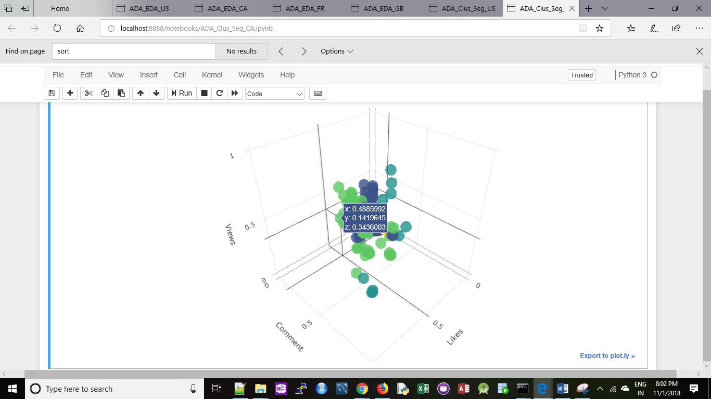

**France YouTube dataset Clustering and Segmentation Analysis**

***Import necessary libraries and FR YouTube Dataset into jupyter notebook***

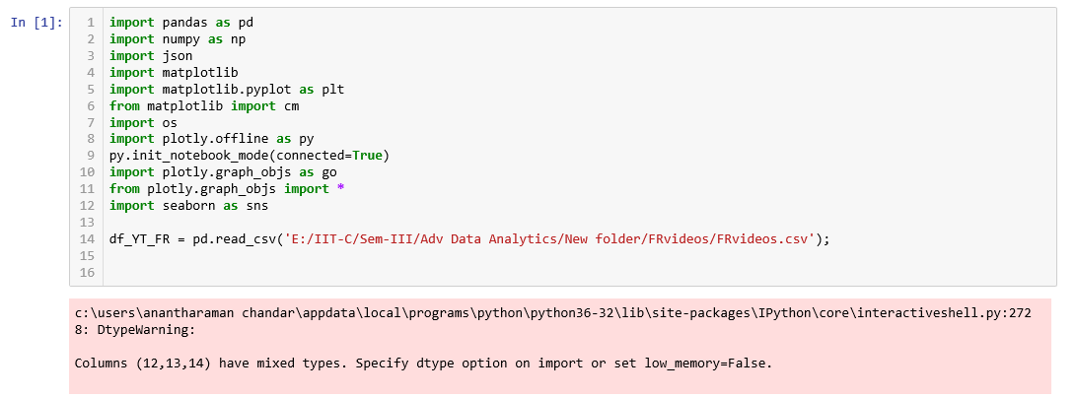

***Display the total number of frequency of FR YouTube data based on the category***

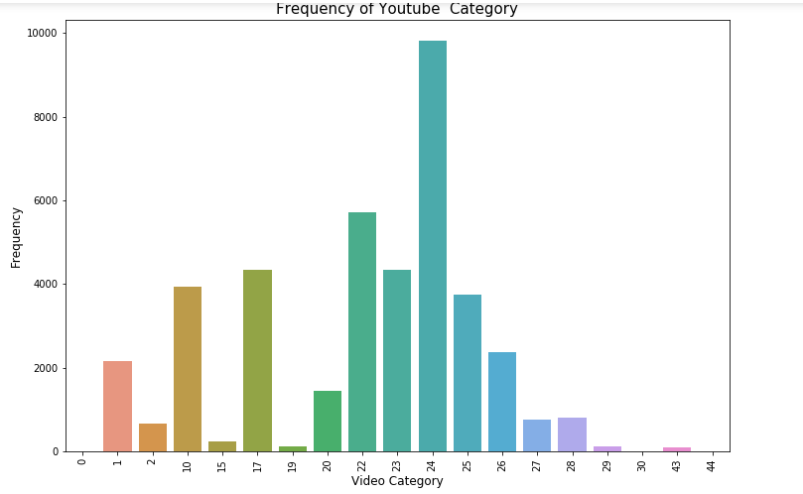

***Analyzing No.of Clusters before normalizing FR YouTube dataset***

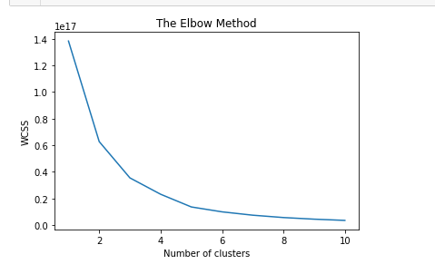

***Analyzing No.of Clusters after normalizing CA YouTube dataset. Below diagram shows that 5 clusters will be good to carry on the data analysis.***

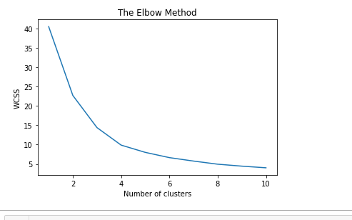

***Map Likes/Comments/Views in a 3D graph to show data distribution.***

***No of Clusters Taken: 5***

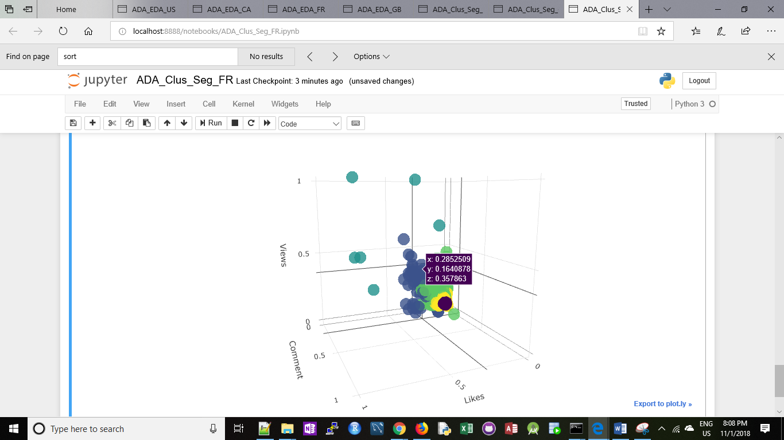

**Great Britain YouTube dataset Clustering and Segmentation Analysis**

***Import necessary libraries and GB YouTube Dataset into jupyter notebook***

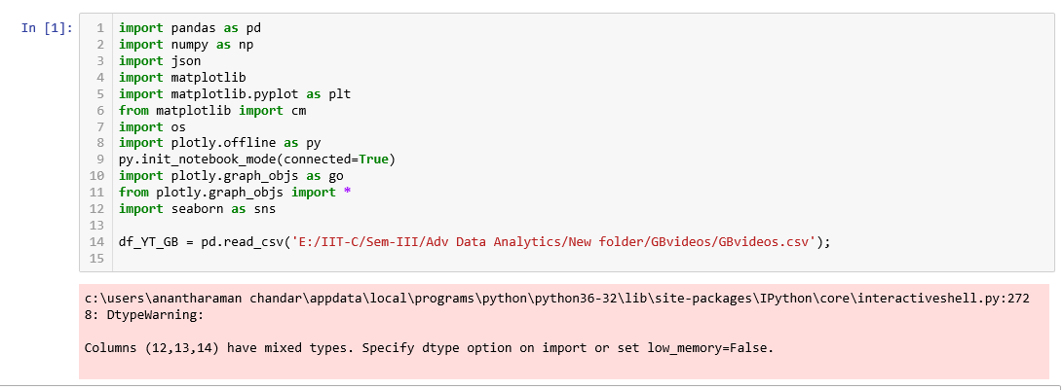

***Display the total number of frequency of GB YouTube data based on the category***

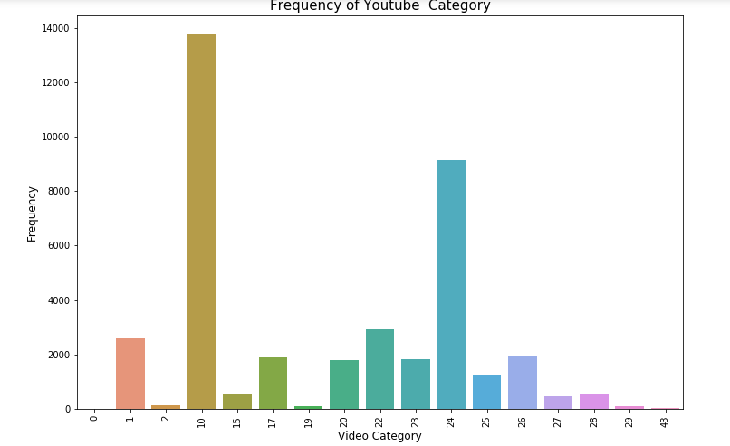

***Analyzing No.of Clusters before normalizing GB YouTube dataset***

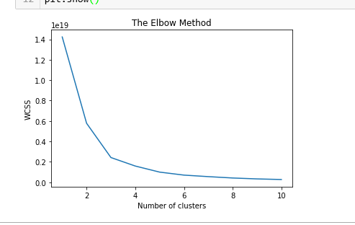

***Analyzing No.of Clusters after normalizing GB YouTube dataset. Below diagram shows that 5 clusters will be good to carry on the data analysis.***

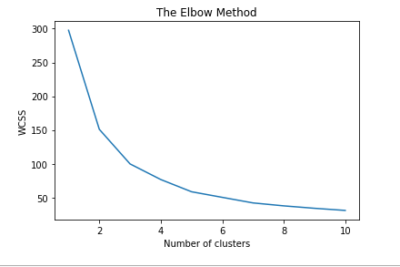

***Map Likes/Comments/Views in a 3D graph to show data distribution.***

***No of Clusters Taken: 5***

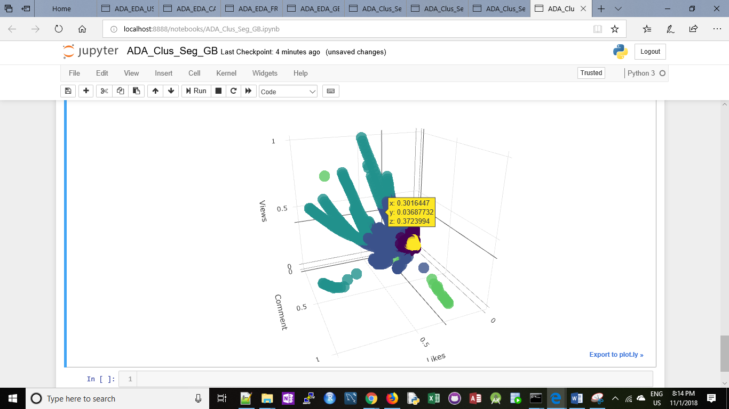

**Germany YouTube dataset Clustering and Segmentation Analysis**

***Import necessary libraries and DE YouTube Dataset into jupyter notebook***

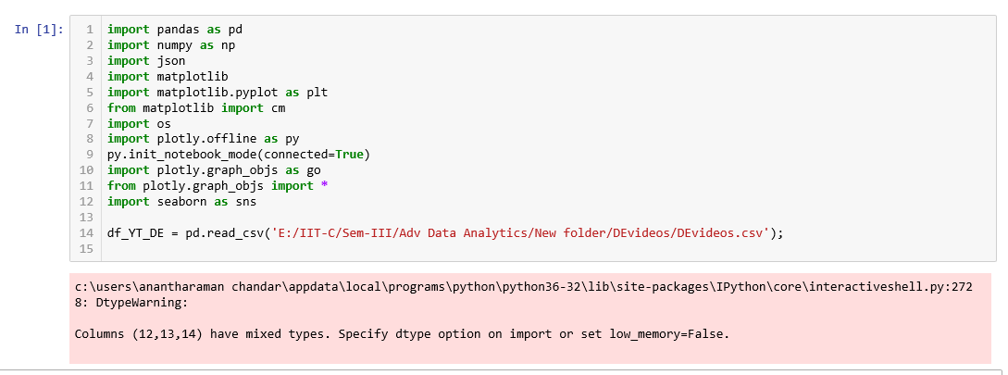

***Display the total number of frequency of DE YouTube data based on the category***

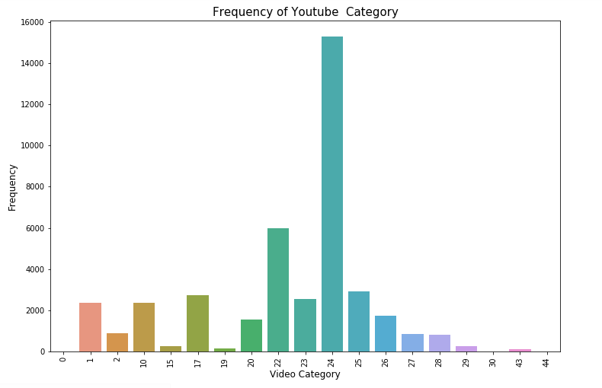

***Analyzing No.of Clusters before normalizing DE YouTube dataset***

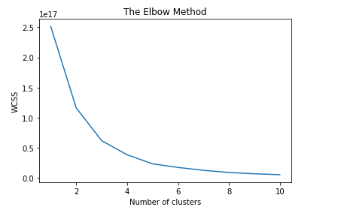

***Analyzing No.of Clusters after normalizing DE YouTube dataset. Below diagram shows that 5 clusters will be good to carry on the data analysis.***

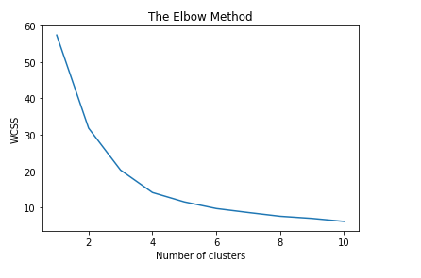

***Map Likes/Comments/Views in a 3D graph to show data distribution.***

***No of Clusters Taken: 5***

