Statistical Tasks
- Student’s performance at elementary school education, especially in mathematics, has been a concern in Sweden for quite some years. Recent results published by the Programme for International Student Assessment (PISA) revealed that, at national (aggregated level), overall Swedish student’s performance has improved over the last decade (see Figure 1). However, still there are some regions in Sweden, e.g. Dalarna County, where the students’ performances are not up to the mark.

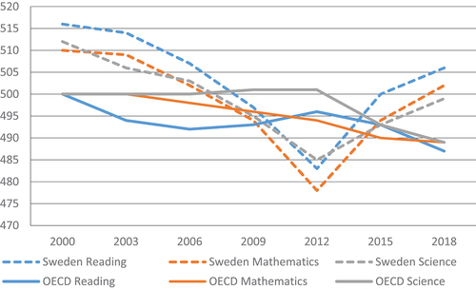
Figure 1 PISA test results of 15-year-old Swedish school students (source: https://doi.org/10.1080/0969594X.2023.2189566)

In this assignment, your task is to analyse the data on overall passing rate in Mathematics at grade 9 exam at different municipalities in Dalarna County and check whether there has been some overall trend (increasing or decreasing) in the student’s results in mathematics in these municipalities over the last 10 years (2015-2024). In doing so, you should also check whether any demographic characteristics and political preferences are also associated with the varying results in mathematics. The relevant data are provided in different excel files (Result_AK9_Dalarna_Kum.xlsx, Dalarna_MunicipalElectionResults.xlsx, Dalarna_AverageIncome.xlsx, Dalarna_Population_HigherEducation.xlsx) which you might need to clean and merge them, before you conduct your final data analysis.

- This task is about assessing usability of accelerometer in detecting real-time behaviour of a certain domestic animal species. Data were collected using video recording, and accelerometer attached on individual animal’s neck. A human observer coded the animal behaviour (see behaviour coding scheme in Table 2) by watching video recordings. Data from accelerometer give displacement in three axes (X, Y, and Z). These values were standardized, and certain features (such as mean, sd, minimum, maximum etc. of static acceleration, dynamic acceleration, pitch, roll, etc.) were calculated using a 5- second window. A text file (df4_5s.txt) provides all the extracted features and (major) behaviour classifications for unique 5-second intervals, for a subset of observations.

Table 2 Animal behaviour coding scheme
Main behaviour | General description | Subgroup | Additional clarifications
Browsing | Moving lips towards a branch in a tree or a shrub | Browsing with head up | Standing on all four legs, stretching the neck upwards, head level above shoulder height (minimum 45º head angle) or standing on the hind legs, stretching neck upwards.
 |  | Browsing with head low | Standing on all four legs, moving the head forward or downwards, but without mouth touching the ground
Grazing | Lower the head to the ground and foraging from the ground. Mouth close to the ground. | Grazing from the ground on place or while walking | From ground while standing still or taking one or two steps without moving head position (grazing standing still) or grazing while walking slowly and foraging from the ground (mouth close to the ground).
Inactivity | Belly or side on the ground with folded or extended legs and head in different positions | Resting | Folded legs with head raised from the ground facing forward or with the neck bent on the side
 |  | Sleeping | Head close to (leaning on) ground (on ground or against body) in the same position
 |  | Ruminating | Lying with legs folded and belly on the ground, head raised from the ground facing forward or with the neck bent on the side while chewing
 | Standing on all four legs without moving forward without chewing | Standing
Walking | Moving forward by alternately moving the legs from one point to another | Walking | Lifting all four legs in a symmetric movement and moving forward, with mouth up from the ground (not grazing)
Trotting | Simultaneous movement of hoof paired two by two diagonally | Trotting
 | Three-beat gait faster than the average trot | Running

