HOSPITAL MANAGEMENT SYSTEM

STRUCTURE(AS PER VSCODE):
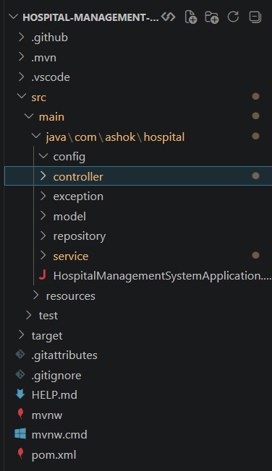
CLASSES:
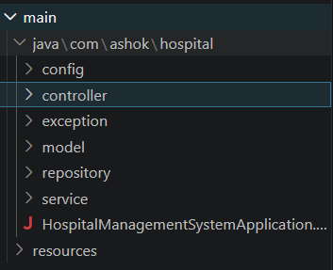

MODEL CLASS:
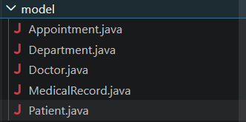
REPOSITORY CLASS:
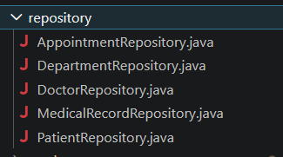
SERVICE CLASS:
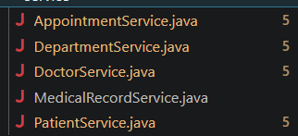
CONTROLLER CLASS:
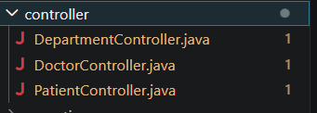

MONGODB DATABASE CONNECTION:

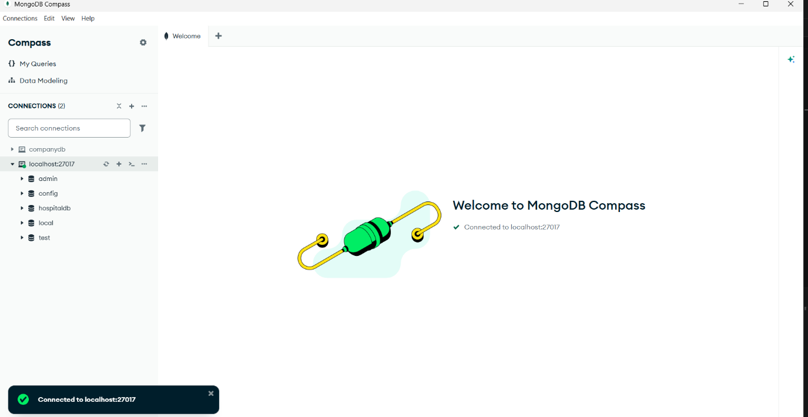
POSTMAN for TESTING:
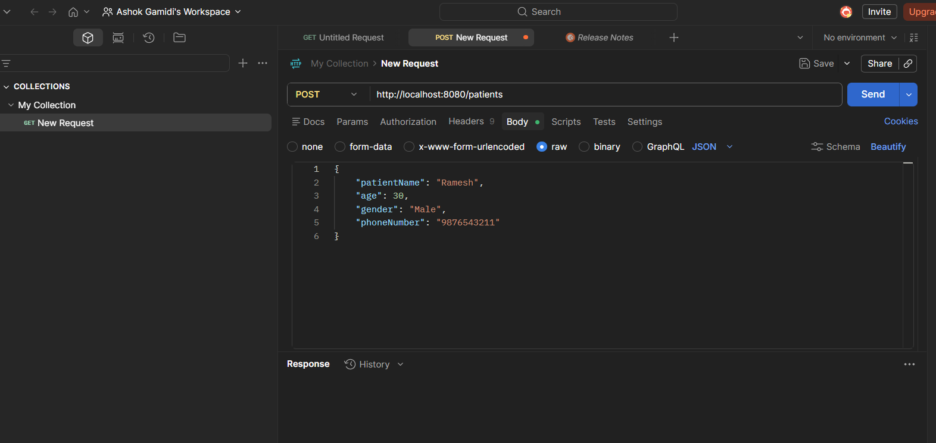

POST,GET,DELETE,PUT for testing to get details :
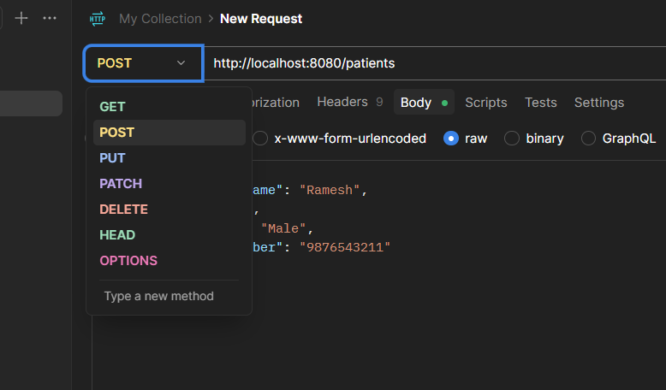
Maven handles downloading, updating, and managing all required libraries.
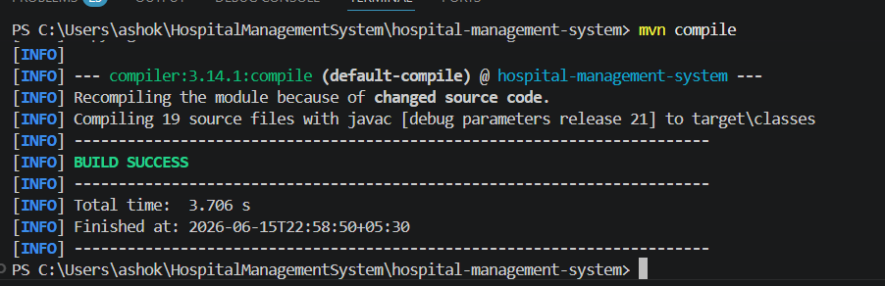
CREATING APPOINTMENT TABLE
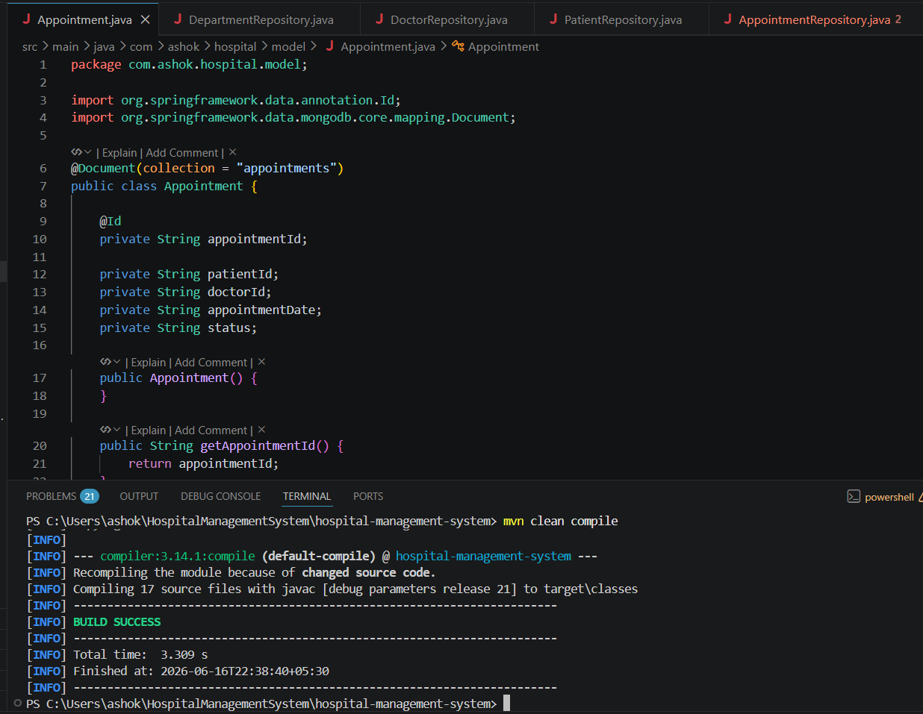
APPOINTMENT REPOSITORY
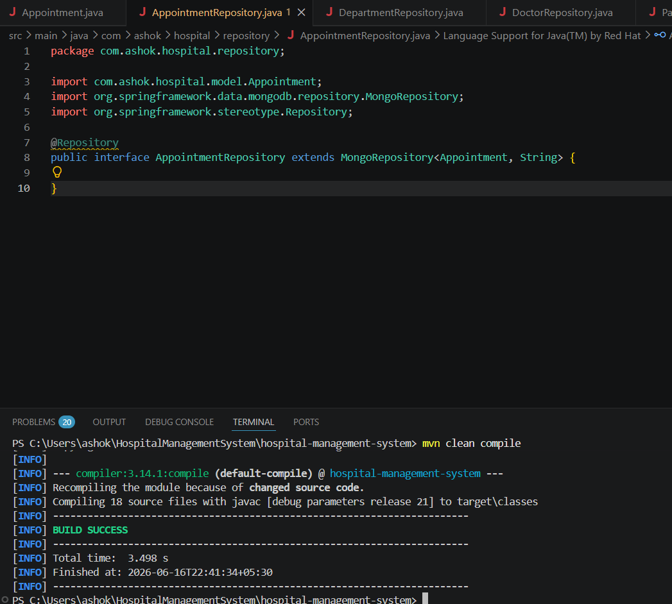

APPOINTMENT SERVICE
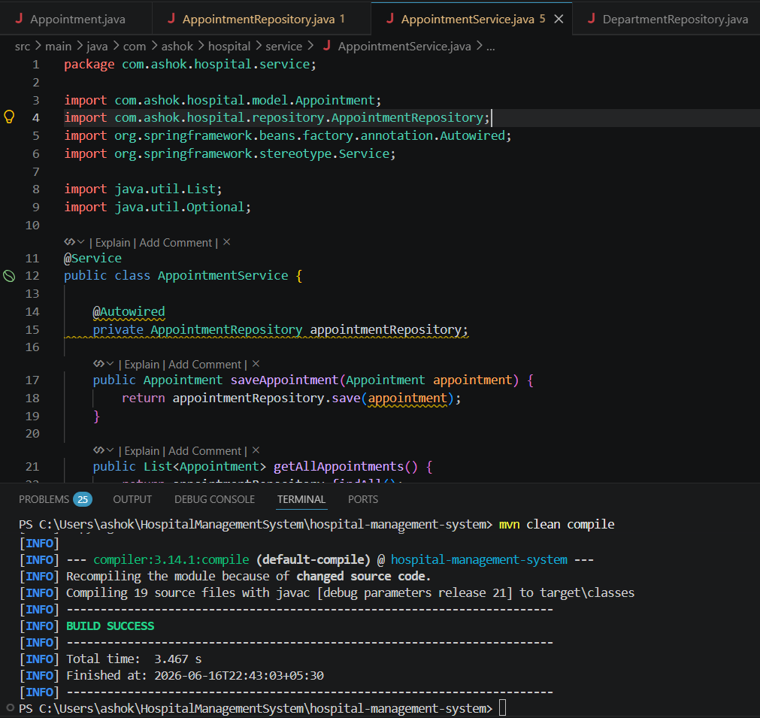
APPOINTMENT CONTROLLER
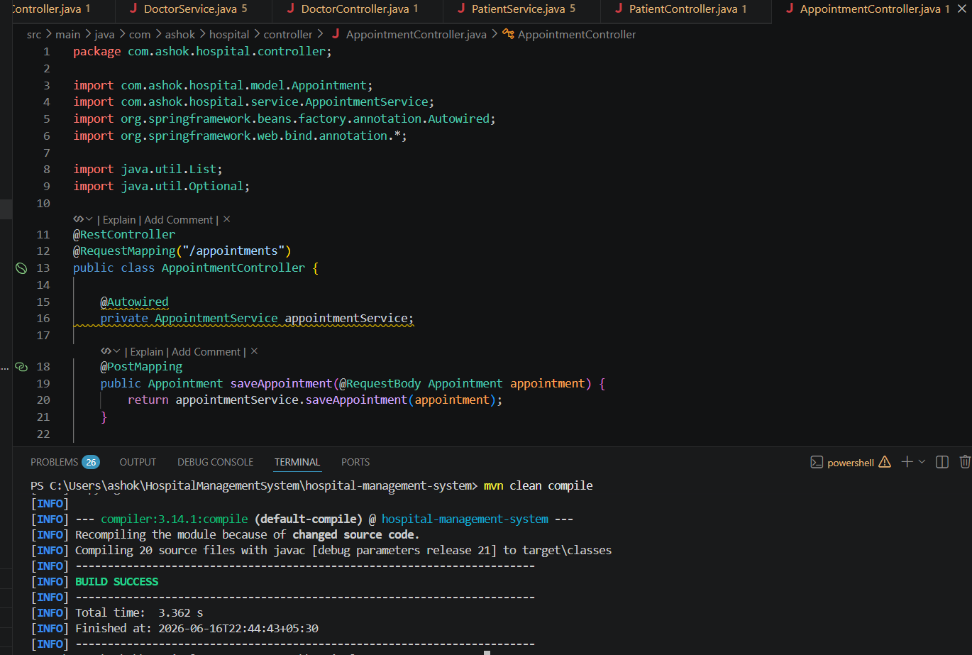

Similarly remaining modules like department doctor and patient are created
Lets start testing the Appointment module using the postman
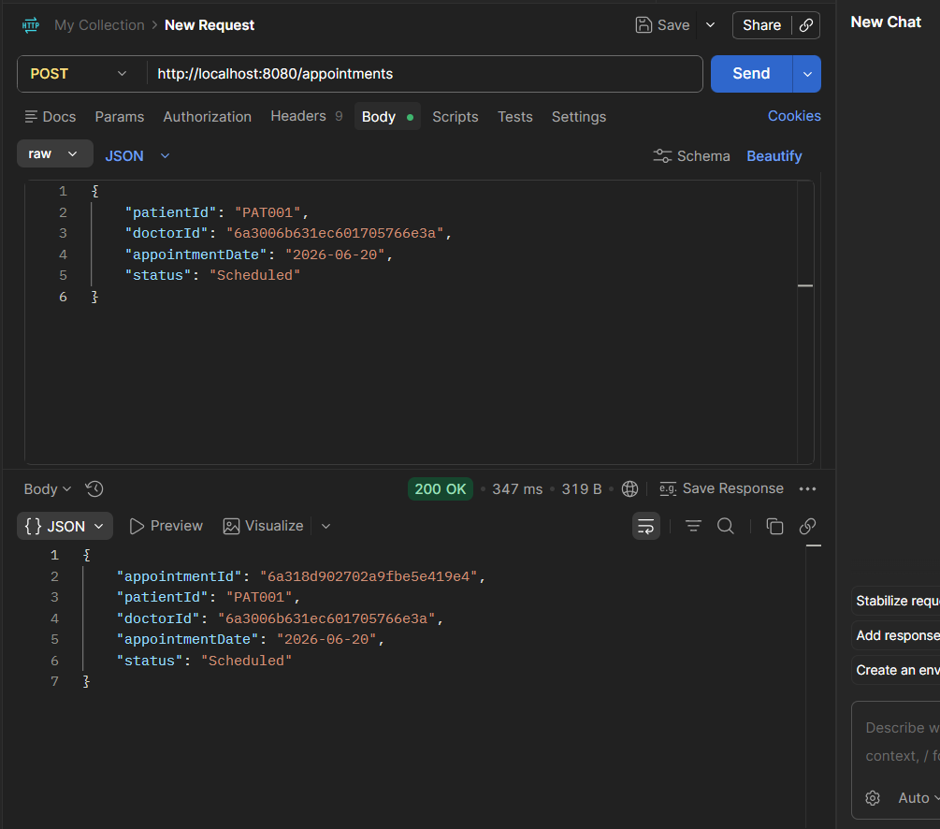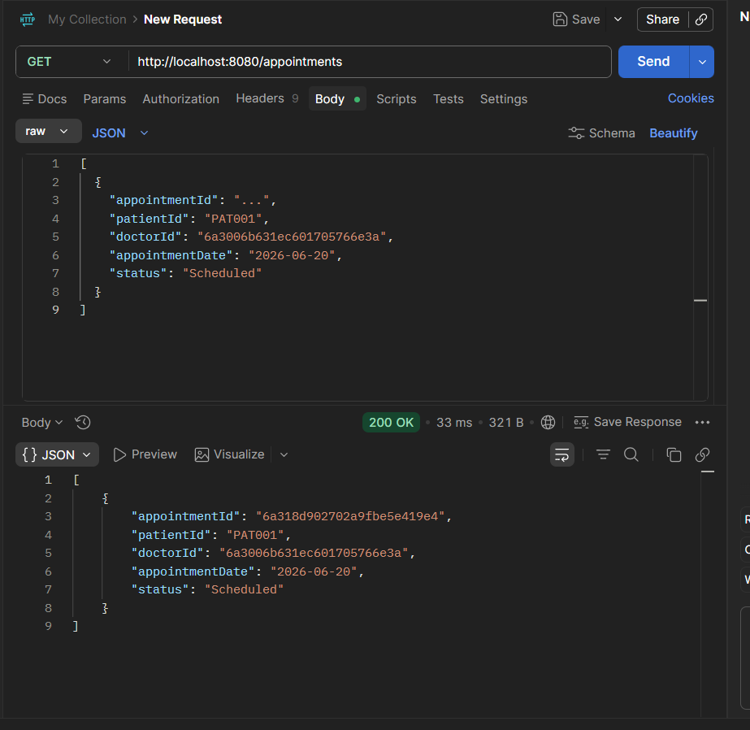
GET BY ID
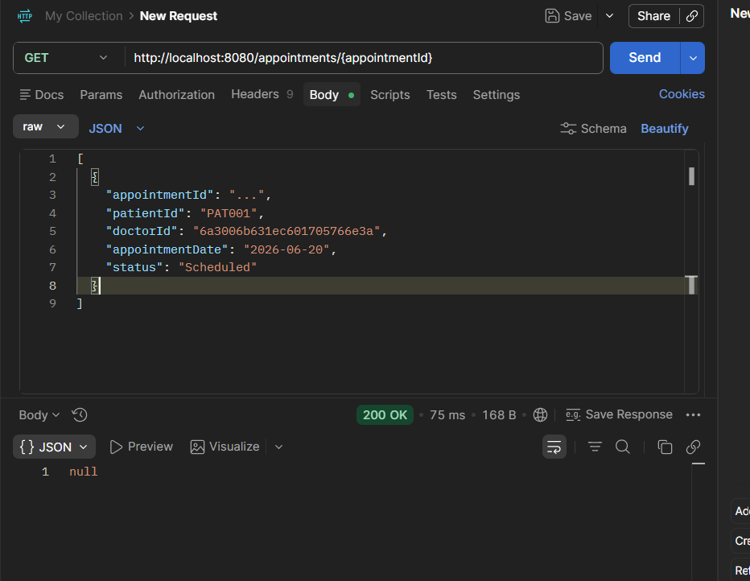

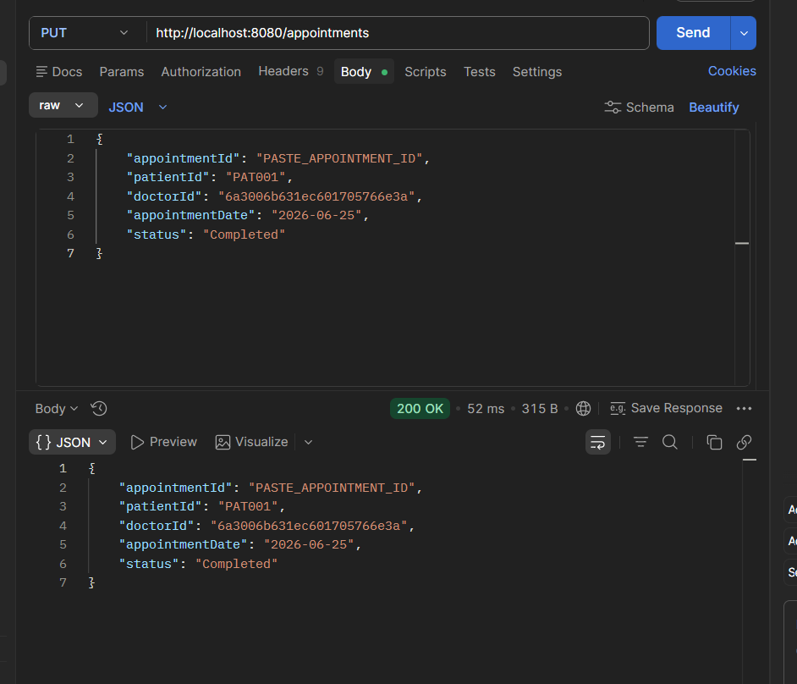
DELETE
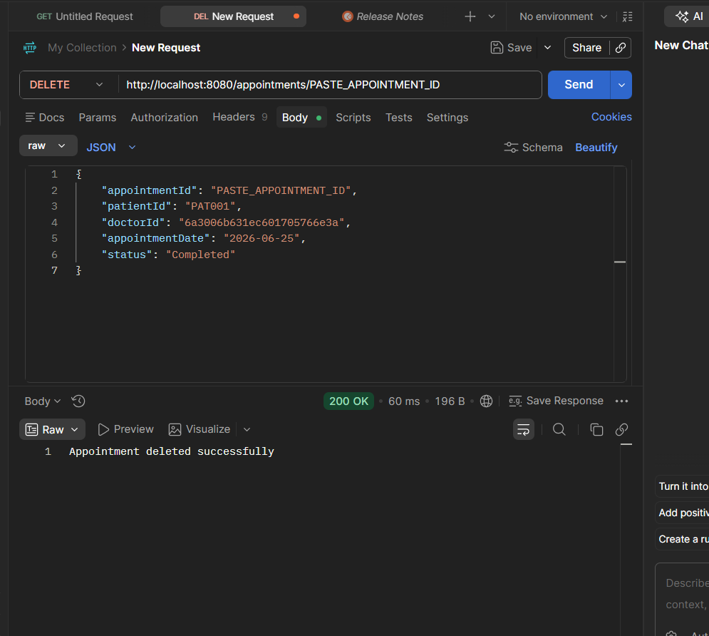

PROJECT STATUS
Nearly 75-80 percent of the project is completed.

