HOSPITAL MANAGEMENT SYSTEM

STRUCTURE:
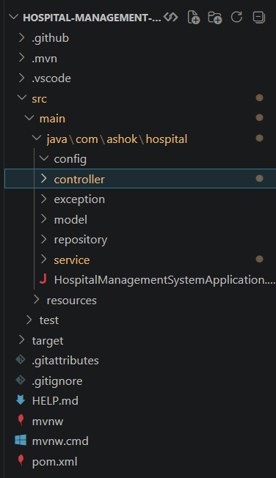
CLASSES:
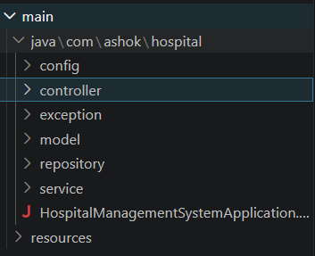

MODEL CLASS:
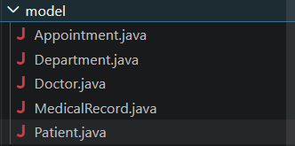
REPOSITORY CLASS:
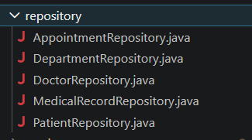
SERVICE CLASS:
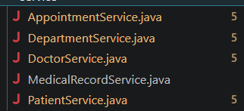
CONTROLLER CLASS:
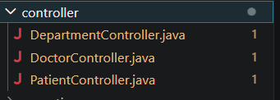

MONGODB DATABASE CONNECTION:

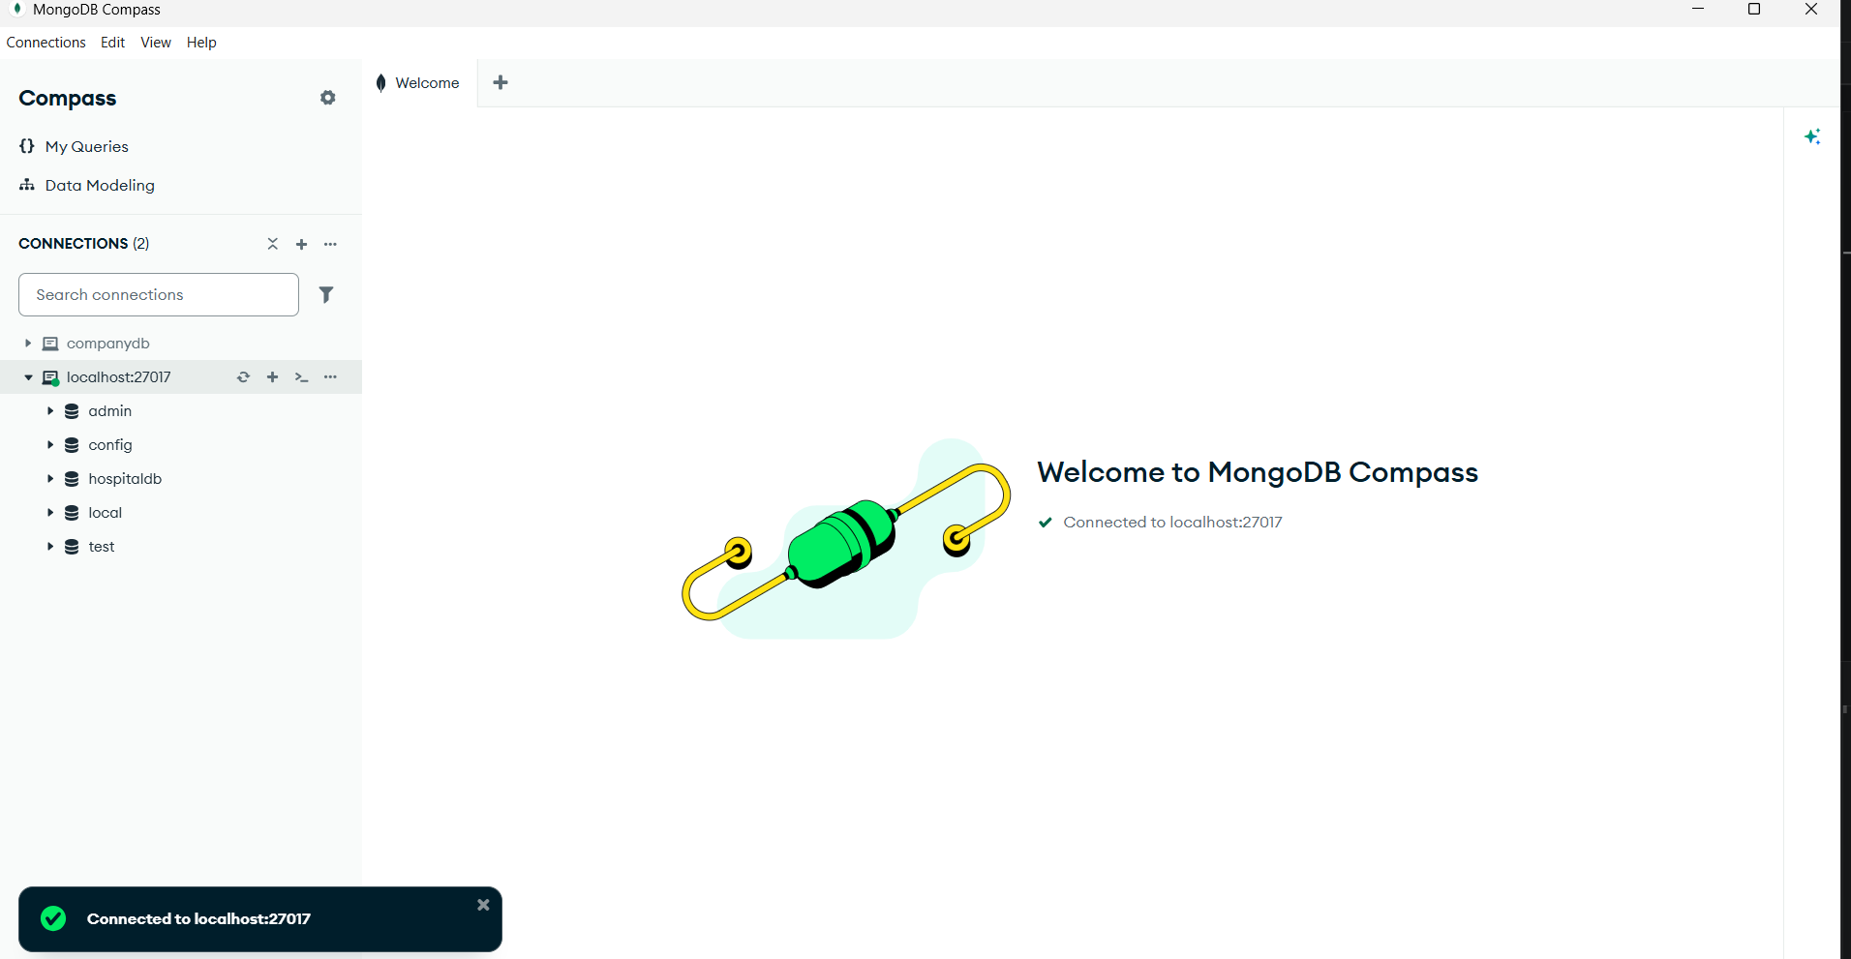
POSTMAN for TESTING:
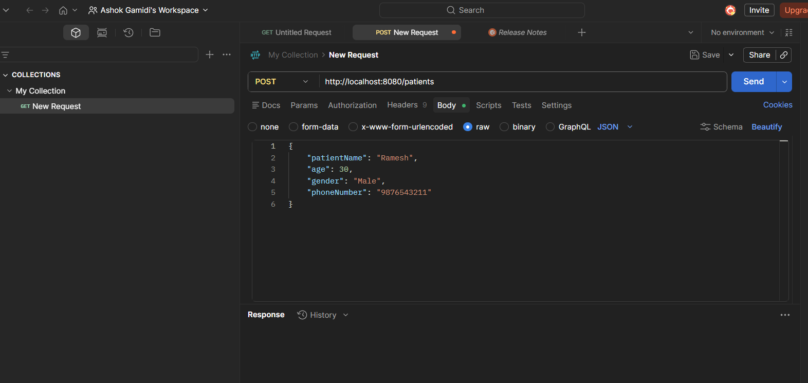

POST,GET,DELETE,PUT for testing to get details :
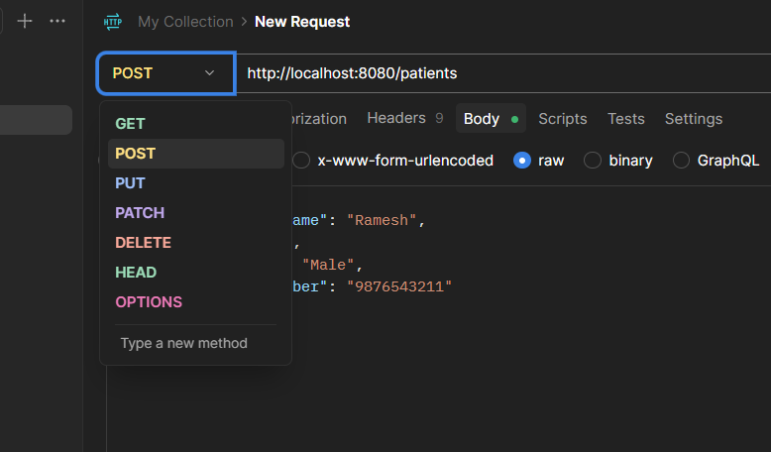
Maven handles downloading, updating, and managing all required libraries.
