[DevNet Sandbox - Workspace - Lab Catalog - ACI Simulator 4.2 (cisco.com)](https://devnetsandbox.cisco.com/RM/Diagram/Index/661da090-c16c-4b8c-95db-1194e461964c?diagramType=Topology)

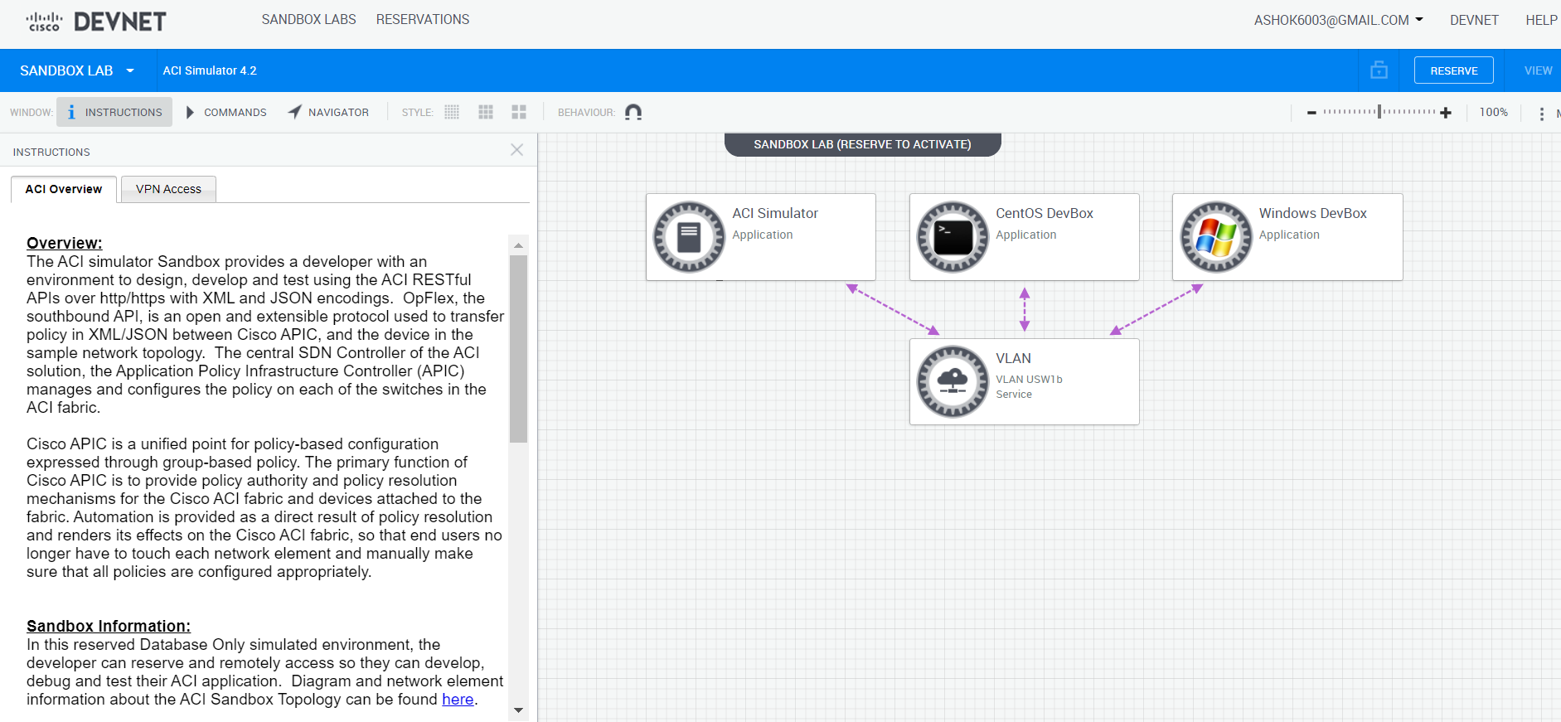

Need to reserve it

**DevBox**

(py3venv) [developer@devbox ~]$ cat hosts

APIC

10.10.20.14

(py3venv) [developer@devbox ~]$ cat ansible.cfg

[defaults]

inventory = ./hosts

host_key_checking = false

timeout = 100

validate_certs: false 🡪 added in the playbook to avoid certificate verification

delegate_to: localhost 🡪added in the playbook to avoid SSH

Test is added in the APIC

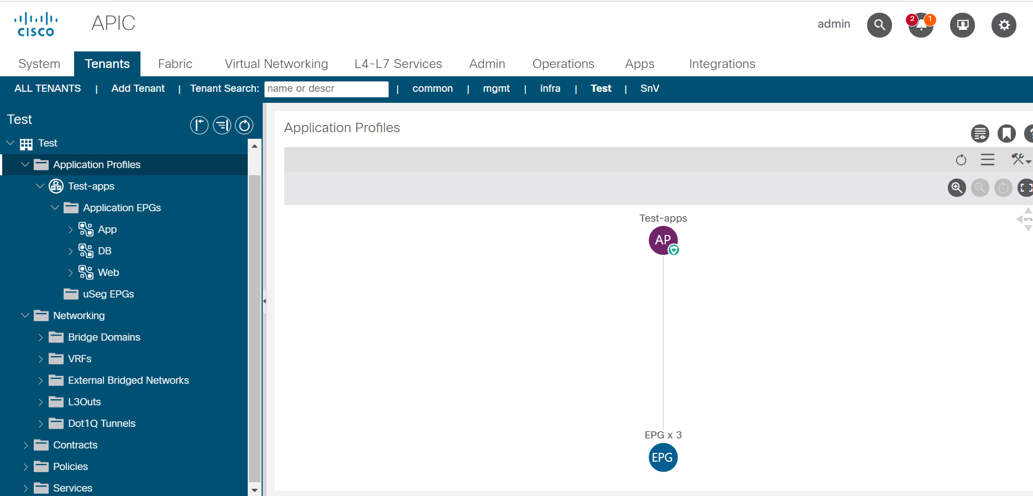

After Rollback Test Application Profile will be removed

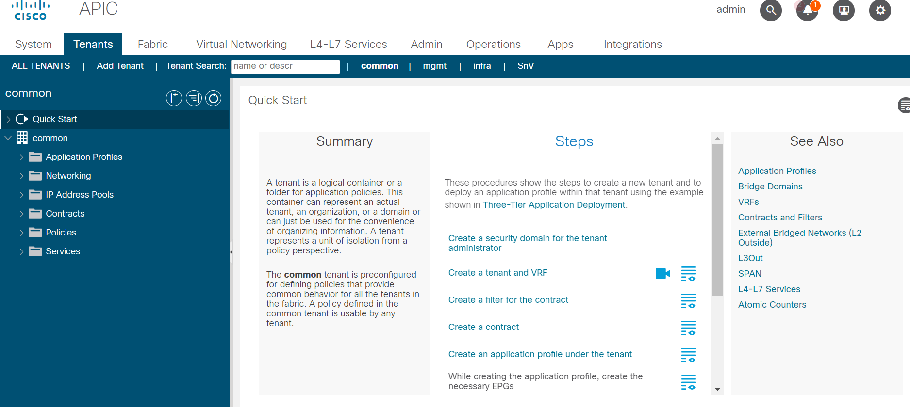

Playbook for ACI:

