

**Screenshot and output:-**

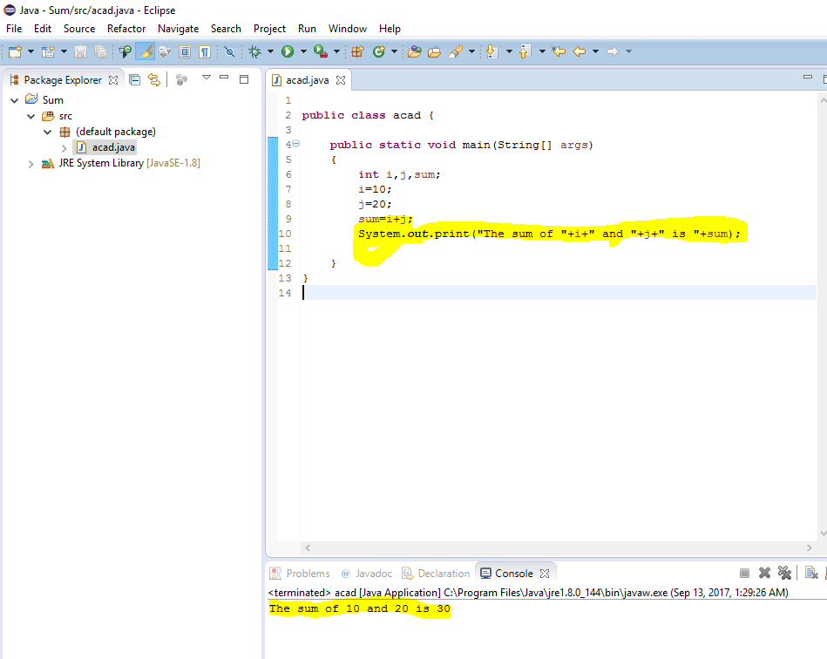

**Program code:-**

**public** **class** acad {

**public** **static** **void** main(String[] args)

{

**int** i,j,sum;

i=10;

j=20;

sum=i+j;

System.***out***.print("The sum of "+i+" and "+j+" is "+sum);

}

}