

**Screenshot and output:-**

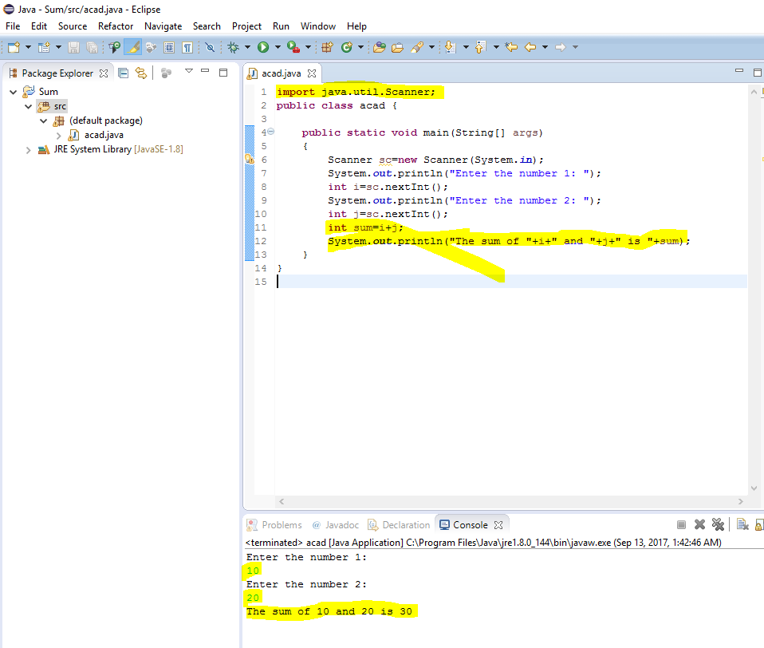

**Program code:-**

**import** java.util.Scanner;

**public** **class** acad {

**public** **static** **void** main(String[] args)

{

Scanner sc=**new** Scanner(System.***in***);

System.***out***.println("Enter the number 1: ");

**int** i=sc.nextInt();

System.***out***.println("Enter the number 2: ");

**int** j=sc.nextInt();

**int** sum=i+j;

System.***out***.println("The sum of "+i+" and "+j+" is "+sum);

}

}