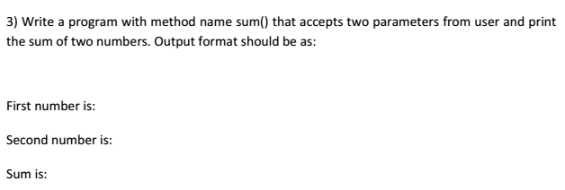

**Screenshot and output:-**

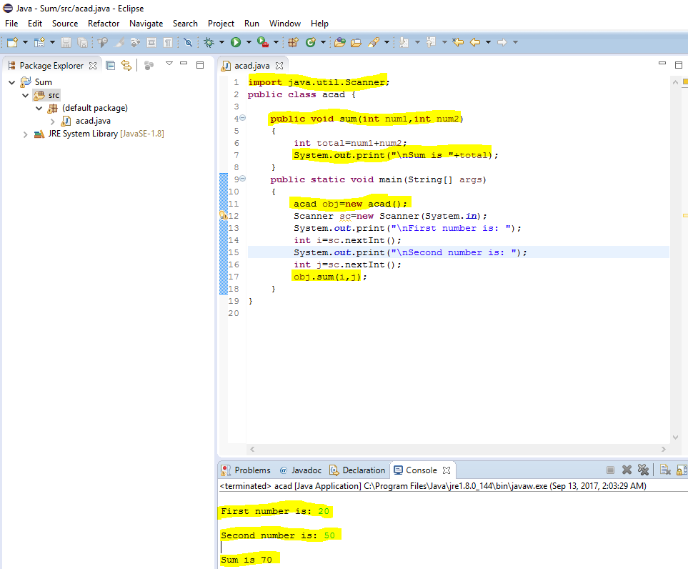

**Program code:-**

**import** java.util.Scanner;

**public** **class** acad {

**public** **void** sum(**int** num1,**int** num2)

{

**int** total=num1+num2;

System.***out***.print("\nSum is "+total);

}

**public** **static** **void** main(String[] args)

{

acad obj=**new** acad();

Scanner sc=**new** Scanner(System.***in***);

System.***out***.print("\nFirst number is: ");

**int** i=sc.nextInt();

System.***out***.print("\nSecond number is: ");

**int** j=sc.nextInt();

obj.sum(i,j);

}

}