

**Screenshot and output:-**

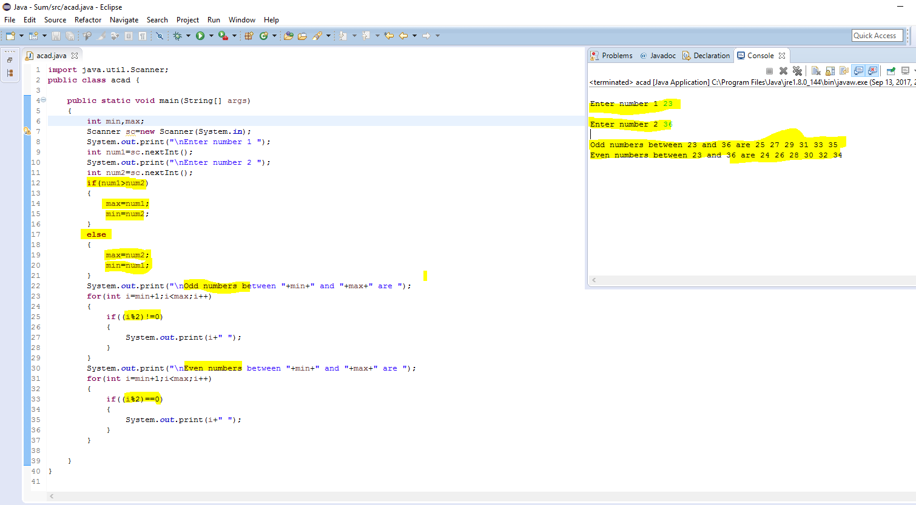

**Program code:-**

**import** java.util.Scanner;

**public** **class** acad {

**public** **static** **void** main(String[] args)

{

**int** min,max;

Scanner sc=**new** Scanner(System.***in***);

System.***out***.print("\nEnter number 1 ");

**int** num1=sc.nextInt();

System.***out***.print("\nEnter number 2 ");

**int** num2=sc.nextInt();

**if**(num1>num2)

{

max=num1;

min=num2;

}

**else**

{

max=num2;

min=num1;

}

System.***out***.print("\nOdd numbers between "+min+" and "+max+" are ");

**for**(**int** i=min+1;i<max;i++)

{

**if**((i%2)!=0)

{

System.***out***.print(i+" ");

}

}

System.***out***.print("\nEven numbers between "+min+" and "+max+" are ");

**for**(**int** i=min+1;i<max;i++)

{

**if**((i%2)==0)

{

System.***out***.print(i+" ");

}

}

}

}