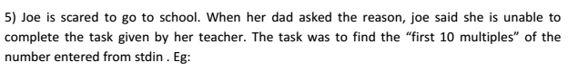

**Screenshot and Output:-**

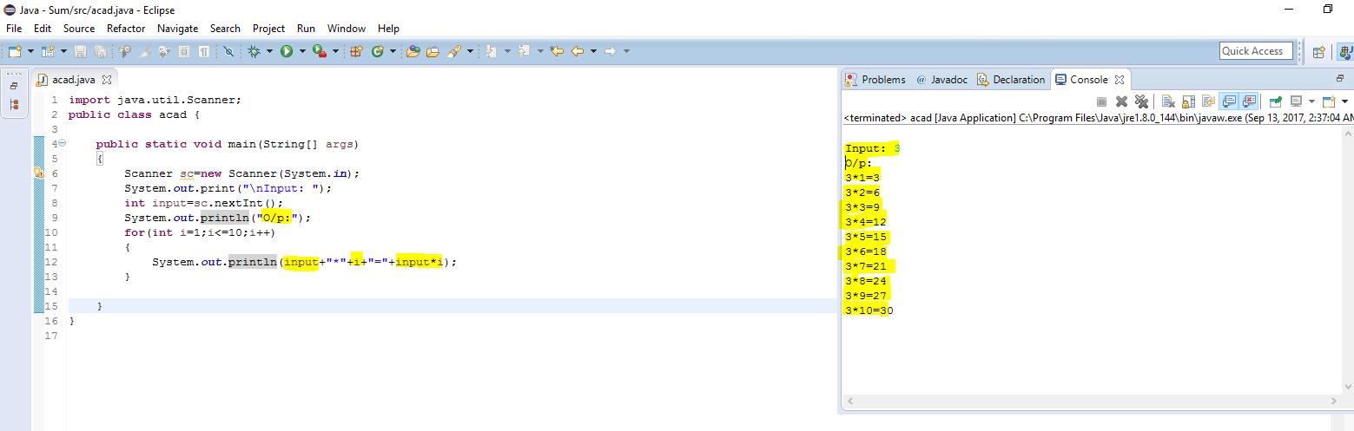

**Program code:-**

**import** java.util.Scanner;

**public** **class** acad {

**public** **static** **void** main(String[] args)

{

Scanner sc=**new** Scanner(System.***in***);

System.***out***.print("\nInput: ");

**int** input=sc.nextInt();

System.***out***.println("O/p:");

**for**(**int** i=1;i<=10;i++)

{

System.***out***.println(input+"*"+i+"="+input*i);

}

}

}