

**Screenshot and output:-**

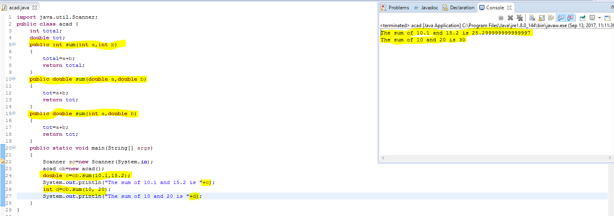

**Explanation:-**

Method Overloading is nothing but many methods have **same name** but it **differs by number of arguments or type of arguments or return type of a function**. Here the **method named sum is overloaded.**

**Program code:-**

**import** java.util.Scanner;

**public** **class** acad {

**int** total;

**double** tot;

**public** **int** sum(**int** a,**int** b)

{

total=a+b;

**return** total;

}

**public** **double** sum(**double** a,**double** b)

{

tot=a+b;

**return** tot;

}

**public** **double** sum(**int** a,**double** b)

{

tot=a+b;

**return** tot;

}

**public** **static** **void** main(String[] args)

{

Scanner sc=**new** Scanner(System.***in***);

acad ob=**new** acad();

**double** c=ob.sum(10.1,15.2);

System.***out***.println("The sum of 10.1 and 15.2 is "+c);

**int** d=ob.sum(10, 20);

System.***out***.println("The sum of 10 and 20 is "+d);

}

}