

**Screenshot and output:-**

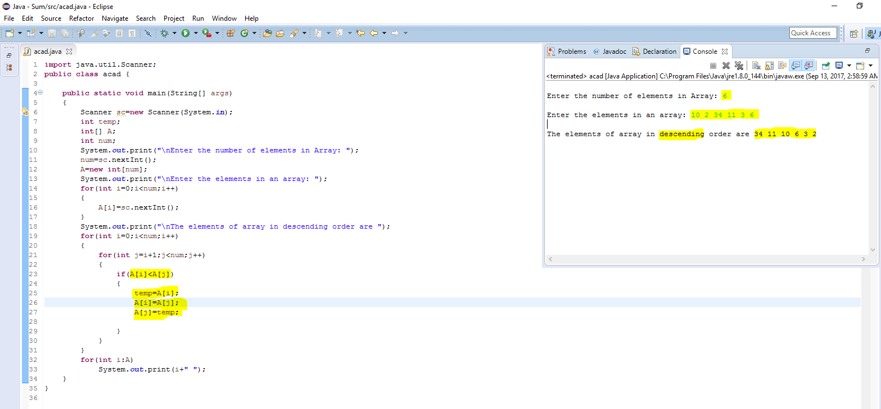

**Program code:-**

**import** java.util.Scanner;

**public** **class** acad {

**public** **static** **void** main(String[] args)

{

Scanner sc=**new** Scanner(System.***in***);

**int** temp;

**int**[] A;

**int** num;

System.***out***.print("\nEnter the number of elements in Array: ");

num=sc.nextInt();

A=**new** **int**[num];

System.***out***.print("\nEnter the elements in an array: ");

**for**(**int** i=0;i<num;i++)

{

A[i]=sc.nextInt();

}

System.***out***.print("\nThe elements of array in descending order are ");

**for**(**int** i=0;i<num;i++)

{

**for**(**int** j=i+1;j<num;j++)

{

**if**(A[i]<A[j])

{

temp=A[i];

A[i]=A[j];

A[j]=temp;

}

}

}

**for**(**int** i:A)

System.***out***.print(i+" ");

}

}