IntraTeams
Intranet voice, video and screen sharing over WebRTC without STUN or TURN
Proof of Concept — Technical Design Document
Field | Value
Document type | Technical design and architecture reference
Audience | Development team and solution architects
Status | Proof of Concept — not production ready
Date | 25 August 2026
Solution | IntraTeams.sln — 3 projects plus an automated signaling test
Platform | .NET 10 · WPF · ASP.NET Core SignalR · WebRTC via SIPSorcery
Scope | 1-to-1 presence, text chat, audio, video and screen share on a closed intranet

Contents
If this page appears empty, place the cursor here and press F9 (or right-click and choose Update Field). Word builds the table of contents from the document's headings when the file is opened.

1. Purpose and scope
IntraTeams is a proof of concept for a Microsoft Teams–style 1-to-1 communication client that runs entirely inside a closed corporate network. It provides a live presence list of connected users, text chat, audio calls, video calls and screen sharing, with no dependency on any STUN, TURN or coturn server — the requirement that shaped almost every design decision in this document.
The deliverable is a Visual Studio solution containing three projects and one automated test harness:
Project | Target | Responsibility
IntraTeams.Shared | net10.0 | Data contracts and hub method-name constants shared by client and server
IntraTeams.Server | net10.0 | ASP.NET Core host with a single SignalR hub for presence and signaling
IntraTeams.Client | net10.0-windows | WPF desktop application: UI, media capture and playback, WebRTC peer connection
IntraTeams.HubSmokeTest | net10.0 | Automated end-to-end exercise of the signaling protocol over raw WebSockets

1.1 What this document covers
- How SignalR and WebRTC divide responsibility between signaling and media.
- Why the absence of STUN and TURN servers is correct for an intranet, and how it is enforced in code.
- Every open-source package used, its licence, and the reasoning behind each selection.
- End-to-end flows for chat, audio, video and screen share.
- Design decisions, verification performed, and the gaps between this POC and a production system.

1.2 Explicit non-goals
- Group calls. The design is strictly 1-to-1; multi-party requires an SFU or a full mesh.
- Federation or external access. Clients outside the intranet are out of scope by definition.
- Browser interoperability, although the standards-based stack does not preclude it later.
- Production hardening: authentication, high availability, persistence and observability.

2. Architecture at a glance
The system separates two planes that are commonly conflated. The signaling plane is client–server: every client holds a SignalR connection to a single hub, which maintains the roster and relays call-control messages. The media plane is peer-to-peer: once a call is established, audio, video and screen frames travel directly between the two machines and never pass through the server again.
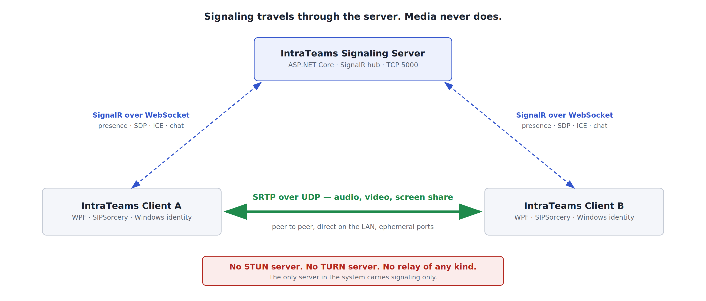
Figure 1 — Signaling is relayed by the server; media is direct between peers.
This split is what makes the server cheap. It handles a few hundred bytes of JSON per call and then goes idle for the call's duration, regardless of whether that call carries audio, 1080p video or a shared desktop. Server sizing is therefore driven by concurrent users, not by concurrent media minutes.

2.1 Component responsibilities
Component | Responsibility
SignalingHub | Roster of connected users, presence state, call invite/accept/reject/hangup, verbatim relay of SDP and ICE candidates, 1-to-1 chat
UserRegistry | In-memory map of connection id to user, plus the active call pairing used to answer "is this person busy?"
SignalingClient | Wraps the SignalR HubConnection and re-exposes the protocol as plain .NET events, so the view model never references SignalR types
PeerSession | Owns one RTCPeerConnection: track setup, SDP offer/answer, ICE candidate handling and the host-candidate-only policy
MediaStack | Owns every capture and playback device for a call, plus the VP8 encode and decode path and the camera/screen source switch
GdiScreenCapture | Desktop capture written against the Win32 GDI API, because the media library provides no screen source
VideoSurface | Marshals decoded frames onto the WPF UI thread and blits them into a reused WriteableBitmap
MainViewModel | Call state machine, roster projection, chat history and the in-call control toggles

3. Operating without STUN or TURN servers

3.1 A necessary clarification on terminology
Important: ICE is still used. ICE servers are not. These are different things and the distinction matters when reviewing this design.
ICE (Interactive Connectivity Establishment, RFC 8445) is the algorithm built into WebRTC that discovers how two endpoints can reach each other. It gathers candidate addresses, forms pairs, and runs connectivity checks until it finds a working path. It is mandatory in WebRTC and cannot be disabled.
What people normally mean by "ICE servers" are the external STUN and TURN servers that ICE can optionally consult. IntraTeams uses zero of those. The distinction is worth stating precisely in review, because "we are not using ICE" would be inaccurate, while "we are not using ICE servers" is exactly right.

3.2 Why host candidates are sufficient
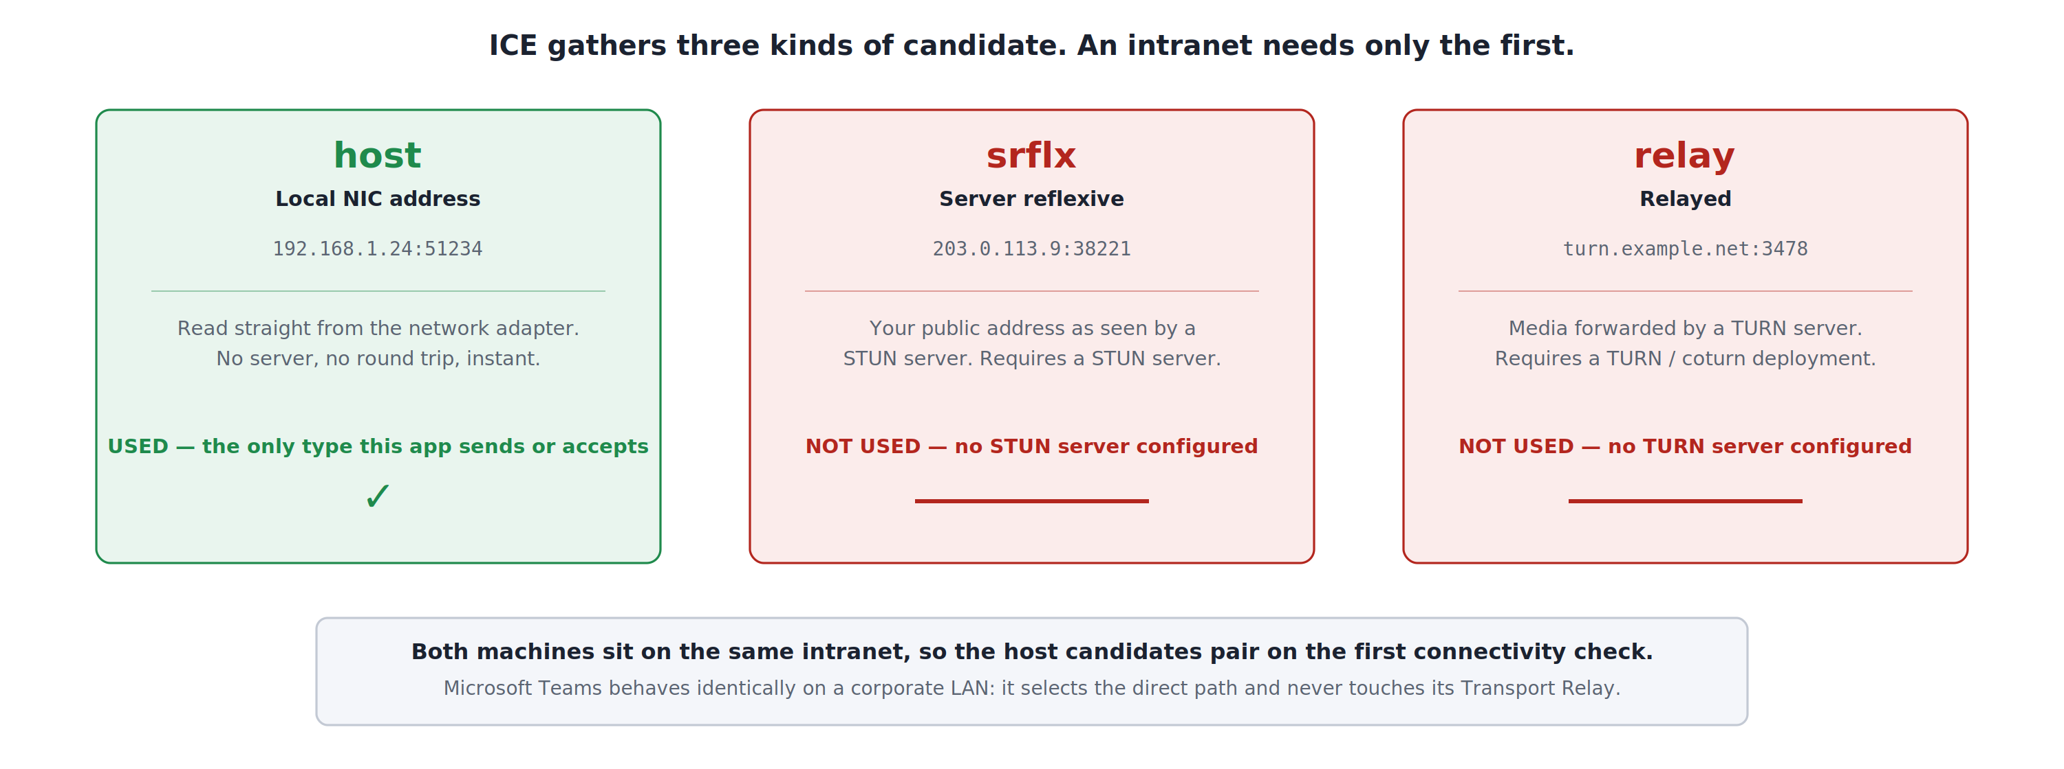
Figure 2 — The three ICE candidate types, and why only the first is required on an intranet.
A host candidate is simply an IP address and port belonging to a local network adapter. It is read directly from the operating system: no external server, no network round trip, and effectively instantaneous. When two machines sit on the same intranet, exchanging host candidates is enough for the connectivity checks to succeed on the first pair tried.
The other two candidate types exist to solve problems this deployment does not have. A server-reflexive candidate discovers a client's public address as seen from outside its NAT, which requires a STUN server and only matters when peers are on different networks. A relay candidate routes media through a TURN server, which is a fallback for when no direct path exists at all — typically symmetric NAT or a restrictive firewall between two internet endpoints.

3.3 Precedent: this is how Microsoft Teams behaves on a LAN
This is not an unusual optimisation. Microsoft's published call-flow documentation for Teams describes the same selection logic: clients gather local, reflexive and relay candidates, run STUN connectivity checks, and select the best working path — and when local IP and port candidates have connectivity, the direct peer-to-peer path is chosen and the Microsoft 365 Transport Relay is never involved.
Teams still deploys a relay because it must serve users at home, on mobile networks and behind hostile firewalls. An intranet-only application has no such population, so the relay has nothing to do. Removing it removes infrastructure, not capability, for this deployment scope.

3.4 The configuration
The entire ICE configuration for the application is five lines:
var configuration = new RTCConfiguration
{
// Empty, NOT null: no STUN and no TURN will be contacted,
// so only host candidates are gathered.
iceServers = new List<RTCIceServer>(),

// Advertise a candidate for every local NIC.
X_ICEIncludeAllInterfaceAddresses = true,

// With no STUN to wait on, gathering finishes almost immediately.
X_GatherTimeoutMs = 3000
};
X_ICEIncludeAllInterfaceAddresses deserves comment. Corporate desktops frequently carry virtual adapters from Hyper-V, WSL, Docker or a VPN client. Left to pick a single "best" local address, the library will sometimes choose one of those instead of the real LAN interface — and a single wrong candidate with no alternatives means the call simply fails. Advertising every interface lets the connectivity checks discover which one actually works.

3.5 How the constraint is enforced, not merely intended
Three independent mechanisms prevent an ICE server from creeping in unnoticed:
- Construction fails loudly. PeerSession throws InvalidOperationException if iceServers is ever non-empty. A STUN URL added later cannot silently start working.
- Outgoing candidates are filtered. Each gathered candidate's type token is parsed. Only host candidates are sent to the peer; srflx or relay types are logged as a warning and dropped.
- Incoming candidates are filtered too. If the far end were misconfigured with a TURN server, this client refuses its relay candidate. Media therefore cannot traverse a third party even by accident, in either direction.
The behaviour is observable at runtime in the client's Connection log:
ICE servers configured: 0. No STUN, no TURN - host candidates only.
Local candidate #1 [host]: candidate:... 192.168.1.24 51234 typ host
Remote candidate #1 [host]: candidate:... 192.168.1.31 49876 typ host
ICE connection state: connected
Every candidate is tagged [host]. For independent confirmation, a packet capture during a call will show no traffic whatsoever to UDP port 3478, the well-known STUN and TURN port.
Trade-off to record: This design is correct only while both endpoints can reach each other directly. A remote worker on VPN, a client on a guest network with wireless client isolation, or any future requirement to call across sites will fail to connect. Adding TURN later is a configuration change plus a deployed relay, but it is a genuine change — not something the current build can be talked into.

4. Technology selection

4.1 Why SignalR for signaling
WebRTC deliberately specifies no signaling protocol. Applications must move SDP offers, SDP answers and ICE candidates between peers by some other means, and the choice is left open. SignalR fits this POC well:
- It is bidirectional and server-push capable, which call signaling requires — a callee must be told about an incoming call it did not ask for.
- It negotiates WebSockets automatically and degrades to Server-Sent Events or long polling where a proxy interferes.
- It is Microsoft first-party, ships inside the ASP.NET Core shared framework, and needs no third-party server component.
- Connection lifetime maps naturally onto presence: connect means online, disconnect means offline, with no heartbeat protocol to design.
For reference, Teams itself does not use SignalR — it uses HTTPS/REST plus a proprietary push channel. But the role is identical, and nothing about the WebRTC design depends on which transport fills it.

4.2 Why WebRTC for media
The alternative considered was a custom UDP media protocol. WebRTC was chosen because it supplies, as tested and standardised components, four things that would otherwise have to be built:
Capability | What it would cost to replace
DTLS-SRTP encryption | There is no DTLS implementation in the .NET base class library. SslStream is TLS only. Writing one is out of scope for any POC.
ICE connectivity establishment | Candidate gathering, pairing, STUN binding checks and nomination — a substantial protocol in its own right, even when only host candidates are used.
RTP/RTCP transport | Packetisation, sequencing, jitter handling and receiver reports.
SDP negotiation | A codec and capability negotiation format that both ends already agree on.

4.3 Why SIPSorcery
The requirement was a pure WPF desktop application with no embedded browser engine. That rules out the usual approach of hosting WebView2 and using the browser's WebRTC implementation, and it leaves very few options. SIPSorcery is the only mature, actively maintained, fully managed WebRTC implementation for .NET.
It provides an API deliberately shaped like the browser's — RTCPeerConnection, createOffer, setRemoteDescription, onicecandidate — which keeps the code recognisable to anyone who has written WebRTC elsewhere, and keeps a future browser-interop path open.

4.4 Package inventory
Package | Version | Licence | Role and rationale
SIPSorcery | 10.0.16 | BSD-3-Clause + use restriction | Core WebRTC: RTCPeerConnection, ICE, DTLS-SRTP, RTP, SDP. The only viable pure-managed option.
SIPSorceryMedia.Abstractions | 10.0.16 | BSD-3-Clause + use restriction | Interfaces and format types shared across the media packages. Arrives transitively.
SIPSorceryMedia.Windows | 10.0.15 | BSD-3-Clause + use restriction | Microphone and speaker via NAudio, webcam via Media Foundation. Note: provides no screen capture.
SIPSorcery.VP8 | 10.0.16 | BSD-3-Clause | Pure-managed VP8 encoder and decoder. Chosen over the FFmpeg package to avoid shipping native binaries.
Microsoft.AspNetCore.SignalR.Client | 8.0.11 | MIT | Hub client. Microsoft first-party; runs on .NET 10 without issue.
Transitive dependencies pulled in by SIPSorcery, listed because they appear in any dependency scan:
Package | Why it is present
BouncyCastle.Cryptography | Provides the DTLS implementation that .NET itself lacks. This is the dependency that makes managed WebRTC possible at all.
Concentus | Managed Opus codec. Present in the package but not exercised by this POC, which negotiates G.711/G.722.
DnsClient, Makaretu.Dns.Multicast | DNS and mDNS resolution used by the wider SIP feature set.
SIPSorcery.WebSocketSharp | WebSocket support for SIPSorcery's own signaling helpers. Not used here; the app uses SignalR.
Microsoft.Extensions.Logging.Abstractions | Logging façade.

4.5 Licensing — requires a compliance decision
Flag for legal / OSS governance review: SIPSorcery is not published under a plain MIT or BSD licence. It is BSD 3-Clause with an additional clause restricting use in Israel and the Occupied Territories. Because it restricts a field of use, it is not an OSI-approved open-source licence in the strict sense, and many corporate OSS policies treat licences with use restrictions as requiring explicit approval.
The practical points for review are: the core terms are otherwise standard BSD 3-Clause (attribution and disclaimer of warranty); the restriction is geographic and political rather than technical or commercial; and SIPSorcery.VP8 is plain BSD 3-Clause with no such clause.
Separately — and favourably — this POC does not use SIPSorceryMedia.FFmpeg, which is LGPL v2.1. Avoiding it means no LGPL obligations and no FFmpeg redistribution to reason about. That was a deployment decision first, but it is a licensing benefit as well.
If the use restriction is unacceptable to your organisation, the realistic alternatives are a WebView2-hosted browser WebRTC stack, or a custom UDP media protocol with no WebRTC at all. Both were considered and are recorded below.

4.6 Options considered and rejected
Option | Why it was not chosen
WebView2 hosting browser WebRTC | Rejected by requirement: the application had to be pure WPF with no embedded browser engine. Technically this is the easiest path to working media.
Custom UDP media protocol, no WebRTC | Viable and dependency-free, but forfeits DTLS-SRTP encryption, standards compliance and any future browser interop, while requiring substantially more code.
Hand-written WebRTC, no third-party code | Not feasible. .NET has no DTLS implementation, and a video codec would have to be written from scratch. This is months of work, not a POC.
Microsoft.MixedReality.WebRTC | Archived and unmaintained.
SIPSorceryMedia.FFmpeg | Better codecs and a ready-made screen source, but requires FFmpeg 8.1 shared binaries installed on every desktop, and is LGPL v2.1.
SIPSorceryMedia.Encoders | The legacy VP8 package. Still compiled against Abstractions 8.0.12 and superseded by SIPSorcery.VP8.

5. Signaling protocol
The hub is mapped at /hubs/signaling. Method names are defined as constants in the shared project so the client and server cannot drift apart.

5.1 Client to server
Method | Purpose
Register(userName, machineName) | First call after connecting. Returns the current roster and broadcasts the updated roster to everyone else.
InviteCall(target, callId, withVideo) | Ring a peer. Fails soft if the peer has disconnected or is already in a call.
AcceptCall(caller, callId) | Accept an incoming call. Marks both parties busy.
RejectCall(caller, callId, reason) | Decline an incoming call.
EndCall(peer, callId, reason) | Hang up, or cancel an outgoing call that is still ringing.
SendSdp(SdpMessage) | Relay an SDP offer or answer to the other peer.
SendIceCandidate(IceCandidateMessage) | Relay one trickled ICE candidate.
SendChat(target, text) | Send a 1-to-1 text message.

5.2 Server to client
Callback | Meaning
RosterChanged(UserInfo[]) | Full roster snapshot. Sent on every join, leave and presence change.
IncomingCall(CallInvite) | Someone is calling; the client should ring.
CallAccepted(from, callId) | The callee picked up. The caller now creates the SDP offer.
CallRejected(from, reason) | Declined, or the callee was already busy.
CallEnded(from, reason) | Hung up, cancelled, or the peer's connection dropped.
ReceiveSdp(SdpMessage) | An offer or answer from the other peer.
ReceiveIceCandidate(IceCandidateMessage) | One trickled candidate from the other peer.
ReceiveChat(ChatMessage) | A text message. Also echoed to the sender.

5.3 Anti-spoofing
Every relayed message carries a FromConnectionId field, and the server overwrites whatever the client supplied with the connection id it observed. A client therefore cannot impersonate another user by forging that field. This behaviour is covered by an automated test.

6. Feature flows

6.1 Presence and roster
Identity is taken from Windows automatically — Environment.UserName and Environment.MachineName — so there is no login step. On connect, the client calls Register and receives the roster; the server then pushes an updated roster to every other client. Presence has two states, Available and In a call, and the server maintains them as part of call setup and teardown.
When a connection drops, the server removes the user from the roster and, if that user was mid-call, notifies the other party so its UI does not hang waiting on a call that can never complete.

6.2 Text chat
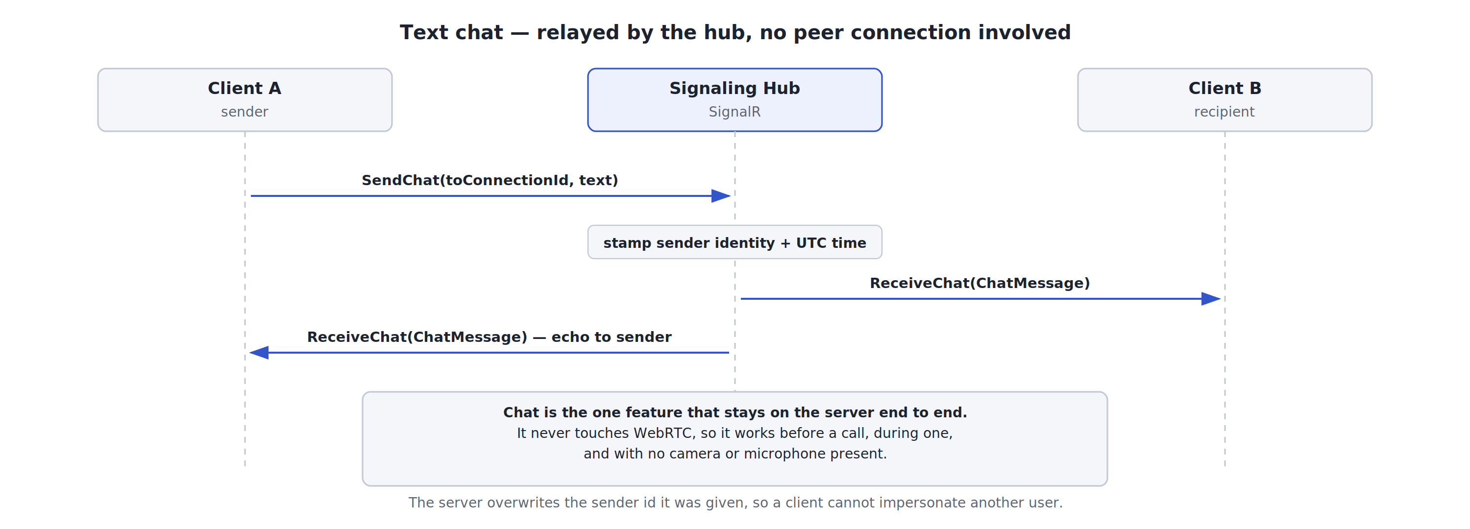
Figure 3 — Chat is relayed by the hub and never involves a peer connection.
Chat is the only feature that stays server-side end to end. It requires no peer connection, no codec negotiation and no media devices, which means it works before a call, during a call, and on a machine with neither camera nor microphone. The hub stamps the sender's identity and a UTC timestamp, delivers the message to the recipient, and echoes it back to the sender so both windows render from the same object.
Production note: messages are relayed but never stored. There is no history, no delivery receipt and no offline queue — a message to a user who is not connected is silently discarded.

6.3 Audio call
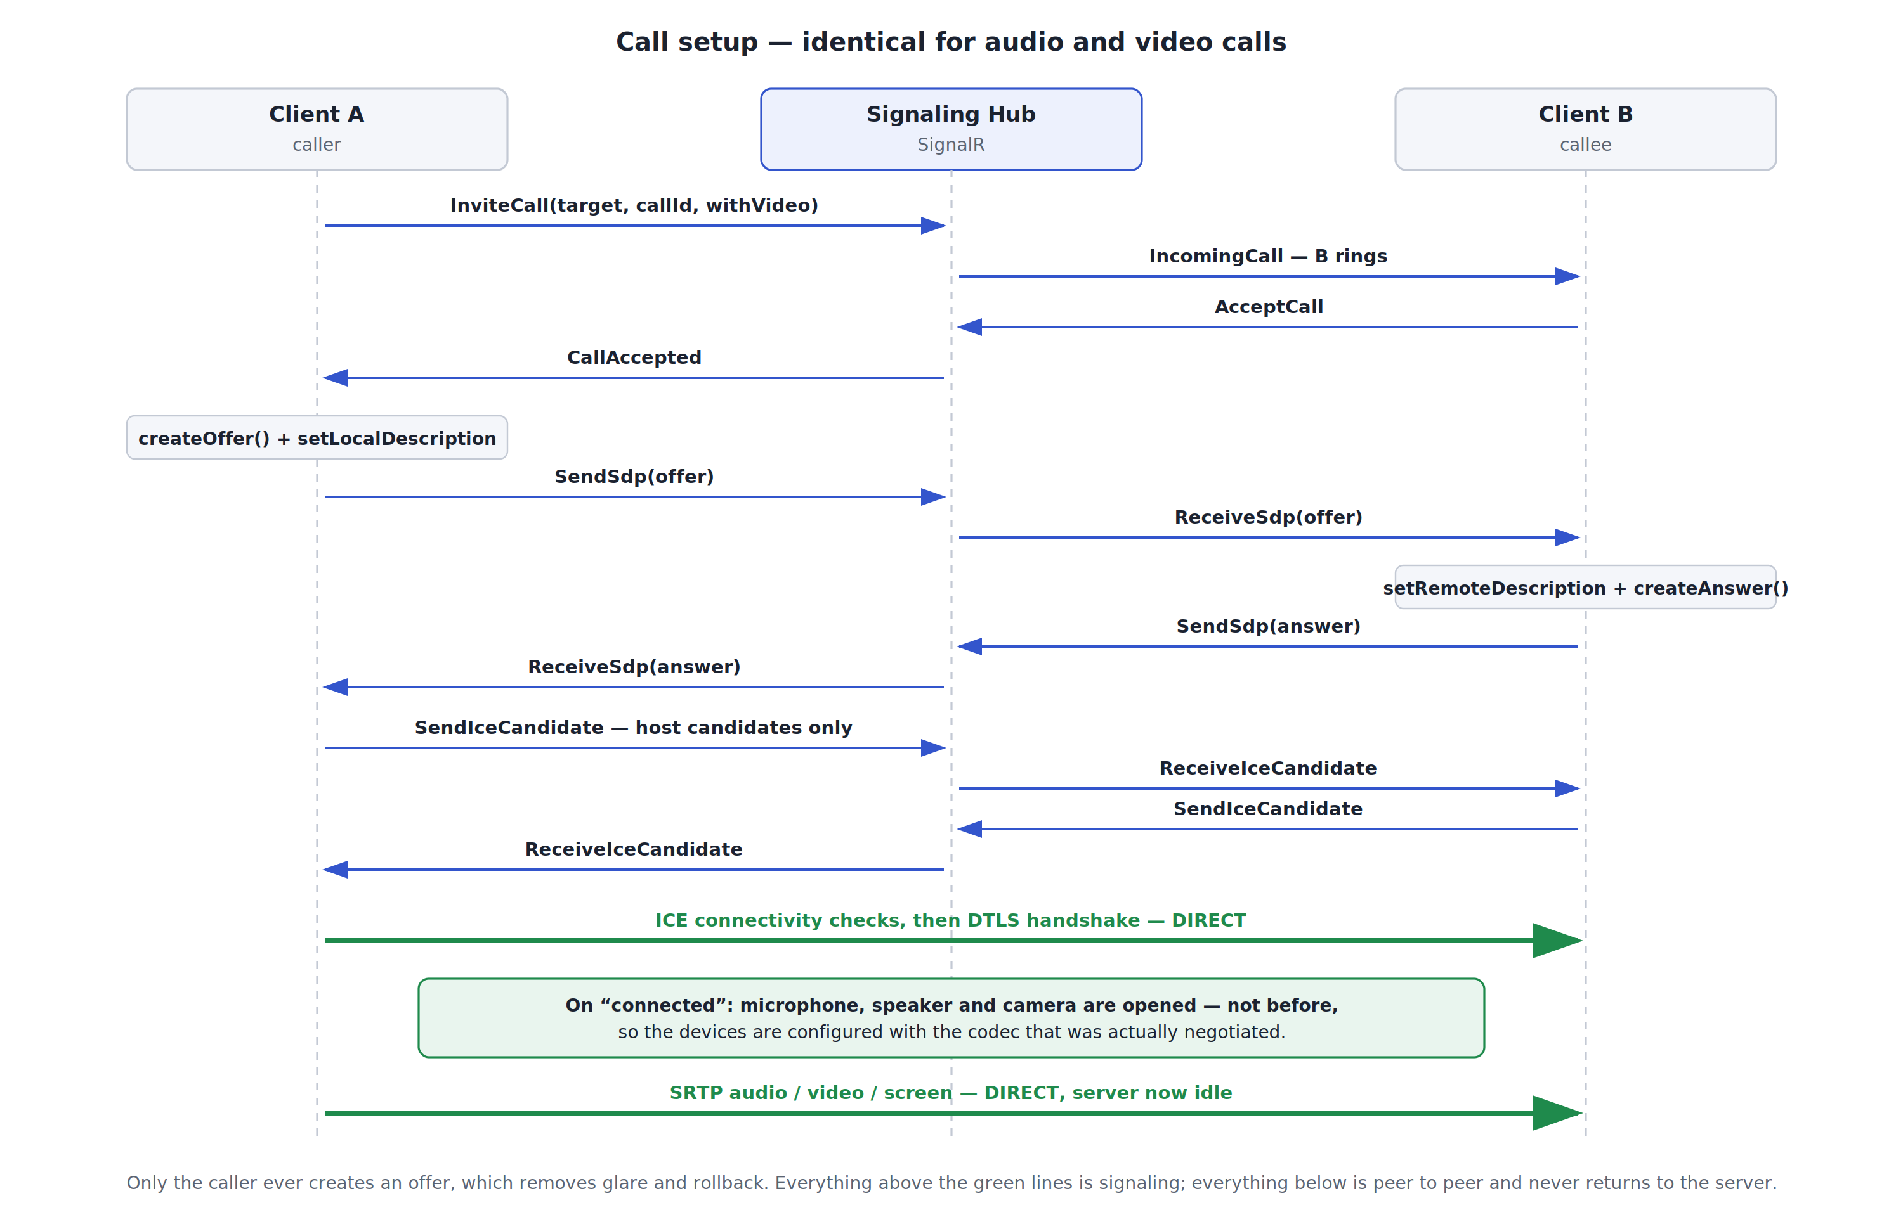
Figure 4 — Call setup. The sequence is identical for audio and video calls.
The sequence divides into four phases:
- Call control. The caller invites; the callee's client rings; the callee accepts. Only at this point does either side open a peer connection, so a declined call never touches a media device.
- Negotiation. The caller creates the SDP offer, the callee applies it and answers. Both are relayed by the hub.
- Connectivity. Both sides trickle host candidates through the hub. ICE runs its connectivity checks directly between the machines, then DTLS negotiates the SRTP keys.
- Media. Encrypted RTP flows directly peer to peer. The server is idle for the rest of the call.
Design decision — only the caller offers. Keeping offer creation on one side removes SDP glare (both peers offering at once) and with it the entire rollback state machine. For a 1-to-1 POC this is a large simplification for no functional loss.
Design decision — devices open on "connected", not before. The audio endpoint initialises its capture and playback devices against whichever codec is current when it starts. Opening the microphone before negotiation completes leaves it configured for the wrong sample rate, and the symptom is a call that connects perfectly and carries no audible audio. Deferring device startup to the connected transition is what makes audio work.
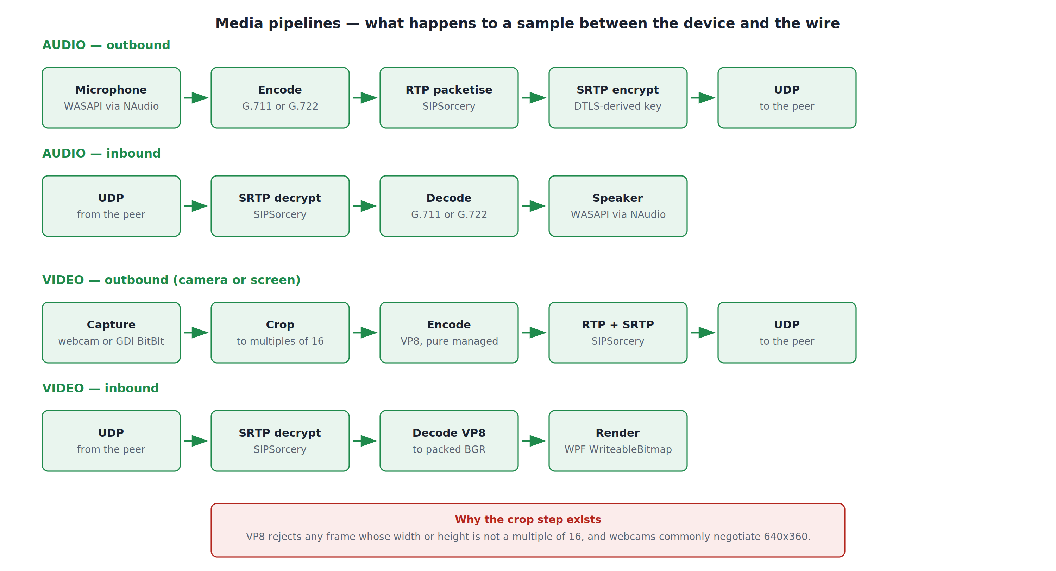
Figure 5 — What happens to an audio or video sample between the device and the wire.
Audio is captured through NAudio and encoded as G.711 (PCMU/PCMA) or G.722. These are old, low-complexity codecs, and on a LAN their bandwidth cost — 64 kbit/s — is irrelevant. Opus is available in the dependency tree but was not needed.

6.4 Video call
Video call setup is byte-for-byte the same flow as Figure 4; the only difference is that the invite carries a WithVideo flag and the camera is started alongside the microphone. The video-specific work is all in the media pipeline.
Frames are captured from the webcam, cropped, encoded as VP8 in pure managed code, packetised into RTP and encrypted. Inbound, the reverse: decrypt, decode to packed BGR, and blit into a reused WPF WriteableBitmap on the UI thread.

The crop step, and why it exists
VP8 requires both frame dimensions to be positive multiples of 16. Webcams routinely negotiate 640×360, and 360 is not a multiple of 16. Every frame is therefore cropped to the largest centred region that satisfies the constraint — 640×360 becomes 640×352, losing four rows top and bottom. Cropping was chosen over scaling because it costs almost nothing per frame and introduces no blur.
The crop handles packed BGR, RGB, BGRA and RGBA as well as planar I420 and NV12, because the pixel format a given webcam delivers cannot be assumed.

Frame dropping
Both the encoder and the WPF surface skip a frame when the previous one is still in flight, rather than queueing it. A backlog would present to the user as steadily growing latency, which is worse than an occasional dropped frame.

6.5 Screen sharing
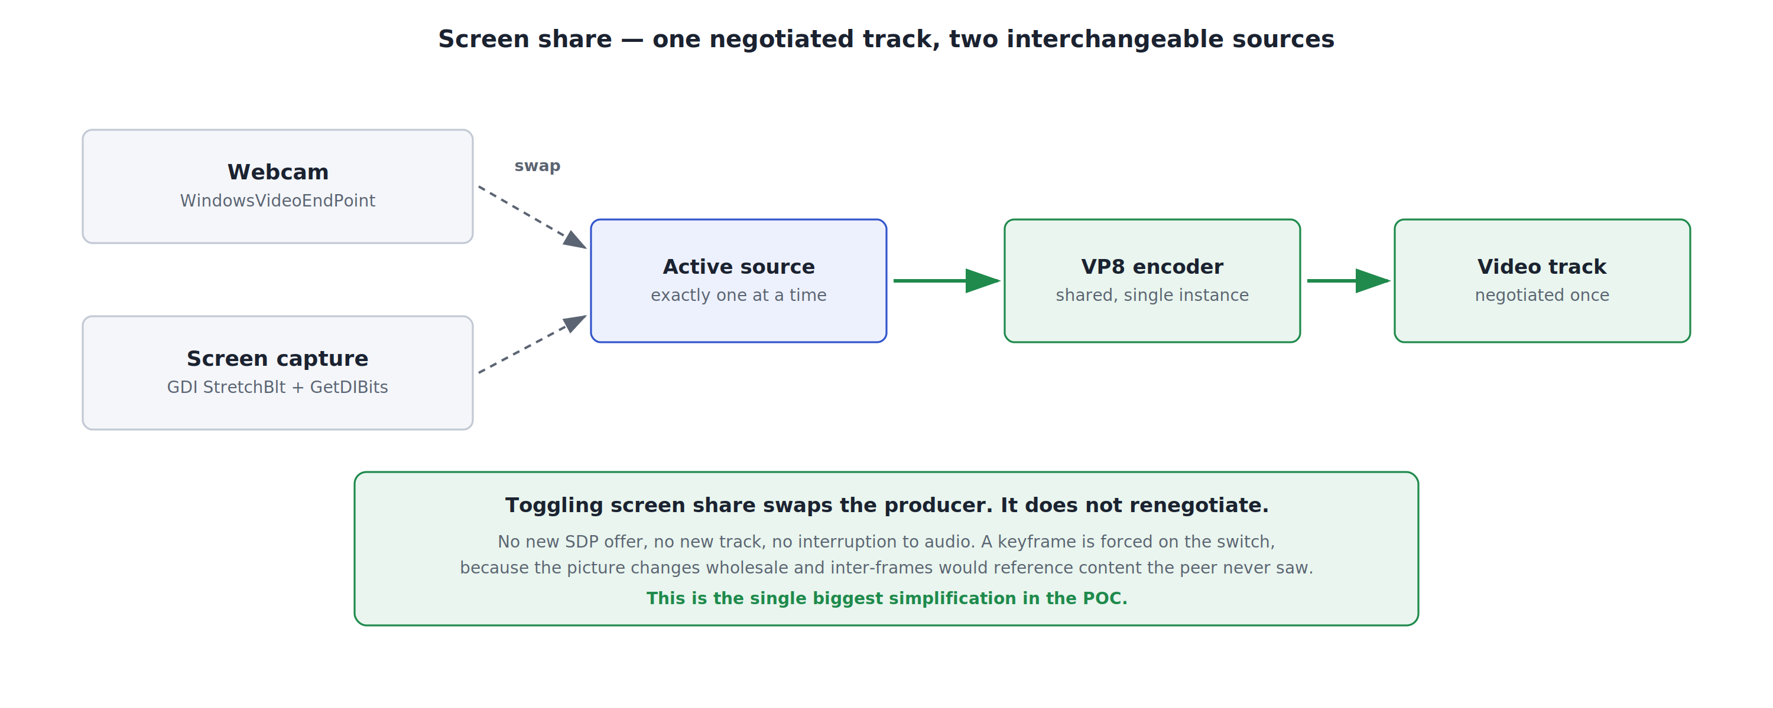
Figure 6 — One negotiated track fed by two interchangeable sources.
SIPSorceryMedia.Windows provides no screen capture at all — its video endpoint is webcam-only. Screen capture is therefore implemented directly against the Win32 GDI API: StretchBlt to copy and downscale the desktop, GetDIBits to read it back as packed 24-bit BGR, at a configurable resolution and frame rate. The alternative was SIPSorceryMedia.FFmpeg, which supplies a screen source but requires FFmpeg shared binaries installed on every desktop.
The key architectural choice is that there is one video track, not two. Camera and screen capture both feed the same VP8 encoder and the same negotiated track, so toggling screen share swaps the frame producer rather than renegotiating SDP. There is no new offer, no new track, and no interruption to audio. A keyframe is forced on the switch, because the picture changes wholesale and inter-frames would otherwise reference content the far end has never seen.
Known limitations of the GDI approach: primary monitor only, with no monitor picker; the mouse cursor is not included in the captured image; and GDI cannot capture hardware-protected content or some exclusive-fullscreen applications.

7. Design decisions
The decisions worth carrying forward, and the reasoning behind each:
Decision | Rationale | Consequence if changed
No STUN or TURN servers | Both peers are on one intranet, so host candidates always pair | Off-network or cross-site calling requires a deployed TURN relay
Only the caller creates an offer | Removes SDP glare and the rollback state machine entirely | Any move to renegotiation mid-call reintroduces glare handling
One video track, two sources | Screen share becomes a producer swap, not a renegotiation | Sending camera and screen simultaneously requires a second track
Devices opened on "connected" | The codec must be known before the device initialises, or audio is silent | Reverting this produces calls that connect and carry no media
Crop frames to multiples of 16 | VP8 rejects other dimensions; webcams negotiate 640x360 | Removing it throws on every frame from a typical webcam
Drop frames rather than queue | A backlog manifests as growing latency | Queueing trades a visible stutter for unbounded delay
Own VP8 encode path | Camera and screen share one encoder and one keyframe cadence | Letting the library encode reintroduces the dimension constraint
GDI screen capture | Avoids an FFmpeg install on every desktop | FFmpeg would give better compression and multi-monitor support
In-memory roster | Adequate for a single-instance POC | More than one server instance requires a Redis backplane

8. Security posture
Aspect | Current state
Media confidentiality | Encrypted. DTLS-SRTP is mandatory in WebRTC and is active; keys are negotiated directly between peers.
Signaling confidentiality | Not encrypted. The hub runs over plain HTTP in this POC. TLS is a configuration change, not a code change.
Authentication | None. The hub is anonymous; a client asserts its own Windows username.
Impersonation within the protocol | Prevented. The server overwrites the sender id on every relayed message.
Authorisation | None. Any connected user may call or message any other connected user.
Media path exposure | Minimal. Media never traverses the server and never leaves the intranet; no third-party relay is involved.
Audit trail | None. Nothing is persisted — not chat, not call records.
Before any wider rollout: enable TLS on the hub, add Windows Authentication (Negotiate) so identity is verified rather than asserted, and decide whether chat and call metadata must be retained for audit.

9. Verification performed

9.1 Automated signaling test
The solution includes IntraTeams.HubSmokeTest, a test harness that speaks the SignalR JSON protocol directly over raw WebSockets and drives two simulated peers through the entire call protocol. It runs against a live server and reports 31 of 31 checks passing.
Coverage includes registration and roster broadcast, presence transitions to and from In a call, ring/accept/decline, busy rejection when calling a peer already in a call, SDP offer and answer relay, ICE candidate relay, sender-spoofing rejection, chat delivery and echo, hang-up, and notification of the survivor when a peer's connection drops mid-call.
dotnet run --project tests\IntraTeams.HubSmokeTest -- http://localhost:5000

31/31 checks passed
SIGNALING LAYER OK

9.2 What this does and does not prove
Proven: the signaling protocol is correct and complete, including its failure paths. Because this layer is exercised without any media devices, a media problem can never be confused with a protocol problem — which is the main reason the harness exists.
Not proven by that test: audio and video quality, device compatibility across different webcam and headset models, behaviour under packet loss, and performance with many concurrent users. These require manual testing on representative hardware.

10. Limitations and the road to production
This is a proof of concept. The following are known gaps, listed so they are not discovered late:
Area | Limitation | What production would need
Scale | Strictly 1-to-1 | An SFU for group calls; a mesh does not scale past ~4 participants
Server | Single instance, in-memory roster | Redis backplane, health checks, horizontal scale
Security | Anonymous hub over plain HTTP | TLS plus Windows Authentication
Video quality | Managed VP8 encoder is experimental and has no motion estimation | FFmpeg with H.264, or hardware encoding
Screen share | Primary monitor only, no cursor | Desktop Duplication API with monitor selection and cursor compositing
Audio | No echo cancellation, so headsets are required | An AEC implementation, or a device layer that provides one
Resilience | A SignalR reconnect issues a new connection id, so an in-progress call does not survive it | Stable user identity decoupled from connection id
Observability | A per-client diagnostic log only | Centralised logging, call quality metrics, alerting
Deployment | Run from Visual Studio or dotnet run | Signed installer, service registration for the server, update mechanism

10.1 Recommended next steps
- Confirm the SIPSorcery licence restriction is acceptable to legal and OSS governance. This gates everything else.
- Test across two physical machines on the target network segment — single-machine testing cannot exercise ICE, because loopback always connects.
- Validate against the real desktop fleet: webcam formats, headset models and any endpoint security software that intercepts media devices.
- Decide whether video quality from the managed VP8 encoder is sufficient, or whether the FFmpeg/H.264 path and its deployment cost are justified.
- Add TLS and Windows Authentication before any pilot with real users.

Appendix A — Target framework constraint
Every project targets .NET 10. This is not a preference: SIPSorceryMedia.Windows 10.x ships a single target framework, net10.0-windows10.0.17763, and no other. The client must therefore target it, and since a net8.0 project cannot reference a net10.0 library, the shared and server projects follow.
If .NET 10 were unavailable, the only coherent alternative set drops SIPSorceryMedia.Windows entirely and uses SIPSorceryMedia.FFmpeg for camera, microphone and screen — accepting the FFmpeg binary deployment, the LGPL obligation, and the need to supply an audio sink.

Appendix B — Network and firewall requirements
Traffic | Port | Notes
SignalR signaling | TCP 5000 | Inbound on the server machine only. Configurable.
RTP / SRTP media | UDP, ephemeral | Directly between the two clients. WebRTC selects ports at runtime.
STUN / TURN | none | Not used. No traffic to UDP 3478 is generated.
Because WebRTC selects its own UDP ports, a restrictive environment needs either a per-program firewall rule for the client executable or a pinned port range, which can be supplied by passing a PortRange to the RTCPeerConnection constructor.
Most common deployment failure: the Windows Defender Firewall prompt on first run is dismissed rather than allowed. The symptom is a call that signals correctly — both sides show Connecting — but never reaches the connected state. The second most common cause is wireless client isolation on a guest or corporate access point, which blocks client-to-client traffic entirely.

Appendix C — Client configuration
Settings live in appsettings.json beside the executable, with command-line overrides:
Setting | Default | Purpose
ServerUrl | http://localhost:5000 | Address of the signaling server. Override with --server.
CameraDeviceId | (empty) | Specific webcam to use. List available ids with --list-cameras.
CameraWidth / CameraHeight | 640 / 480 | Requested capture size. The device may negotiate something else, which the crop step then handles.
CameraFps | 20 | Requested capture frame rate.
ScreenShareWidth | 1280 | Screen capture is downscaled to this width before encoding.
ScreenShareFps | 8 | Screen capture frame rate. Lower this first if CPU or bandwidth is constrained.
--suffix | (none) | Appends a label to the display name, so two instances on one machine are distinguishable during a demo.

