E-commerce Application on IBM Cloud Foundry

# Phase 2: Innovation Overview:

The project aims to develop an artisanal e-commerce platform using IBM Cloud Foundry. This platform's primary goal is to connect skilled artisans with a worldwide audience, enabling them to showcase and sell handmade products such as jewellery and home decor. Key objectives include creating a user-friendly platform, facilitating artisan connectivity, offering an attractive product showcase, ensuring robust security and payment integration, optimizing the user experience, supporting small businesses, and efficiently managing the marketplace. Ultimately, the project seeks to foster creativity and provide a nurturing marketplace for artisans while serving a global customer base.

# Implementation Steps:

## Defining Business Strategy:

* Defining your business goals, target audience, and unique selling points for the artisanal e-commerce platform.

## Set Up IBM Cloud Foundry:

* Creating an IBM Cloud account and Provision an IBM Cloud Foundry environment to host your web application.

## Design Your Platform:

* Collaborate with a web designer to create an appealing and user- friendly website design that showcases handmade products effectively, with high-quality images and intuitive navigation.

## Development Stack:

* HTML,CSS,JAVASCRIPT,Tailwind CSS, Python Flask, IBM Cloud Foundry.

## User Registration and Authentication:

* Developing a secure user registration and login system.

## Product Listings:

* Creating a database to store artisan and product information.
* Developing a product management system for artisans to add, edit, and remove their listings and implementing a search and filter system for users to find products easily.

## Shopping Cart and Checkout:

* Building a shopping cart system that allows users to add and remove items.
* Integrating a secure checkout process with payment gateway options and Implementation of SSL encryption to secure user data during checkout.

## Payment Gateway Integration:

* Integrating payment gateways like gpay,phonepe,Paytm,Stripe, PayPal, or IBM Cloud's payment services.
* Ensuring PCI compliance and secure handling of payment data.

## Wishlist and Personalization:

* Developing wishlist functionality for users to save favorite products.
* Implementing personalized recommendations based on user behavior and preferences.

## User Profiles:

* Allow users to create and manage profiles with personal information, shipping addresses, and order history.

## Global Shipping and Tracking:

* Partner with shipping providers to offer international shipping options.
* Implement order tracking and notifications.

## Marketing and SEO:

* Optimize your website for search engines (SEO) to improve organic traffic.
* Developing a digital marketing strategy to attract artisans and customers.

## Artisan Onboarding:

* Creating an onboarding process for artisans to join your platform.
* Provide resources and support to help artisans create compelling product listings.

## Support and Community Building:

* Establishing customer support channels to assist users and create a community forum or blog section to engage with artisans and customers.

## Testing and Quality Assurance:

* Thoroughly testing the platform for functionality, security, and performance.
* Conduct user testing to identify and address usability issues.

## Launch and Monitoring:

* Launch your artisanal e-commerce platform and monitor its performance and using IBM Cloud monitoring tools to track website performance and respond to issues promptly.

## Continuous Improvement:

* Gather feedback from artisans and customers to make ongoing

improvements to your platform and stay updated with the latest e- commerce trends and technologies.

## Data Security and Compliance:

* Ensure compliance with data privacy regulations like GDPR and implementing data security measures to protect user information.

## Scaling:

* Plan for scalability as platform grows, considering load balancing and auto-scaling configurations.

# Features of our platform:

## Search and Filter Features:

* + Implement advanced search and filter options to help users find products easily and Allow filtering by category, price range, location, and artisan ratings.

## Artisan Profiles:

* + Create detailed artisan profiles, highlighting their skills, background, and previous work. This builds trust and gives customers insight into the creators behind the products.

## Secure Shopping Carts and Payment Gateways:

* + Integrate robust and secure shopping cart functionality, ensuring data encryption and protection.
  + Partner with trusted payment gateways to provide seamless and secure transactions. IBM Cloud Foundry can integrate with various payment service providers.

## Reviews and Ratings:

* + Creating a review and rating system for customers to provide feedback on products.
  + Display ratings and reviews on product pages to build trust.

## Artisan Blog and Community:

* + Create a blog or forum section where artisans can share their stories, techniques, and inspirations. This fosters a sense of community and engages users.

## Artisan Workshops and Tutorials:

* + Offer online workshops and tutorials hosted by artisans to nurture creativity among customers. This can be a paid or free feature, depending on your business model.

## Intuitive Checkout Process:

* + Simplify the checkout process to reduce cart abandonment rates. Offer guest checkout options and save customer information securely for returning users.

## Product Customization:

* + Allow customers to customize certain artisan products, such as jewellery with personalized engravings or custom colours for home decor items.

# Sitemap of Platform:

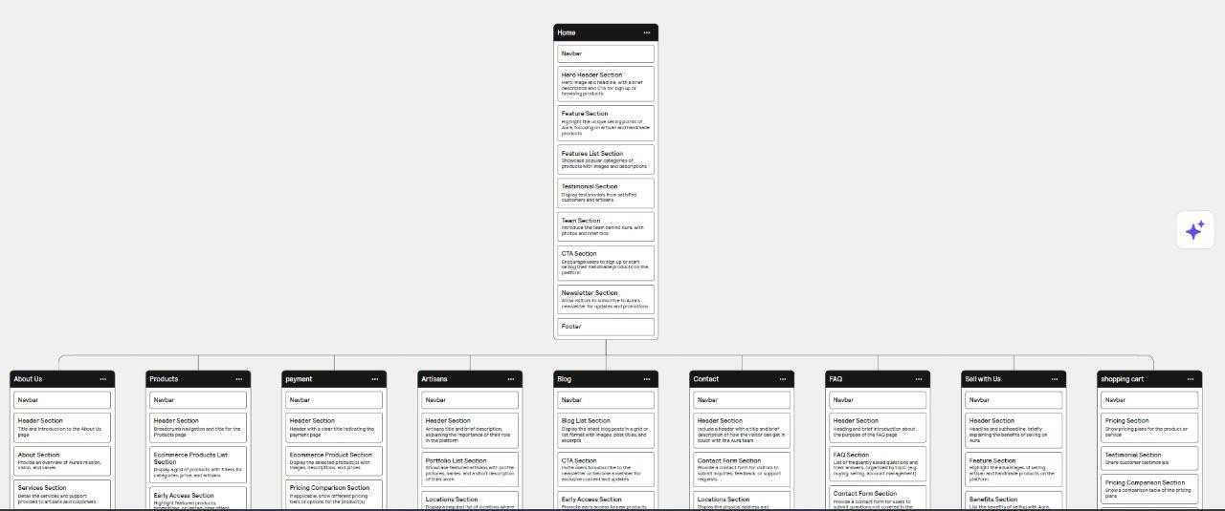

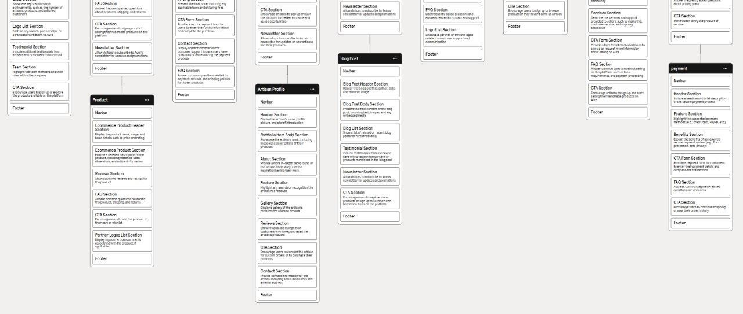

**Sample Wireframe of platform:**

