Section-IV:

1. Hypothesis testing is a predictional analysis in which the surveys and experiments must be carry out on a group for some paramaters and find whether the decision is correct or not.

For example, people in the city are more addicted to smoking, by taking hypothesis, the decision is taken. The types of Hypothesis testing are simple, complex, empirical, Null, alternative, logical, statistical. The hypothesis is used for verification, Analysis and dtermination of population related parameters.

1. Correlation is a statistical technique to determine whether two or more variables are related and measured, this measuring of correlation is called correlation coefficient, for example,height and weight of two person are calculated and measured .
2. The methods of computing correlation are Scatter diagram method, Karl Pearson’s coefficient of correlation, Spearman’s Rank correlation coefficient and Methods of least squares.
3. In Biomedical Engineering, correlation is used in biosignal processing, medical image processing to detect or diagnose any abnormalities.
4. P-value is the level of marginal significance represents the probability of an event tends to occur.p-value is calculated by using p-value tables or statistical software because the value of p determines which hypothesis must going to be tested.
5. a) Mean=48.739, Variance=4.202, SD=2.05

b)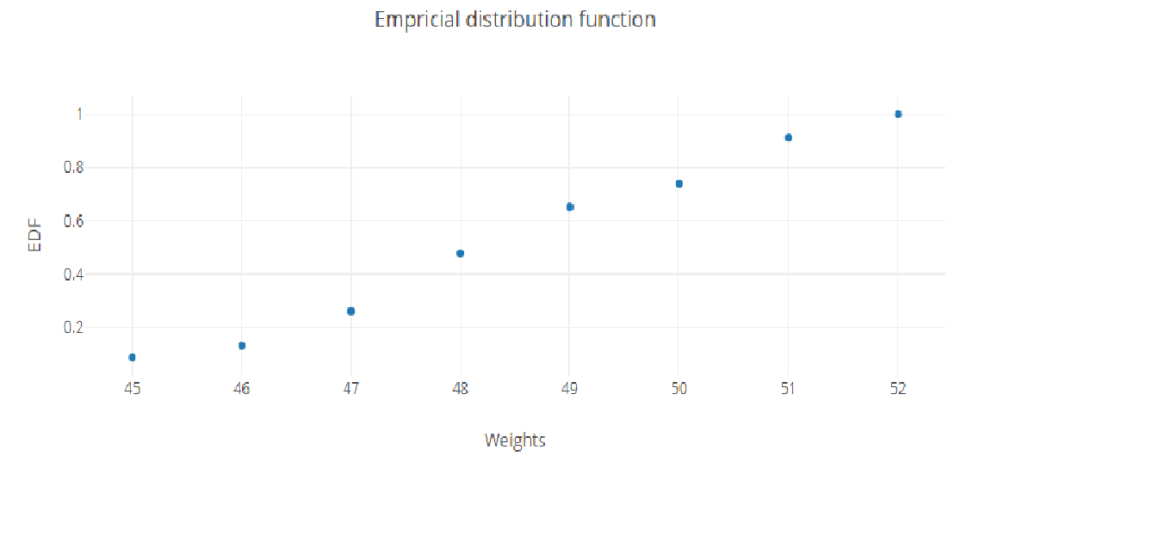

EDF values are 0.087,0.1305,0.2609,0.4783,0.6522,0.7392,0.9131,1

c)Quantiles for 10%=0.087, 40%=0.4783, 75%=0.913, Median=0.6522

1. a) Normal model with μ mean element and variable σ²>0

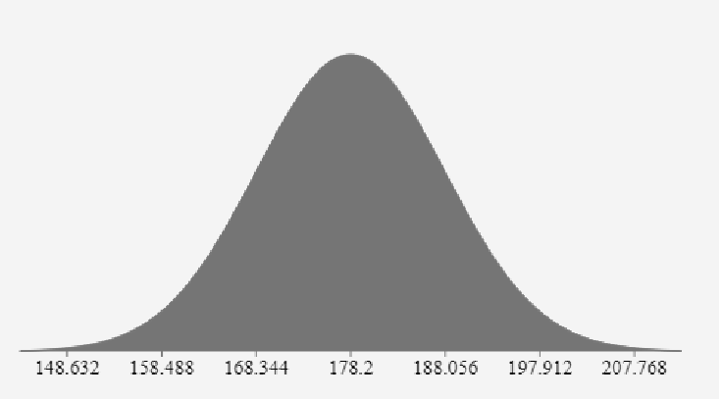

b) Estimates of μ=178.2, σ²=97.16

c) 90%confidence levels interval for the mean height calculation is 190.83