Assignment-9

By

Ashok Yaganti (Class ID: 68).

1. Project Deployment on IBM Bluemix.

URL : <http://trademarketing.mybluemix.net/>

Screen Shots :

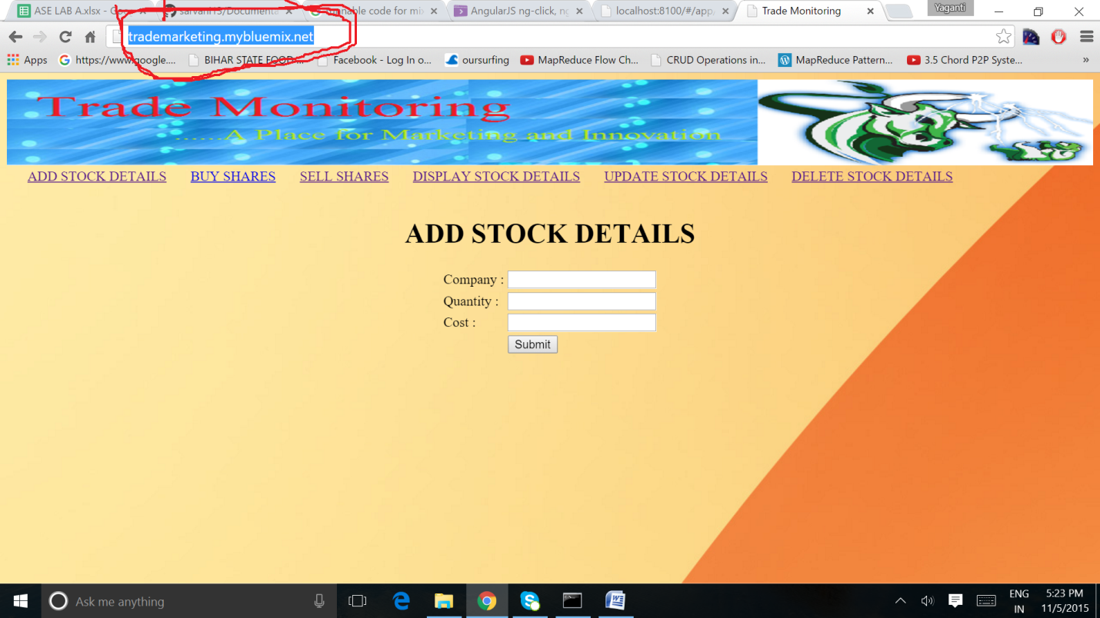

1. Design Patterns.
2. Singloton Pattern.

I have used this pattern to say hello to the user when user logged.

Please find the screen shot and code for reference.

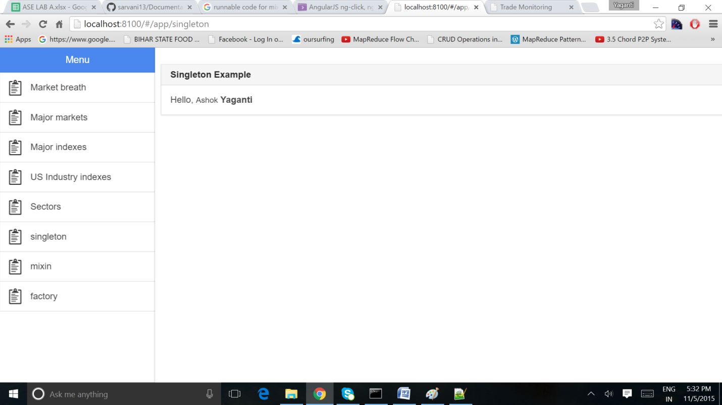

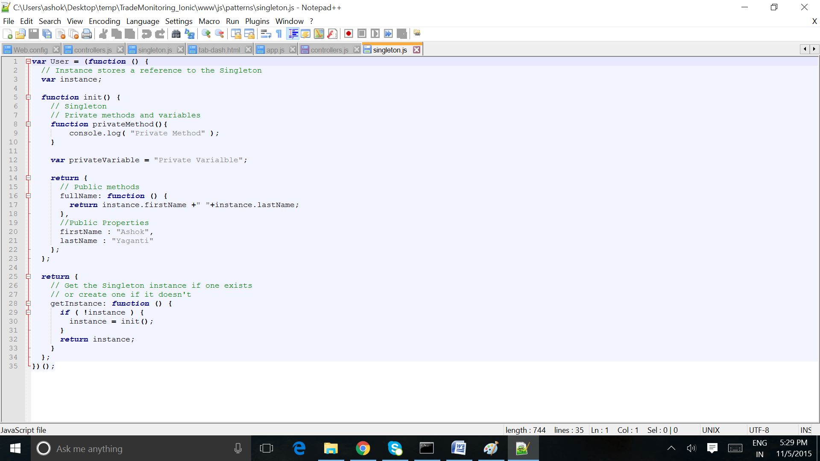

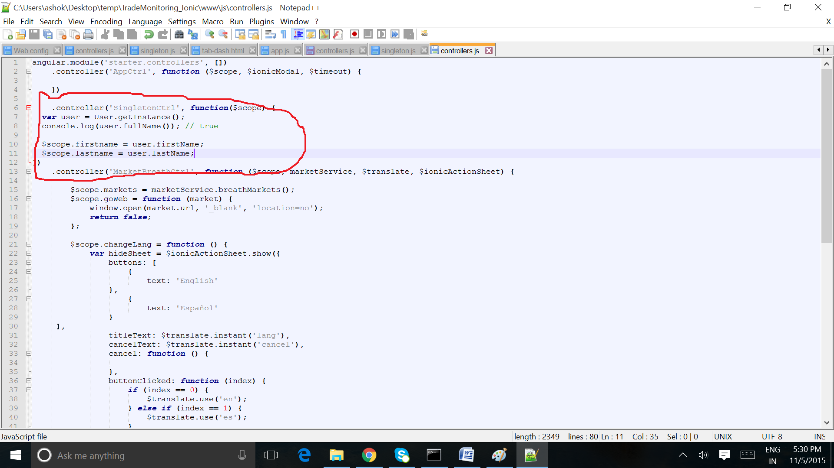

1. Mixin Pattern:

I Have used Mixin Pattern to display the share details.

Below is the screen shots for the reference.

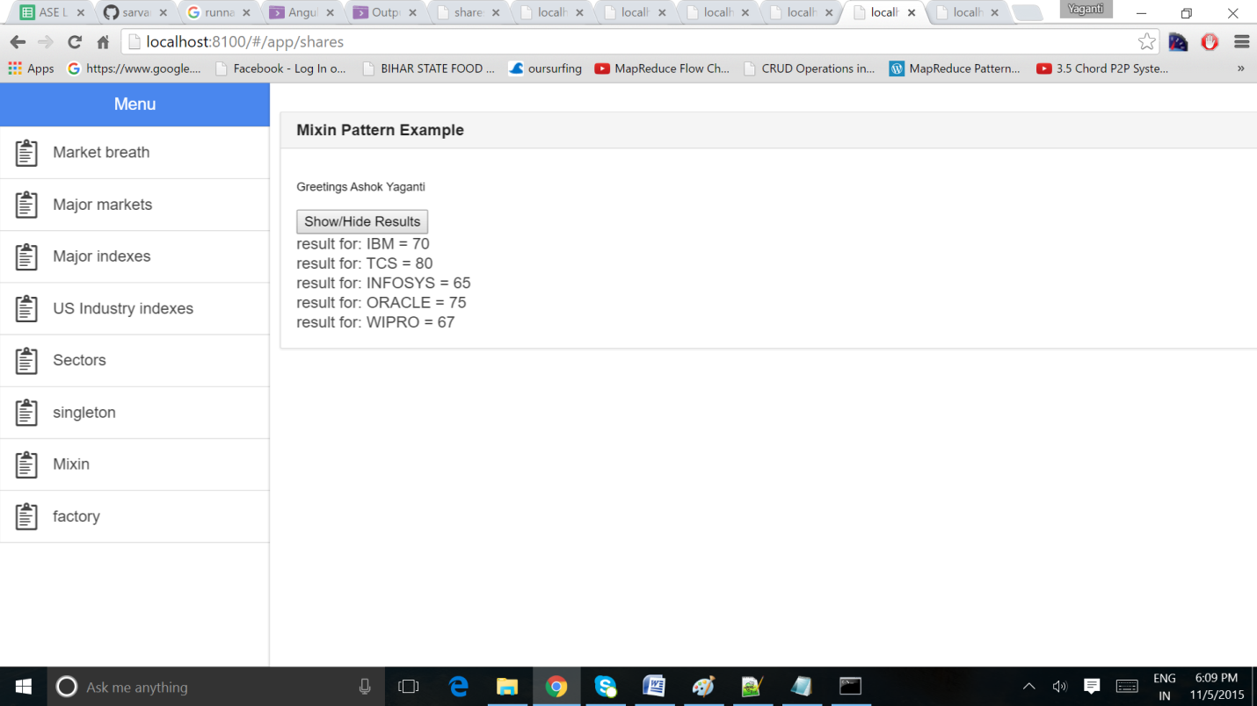

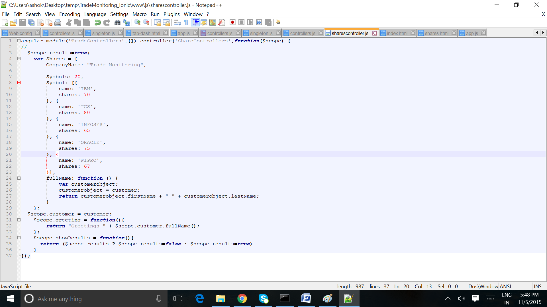

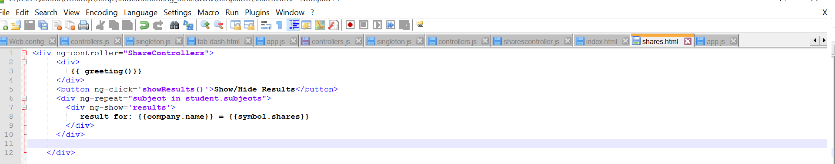

1. **Factory Pattern.**

Factory Pattern I have used to Display the user details and Delete and edit the customer details.

