1 .  Open the [Teaching Ratings data](https://courses.cognitiveclass.ai/assets/courseware/v1/8b5e886922d6d1b5cf057fd0ff3b974a/asset-v1:IBM+ST0101EN+v1+type@asset+block/teachingratings.sav) in SPSS and switch to variable view. Consider the following variables:  **age, gender, beauty, eval, tenure, students**. Thought questions: Can you identify which variables are **continuous variables** and which ones are **categorical variables**? Are any of the variables in the above list of **ordinal** type?

Ans :

* **Continuous variables**: age, beauty, eval, students
* **Categorical variables**: gender, tenure
* **Potential ordinal**: beauty (subjective), eval (Likert scale)

**Beauty** and eval might be considered **ordinal** if it’s a **subjective rating scale**

**2. Can you identify whether the Teaching Ratings data is a time series, cross-sectional, and/or multivariate data set?**

**Ans :** Cross-sectional and multivariate — not a time series.

3. Does the Teaching Ratings data set represents information on an entire population or just a sample?

Ans : Sample not the whole population.

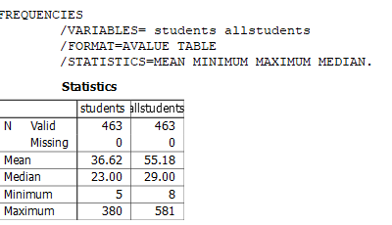4. Using SPSS Statistics, find the **mean**, **median**, **minimum**, and **maximum** values for **students** and **allstudents** in the Teaching Ratings data.

5. What is the mathematical relationship between **variance** and **standard deviation**?

*Standard Deviation= $\sqrt{variance}$ and variance =SD2*

6. Using SPSS Statistics, try to reproduce the following **descriptive statistics table** on the Teaching Ratings data:

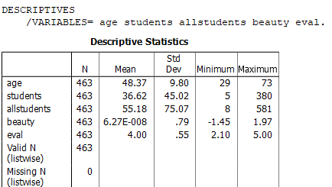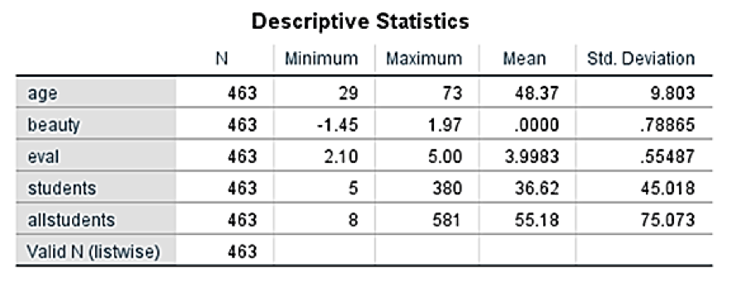

Ans :

7. Create a *histogram* of **beauty** and briefly comment on the distribution of data (as a thought question).

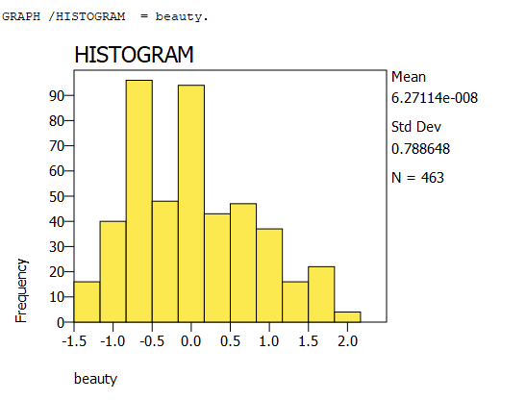

8. Does average **beauty** score differ by **gender** in the Teaching Ratings data? Produce averages and standard deviations for each of the two variables.

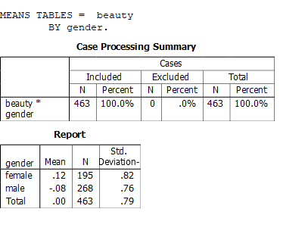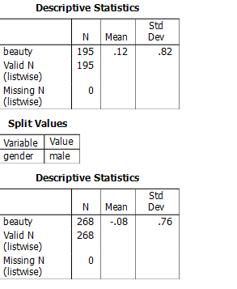

Yes, the average beauty score differs by gender.

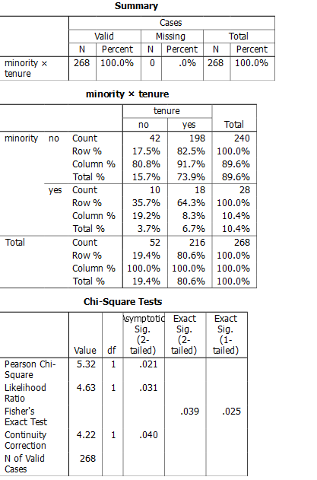9. Does **tenure** status differ by **vismin** (visible minority) status? Produce *cross tabulations* explaining what percentage of visible minorities are tenured.

Ans :

tenure status differs by vismin status.

10. What is the probability of rolling two dice and getting 9 or less?

Ans :

$$6×6=36$$

*Total outcomes = 1 + 2 + 3 + 4 + 5 + 6 + 5 + 4 =* ***30***

11. What is the probability of rolling two dice and getting 7 or less?

Ans ;

$$6×6=36$$

Total outcomes = 1 + 2 + 3 + 4 + 5 + 6 = **21**

12. With an average teaching evaluation score of 4 and standard deviation of 0.55, what is the probability of getting a teaching evaluation of greater than 4.75?

Mean μ=4

Standard deviation σ=0.55

$$z=\frac{4.75-4}{0.55}=1.36$$

standard normal distribution tables or a calculator:

p=1-0.9131=0.0869