Q-1. Write an SQL query to fetch “FIRST_NAME” from Employee table using the alias name as

<EMPLOYEE_NAME>.

Ans.

## select FIRST_NAME AS "EMPLOYEE _NAME"

**from employee;**

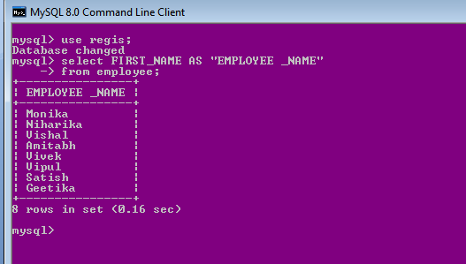

Q-2. Write an SQL query to fetch “FIRST_NAME” from EMPLOYEE table in upper case.

Ans.

### select upper(FIRST_NAME) from employee;

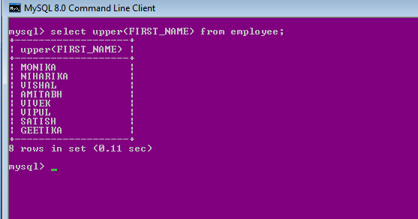

Q-3. Write an SQL query to fetch unique values of DEPARTMENT from EMPLOYEE table.

Ans.

The required query is:

# select distinct department from employee;

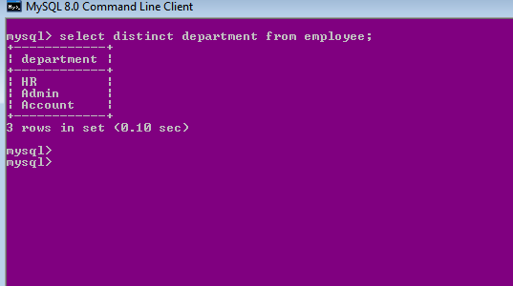

Q-4. Write an SQL query to print the first three characters of FIRST_NAME from EMPLOYEE table.

Ans.

The required query is:

### select SUBSTRING(FIRST_NAME,1,3) from employee;

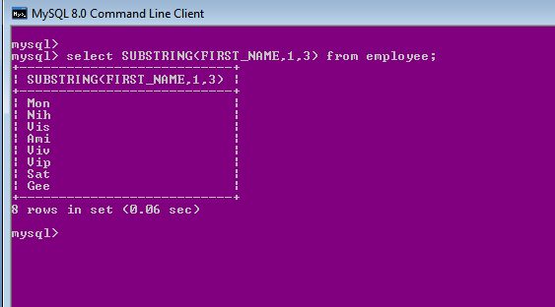

Q-5. Write an SQL query to find the position of the alphabet (‘a’) in the first name column ‘Amitabh’ from EMPLOYEE table.

Ans.

The required query is:

**Select INSTR(FIRST_NAME, BINARY'a')**

**from employee where FIRST_NAME = 'Am**

# itabh';

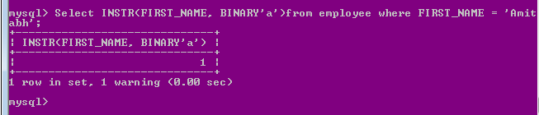

Q-6. Write an SQL query to print the FIRST_NAME from EMPLOYEE table after removing white spaces from right

side.

Ans:

The required query is:

### Select RTRIM(FIRST_NAME) from employee;

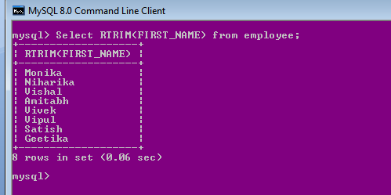

Q-7. Write an SQL query to print the DEPARTMENT from EMPLOYEE table after removing white spaces from the left side.

Ans.

The required query is:

### Select LTRIM(DEPARTMENT) from employee;

### 7.png

Q-8. Write an SQL query that fetches the unique values of DEPARTMENT from EMPLOYEE table and prints its length.

Ans.

The required query is:

### select distinct( length(department)) from employee;

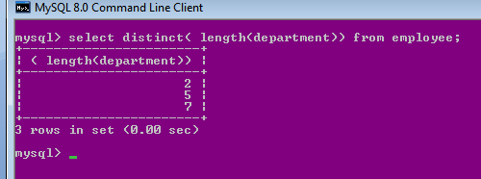

Q-9. Write an SQL query to print the FIRST_NAME from EMPLOYEE table after replacing ‘a’ with ‘A’.

Ans.

The required query is:

### select replace(FIRST_NAME,'a','A') from employee;

### 9.png

Q-10. Write an SQL query to print the FIRST_NAME and LAST_NAME from EMPLOYEE table into a single column

COMPLETE_NAME. A space char should separate them. Ans.

The required query is:

**Select CONCAT(FIRST_NAME, ' ', LAST_NAME) AS**

**'COMPLETE_NAME' from employee;**

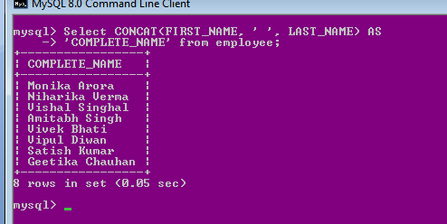

Q-11. Write an SQL query to print all EMPLOYEE details from the EMPLOYEE table order by FIRST_NAME Ascending.

Ans.

The required query is:

**select* from employee order by FIRST_NAME ;**

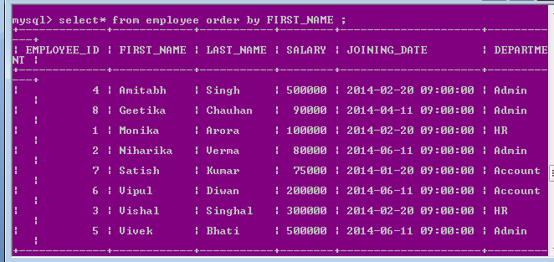

Q-12. Write an SQL query to print all EMPLOYEE details from the EMPLOYEE table order by FIRST_NAME Ascending and DEPARTMENT Descending.

Ans.

The required query is:

### select* from employee order by FIRST_NAME asc,DEPARTMENT desc;

### 12.png

Q-13. Write an SQL query to print details for EMPLOYEEs with the first name as “Vipul” and “Satish” from EMPLOYEE table.

Ans.

## Select * from employee where FIRST_NAME in ('Vipul','Satish');

The required query is:

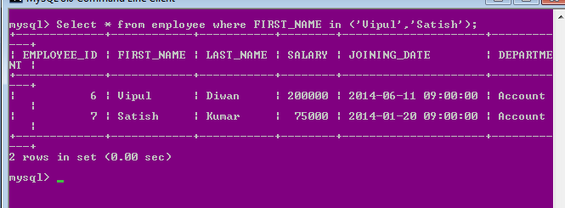

Q-14. Write an SQL query to print details of EMPLOYEEs excluding first names, “Vipul” and “Satish” from EMPLOYEE table.

Ans.

The required query is:

# Select * from employee where FIRST_NAME not in ('Vipul','Satish');

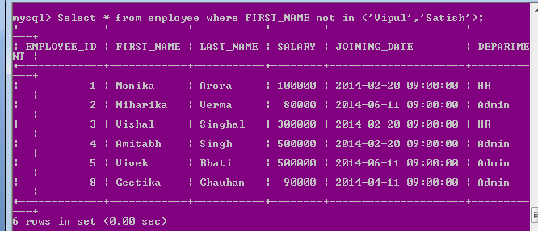

Q-15. Write an SQL query to print details of EMPLOYEEs with DEPARTMENT name as “Admin”.

Ans.

The required query is:

# select*from employee where department='Admin';

# 15.png

**or**

# select*from employee where department like 'Admin%';

Q-16. Write an SQL query to print details of the EMPLOYEEs whose FIRST_NAME contains ‘a’. Ans.

The required query is:

# select*from employee where FIRST_NAME like'%a%';

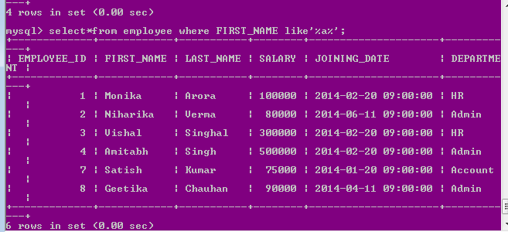

Q-17. Write an SQL query to print details of the EMPLOYEEs whose FIRST_NAME ends with ‘a’. Ans.

The required query is:

## select*from employee where FIRST_NAME like'%a';

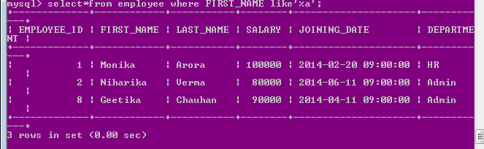

Q-18. Write an SQL query to print details of the EMPLOYEEs whose FIRST_NAME ends with ‘h’ and contains six alphabets.

Ans.

The required query is:

## select*from employee where FIRST_NAME like' h ';

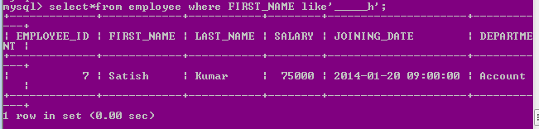

Q-19. Write an SQL query to print details of the EMPLOYEEs whose SALARY lies between 100000 and 500000.

Ans.

The required query is:

## select * from employee where SALARY between 100000 and 500000;

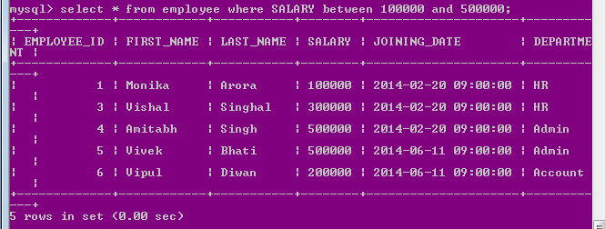

Q-20. Write an SQL query to print details of the EMPLOYEEs who have joined in Feb’2014.

Ans.

The required query is:

**select *from employee where year(JOINING_DATE)=2014 and month(JOINING_DATE)=2;**

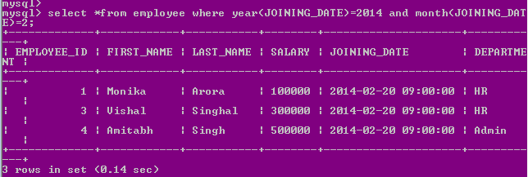

Q-21. Write an SQL query to fetch the count of employees working in the department ‘Admin’.

Ans.

The required query is:

## select count(*) as total_employee from employee where department='Admin';

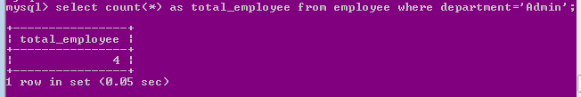

Q-22. Write an SQL query to fetch EMPLOYEE names with salaries >= 50000 and <= 100000.

Ans.

The required query is:

**SELECT CONCAT(FIRST_NAME, ' ', LAST_NAME) As employee_Name, Salary from employee WHERE Salary BETWEEN 50000 AND 100000;**

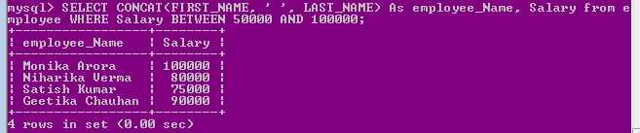

Q-23. Write an SQL query to fetch the no. of EMPLOYEEs for each department in the descending order.

Ans.

The required query is:

**select DEPARTMENT, count(employee_ID) No_Of_employee from employee GROUP BY DEPARTMENT ORDER BY No_Of_employee desc;**

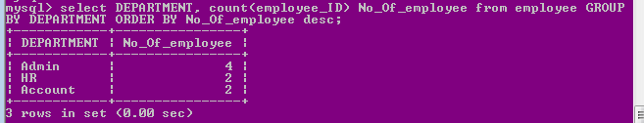

Q-24. Write an SQL query to print details of the EMPLOYEEs who are also Managers.

Ans.

The required query is:

Select first_name , EMPLOYEE_TITLE from employee inner join title on employee_id= EMPLOYEE_REF_ID and EMPLOYEE_TITLE in('Manager');

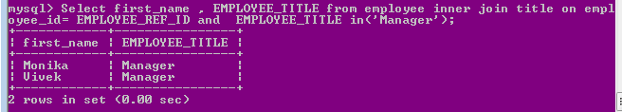

Q-25. Write an SQL query to fetch duplicate records having matching data in some fields of a table.

Ans.

### SELECT EMPLOYEE_TITLE, AFFECTED_FROM, COUNT(*) FROM Title

**GROUP BY EMPLOYEE_TITLE, AFFECTED_FROM HAVING COUNT(*) > 1;**

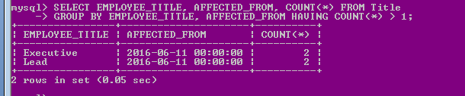

--------------------------------------------------------------

The required query is(another table)

### Ans. SELECT SALARY,count(*) from employee group by SALARY having count(*)>1;

Q-26. Write an SQL query to show only even rows from a table.

Ans.

The required query is:

**select * from employee where mod(employee_id,2)=0;**

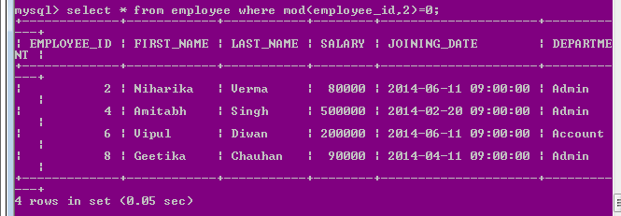

Q-27. Write an SQL query to show only odd rows from a table.

Ans.

The required query is:

**select * from employee where mod(employee_id,2)<>0;**

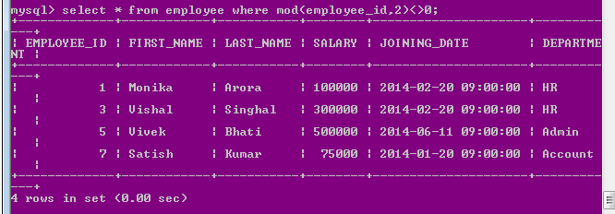

Q-28. Write an SQL query to show the current date and time.

**Ans. select now();**

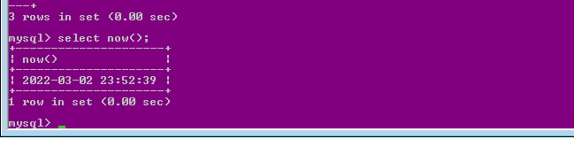

**For current date: select curdate();**

Q-29. Write an SQL query to show the top n (say 10) records of a table.

Ans.

### select* from employee order by salary desc limit 10;

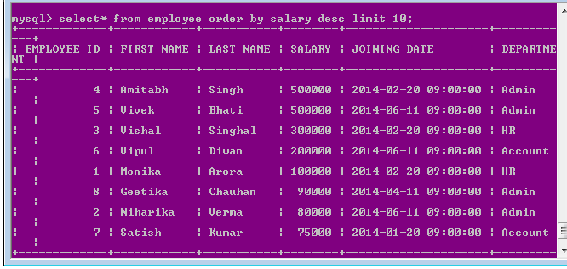

Q-30. Write an SQL query to fetch three max salaries from a table.

Ans.

The required query is:

### select* from employee order by salary desc limit 3;

### 30.png