**Customer table**

**2.Display the structure of the table you have created.**

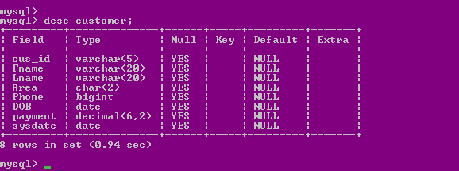

**3. Display the data of the created table.**

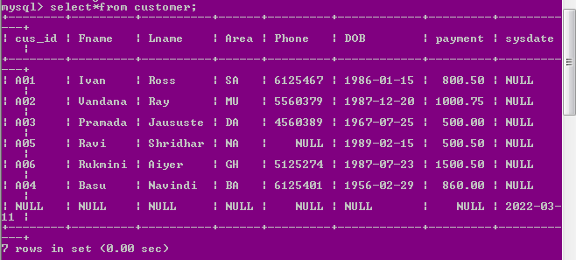

**4. Insert a row which will accept system date.**

alter table customer add column sysdate date;

insert into customer(sysdate) values (curdate());

**5. Update the phone numbers of customer A02 and A04**

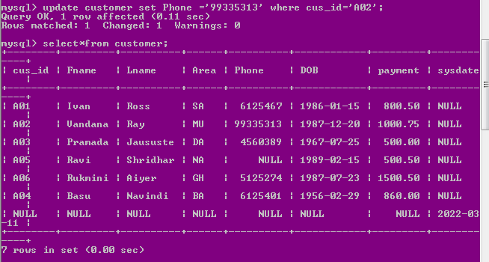

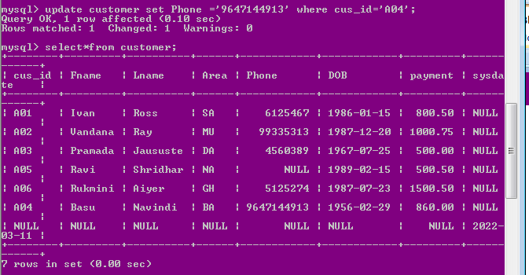

**6. Update the date of birth of customer A03 and A05**

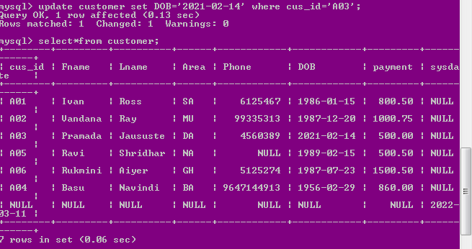

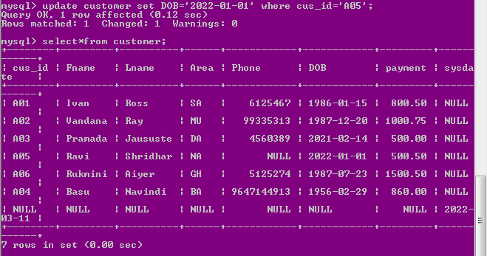

**7. Display the updated table.**

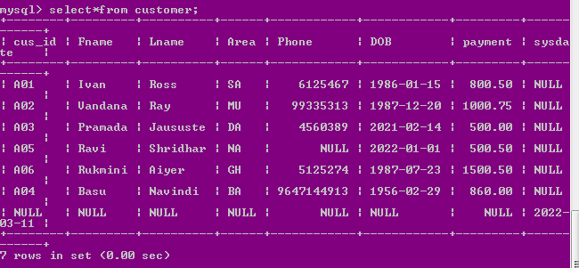

**8. Delete 2 rows from the table for customers A01 and A05.**

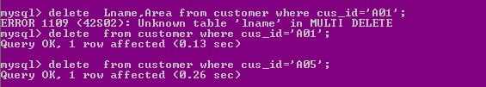

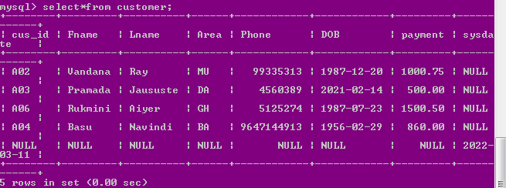

**9. . Delete all the rows from the table**



**10. . Insert 5 records according to your own wish.**

insert into customer(cus_id,Fname,Lname,Area,Phone,DOB,payment) values('A01','Raja','Ross','PA',9732561201,'1980-01-15',200.50);

insert into customer(cus_id,Fname,Lname,Area,Phone,DOB,payment) values('A02','Ashoke','Malakar','PA',9647144913,'1995-07-08',700.75);

insert into customer(cus_id,Fname,Lname,Area,Phone,DOB,payment) values('A03','Biman','Das','DA',9933531356,'1967-07-25',500.00);

insert into customer(cus_id,Fname,Lname,Area,Phone,DOB,payment) values('A04','Riya','Navindi','BA',67675451,'1956-02-25',830.50);

insert into customer(cus_id,Fname,Lname,Area,Phone,DOB,payment) values('A05','Kiran','Sinha','Gh',9339761402,'1999-02-15',500.50);

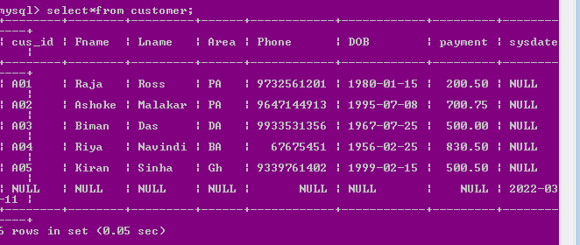

**11. . Update one record based on any criteria according to your own wish.**

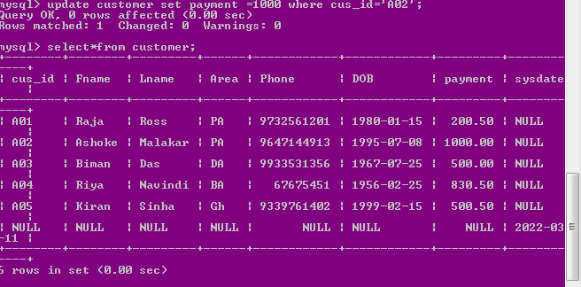

**12. . Delete any 1 record from the table based on particular criteria.**

