1. *Create a table EMP1 with following structure.*

**CREATE TABLE EMP1 (**

**ID int (2) NOT NULL PRIMARY KEY ,**

**Name Varchar(10),**

**Basic decimal(6,2),**

**Designation Varchar (10),**

**Age int(2));**

1. Change the data type of the field Basic from float to integer with required size of the EMP1 table.

**Alter Table EMP1 Modify column Basic int(10)**

1. *Change the field size of Name column of the EMP1 table from 10 to 15.*

***Alter Table EMP1 Modify column Name Varchar(15);***

1. Create another table EMP_trainee with the same (changed) structure. The column ID to be renamed as Emp_id in the EMP_trainee table

***CREATE TABLE EMP_trainee (***

***Emp_id int (2) NOT NULL PRIMARY KEY ,***

***Name Varchar(15),***

***Basic int(10),***

***Designation Varchar (22),***

***Age int(2));***

*5.* *Insert following data in EMP1 table: -*

*(1, Rohit, 6700, Manager, 24)*

*(2, Sunil, 6200, Engineer, 27)*

*(3, Payal, 6300, Engineer, 25)*

*(4, Kunal, 6700, Trainee, 28)*

*(5, Sunita, 6230, Trainee, 26)*

*(6, Bimal, 7000, Trainee, 25)*

***insert into EMP1 values(1,'Rohit',6700,'Manager',24);***

***insert into EMP1 values(2,'Sunil',6200,'Engineer', 27);***

***insert into EMP1 values(3,'Payal',6300,'Engineer',25);***

***insert into EMP1 values(4,'Kunal',6700,'Trainee', 28);***

***insert into EMP1 values(5,'Sunita',6230,'Trainee',26);***

***insert into EMP1 values(6,'Bimal',7000,'Trainee','25');***



1. *Insert all rows with the designation ‘trainee’ from the EMP1 table to EMP_trainee table..*

*insert into emp_trainee (select*from emp1 where Designation='trainee');*

1. Display the structure of both the tables.

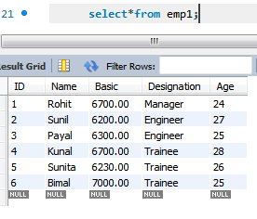

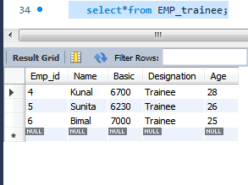

*8.* *. Add columns Skills (data type-varchar2 and size-10) and DOJ (data type-date) to the*

*EMP1 table and add data for the Skills and DOJ columns according to your own wish*

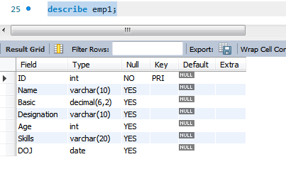

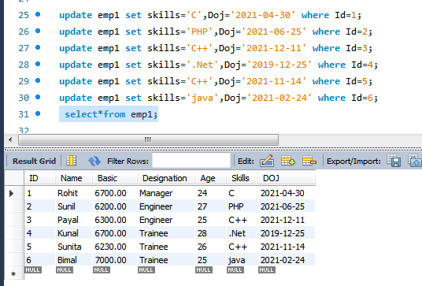

1. *Change the designation of all trainees in EMP_trainee table to ‘Programmer _Trainee’*

***update emp_trainee set Designation='Programmer' where Designation='Trainee';***

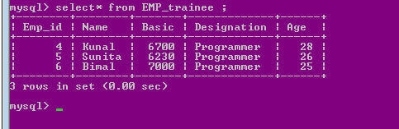

1. *. Update more than one row in one query in EMP1 table.*

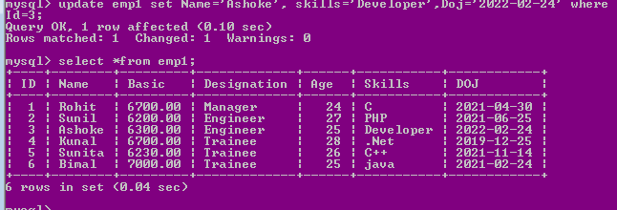

1. *Change the data type of ID in EMP1 table to varchar2 and increase the data size to 5.*

***alter table emp1 modify id varchar(5);***

1. .Display both the tables EMP1 and EMP_trainee.

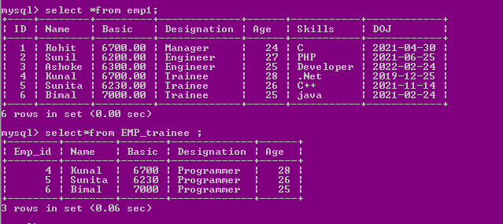

1. *.Rename the column Age of EMP1 table to Age_in_Years.*

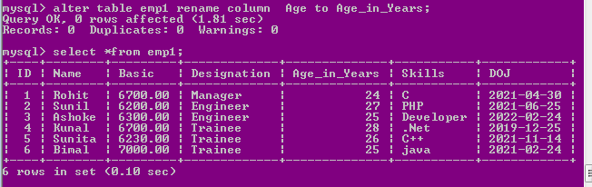

1. *Delete the details of all the trainees from the EMP1 table.*

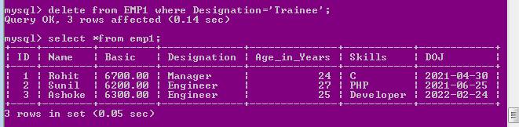

1. *Drop the Age column from the EMP_trainee table.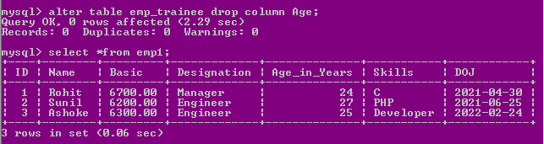*
2. *6.Drop two columns in one query from EMP_trainee table*

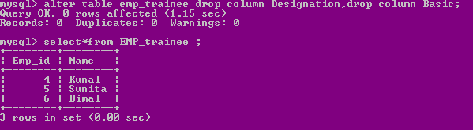

1. *Rename the table EMP to EMP_Mgr_Engr.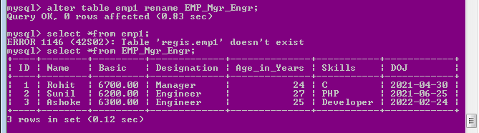*
2. Drop the table EMP_Trainee

*18.png*

1. *Truncate EMP_Mgr_Engr table*

*19.png*