1. Create table EMPLOYEE with the following details

**CREATE TABLE EMPLOYE (**

**EMPLOYEE_ID int(6) NOT NULL PRIMARY KEY ,**

**LAST_NAME Varchar(25),**

**JOB_ID Varchar(10),**

**SALARY decimal (8,2),**

**COMM_PCT decimal (4,2),**

**MGR_ID int(6),**

**DEPARTMENT_ID int(4));**

2. Insert the following data into EMPLOYEE table.

**insert into employe values(198,'Connell','SH_CLERK',2600,2.5,124,50);**

**insert into employe values(199,'Grant','SH_CLERK',2600,2.2,124,50);**

**insert into employe values(200,'Whalen','AD_ASST',4400,1.3,101,10);**

**insert into employe values(201,'Hartstein','IT_PROG',6000,null,100,20);**

**insert into employe values(202,'Fay','AC_MGR',6500,null,210,20);**

**insert into employe values(203,'Mavris','AD_VP',7500,null,101,40);**

**insert into employe values(204,'Baer','AD_PRES',3500,1.5,101,90);**

**insert into employe values(205,'Higgins','AC_MGR',2300,null,101,60);**

**insert into employe values(206,'Gitz','IT_PROG',5000,null,103,60);**

**insert into employe values(100,'King','AD_ASST',8956,0.3,108,100);**

**insert into employe values(101,'Kochar','SH_CLERK',3400,1.3,118,30);**

**3.**Display last_name, job_id, employee_id for each employee with employee_id appearing first

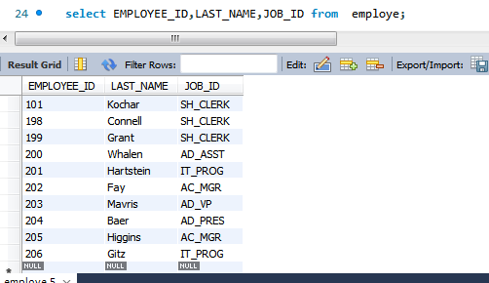

**4.** Display the details of all employees of department 60.

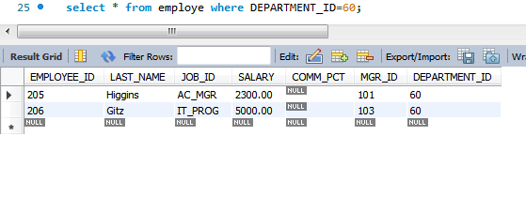

5. Display the employee details of the employee who’s last_name is King

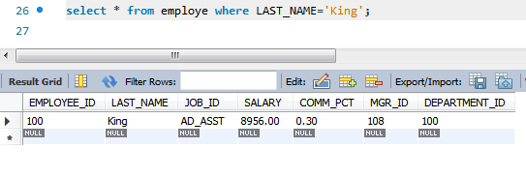

6. Display unique job_id from EMPLOYEE table. Give alias name to the column as JOB_TITLE.

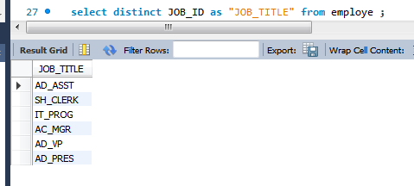

7. Display last_name, salary and salary increase of Rs300. Give the new column name as ‘Increased Salary’.

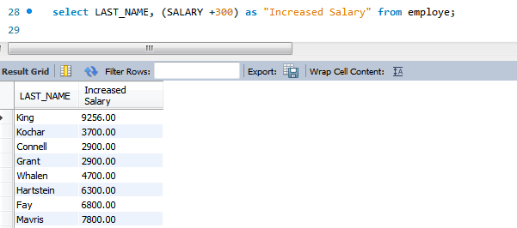

8. Display last_name, salary and annual compensation of all employees, plus a onetime bonus of Rs 100. Give an alias name to the column displaying annual compensation.

9. Display the details of those employees who get commission

10.Display the details of those employees who do not get commission.

11.Display the Employee_id, Department_id and Salary all employees whose salary is greater than 5000.

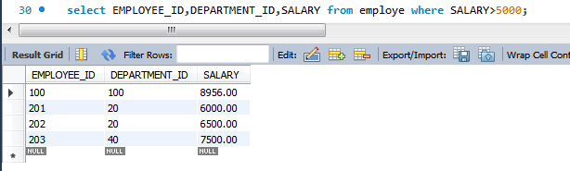

12. Display the Last_Name and Salary of all employees whose salary is between 4000 and 7000.

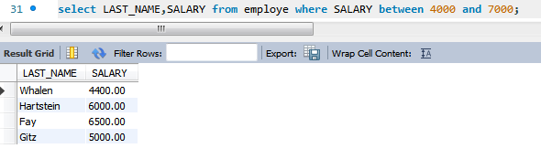

13.Display the details of all employees whose salary is either 6000 or 6500 or 7000.

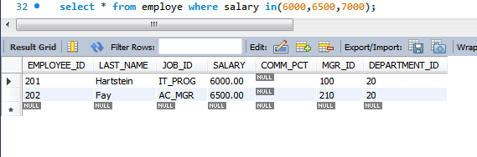

**14.** 14.Display the details of all those employees who work either in department 10 or 20 or 30 or 50.

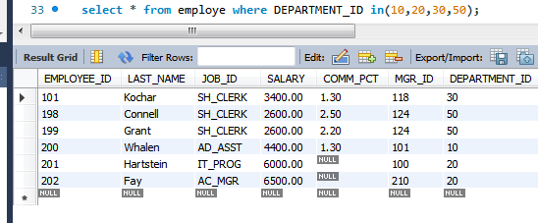

15.Display the details of all employees whose salary is not equal to 5000.

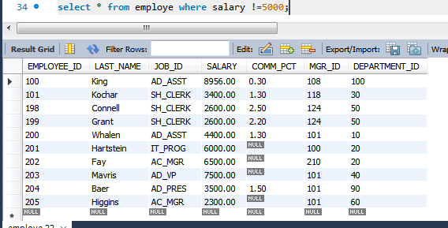

16.Display the details of all the CLERKS working in the organization.

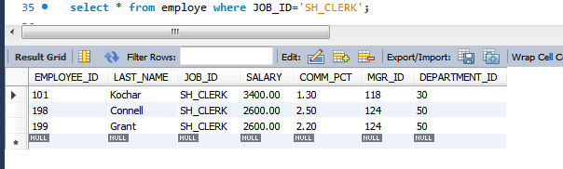

17.Update the job_id’s of the employees who earn more than 5000 to Grade_A. Display the table EMPLOYEE after updating.

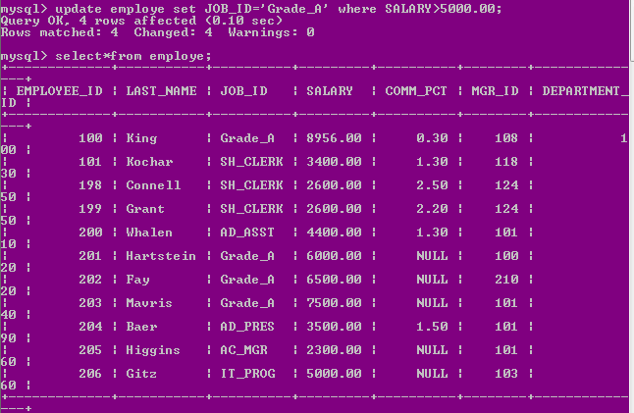

18.Display the details of all those employees who are either CLERK or PROGRAMMER or ASSISTANT.

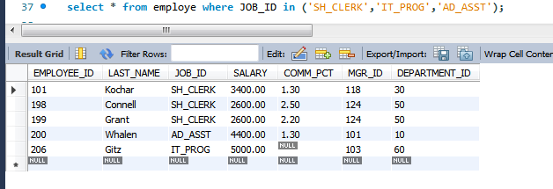

19.Display those employees from the EMPLOYEE table whose designation is CLERK and salary is less than 3000.

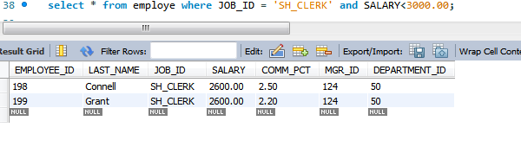

20 .Display those employees Last_Name, Mgr_id from the EMPLOYEE table whose salary is above 3000 and work under Manager 101.

