**Question:**

Find the First Non-Repeating Character

Write a program to find the first non-repeating character in a string. For input "swiss", the output

should be "w". You cannot use any built-in string or character frequency counting functions.

Instructions: Implement manual string traversal and counting logic to solve the problem.

**Program:**

import java.util.Scanner;

class NonRepeat {

void nonrepeatcharacter(String str) {

int n = str.length();

int[] count = new int[256];

for (int i = 0; i < n; i++) {

count[str.charAt(i)]++;

}

for (int i = 0; i < n; i++) {

if (count[str.charAt(i)] == 1) {

System.out.println("First Non-Repeating Character: " + str.charAt(i));

return;

}

}

System.out.println("No Non-Repeating Character found.");

}

public static void main(String args[]) {

Repeat r = new Repeat();

Scanner s = new Scanner(System.in);

System.out.print("Enter the string: ");

String str = s.nextLine();

r.nonrepeatcharacter(str);

}

}

**Output:**

**Testcase1:**

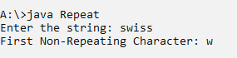

**Testcase2:**

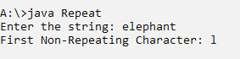

**Testcase3:**

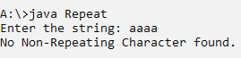

**Testcase4:**

