**Full Name:** Ashok Kumar A

**Selfie Pic:**



**First Task Email Screenshot:**

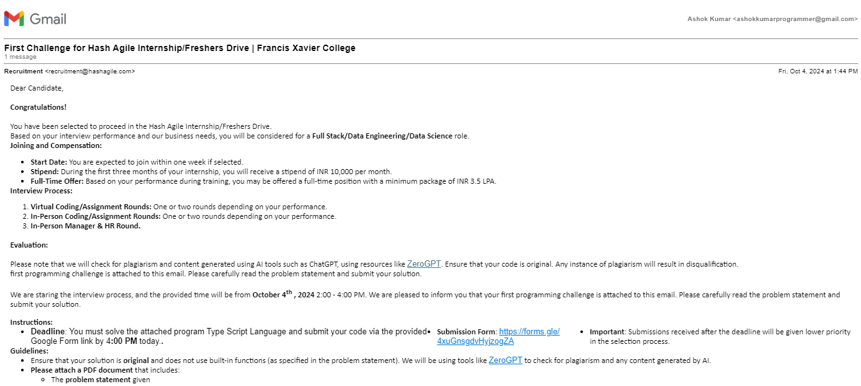

**Second Task Email Screenshot:**

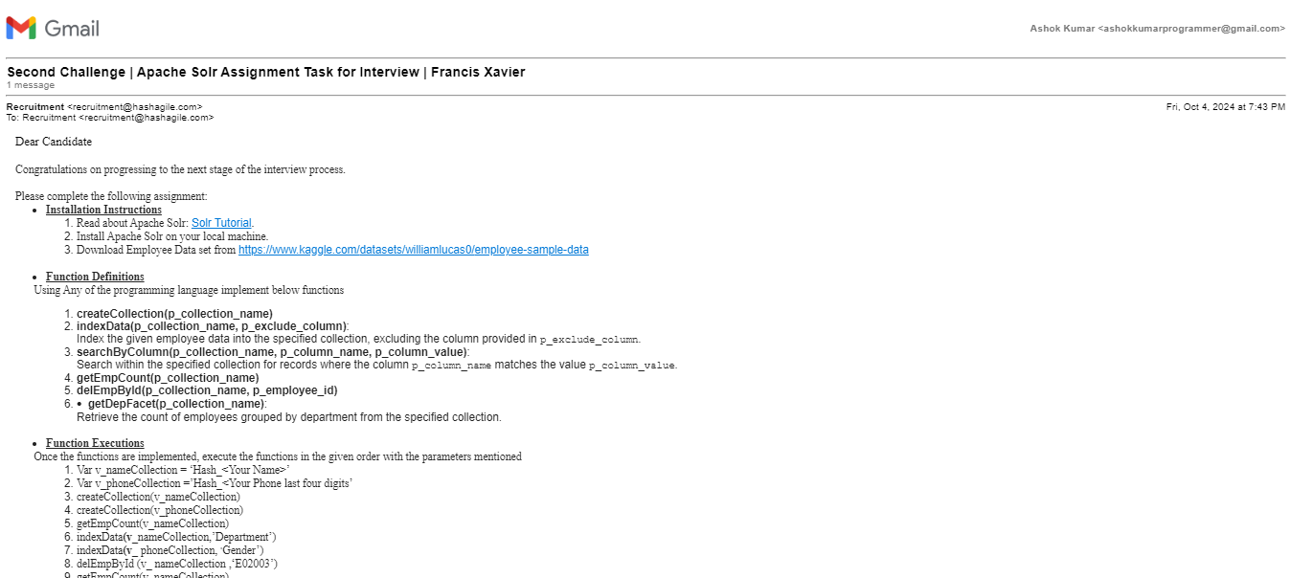

**GitHub URL for Round 1:**

https://github.com/Ashokkumar-Programmer/HAT-Interview/tree/main/Round1

**GitHub URL for Assignment:**

<https://github.com/Ashokkumar-Programmer/HAT-Interview/tree/main/Round2>

**Program Coding:**

import pysolr

import requests

import csv

def createCollection(collection_name):

url= f'http://localhost:8983/solr/admin/collections?action=CREATE&name={collection_name}&numShards=1&replicationFactor=1'

response = requests.get(url)

if response.status_code == 200:

print(f"Collection '{collection_name}' created successfully.")

else:

print(f"Failed to create collection '{collection_name}'. Response: {response.content}")

def indexData(collection_name, exclude_column):

url = f'http://localhost:8983/solr/{collection_name}'

solr = pysolr.Solr(url, always_commit=True)

encodings_to_try = ['utf-8', 'ISO-8859-1', 'windows-1252']

documents = []

for encoding in encodings_to_try:

try:

with open('EmployeeData.csv', mode='r', encoding=encoding, errors='replace') as file:

reader = csv.DictReader(file)

for row in reader:

documents.append(row)

break

except UnicodeDecodeError as e:

print(f"Failed to read with encoding {encoding}: {e}")

except FileNotFoundError:

print("CSV file not found. Please check the file path.")

return

except Exception as e:

print(f"An error occurred: {e}")

if documents:

try:

solr.add(documents)

print(f"Indexed {len(documents)} documents into {collection_name}.")

except pysolr.SolrError as e:

print(f"Failed to index documents in Solr: {e}")

except Exception as e:

print(f"Unexpected error while indexing: {e}")

else:

print("No documents were indexed.")

def searchByColumn(collection_name, column_name, column_value):

url = f'http://localhost:8983/solr/{collection_name}'

solr = pysolr.Solr(url, always_commit=True)

query = f'{column_name}:"{column_value}"'

try:

results = solr.search(query)

return results

except pysolr.SolrError as e:

print(f"Solr Error: {e}")

def getEmpCount(collection_name):

url = f'http://localhost:8983/solr/{collection_name}'

solr = pysolr.Solr(url, always_commit=True)

results = solr.search('*:*', **{'rows': 0})

count = results.hits

print(f"Total employees in '{collection_name}': {count}")

return count

def delEmpById(collection_name, employee_id):

url = f'http://localhost:8983/solr/{collection_name}'

solr = pysolr.Solr(url, always_commit=True)

solr.delete(id=employee_id)

print(f"Deleted employee with ID: {employee_id}")

def getDepFacet(collection_name):

url = f'http://localhost:8983/solr/{collection_name}'

solr = pysolr.Solr(url, always_commit=True)

try:

facet_query = solr.search('*:*', **{

'facet': 'true',

'facet.field': 'Department',

'rows': 0

})

print(f"Facet response: {facet_query}")

except pysolr.SolrError as e:

print(f"Solr responded with an error (HTTP 400): {e}")

except Exception as e:

print(f"Unexpected error while getting facets: {e}")

v_nameCollection = 'Hash_AshokKumar'

v_phoneCollection = 'Hash_8843'

print("\n\nCollection Creation")

createCollection(v_nameCollection)

createCollection(v_phoneCollection)

print("\n\nIndexing Data into collections")

indexData(v_nameCollection, 'Department')

indexData(v_phoneCollection, 'Gender')

print("\n\nEmployee Count of Hash_AshokKumar")

getEmpCount(v_nameCollection)

print("\n\nDelete E02003 from Hash_AshokKumar")

delEmpById(v_nameCollection, 'E02003')

print("\n\nSearch Department column in Hash_AshokKumar")

results = searchByColumn(v_nameCollection, 'Department', 'IT')

if results:

print(f"Search results in '{v_nameCollection}' for Department 'IT': {len(results)} found.")

for result in results:

print(result)

print("\n\nSearch Gender column in Hash_AshokKumar")

results = searchByColumn(v_nameCollection, 'Gender', 'Male')

if results:

print(f"Search results in '{v_nameCollection}' for Gender 'Male': {len(results)} found.")

for result in results:

print(result)

print("\n\nSearch Department column in Hash_8843")

results = searchByColumn(v_phoneCollection, 'Department', 'IT')

if results:

print(f"Search results in '{v_phoneCollection}' for Department 'IT': {len(results)} found.")

for result in results:

print(result)

print("\n\nGetting Department Facet of collections")

getDepFacet(v_nameCollection)

getDepFacet(v_phoneCollection)

**Function Execution Results:**

1. **Creating Collections:**

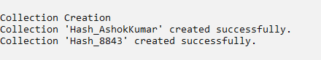

1. **Indexing Data into collections:**

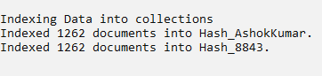

1. **Employee Count of Hash_AshokKumar:**



1. **Delete E02003 from Hash_AshokKumar:**



1. **Search Department column in Hash_AshokKumar:**

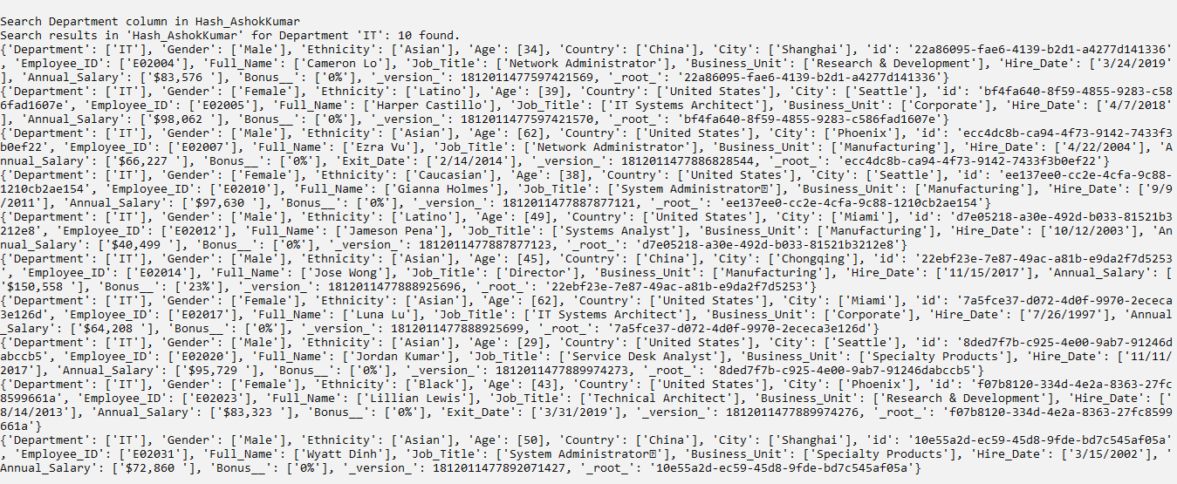

1. **Search Gender column in Hash_AshokKumar:**

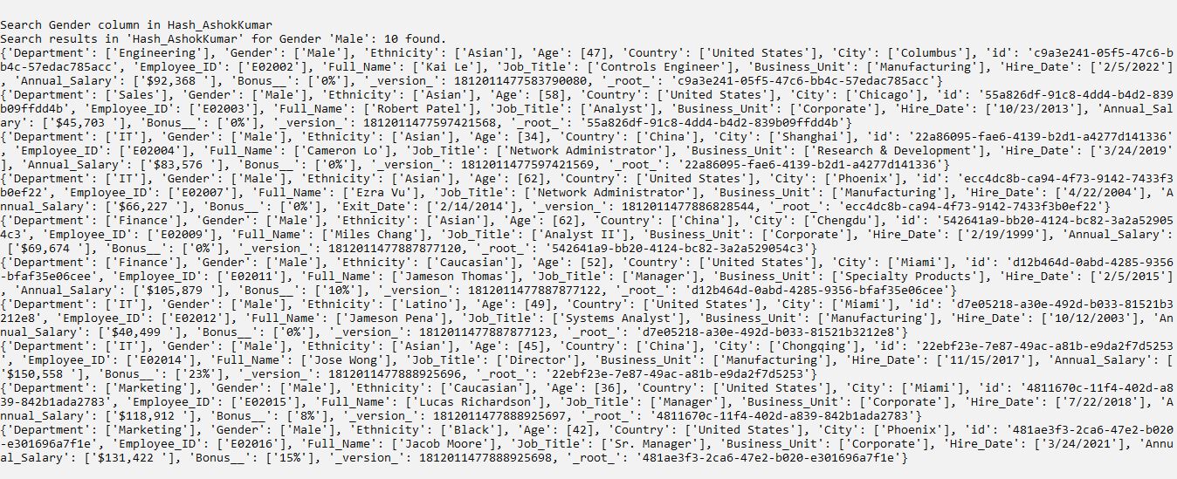

1. **Search Department column in Hash_8843:**

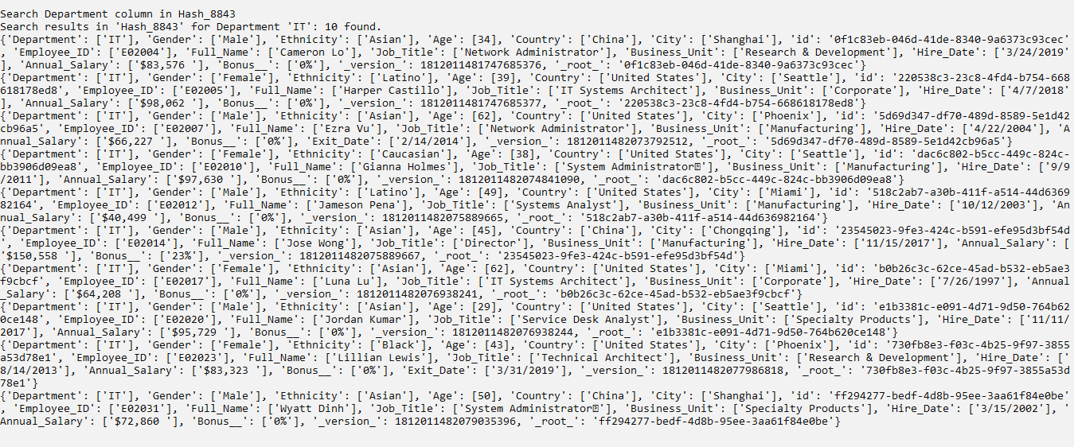

1. **Getting Department Facet from collections:**



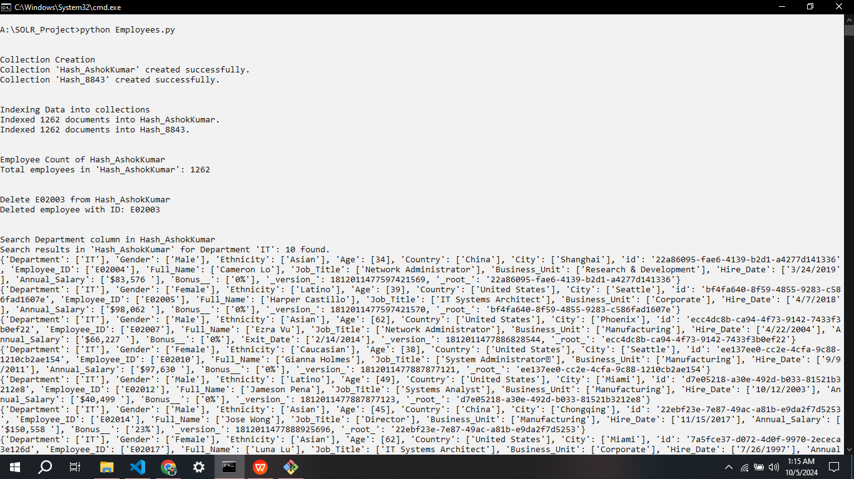**Full Screen:**