**INDEX**

|  |  |  |  |  |  |
| --- | --- | --- | --- | --- | --- |
| **S. NO** | **DATE** | **PROJECT CONTENT** | **P NO.** | **MARK** | **SIGN** |
| 1. |  | Title |  |  |  |
| 2. |  | Abstract |  |  |  |
| 3. |  | Introduction |  |  |  |
| 4. |  | Design / Methodology |  |  |  |
| 5. |  | Results and discussion |  |  |  |
| 6. |  | Conclusion |  |  |  |

**FoodLore**

*A PROJECT REPORT*

Submitted by

**Your name**

(Reg No. )

**Master**

**Of**

**Machine Learning and Artficial Intelligence**

**ABSTRACT**

FoodLore is an innovative web-based platform designed to bridge the gap between food history exploration and online shopping convenience. The platform caters to users seeking both knowledge and convenience, providing a rich experience in viewing detailed information about various foods while integrating external food delivery services like Zomato and Swiggy for seamless ordering. The project is built with a strong emphasis on accessibility, user-friendliness, and responsiveness. Leveraging Node.js for backend development, MySQL for database management, and a combination of HTML, CSS, and JavaScript for the frontend, FoodLore delivers a robust, scalable solution that meets modern web standards. The use of Bootstrap ensures a fully responsive design, making the platform easily accessible across multiple devices, from desktops to smartphones, without compromising functionality or usability. Users can navigate the site with ease, whether they're browsing food history or adding items to their favorites list. At the core of FoodLore's accessibility is its focus on creating a seamless and intuitive experience for all users, including those with disabilities. The platform incorporates a dynamic search bar that allows users to quickly find specific food items or categories, enhancing the user experience. In addition, role-based access ensures that different users, whether customers or administrators, have access to relevant features and functionalities based on their account type. The inclusion of a flexible dropdown menu further simplifies navigation, enabling users to switch between delivery services and other options with minimal effort. The integration of food delivery services such as Zomato and Swiggy makes FoodLore stand out by offering users the ability to order food directly after exploring its history, blending learning and shopping into a single experience. Each food item comes with detailed descriptions, including its origin and cultural significance, giving users more than just a shopping experience — it provides a journey into the stories behind the food. FoodLore’s favorites feature allows users to easily save their preferred food items, which can then be accessed for quick reference or ordering. The platform's role-based access control supports multiple types of users, including customers and admins. Admin users have control over managing food data, monitoring user activities, and making changes to the available food listings, ensuring smooth backend operations.

**INTRODUCTION**

FoodLore is a one-of-a-kind platform that blends food discovery and e-commerce, offering users an engaging and educational experience. It allows users to explore the fascinating history behind various foods while providing an effortless way to shop for meals via integrated food delivery services like Zomato and Swiggy. This platform is crafted to cater to a wide range of users, from casual visitors to passionate food enthusiasts, offering something for everyone. At its core, FoodLore emphasizes user-friendliness and accessibility. Whether users are looking to explore the background of their favorite cuisines, mark food items they love as favorites, or simply place an order, the platform ensures that these tasks can be done with ease. The interface is intuitively designed, enabling users to navigate quickly and find relevant content without difficulty. FoodLore’s design ensures that users can easily browse between learning about different foods and accessing meal delivery options through a seamless and integrated experience. Accessibility is a key aspect of the platform, ensuring that all users, regardless of their technical proficiency, can engage with the content. The platform also prioritizes responsive design, making it accessible across a variety of devices, including desktops, tablets, and smartphones. Whether users are at home or on the go, they can effortlessly explore and order their desired meals without any technical barriers. The system features role-based access, which differentiates between various types of users. Customers have access to content such as food descriptions, cultural histories, and delivery services, while admins can manage backend operations, including adding new food items, monitoring user activity, and overseeing order management. This division of roles ensures that each user has access to tailored functionalities suited to their needs, streamlining their experience and making the platform more efficient. FoodLore’s dynamic search functionality enables users to quickly find specific foods, cuisines, or cultural histories they’re interested in. This search capability allows users to efficiently filter through vast amounts of content, ensuring that they can locate the foods they want to learn more about or order. Moreover, the platform's favorites system allows users to bookmark items, providing an easy way to save foods they’d like to revisit or order in the future. The integration of external food delivery services like Zomato and Swiggy offers a significant convenience for users. After discovering a new dish or cuisine, users can instantly order that item for delivery, streamlining the process from food discovery to meal ordering. This unique integration of food history and e-commerce offers a new way for users to engage with both food culture and meal delivery. Admins benefit from specialized tools that enable them to manage the system effectively, including the ability to add new content, monitor user activity, and handle operational tasks such as updating food listings. This ensures that the platform remains current, functional, and engaging for all users.

**CHARACTERISTICS:**

**USER MODULE:**

**Admin:**

**Manage Users:** The admin can add, update, or delete user accounts, including both customers and sellers.

**View Reports:** Admin can view detailed reports on user activities, such as product sales and revenue.

**Monitor Malpractice:** Admin can identify and take action on any suspicious activities or malpractice by users.

**Seller:**

**Manage Products:** The seller can upload, edit, or delete products available for customers to view and purchase.

**View Sales Status:** Sellers can track product sales and view the status of their listings.

**Customer:**

**Browse Products:** Customers can view a list of products, search for specific items, and explore product categories.

**Add to Favorite:** Customers can mark products as favorites for future reference.

**View Favorite Products:** Customers can easily access a dedicated section to view and manage their list of favorite products.

**EXISTING SYSTEM AND PROPOSED SYSTEM**

**EXISTING SYSTEM:**

Many current food platforms, while functional in providing basic services, focus primarily on food browsing and ordering through integrations with external services like Zomato and Swiggy. These systems cater to the practical aspect of food delivery but often lack depth in providing meaningful and detailed insights about the food itself. Users typically have access only to basic details such as food names, prices, and restaurant information, but they miss out on a more enriched experience that includes the history, origin, and cultural significance of the dishes. This lack of comprehensive food information limits the platform's ability to engage users beyond the transactional aspect of ordering food.Moreover, most existing platforms are designed with a one-size-fits-all approach, lacking a robust role-based access control system. This means that every user—be it a customer, admin, or seller—has the same level of access and interaction capabilities. As a result, administrative tasks such as content management, user management, or the monitoring of platform activities are often cumbersome and inefficient. Admins cannot efficiently oversee user engagement or modify content without more specialized features, and sellers do not have dedicated interfaces to manage their offerings.

**Disadvantage:**

* **Limited Food Information:** Most platforms fail to provide detailed descriptions, origins, or cultural contexts for the dishes, limiting the educational and experiential value for users.
* **No Role-Based Access:** Existing systems do not differentiate between Admins, Sellers, and Customers, leading to inefficiencies in managing users, products, and content. This one-dimensional approach lacks the flexibility needed for effective platform administration.
* **Lack of Personalization:** Since there is no role-specific functionality, users have a uniform experience that does not cater to their specific needs or preferences, resulting in a lack of personalized engagement.
* **Limited Accessibility:** Current platforms generally do not prioritize accessibility features for users with disabilities, particularly those with visual impairments, reducing their inclusiveness and usability.

**PROPOSED SYSTEM:**

This project is designed to offer a comprehensive platform that not only facilitates food ordering but also enriches users' culinary experiences by providing in-depth information about the history and significance of various foods. Unlike existing systems, FoodLore enables users to explore the origins, cultural backgrounds, preparation methods, and stories behind the dishes, making the platform much more than a simple food delivery service. The goal is to create a rich, informative, and interactive environment that enhances the user’s knowledge and appreciation of food while seamlessly integrating with external services like Zomato and Swiggy for ordering convenience.

**Advantages :**

* **Comprehensive Food Knowledge:** Users can explore the rich history, origin, and cultural significance of the foods they order, transforming the platform into an educational experience.
* **Seamless External Integration:** The integration with external services like Zomato and Swiggy allows for a seamless transition between exploring food and ordering it, making the platform convenient for users.
* **Role-Based Access:** Admins, Sellers, and Customers each have tailored functionalities, making the platform more efficient to manage and enhancing the overall user experience.
* **Advanced Search and Filtering:** The proposed system introduces a dynamic search bar with advanced filtering capabilities.
* **Favorites and User Interaction:** Customers can interact with the platform by marking dishes as favorites, which are then easily accessible for future visits.
* **User-Friendly Interface:** FoodLore offers a clean, intuitive, and responsive interface powered by Bootstrap, ensuring a smooth and enjoyable user experience across multiple devices, including desktops, tablets, and smartphones.
* **Multi-Platform Support:** With compatibility across various devices and platforms, users can easily explore food histories and place orders whether they are at home or on the go.

**Flow Diagram**

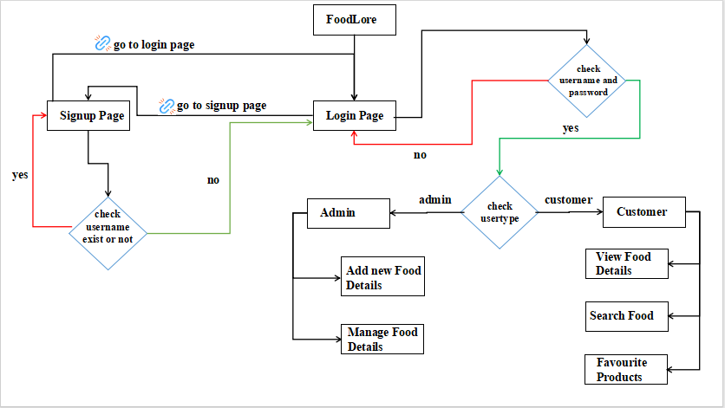

**WORKING ENVIRONMENT**

**User Interface:**

* A visually appealing and intuitive front end developed using modern web technologies (HTML, CSS, JavaScript) that ensures ease of navigation for all users, including those with visual impairments.
* Responsive design utilizing Bootstrap to ensure compatibility across various devices, including desktops, tablets, and smartphones.

**Backend Infrastructure:**

* The backend is powered by Node.js, which provides a robust environment for handling server-side logic and managing user requests efficiently.
* A MySQL database is utilized for data management, allowing for efficient storage, retrieval, and manipulation of user data, food information, and order history.

**Role-Based Access Control:**

* The system supports distinct roles (Admin, Seller, Customer), each with tailored functionalities, ensuring that users have access only to the features relevant to their roles.
* Admins can manage users and monitor platform performance, while Sellers can manage their product listings, and Customers can browse, favorite, and order food items.

**Development Tools:**

* The project is developed using version control systems (e.g., Git) for collaborative development and efficient management of code changes.
* Development environments like Visual Studio Code or similar IDEs for coding and debugging.

**SAMPLE SREENSHOTS**

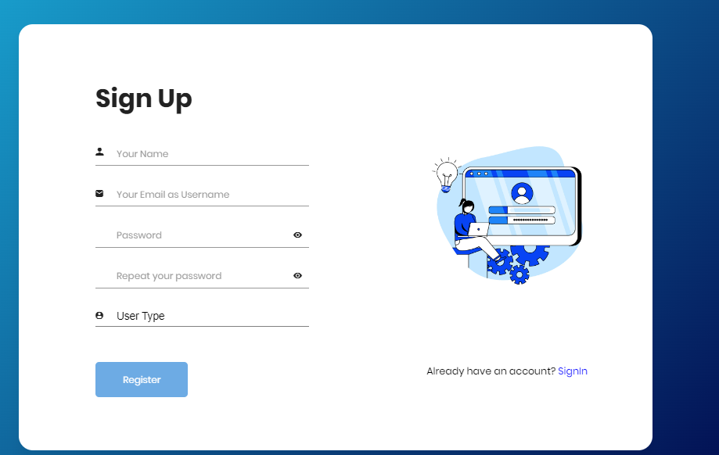**Figure 1: Signup Page**

**Figure 2: Login Page**

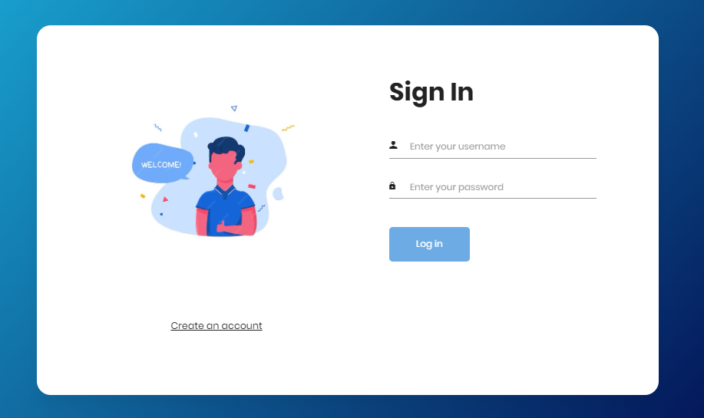

**Figure 3: Food Management(Admin)**

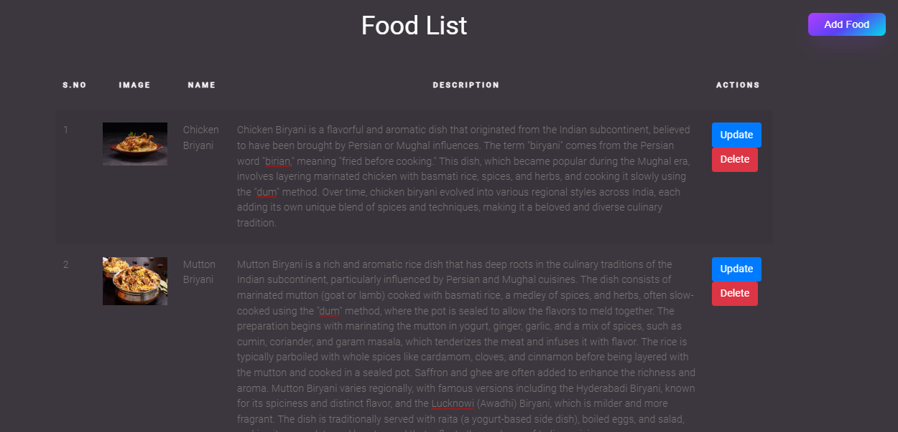

**Figure 4: Add new Food (Admin)**

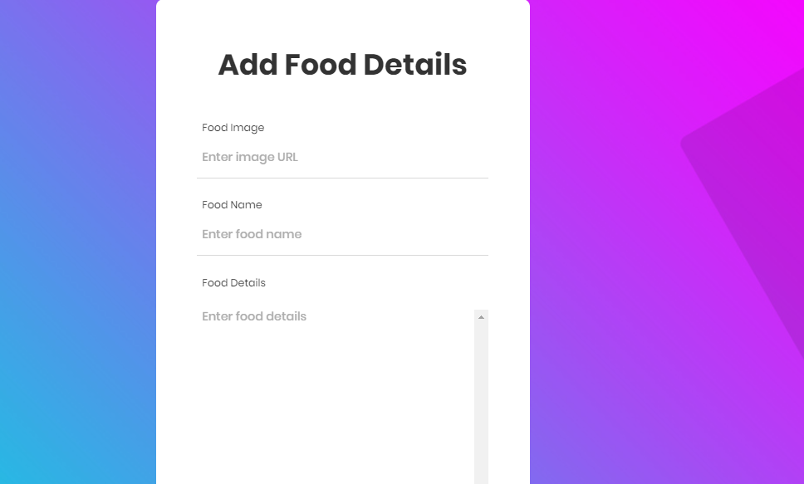

**Figure 5: Home Page(Customer)**

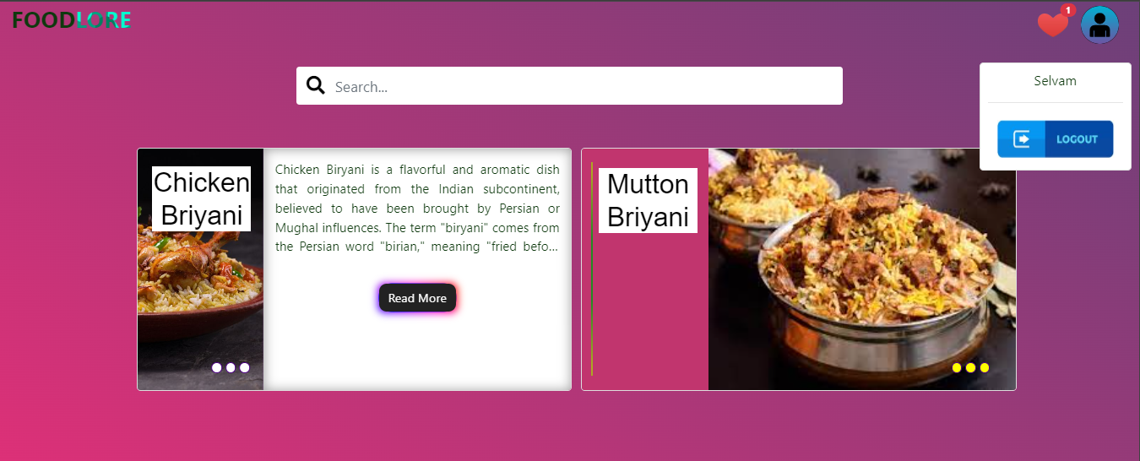

**Figure 6: Search Food Page(Customer)**

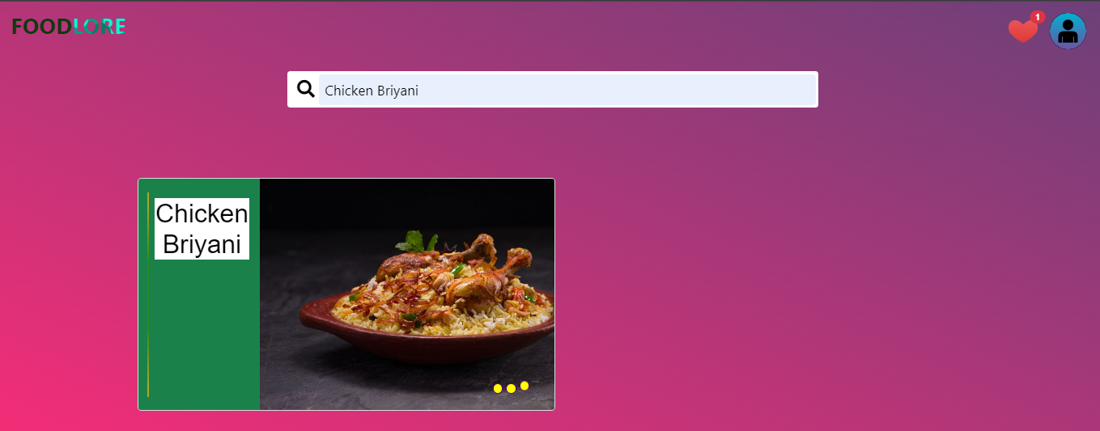

**Figure 7: Favourite Food Page**

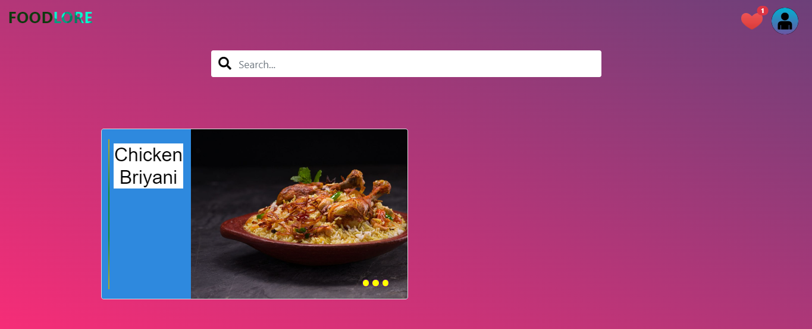

**CONCLUSION**

In conclusion, The FoodLore project represents a significant advancement in the way users interact with food-related information and services. By combining an educational exploration of food history with a user-friendly shopping experience, FoodLore not only enriches users’ culinary knowledge but also makes ordering food from external services like Zomato and Swiggy seamless and efficient. FoodLore stands out as an innovative solution in the food technology space, fostering a more inclusive, informative, and enjoyable experience for all users. Through continuous updates and improvements based on user feedback, FoodLore aims to maintain its relevance and effectiveness in meeting the evolving needs of its users.

**FUTURE ENHANCEMENT**

The project has a very vast scope in future. The FoodLore project has the potential for several exciting enhancements. Personalized recommendations can be implemented using machine learning algorithms to tailor food suggestions based on user preferences. Integrating Augmented Reality (AR) features will offer immersive experiences, allowing users to explore food preparation methods and origins interactively. Continuous updates to the expanded food database will provide a wealth of diverse cuisines and historical insights. Utilizing enhanced user analytics will help track engagement patterns and inform future updates. Additionally, social integration can create a community around food exploration, while sustainability features will highlight eco-friendly practices, promoting informed and responsible food choices among users.