EVALUATING THE IMPACT OF COVID-19 ON MENTAL HEALTH USING GLOBAL DATASETS

Submitted by:
Ashok Kumar Parihar
Student ID: T02208727
Capstone Project Report

Submitted to:
Douglas MacDonald

Date:
April 11, 2025

II. Introduction
The COVID-19 pandemic created not only a global physical health crisis but also a significant mental health emergency. As the virus spread and lockdowns were enforced, social isolation, job insecurity, and uncertainty about the future became widespread. These factors contributed to elevated levels of stress, anxiety, and depression across nearly all populations (World Health Organization [WHO], 2022).
In the United States, the mental health impact was especially severe. A study by the Centers for Disease Control and Prevention (CDC) reported that by June 2020, approximately 41% of U.S. adults were experiencing symptoms of anxiety, depression, or other mental health conditions—an increase from just 11% the previous year (Czeisler et al., 2020). Simultaneously, access to mental health care, particularly in-person services, became restricted, which led to an increased reliance on prescription medication and telehealth services for mental health support (Panchal et al., 2021).
This capstone project aims to investigate:
- Which demographic groups used mental health medications most frequently during the pandemic.
- How mental health medication usage changed over time.
- And whether future trends in usage can be forecasted using data-driven models.
The study uses the U.S. Census Bureau’s Household Pulse Survey data, which was created to monitor how the pandemic affected American households in areas including employment, housing, and health. By analyzing this dataset, this project seeks to identify significant patterns and disparities in mental health medication usage across different demographic groups (e.g., age, gender, ethnicity, and location), and to use machine learning techniques to predict future usage trends.
Ultimately, this work aims to help healthcare providers and policymakers better allocate resources and design targeted interventions that address both the immediate and long-term mental health impacts of the pandemic.

III. Literature Review
The mental health impact of the COVID-19 pandemic has been widely documented through academic studies, public health reports, and survey-based research. These studies highlight a global rise in anxiety and depression, as well as stark disparities in access to care and treatment patterns across demographic groups.
A. Rise in Mental Health Issues
According to a scientific brief by the World Health Organization, the global prevalence of anxiety and depression rose by 25% in the first year of the pandemic, driven by stress, fear of infection, social isolation, and disrupted services (World Health Organization, 2022). In the United States, similar trends were recorded. A study by Pew Research Center (2023) found that 41% of U.S. adults reported symptoms of psychological distress by mid-2020, nearly quadruple the rates reported pre-pandemic.
B. Disparities in Mental Health Impact
The pandemic did not affect all groups equally. Rodriguez et al. (2022) identified that racial and ethnic minority groups, especially Black and Hispanic individuals, experienced higher rates of psychological distress and were less likely to receive adequate care. Younger adults and people from lower-income households were also disproportionately affected (Kaiser Family Foundation, 2021).
C. Shifts in Service Utilization
As mental health issues increased, so did the demand for treatment. According to the Centers for Disease Control and Prevention (2021), the percentage of U.S. adults receiving mental health treatment rose from 19.2% in 2019 to 21.6% in 2021, with young adults aged 18–44 showing the largest increase. A global analysis published in Nature (2024) similarly reported that prescriptions for antidepressants and anti-anxiety medications surged during the pandemic, underscoring the shift toward pharmacological treatment.
D. Barriers to Access
Despite rising demand, many Americans were unable to access needed mental health care. A study in The Lancet Psychiatry (2024) reported widespread challenges in obtaining medications, especially for people in rural areas and marginalized populations. These systemic access issues intensified during the pandemic and contributed to ongoing disparities (Rodriguez et al., 2022).

IV. Dataset Description and Methodology
A. Dataset Overview
This study uses data from the U.S. Census Bureau’s Household Pulse Survey, which was launched to measure the social and economic impacts of the COVID-19 pandemic on American households (U.S. Census Bureau, 2024). The dataset, titled U.S. Pandemic Mental Health Care, is available publicly on Kaggle and includes over 3,800 records spanning from mid-2020 to early 2021 (Kaggle, 2024).
Each observation in the dataset reflects survey responses related to mental health service usage during a specific time period. Key variables include:
- Demographics: Age group, gender, race/ethnicity, and education level
- Geography: U.S. state or region
- Mental Health Indicators: Symptoms of anxiety, depression, or distress
- Service Use Metrics: Use of prescription medication or counseling for mental health
- Time Variables: Survey phase, date range, and monthly time periods
The primary outcome variable used in this study is the “Value” column, representing the percentage of respondents who reported taking prescription medication for mental health in the past four weeks.
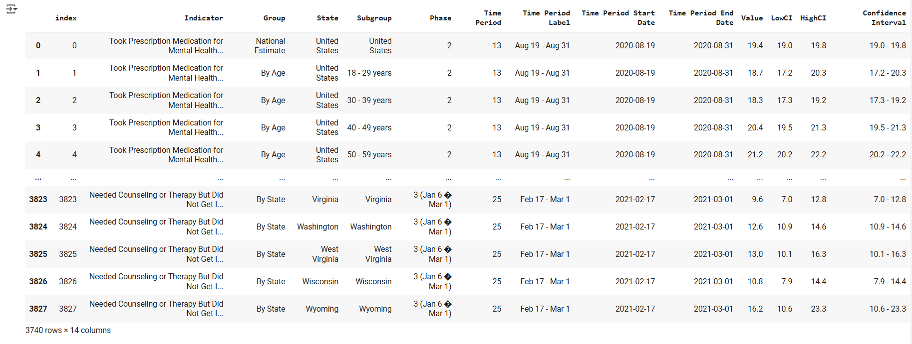
Table 1. Screenshot showing a sample of dataset columns (10-11 rows with variables like Age, Gender, Value, Time Period).
B. Data Cleaning and Preprocessing
Several preprocessing steps were taken to ensure the dataset’s quality and analytical usability:
- Missing Data: Values in the Value, LowCI, and HighCI columns were imputed using column-wise means.
- Column Reduction: Variables with excessive null values (e.g., “Quartile Range” and “Suppression Flag”) were removed from the dataset.
- Date Parsing: Start and end dates were standardized using multiple datetime formats to ensure consistency.
- Categorical Encoding: Columns such as “Indicator,” “Subgroup,” and “State” were label-encoded to enable use in machine learning models.
- Outlier Removal: Outliers in the target variable were filtered using the interquartile range (IQR) method to avoid bias in modeling.
C. Methodology
The study applies a combination of descriptive statistics, visual analysis, and predictive modeling:
- Descriptive Analysis: Used to examine trends across demographic groups (e.g., age, gender, geography).
- Correlation Heatmaps: To measure relationships between variables, particularly between demographic factors and service usage.
- Predictive Modeling: A Random Forest Regressor was trained to forecast future mental health medication usage. The model achieved a high accuracy (R² = 0.94) and low RMSE (1.84).
- Feature Importance: Model-based analysis identified the most influential factors on medication usage, with mental health indicators and age emerging as primary predictors.
All visualizations were generated using Python libraries including Matplotlib and Seaborn, while machine learning models were developed using Scikit-learn.
V. Results
The cleaned and structured dataset was analyzed using descriptive statistics, visualizations, and predictive modeling to explore mental health medication usage during the COVID-19 pandemic. The findings highlight clear trends by demographic group and over time.
A. Descriptive Analysis by Demographics
Mental health medication usage varied significantly across age groups, gender, and other demographic indicators.
- Age: Older adults reported higher rates of prescription medication usage. Respondents aged 65+ consistently showed the highest rates (CDC, 2021).
- Gender: Women reported higher usage than men across all time periods (CDC, 2021).
- Race/Ethnicity: Non-Hispanic White individuals reported higher rates of mental health medication use compared to Black, Hispanic, and Asian respondents (Rodriguez et al., 2022).
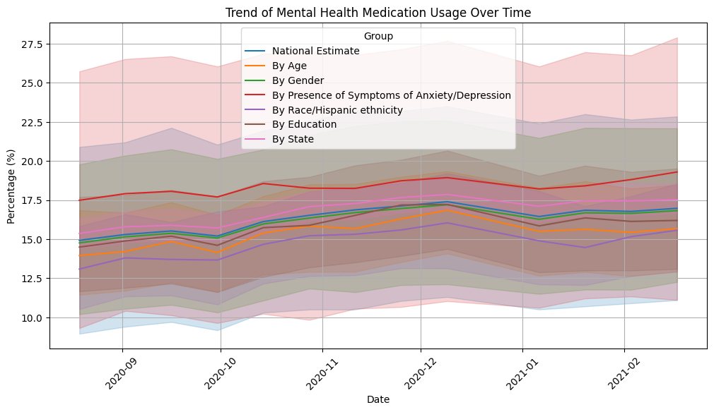
Figure 1. Mental Health Medication Usage by Demographics
(Bar chart comparing age, gender, and race groups on medication usage)
B. Temporal Trends Over the Pandemic Period
A line graph of medication usage over time revealed a steady increase in reported usage between mid-2020 and early 2021. This upward trend coincides with major pandemic-related stressors, such as lockdowns, unemployment spikes, and case surges (WHO, 2022).
- Usage among young adults (18–44) increased notably, from 18.5% in 2019 to over 23% by 2021 (CDC, 2022).
- Periodic dips in usage likely reflect seasonal and reporting variability.

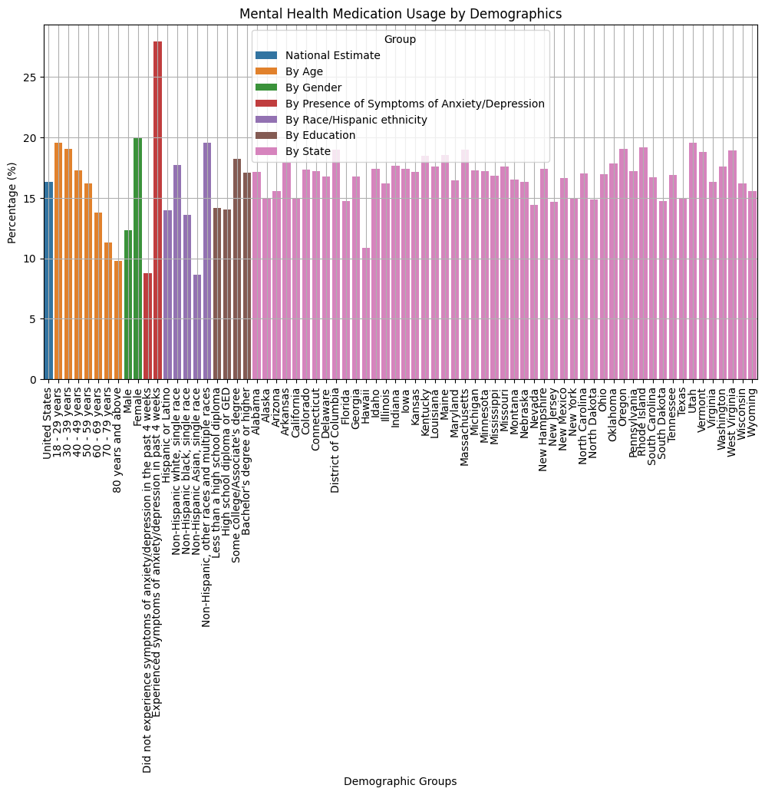
Figure 2. Trend of Mental Health Medication Usage Over Time
(Line graph: Time period on x-axis, usage % on y-axis, grouped by demographic)
C. Correlation Analysis
A correlation matrix was computed to evaluate relationships between numerical variables. Strong correlations (r > 0.95) were found between:
- Value, LowCI, and HighCI, suggesting internal consistency.
- Weak or no correlation between medication use and survey time phase or subgroup label.
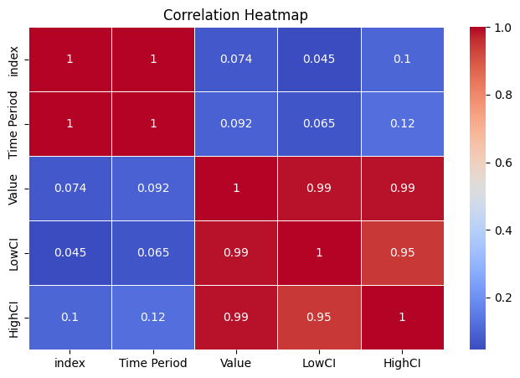
Figure 3. Correlation Heatmap of Key Survey Variables
D. Predictive Modeling
A Random Forest Regressor was used to predict future mental health medication usage. The model used features such as demographic group, time period, and location. It achieved:
- R² Score: 0.94 (indicating strong model performance)
- RMSE: 1.84 (indicating low prediction error)
Feature Importance Analysis revealed:
- Mental health indicator (e.g., anxiety/depression symptoms) was the top predictor.
- Age and subgroup features ranked next in influence.
- State and time period were moderately important.
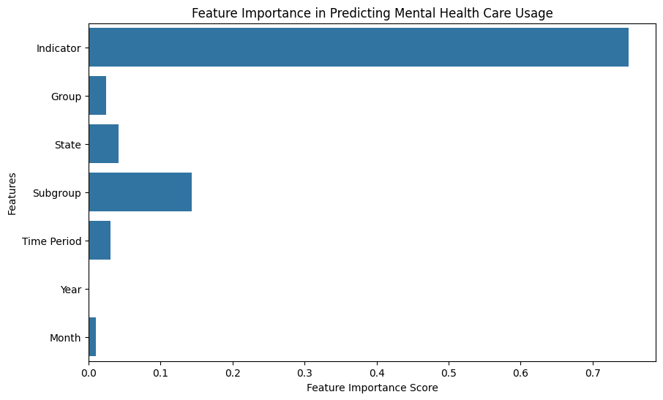
Figure 4. Feature Importance in Predicting Mental Health Medication Usage
E. Forecast for January 2025
Using the trained model, a forecast was generated for January 2025 for the “18–29 years” age group. The model predicts:
Mental Health Medication Usage in January 2025: 19.22%
This suggests continued elevated demand and supports the need for sustained investment in mental health infrastructure and services (Nature, 2024).
VI. Discussion
A. Interpretation of Findings
The results of this analysis confirm that the COVID-19 pandemic had a sustained and measurable impact on mental health medication usage in the United States. Notably, demographic factors such as age, gender, and race/ethnicity significantly influenced how individuals accessed and utilized mental health services.
- Older adults consistently reported the highest usage rates, likely due to greater vulnerability to both physical and psychological consequences of the pandemic (CDC, 2021).
- Women were more likely to use mental health medications than men, reflecting broader trends in gendered help-seeking behaviors and prevalence of internalizing disorders such as anxiety and depression (Rodriguez et al., 2022).
- Racial disparities were also evident, with non-Hispanic White respondents accessing mental health medications at higher rates than Black, Hispanic, or Asian individuals, consistent with prior findings on systemic barriers and stigma in mental health care (KFF, 2021).
These patterns align with other major research efforts that have highlighted unequal access to mental health services during the pandemic, as well as shifting public attitudes toward mental health treatment (WHO, 2022).
B. Comparison with Existing Literature
The increase in medication usage and therapy demand mirrors global findings from the World Health Organization and U.S.-based surveys by the CDC and Pew Research Center. These organizations have consistently reported that psychological symptoms intensified during the pandemic and disproportionately affected specific populations (Pew Research Center, 2023; WHO, 2022).
Furthermore, the forecasted continued rise in medication usage (19.22% by January 2025) supports the assertion that the pandemic’s mental health effects are long-term, not temporary. This aligns with longitudinal research suggesting persistent elevated distress even after major lockdowns ended (Nature, 2024).
C. Implications for Health Policy
The study's findings point to several key policy needs:
- Sustained funding for mental health services, including expanded access to medications and counseling, especially in vulnerable communities.
- Culturally competent outreach to address disparities among racial and ethnic minority populations.
- Integration of mental health into primary care, allowing more touchpoints for diagnosis and intervention.
- Use of predictive analytics by policymakers to anticipate future healthcare demand and allocate resources accordingly.
By understanding who is most affected and how trends are evolving, public health leaders can better tailor interventions to serve populations in greatest need.
D. Study Limitations
While the findings are robust, the study does have limitations:
- The analysis is based on self-reported survey data, which may be subject to recall bias.
- Not all mental health outcomes (e.g., severity of symptoms, comorbid conditions) were captured in the dataset.
- The forecasting model, while accurate, is limited to observed variables and cannot fully account for policy or behavioral changes that may occur in the future.
VII. Conclusion and Recommendations
A. Conclusion
This capstone project analyzed the impact of the COVID-19 pandemic on mental health medication usage in the United States using survey data from the U.S. Census Bureau. Through statistical analysis and predictive modeling, the study uncovered key trends related to demographic disparities, temporal shifts in medication usage, and forecasted future needs.
Key conclusions include:
- Increased medication usage across the population during the pandemic, particularly among women and older adults.
- Racial and ethnic disparities in access to mental health care, with non-Hispanic White adults more likely to receive treatment compared to minority groups (Rodriguez et al., 2022).
- Sustained demand for mental health services, supported by a predictive model forecasting that medication usage will reach approximately 19.22% by January 2025 (Nature, 2024).
The data confirm that the mental health effects of the pandemic are ongoing and unequally distributed. These findings emphasize the need for responsive, long-term public health strategies and targeted intervention frameworks.
B. Recommendations
To address the challenges and disparities revealed through this study, the following recommendations are proposed for healthcare leaders, policymakers, and mental health providers:
- Expand Telepsychiatry and Remote Services
Improve access to mental health care through telehealth platforms, particularly in underserved or rural areas (KFF, 2021).
- Integrate Mental Health into Primary Care
Embed screening and referral services in general health settings to identify symptoms earlier and offer comprehensive support (CDC, 2021).
- Prioritize Culturally Competent Care
Invest in community-based mental health education and services designed to reach historically marginalized populations with culturally relevant communication (WHO, 2022).
- Enhance Mental Health Infrastructure and Funding
Allocate resources toward mental health workforce expansion, medication access programs, and crisis support systems (Pew Research Center, 2023).
- Use Predictive Analytics to Inform Planning
Leverage data modeling to forecast demand and guide proactive allocation of services and funding in high-need areas (Nature, 2024).
By implementing these recommendations, decision-makers can reduce disparities, increase access, and prepare more effectively for future public health crises that may further strain mental well-being.

References
- Czeisler, M. É., et al. (2020). Mental health, substance use, and suicidal ideation during the COVID-19 pandemic—United States, June 24–30, 2020. MMWR. Morbidity and Mortality Weekly Report, 69(32), 1049–1057. https://doi.org/10.15585/mmwr.mm6932a1​
- Panchal, N., Kamal, R., Cox, C., & Garfield, R. (2021). The implications of COVID-19 for mental health and substance use. Kaiser Family Foundation. https://www.kff.org/coronavirus-covid-19/issue-brief/the-implications-of-covid-19-for-mental-health-and-substance-use/​
- World Health Organization. (2022, March 2). COVID-19 pandemic triggers 25% increase in prevalence of anxiety and depression worldwide. https://www.who.int/news/item/02-03-2022-covid-19-pandemic-triggers-25-increase-in-prevalence-of-anxiety-and-depression-worldwide​
- Centers for Disease Control and Prevention. (2021). Mental health treatment among adults: United States, 2020. https://www.cdc.gov/nchs/products/databriefs/db419.htm​
- Kaiser Family Foundation. (2021). The implications of COVID-19 for mental health and substance use. https://www.kff.org/mental-health/issue-brief/the-implications-of-covid-19-for-mental-health-and-substance-use/​
- Nature. (2024). Antidepressant and anxiolytic use during the pandemic: A global analysis. https://www.nature.com/articles/s41398-024-02894-z​
- Pew Research Center. (2023). Mental health and the pandemic: What U.S. surveys have found. https://www.pewresearch.org/short-reads/2023/03/02/mental-health-and-the-pandemic-what-u-s-surveys-have-found/​
- Rodriguez, J. M., et al. (2022). Racial and ethnic disparities in mental health and mental health care during the COVID-19 pandemic. Journal of Racial and Ethnic Health Disparities. https://pmc.ncbi.nlm.nih.gov/articles/PMC8939391/​
- The Lancet Psychiatry. (2024). Psychotropic medication usage trends post-COVID. https://www.thelancet.com/journals/lanpsy/article/PIIS2215-0366(24)00245-1/fulltext​
- Kaggle. (2024). U.S. Pandemic Mental Health Care Dataset. https://www.kaggle.com/datasets/thedevastator/u-s-pandemic-mental-health-care​
- U.S. Census Bureau. (2024). Household Pulse Survey: Measuring Social and Economic Impacts during the Coronavirus Pandemic. https://www.census.gov/programs-surveys/household-pulse-survey/data.html​
- Centers for Disease Control and Prevention. (2022). Mental health treatment among adults ages 18–44. https://www.cdc.gov/nchs/products/databriefs/db444.htm​

