**1. Insert many student record with name, primary address, favourite teacher and age.**

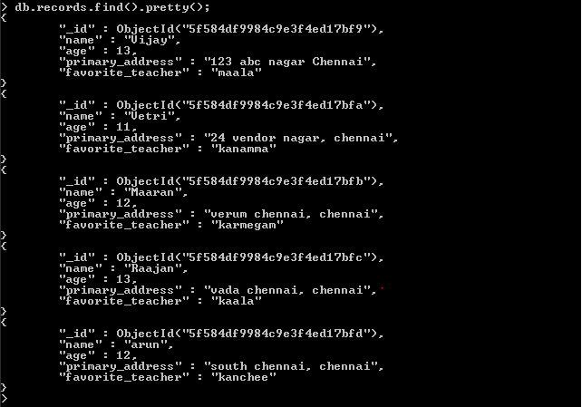

**2. Check weather a student name ‘Arun’ is present in the collection.**



**3. Change the primary address of the student ‘Vijay’ as no ‘123 abc nagar Chennai.’**

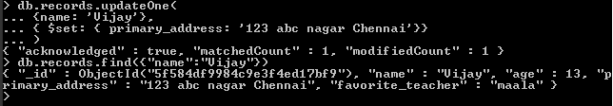

**4. Find all the student whose age is greater than 12.**



**5. Find the favourite teacher of student ‘kaala**



**6. Count the number of student present in student collection.**



**7. Count the students who live in Chennai**

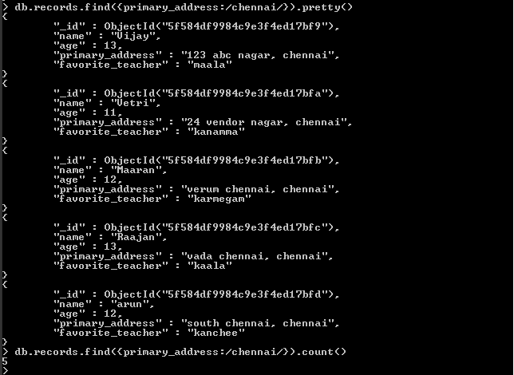

**8. Count the student whose favourite teacher is ‘Anitha’.**

