1. **Find all the information about each film**

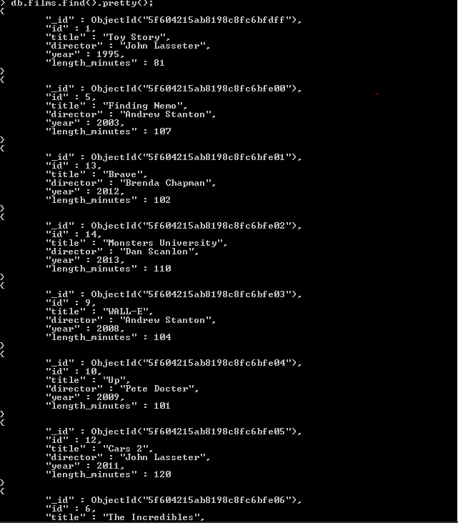

1. **Find the title of each film**

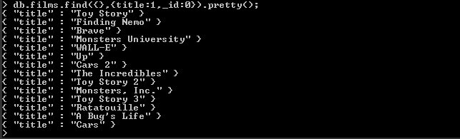

1. **Find the director of each film**



1. **Find the title and director of each film**

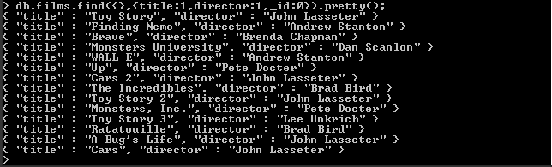

1. **Find the title and year of each film**



1. **Find the movie with a row id of 6**



1. **Find the movies released in the years between 2000 and 2010**

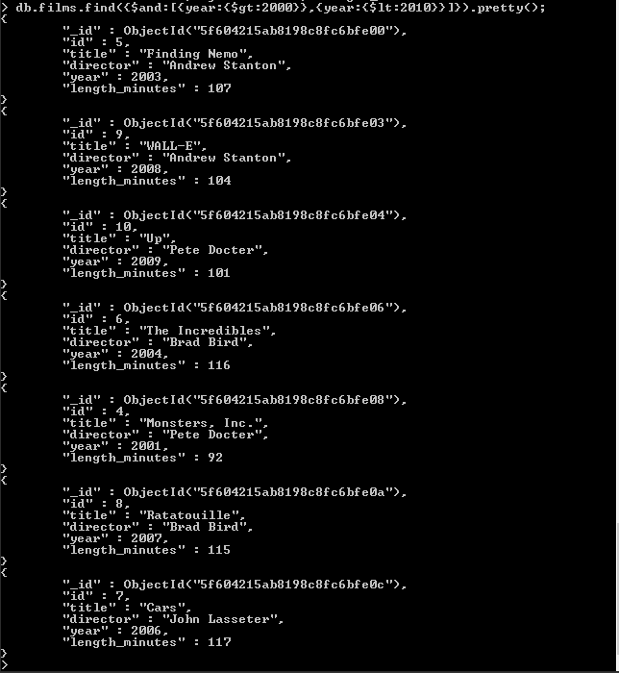

1. **Find the movies not released in the years between 2000 and 2010**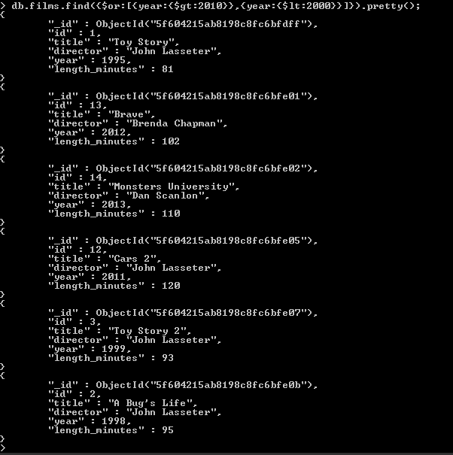
2. **Find the first 5 Pixar movies and their release year**
3. **Find all the Toy Story movies**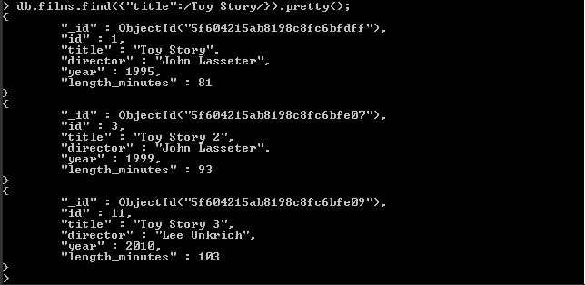
4. **Find all the movies directed by John Lasseter**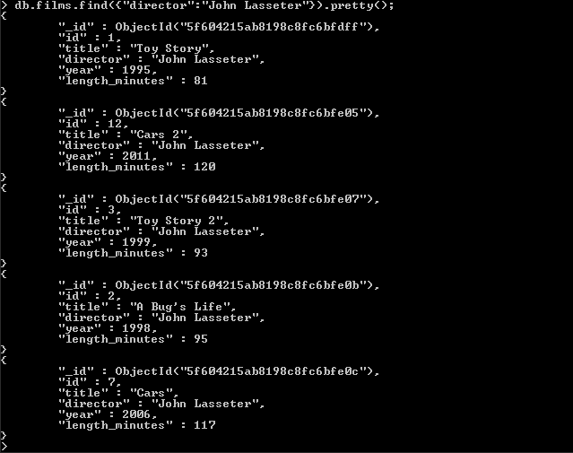
5. **Find all the movies (and director) not directed by John Lasseter**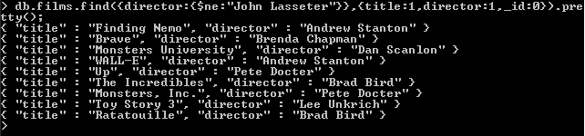
6. **Find all the WALL-* movies**

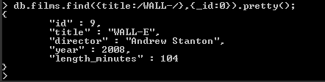

1. **List the last four Pixar movies released (ordered from most recent to least)** 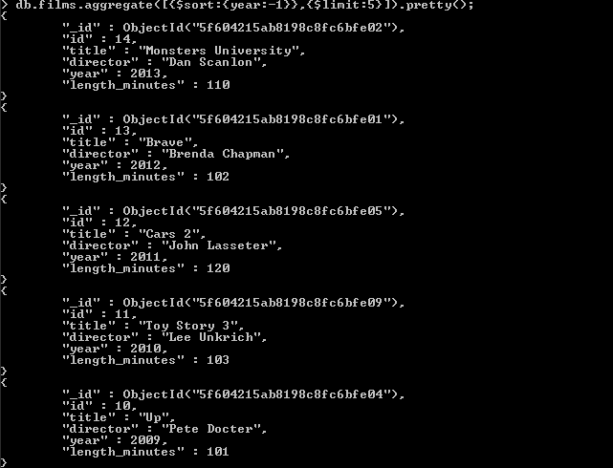
2. **List the first five Pixar movies sorted alphabetically**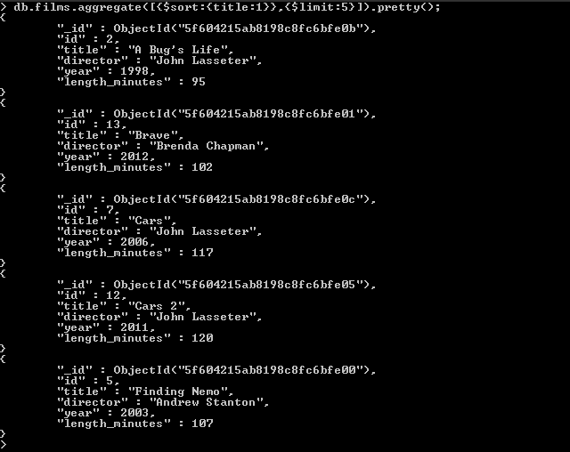
3. **List the next five Pixar movies sorted alphabetically**