1. **Find all the students whos age is between 21 – 30** 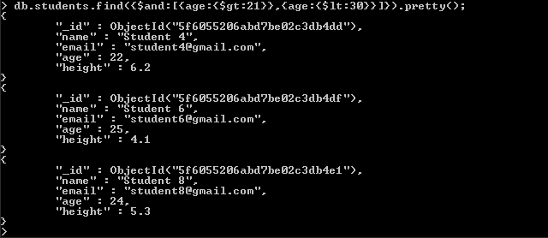
2. **Find all students whos age is between 21 - 30 and height is greater than 5** 