Critique of Frank, Ahn & Moro (2025): AI Exposure Predicts Unemployment Risk
CSCU9DA Written Critique Report
Dataset: github.com/mrfrank8176/unemploymentRisk [2]
Code: Data_Audit_CSCU9DA_Assignment_Final.py
Problem Formulation and Modelling Technique
Generative AI and automation have prompted widespread fear of job loss, yet the many published “AI exposure” scores (Acemoglu & Autor, Frey & Osborne, Arntz et al., Brynjolfsson et al., Felten et al., Webb, Eloundou et al., O*NET) are built from expert judgement, patents or task text and are rarely validated against realised labour-market outcomes [1]. Frank, Ahn and Moro ask whether these scores predict actual occupational unemployment risk, and whether combining them performs better than any single score. The motivation is both scientific (which measures are valid?) and practical (which workers will need support or retraining?).
The unit of analysis is a state–month–occupation record (N = 140,274; 2010–2020). The target is unemployment risk, the share of an occupation’s workforce receiving unemployment insurance in each state and month, log10-transformed. Inputs are the exposure scores mapped to two-digit SOC occupation groups, standardised. Each score is first used alone in a regression; the authors then fit an ensemble LASSO [3] on all scores together. A baseline model contains O*NET skill principal components, national bachelor’s degree share and year, month and state fixed effects. Performance is R² under 10×10-fold cross-validation: best single score 0.107, ensemble alone 0.298, baseline 0.574, baseline plus ensemble 0.755 (+18.1 points).
The study is predictive and associational rather than inferential, it asks how much variance exposure explains beyond skills, education and place, not whether AI causes layoffs, and the authors disclaim causal claims. They also test whether exposure predicts state unemployment rates, job-separation rates and within-occupation skill change.
Hands-on Data Audit and Preliminary EDA
I downloaded both CSV files from the authors’ public repository [2] (10 MB, so no sampling needed, all rows used). The files are labelled “demo” data. demoData_unemploymentRisk.csv has 140,274 rows × 9 columns, exactly matching the paper’s N (Table 1). It covers 50 states (no DC), 22 SOC groups and 132 months, with no blank cells, no sentinel codes (−999, NA) and no duplicate keys, so no imputation was needed.
The file has an unnamed first column that is a leaked pandas index. The panel is also unbalanced: 4,926 of 145,200 possible state, month, occupation cells (3.4%) are absent, which the authors do not document, and which probably reflects suppressed or zero-claim cells. Twenty-six risk values exceed 1, which is impossible for a share; the largest (2.42) is Alaska farming (SOC 45), where the numerator (claims by most recent occupation) and denominator (annual OEWS employment) come from different sources and small bases. In addition, 342 rows have a claimant count of 1, and 669 rows have state unemployment above 15%, all of them in 2020. Finally, the second file holds only 549 state-level rows covering months 1, 2, 4, 8 and 10, and its exposure scores are state aggregates rather than SOC-level, so the paper’s occupation-level regressions cannot be re-run from the repository alone.
For the EDA Fig. 1: risk is extremely right skewed; log10 is near symmetric, supporting the transform. Fig. 2: strong seasonality (education, SOC 25, peaks each summer; farming, SOC 45, each winter) and a COVID-19 spike, justifying month fixed effects and the 2019 cut-off. Fig. 3: exposure scores overlap (median |r| = 0.46; Webb Robot and Software r = 1) yet several are uncorrelated or negatively correlated, so they measure different constructs, motivating an ensemble.
Table 1: Audit of demoData_unemploymentRisk.csv against the paper.
Check | Paper reports | Observed in repository
Rows (N) | 140,274 | 140,274 (exact match)
Columns | not stated | 9 (including leaked index)
States / SOC groups / months | US states / 2-digit SOC / 2010–2020 | 50 / 22 / 132
Missing cells or sentinel codes | not stated | 0
Absent panel cells | not stated | 4,926 of 145,200 (3.4%)
Risk values > 1 | not stated | 26 rows

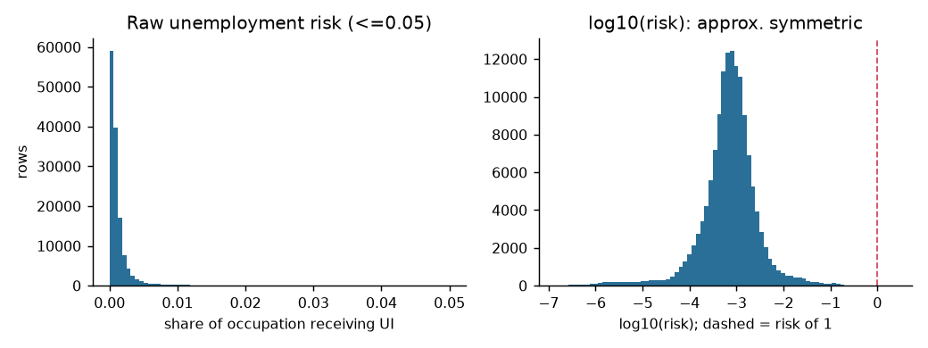
Fig. 1. Unemployment risk, raw (left) and log10 (right).
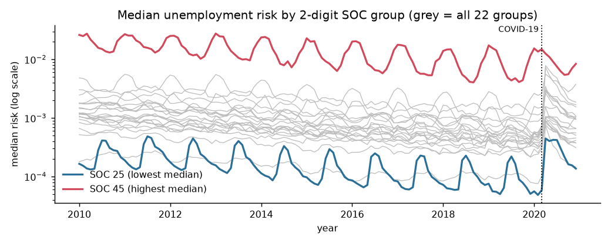
Fig. 2. Median monthly risk by SOC group: seasonality and the 2020 COVID-19 spike.
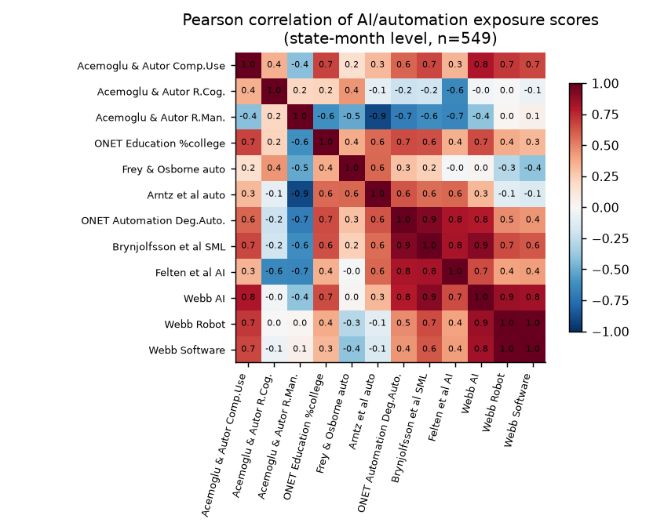
Fig. 3. Correlations among the 11 exposure scores.
Critical Analysis and Reflections
At the data stage, UI claimants exclude the self-employed, non-claimants and labour-force leavers, and claim rates vary by state and wage level, so “risk” over-represents eligible, formal-sector workers; the 26 risks above 1 show that numerator and denominator do not align, and occupation is the claimant’s most recent job, so those who changed occupation before claiming are misclassified. At the modelling stage, scores attach to only 22 SOC major groups, so exposure takes 22 distinct values, and the 140,274 rows are heavily clustered by occupation, state and month, which means the nominal sample overstates the effective one. Unless folds are blocked by time or state, random cross-validation also leaks adjacent months between folds and inflates R², while the 0.574 baseline, largely fixed effects, already explains most variance and an 11-score LASSO on about 22 occupation profiles risks unstable selection. Seasonality, wages, unionisation and offshoring covary with exposure, so the results are associations rather than effects of AI, and the 2010–2019 window pre-dates generative AI, so scores describing future technology are validated on a post-recession labour market. Finally, the repository holds only demo data, without occupation-level scores, OEWS/O*NET joins or modelling code, so the headline R² values cannot be independently verified.
The study is among the first to test many competing exposure measures against realised, monthly, state-level administrative outcomes, rather than against each other. Combining them in one ensemble, and benchmarking against skill-change and job-separation outcomes, is a creative synthesis of otherwise separate literatures.
The data are aggregated and public, so individual privacy risk is low, but small cells (342 counts of one) could permit re-identification in small states or rare occupations. Workers did not consent to secondary use of UI records, although aggregate release is normal. Occupation-level “risk” scores could be misused by employers or policymakers to justify layoffs, discriminate in hiring or deny training budgets, stigmatising occupations dominated by women or minorities. Under-claiming among low-wage workers means the model may understate risk where need is greatest. The paper contains no ethics statement.
References
[1] M. R. Frank, Y.-Y. Ahn, and E. Moro, “AI exposure predicts unemployment risk: A new approach to technology-driven job loss,” PNAS Nexus, vol. 4, no. 4, p. pgaf107, Apr. 2025, doi: 10.1093/pnasnexus/pgaf107.
[2] M. R. Frank, “unemploymentRisk: Unemployment risk data by state, month and occupation,” GitHub repository, 2025. [Online]. Available: https://github.com/mrfrank8176/unemploymentRisk
[3] R. Tibshirani, “Regression shrinkage and selection via the lasso,” J. R. Stat. Soc. B, vol. 58, no. 1, pp. 267–288, 1996.

