Individual Modelling Assignment – CSCU9E5
Student ID: 3115875

State Diagram
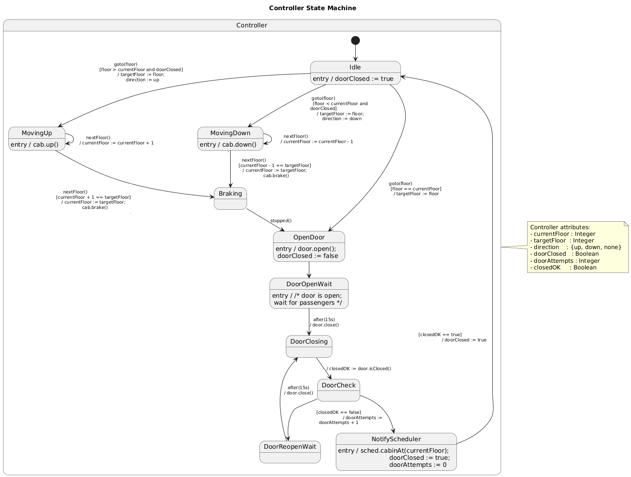

State Descriptions
Idle
Purpose: Controller is waiting for a request from the Scheduler.
Behaviour: Records that the door is closed (doorClosed := true). On a goto(floor) event it either starts moving the cabin (up or down) or, if already at the requested floor, goes directly to opening the door.
MovingUp
Purpose: Cabin is travelling upwards towards the target floor.
Behaviour: On entry, tells the cabin to move up (cab.up()). Each nextFloor() event increases currentFloor. When the next floor would be the target floor, it switches to Braking and asks the cabin to brake.
MovingDown
Purpose: Cabin is travelling downwards towards the target floor.
Behaviour: On entry, tells the cabin to move down (cab.down()). Each nextFloor() event decreases currentFloor. When the next floor would be the target floor, it switches to Braking and asks the cabin to brake.
Braking
Purpose: Cabin is slowing down at the target floor.
Behaviour: Waits for a stopped() event from the cabin. Once received, moves to OpenDoor to start door operations.
OpenDoor
Purpose: Begin opening the door at the target floor.
Behaviour: On entry, sends open() to the door and records that the door is no longer closed (doorClosed := false). Then immediately moves to DoorOpenWait.

DoorOpenWait
Purpose: Keep the door open long enough for passengers.
Behaviour: After 15 seconds, instructs the door to close (door.close()) and moves to DoorClosing.
DoorClosing
Purpose: Door is in the process of closing.
Behaviour: As part of leaving this state, the controller checks the door sensor (closedOK := door.isClosed()) and goes to DoorCheck.
DoorCheck
Purpose: Decide what to do based on whether the door actually closed.
Behaviour: If closedOK is true, it sets doorClosed := true and continues to NotifyScheduler. If closedOK is false, it increments the retry count (doorAttempts := doorAttempts + 1) and goes to DoorReopenWait.
DoorReopenWait
Purpose: Wait before retrying a failed door closure.
Behaviour: After another 15 seconds the controller issues door.close() again and returns to DoorClosing, where the door is checked again.
NotifyScheduler
Purpose: Signal that the cabin is stationary with door safely closed.
Behaviour: On entry, sends cabinAt(currentFloor) to the Scheduler and resets door-related state (doorClosed := true, doorAttempts := 0). Then returns to Idle to await the next goto.

