CSCU9M6 - Sign Language MNIST - CNN Classification Report - 3115875

Introduction
Hand-gesture recognition using sign language has significant practical value for enabling communication with the hearing-impaired and for building inclusive human-computer interaction systems. This report covers the design, implementation, and evaluation of CNN models trained on the Sign Language MNIST dataset, comprising 28x28 grayscale images of 24 ASL letters (A-Y, excluding J and Z), with 27,455 training and 7,172 test images.
Two architectures were implemented and compared: a compact baseline CNN and a deeper VGG-style CNN with residual shortcut connections, both evaluated on accuracy, loss, parameter efficiency, training time, and per-class performance.

1. Data Loading and Preprocessing

1.1 Loading and Tensor Conversion
The dataset was loaded from CSV files using pandas. Each row contains a label and 784 pixel values representing a flattened 28x28 image. These were reshaped into tensors of shape (N, 28, 28, 1) using NumPy. A LabelEncoder was fit jointly on training and test labels to ensure a consistent 0-23 mapping across both splits.

1.2 Normalisation
Pixel values were normalised to the range [0, 1] by dividing by 255. Normalisation is essential for gradient-based optimisers, as it prevents large-magnitude pixel values from dominating parameter updates and accelerates convergence.

1.3 Validation Split
A stratified 15% validation split was extracted from the training set using scikit-learn's train_test_split with a fixed random seed, giving 23,336 training and 4,119 validation samples. Stratification preserves class distribution in both splits.

1.4 Data Augmentation
An augmentation pipeline was embedded directly in the model graph (active only during training), consisting of random horizontal flips, small rotations (+/-5%), zoom (+/-10%), and contrast jitter (+/-10%). Embedding augmentation in the model prevents data leakage and ensures inference is unaffected. These transforms reflect realistic variation in hand orientation and lighting without distorting signs enough to change their class.
Figure 1 shows one representative sample per class from the normalised training set, illustrating the visual diversity and some of the low-resolution challenges inherent in the dataset.

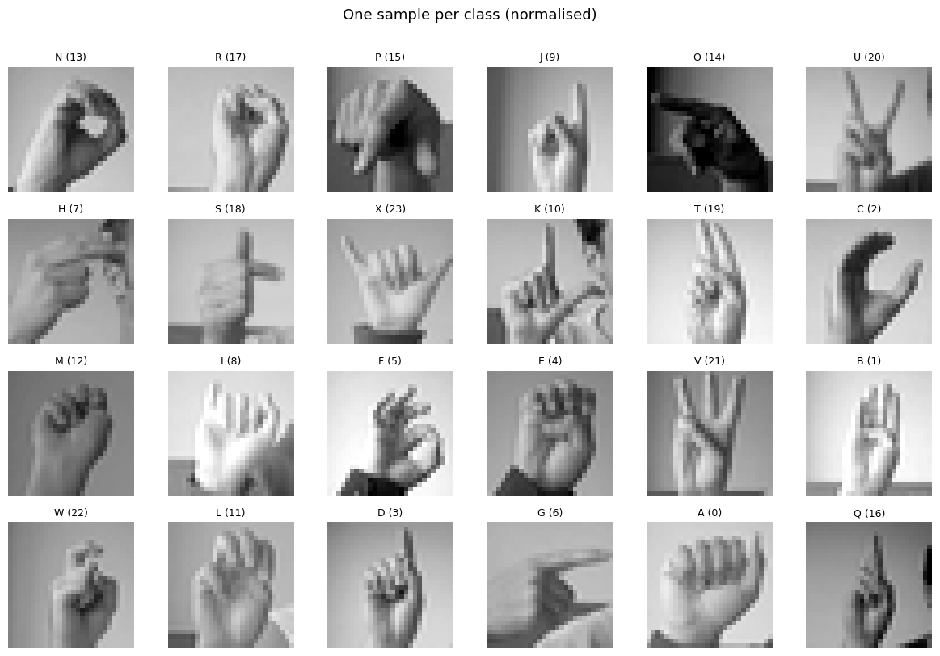
Figure 1: One normalised sample per class from the training set.

2. CNN Architectures

2.1 Baseline CNN
The baseline architecture consists of two convolutional blocks, each containing two Conv2D layers (32 filters, 3x3 kernel, same padding), followed by Batch Normalisation, ReLU activation, MaxPooling (2x2), and Dropout (0.25). The convolutional stack is followed by a global average pooling layer, a fully connected dense layer (128 units, ReLU, Dropout 0.5), and a softmax output layer. Bias terms are omitted in convolutional layers because Batch Normalisation subtracts the mean and renders a separate bias redundant.
This design prioritises parameter efficiency. At 158,776 parameters it is lightweight enough to train in under two minutes, while the double-convolution-per-block structure provides sufficient representational capacity for the 28x28 input.

2.2 VGG-Style CNN
The enhanced architecture is inspired by the VGGNet family (Simonyan and Zisserman, 2014) and adds residual shortcut connections. It comprises three VGG blocks with progressively increasing filter counts (32, 64, 128), each containing two or three convolutional layers, Batch Normalisation, and ReLU activations. If the number of channels changes across a block, a 1x1 convolutional projection is applied to the shortcut to match dimensions. Each block is followed by MaxPooling and Dropout.
The shortcut connections ease gradient flow during backpropagation through the deeper stack and allow the network to learn residual corrections on top of the identity mapping. The classifier head uses a 256-unit dense layer with Dropout 0.5. Total parameter count is 523,512, approximately 3.3 times that of the baseline.

2.3 Design Justification
Both architectures share Batch Normalisation at every convolutional layer, which reduces internal covariate shift, acts as a mild regulariser, and permits higher learning rates. Dropout provides further regularisation at pooling and dense layers. Adam with ReduceLROnPlateau (halving the rate after four stagnant epochs) provides adaptive per-parameter updates and robust convergence.

3. Training, Testing, and Evaluation

3.1 Hyperparameters
The final configuration was reached through iterative experimentation. Batch size of 256 was chosen after testing 64 and 128, both of which produced noisier validation loss curves and added around 40% to training time without any accuracy benefit. For the learning rate, 1e-2 caused both models to diverge in the first two epochs while 1e-4 converged too slowly for early stopping to allow full training. A rate of 1e-3 with Adam struck the right balance, with ReduceLROnPlateau halving the rate after four stagnant epochs to stabilise training during the loss spikes visible around epochs 15-20 in Figure 2.
Dropout was set to 0.25 after pooling layers and 0.5 before the dense head. Removing dropout entirely caused both models to overfit within 10 epochs, with training accuracy hitting 100% while validation stalled near 95%. Early stopping patience was set to 10 rather than 5 because the shorter patience triggered premature stopping during the mid-training validation spikes before the scheduler had time to resolve them.

3.2 Training Curves and Model Comparison
Both models converged rapidly. The baseline reached its best validation accuracy within approximately 20 epochs and the VGG-style model within a similar range. Figure 2 shows the training and validation accuracy and loss curves for both models over 30 epochs.

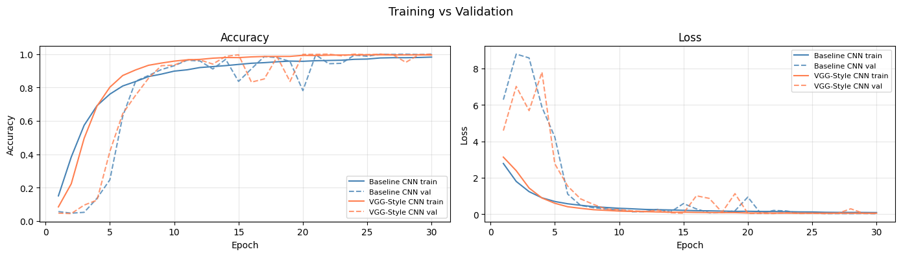
Figure 2: Training vs validation accuracy (left) and loss (right) for both models over 30 epochs.
The comparison table below summarises final performance across both models.

Model | Parameters | Train Acc | Val Acc | Test Acc | Train Time
Baseline CNN | 158,776 | 98.20% | 99.95% | 99.36% | 121 s
VGG-Style CNN | 523,512 | 99.59% | 100.00% | 99.85% | 198 s

Both models generalise well, with test accuracy closely tracking validation accuracy. Notably, validation accuracy exceeds training accuracy in the baseline (99.95% vs 98.20%), which is attributable to two factors. Augmentation is active during training but not validation, and Dropout is disabled at inference. The VGG-style model achieves a 0.49 percentage point improvement in test accuracy over the baseline, representing a reduction in test error from 0.64% to 0.15%.
The VGG-style model achieves a 0.49 percentage point improvement in test accuracy over the baseline, reducing test error from 0.64% to 0.15%. However, it uses 3.3 times more parameters and takes 1.64 times longer to train for that gain. In a deployment with strict latency or memory constraints the baseline would be preferred; here the VGG model is marginally superior on raw accuracy.
The loss curves in Figure 2 reveal an interesting pattern. Both models exhibit spikes in validation loss around epochs 15-20, particularly visible in the baseline, before stabilising. These spikes coincide with the ReduceLROnPlateau scheduler reducing the learning rate, after which the models settle into a low-loss, high-accuracy regime. The training loss decreases monotonically for both models, and the absence of a large, sustained gap between training and validation loss confirms that neither model is overfitting significantly.

3.3 Confusion Matrix Analysis
Figures 3 and 4 show the row-normalised confusion matrices for the baseline and VGG-style models respectively. Analysis reveals that misclassification is concentrated in a small subset of classes.

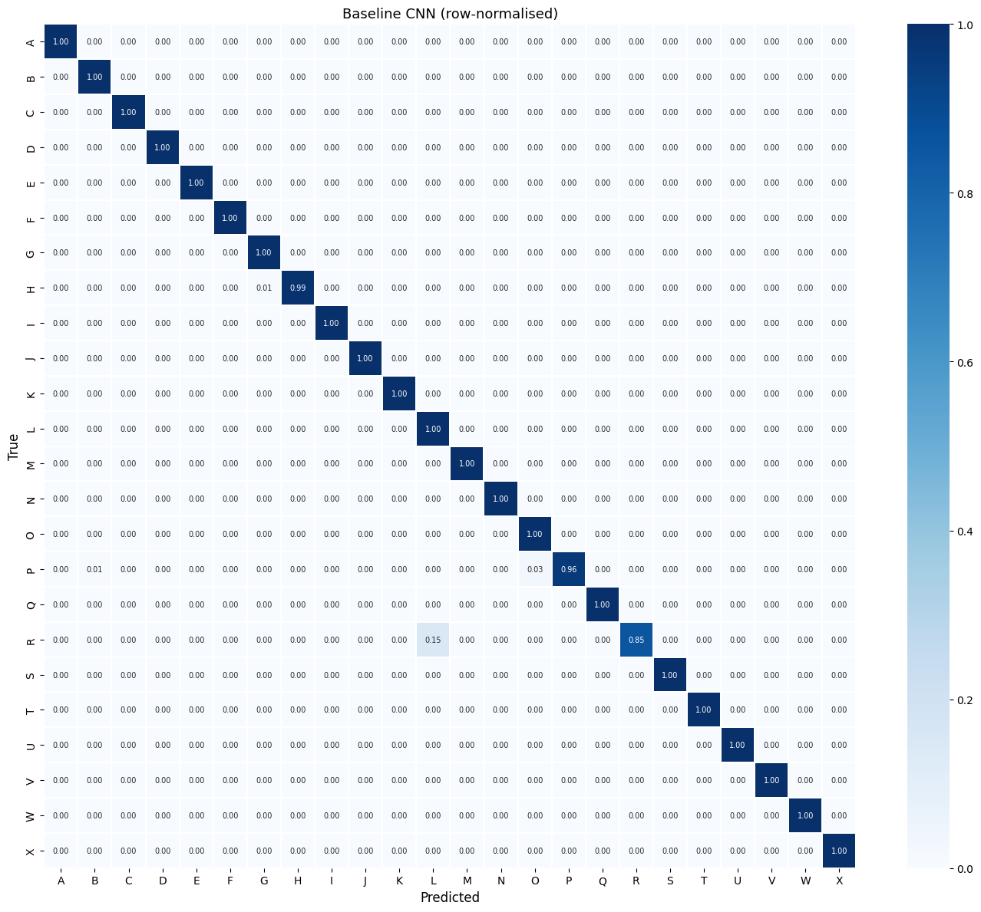
Figure 3: Row-normalised confusion matrix for the Baseline CNN on the test set.
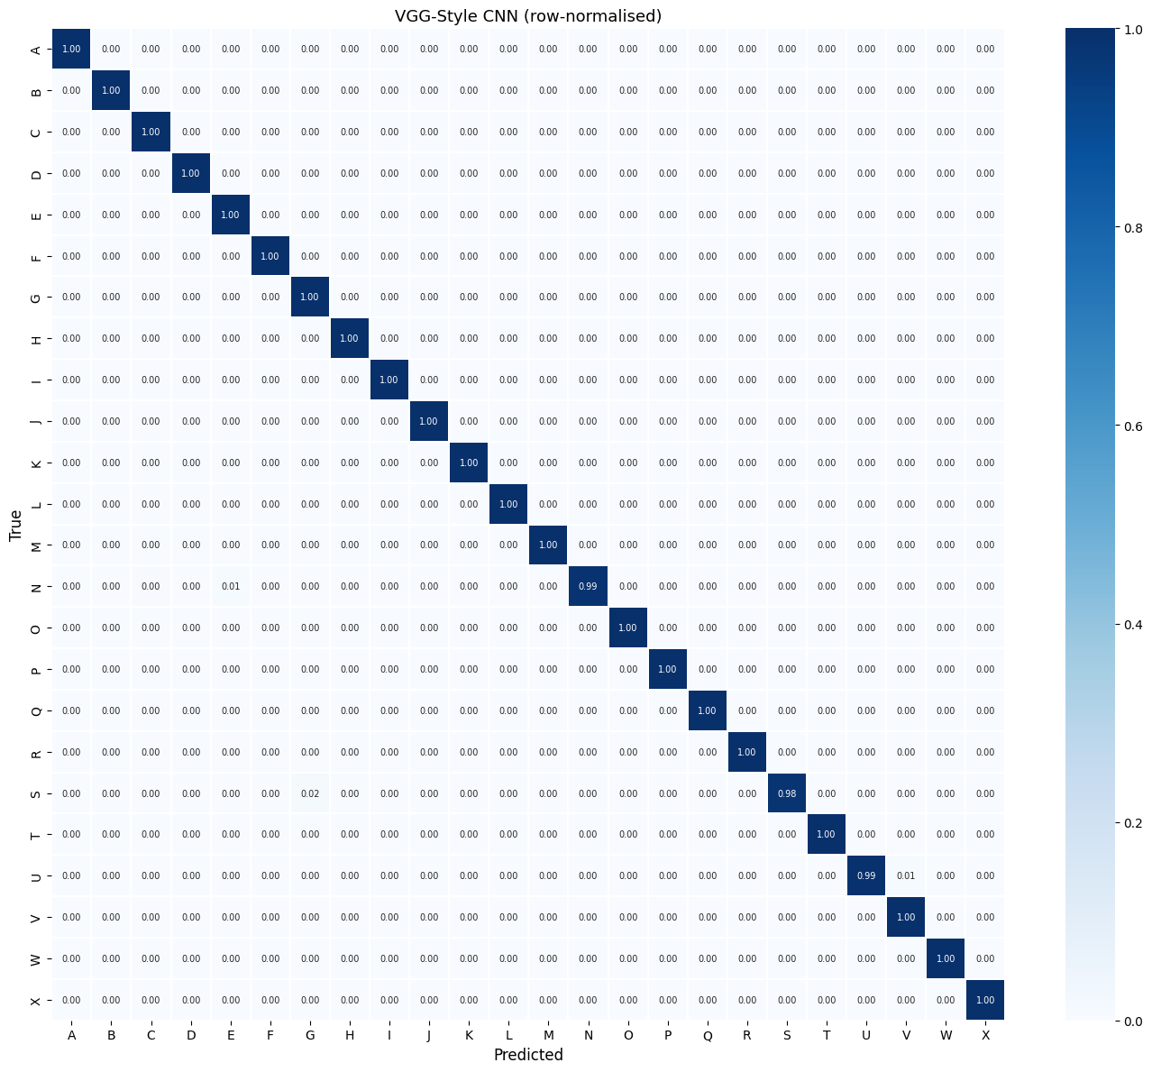
Figure 4: Row-normalised confusion matrix for the VGG-Style CNN on the test set.
The baseline model's hardest letter was R, with a recall of only 85.37% and an F1-score of 0.9211, substantially below all other classes. The confusion matrix confirms that 15% of R samples were misclassified as L. This has a clear geometric explanation. In ASL, R is formed by crossing the index and middle fingers, a configuration that can visually resemble an extended hand at 28x28 resolution. L also underperformed, achieving precision of 0.9163 and F1 of 0.9563, while P had recall of 0.9634 with 3% of samples confused with N.
The VGG-style model resolved the R and L errors entirely, with both achieving perfect F1 of 1.0000. P was also corrected to perfect recall. The only class remaining below 0.9950 in the VGG model is G (F1 0.9943) and N (recall 0.9878, with 1% confused with D). This pattern suggests the baseline's errors were capacity-limited rather than data-limited, and that the additional depth of the VGG architecture provides enough discriminative power to resolve low-resolution shape ambiguities.

3.4 Classification Report and Sample Predictions
The baseline CNN achieves macro-average precision of 0.9954, recall of 0.9920, and F1-score of 0.9933. The VGG-style CNN achieves macro-average precision of 0.9985, recall of 0.9983, and F1-score of 0.9984. In both cases, the weighted averages are virtually identical to the macro averages, reflecting the near-balanced class distribution in the test set.
Figure 5 shows the per-class F1-scores for both models side by side. The gap is most visible at L, R, and P, where the baseline falls below 0.97 and the VGG model achieves 1.0. All other classes are at or near 1.0 for both models.

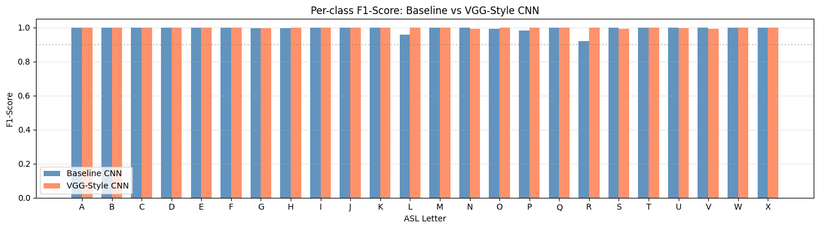
Figure 5: Per-class F1-scores for Baseline CNN and VGG-Style CNN on the test set.
Figures 6 and 7 show sample predictions from the baseline and VGG-style models respectively. All 20 displayed predictions are correct for both models (shown in green), reflecting the high overall accuracy. The samples include visually demanding cases such as R, L, G, and J, all correctly identified. This is consistent with the quantitative results, where errors are rare and concentrated in a small number of ambiguous classes rather than distributed across the full alphabet.

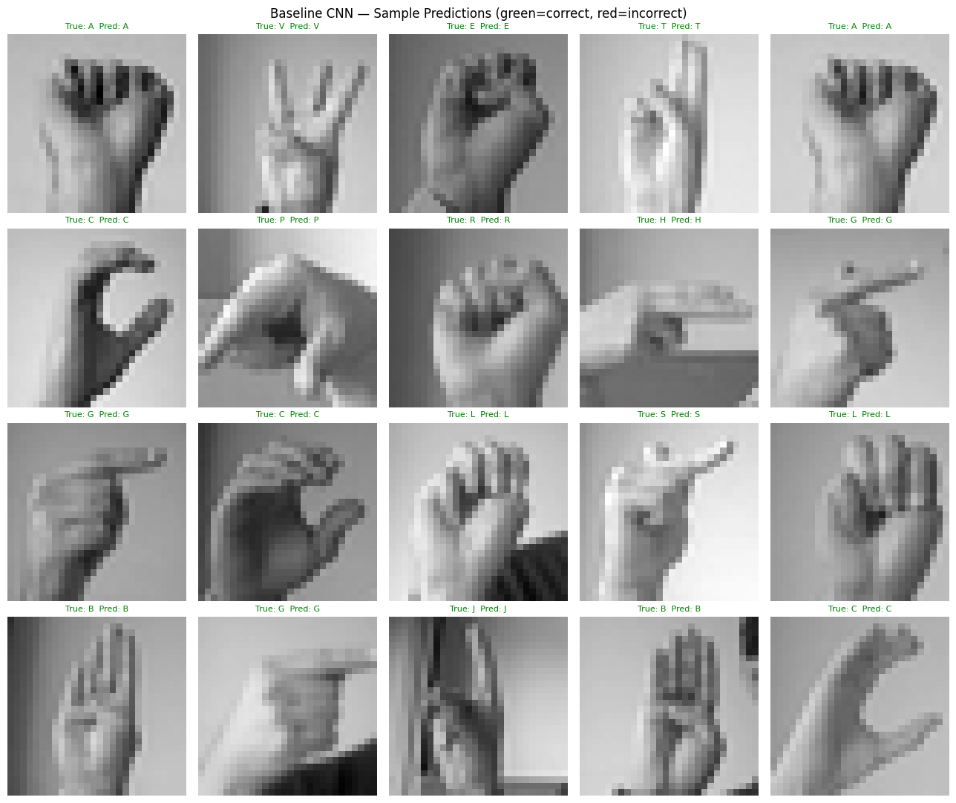
Figure 6: Sample test predictions from the Baseline CNN. Green labels indicate correct predictions.

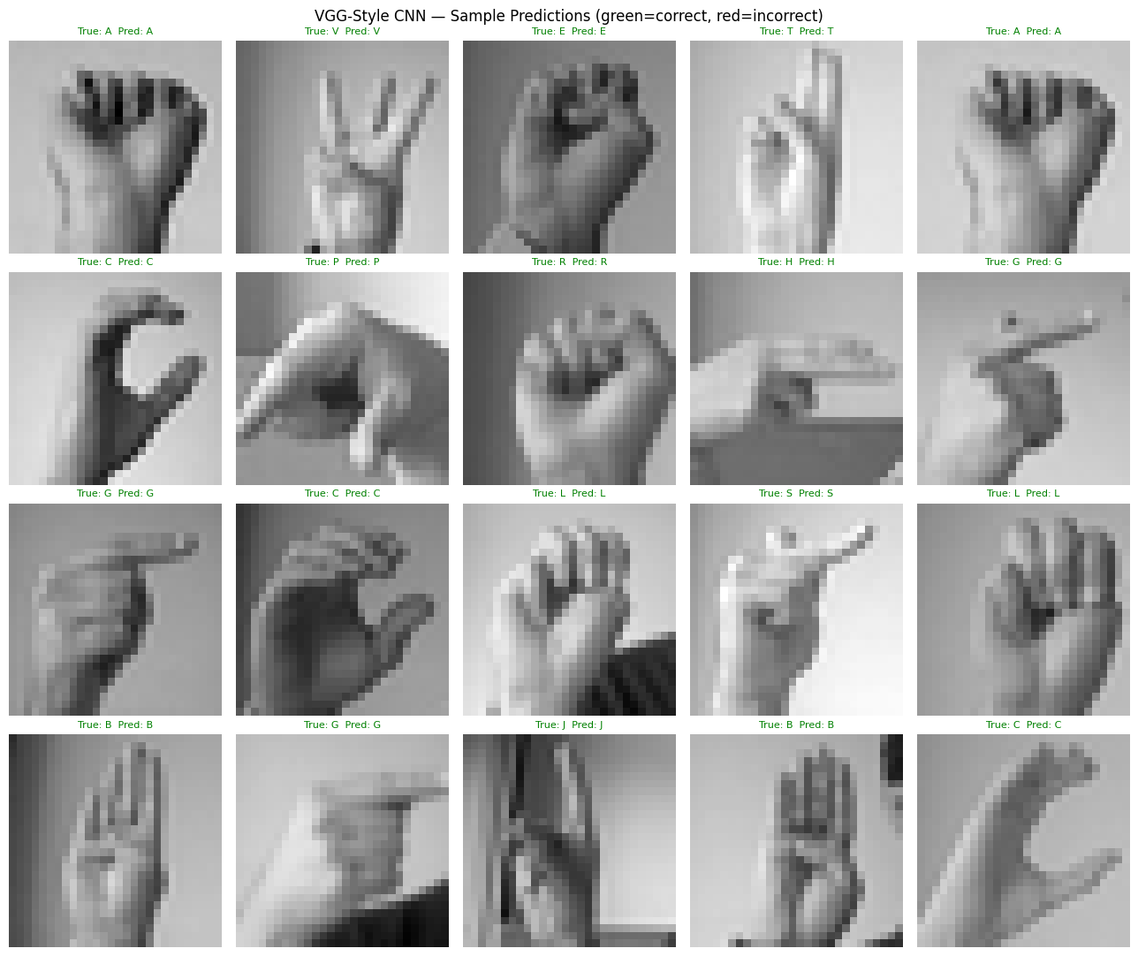
Figure 7: Sample test predictions from the VGG-Style CNN. Green labels indicate correct predictions.

4. Reflection

4.1 Dataset Limitations
The Sign Language MNIST dataset has well-documented limitations. The images were generated synthetically from a small number of source hands using graphical processing, meaning there is very little genuine variation in skin tone, hand size, background, or lighting across samples. This explains the suspiciously high validation accuracy. The validation split contains images generated from the same source distribution as training, rather than representing independent real-world variation.
A direct consequence is that accuracy figures are likely overstated relative to real-world deployment. A model trained on this dataset would be expected to perform significantly worse on real hand photographs due to domain shift. Rigorous evaluation would require an independently captured held-out set with genuine variation in hand appearance, background, and lighting.

4.2 Model Limitations
Both models accept only static, isolated 28x28 images and cannot handle continuous signing, dynamic signs requiring video, or diverse real-world conditions. There is also no uncertainty quantification. A soft confidence score would be preferable in assistive technology contexts where a misclassified letter has real consequences.

4.3 Overfitting and Underfitting
Neither model shows classical overfitting. Generalisation gaps are small and test accuracy tracks validation accuracy closely. However, near-perfect validation accuracy reflects the dataset's low internal diversity more than genuine generalisation. Both models are fitting tightly to the dataset distribution even if not overfitting the training split. Elastic deformations, random occlusion, or cutmix augmentation combined with a small real-world validation set would give a more reliable indication of true generalisation.

4.4 Possible Improvements
Several directions could improve both robustness and real-world applicability.
- Transfer learning from a hand-detection backbone (for example MediaPipe Hands or a model pre-trained on EgoHands) would provide features grounded in real hand morphology rather than synthetic pixel statistics.
- Using higher-resolution images (64x64 or 128x128) with colour channels would preserve more spatial information and allow the network to exploit skin-tone cues.
- Class-conditional augmentation, applying heavier rotation to letters such as R and L where orientation is the primary distinguishing feature, could target the residual confusion identified in the confusion matrix.
- Ensembling the baseline and VGG models at inference time would reduce variance at negligible additional training cost, since both are already trained.
- This work demonstrates that CNN-based hand recognition generalises significantly better when trained on continuous, real-world signing data rather than isolated static frames, a limitation directly applicable to the dataset used in this assignment.

Reference
Koller, O., Zargaran, S., Ney, H., and Bowden, R. (2016). Deep Hand: How to Train a CNN on 1 Million Hand Images When Your Data is Continuous and Weakly Labelled. Proceedings of the IEEE Conference on Computer Vision and Pattern Recognition (CVPR), pp. 3793-3802.

