Employee Notification Application Description

Demo link: <http://goo.gl/ryagGK> or [https://employeenotification-440d8.firebaseapp.com](https://employeenotification-440d8.firebaseapp.com/)

Git Repo: <https://github.com/Ashot72/employee-notification-PWA>

How to run the application: <https://ashot72.github.io/employee-notification-PWA/index.html>

Please read "How to run the application" first.

This application is developed on Ionic3 (Angular 4) platform. It users the latest features of ionic; deep linking, lazy loading, desktop support etc.

Ionic was originally built with mobile applications in mind. Now, it became great solution for progressive web and desktop applications.

First component is "split pane" which makes easy to create a multi-view layout.

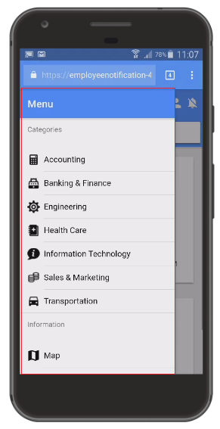

Figure 1

This is the split pane view on mobile.

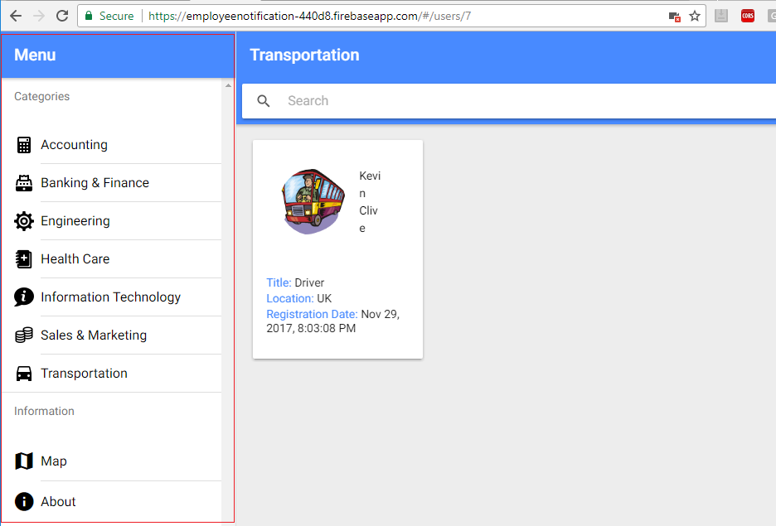

Figure 2

Split pane view on desktop.

Second one is all-new responsive grid system that makes it easy to build UI that scales up from mobile through table and desktop displays.

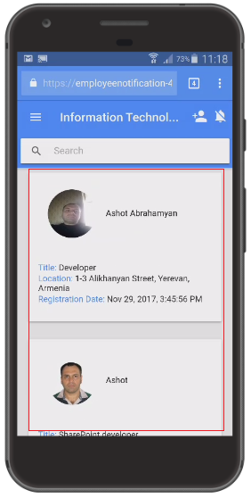

Figure 3

Grid view on mobile.

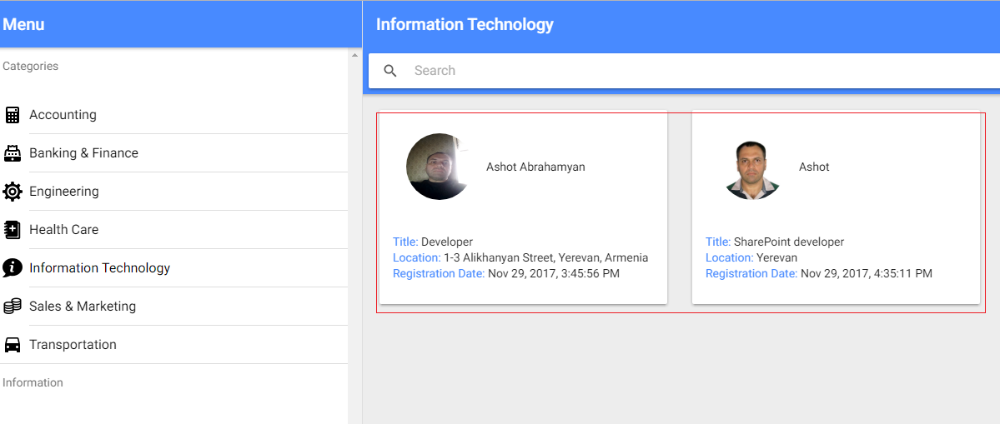

Figure 4

Grid view on desktop.

Ionic does not reply on URL routing for navigation and by default the URL for an Ionic application never changes when navigating the application.

If you want to link something in the application you would force to start on the applications first page.

Deep linking allows you to link to specific content in the application via the URL. It is done via @IonicPage decorator.

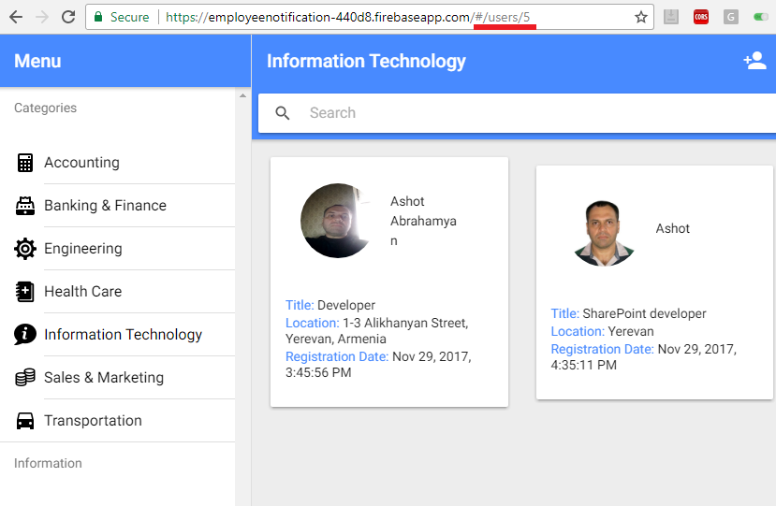

Figure 5

When you reload the page, it will not go to staring page. It will just reload the current one.

With Ionic lazy loading we are taking one segment of code, chunk and loading it on demand as the app requests it.

Ionic allows to preload modules based on priority if preloading is turn on. The following vales are possible for priority: "high", "low" and "off",

In our application we preload all modules by giving them priority in @IonicPage decorator.

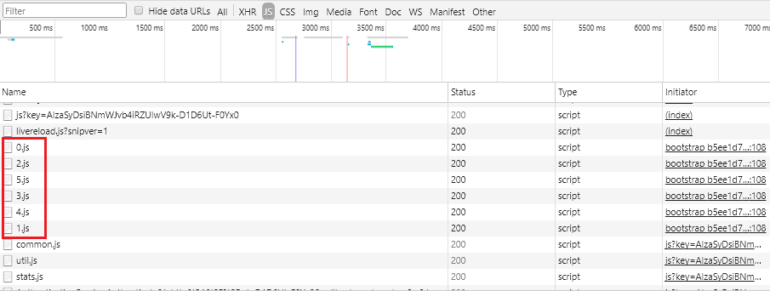

Figure 6

Our application "build chunks" loaded based on preloading priority.

You should consider and implement the following points if you really want to have full featured PWA.

1. Web App Manifest
2. Service Workers
3. Background synching
4. Push notifications

The Web app manifest provides information about an application (such as name, author, icon, and description) in a JSON text file.

The purpose of the manifest it to install web applications to the home screen of a device, providing users with quicker access and a richer experience.

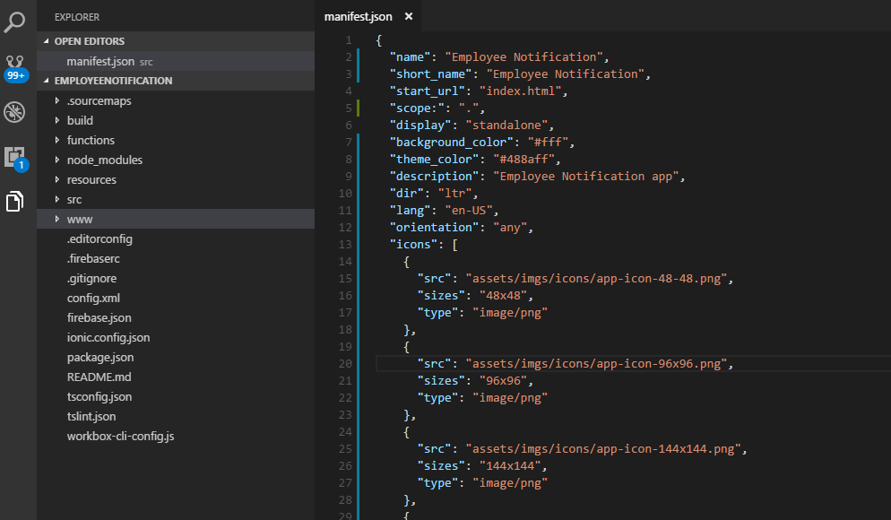

Figure 7

This is Employee Notification web app manifest file.

Service Workers are the core of PWA techniques for resource-caching and push notifications. It is a huge topic. You definitely have to spend some time to learn it.

Resource-caching the most important thing of PWA. Let's go through caching strategies first then look at the Employee Notification app implementation.

Web applications used to be entirely dependent on the server. All data, content, design and application logic were sored on the server.

The client just renders some HTML to the screen. This means that we should think about Offline-First case. With Offline-fist, offline and low connectivity conditions

should not be treated as a catastrophic failure, but just another possible state of Web apps. That is why we should learn about common caching strategies.

**Common Strategies**

*Cache Only*

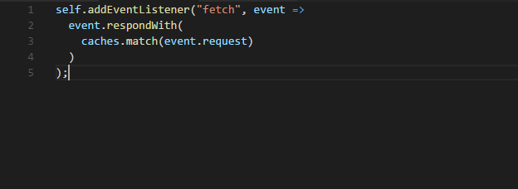

Figure 8

Respond to all requests for a resource with a response from the cache. If it is not found in the cache, the request will fail. The patter assumes that the

resource has been cached before, most likely as a dependency during the service worker's installation. This is useful for static resources that do not change

between releases, such as logos, icons, stylesheets. This does not mean you can never change them. It simply means they do not change within

the lifetime of a single version of your app.

*Cache, falling back to network*

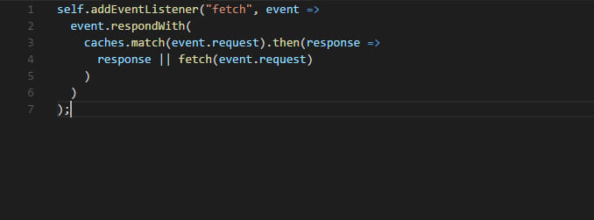

Figure 9

Similar to cache only, this pattern will respond to requests with content from the cache. If, however, the content is not found in the cache,

the service worker will attempt to fetch it from the network and return that.

*Cache, falling back to network with frequent updates*

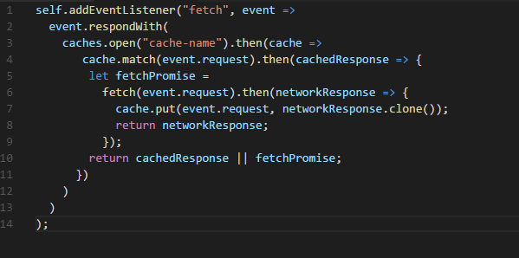

Figure 10

For resources that do change from time to time, but where showing latest version is less important that returning a fast response, we can

modify the cache, falling back to network pattern to always fetch the requested resources from the network even when it is found in the cache.

The pattern delivers a fast response from the cache, while fetching a more-up-to-date version and caching it in the background. Any changes to the

resource fetched from the network will be available the next time the user requests this resource.

*Network Only*

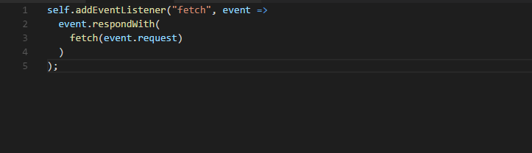

Figure 11

The classic model of the web. Try to fetch the request from the network. If it fails, the request fails.

*Network, falling back to cache*

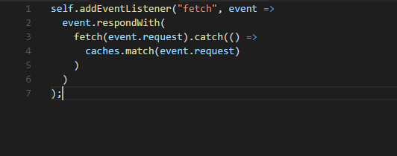

Figure 12

Always fetch the request from the network. If the request fails, return the version from the cache. If it is not found in the cache, the request will fail.

*Network, falling back to cache with frequent updates*

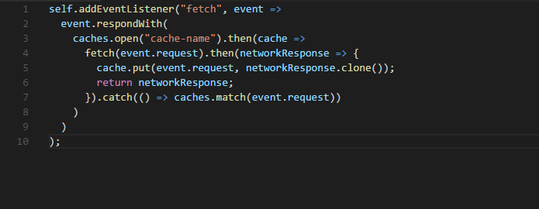

Figure 13

When it is important to always server the latest version of resource available, we cam use this pattern. Like the original

pattern, this one always attempts to fetch the latest version from the network, falling back to the cached version only if the network fails.

In addition, every time the network is accessed successfully, it updates the cache with the network response.

*Cache, then network*

Display data from the cache immediately while checking the network for a more up-to-date version. As soon as a response is returned from

the network, check if it is never than the cache and update the page with the fresh content. You have to modify your app to make two requests,

display cache content, and finally update the page with never content when it becomes available.

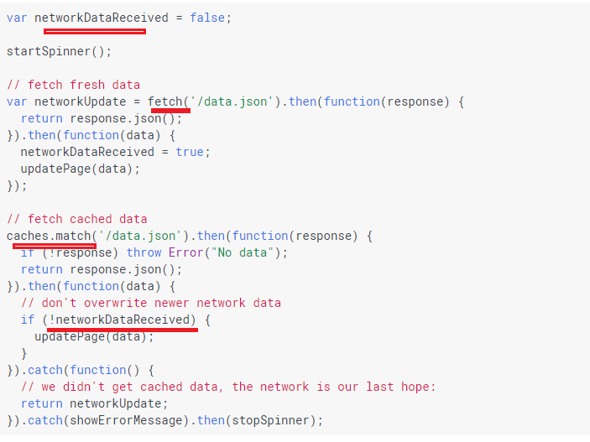

Figure 14

Cache, then network sample code.

*Generic fallback*

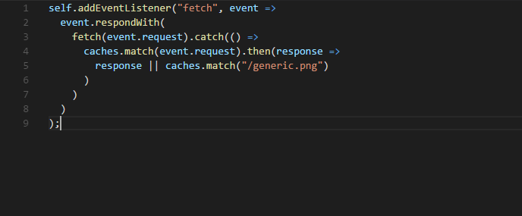

Figure 15

When the content the user asked for could not found in the cache, and network is not available, this pattern returns an alternative 'default fallback'

from the cache instead of returning an error.

I cannot cover all Service Worker functionality. I will show which strategies I used in our application.

First, I will show how to do it using fetch, then I will create another service worker using Workbox <https://developers.google.com/web/tools/workbox/>

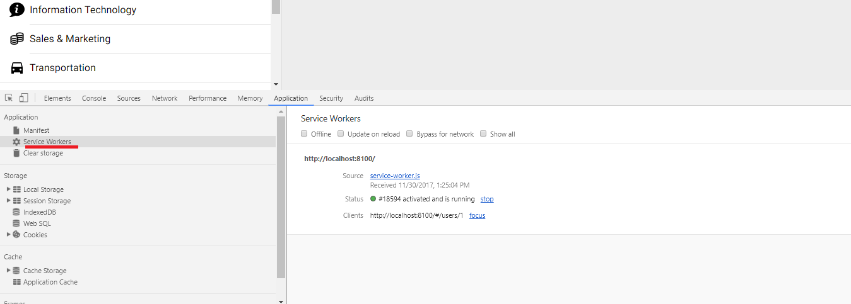

Figure 16

It is easy to test and debug service workers using chrome browser's Service Workers. You can test your app while you are offline,

install new service worker, update, unregister etc.

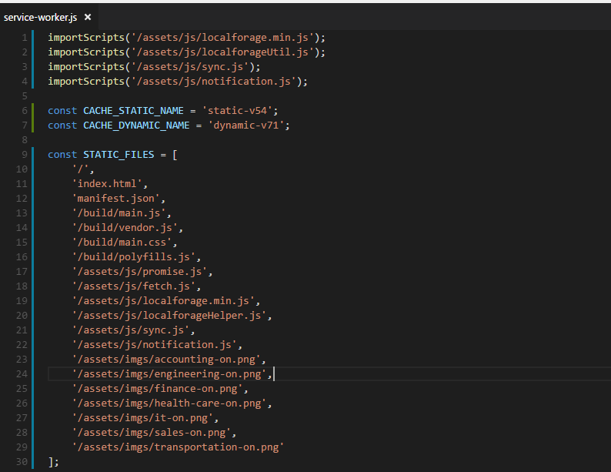

Figure 17

We define static assets to precache.

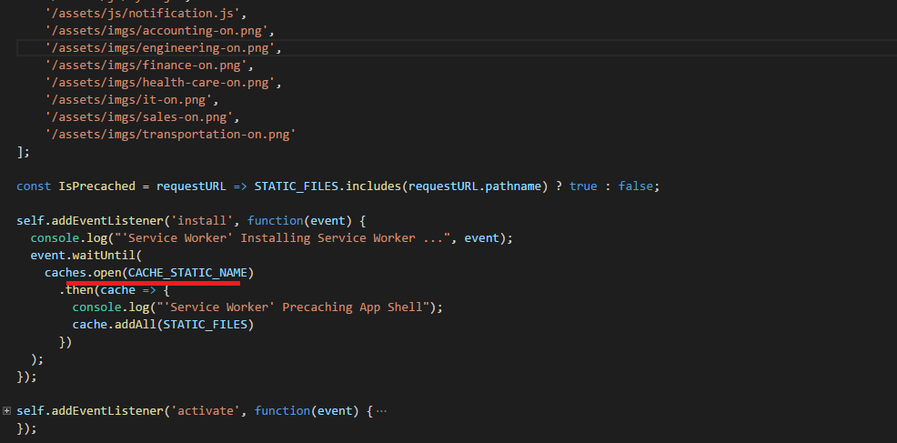

Figure 18

Precaching static files adding them to CACHE_STATIC_NAME cache.

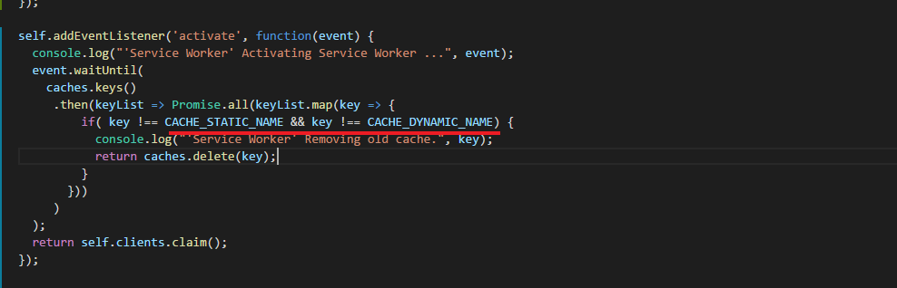

Figure 19

We should also remove old cache either static or dynamic.

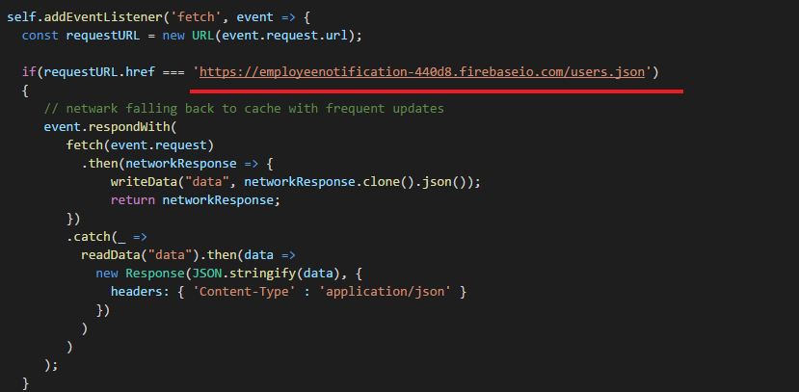

Figure 20

If request is coming from users.json we put it into IndexedDB (will look into it later). We use *network falling back to cache with frequent* *updates* strategies.

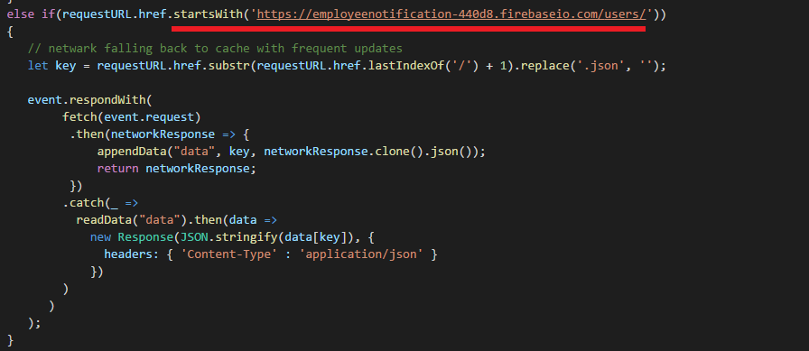

Figure 21

The same strategy for an applicant (applicant's details page).

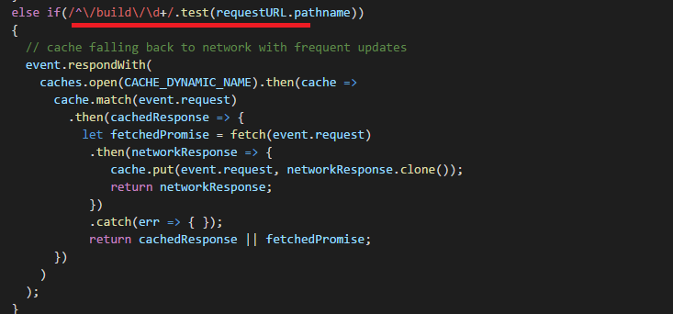

Figure 22

For build chunks (Figure 6) *cache falling back to network* *with frequent updates* strategy is used.

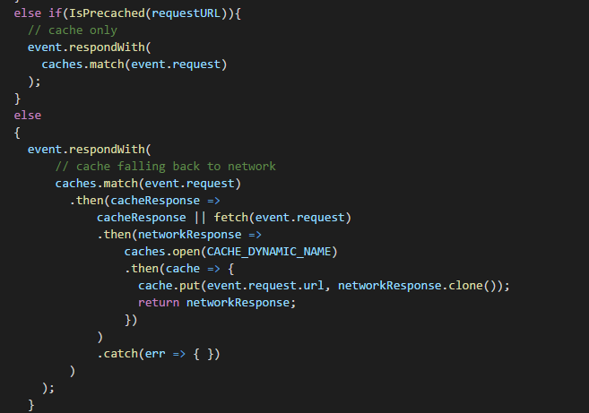

Figure 23

For static assets *cache only,* strategy is used. For other cases *cache falling back to network* strategy is used.

*Cache only* strategy here is kind of redundant but I show it for demo purposes. Caching is mostly useful for static assets.

You can cache JSON data without a problem. But for dynamic data IndexedDB is better option. Almost all browsers support it.

IndexedDB is a low-level API for client-side storage of significant amounts of structured data, including files/blobs. It asynchronous and supports transactions.

It is really not fun to work with IndexedDB directly. For that reason, we will use localForage instead.

<https://localforage.github.io/localForage/#data-api-getitem>

It is super easy to work with it. LocalForage is a JavaScript library that improves the offline experience of your app by using an asynchronous

data store with a simple, localStorage-like API. localForage includes a localStorage-backed fallback store for browsers with no indexedDB or WebSQL support.

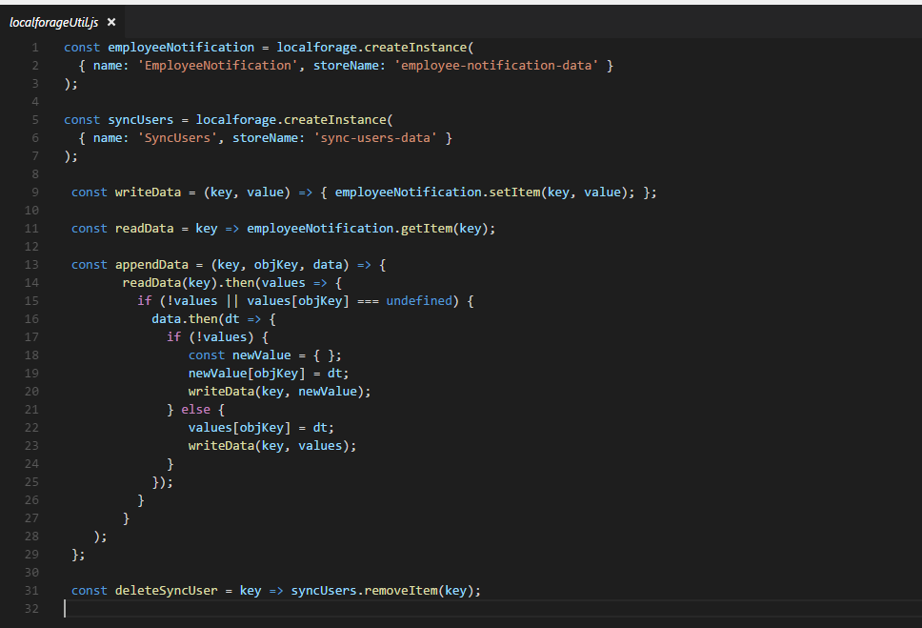

Figure 24

We create two localForage instances.

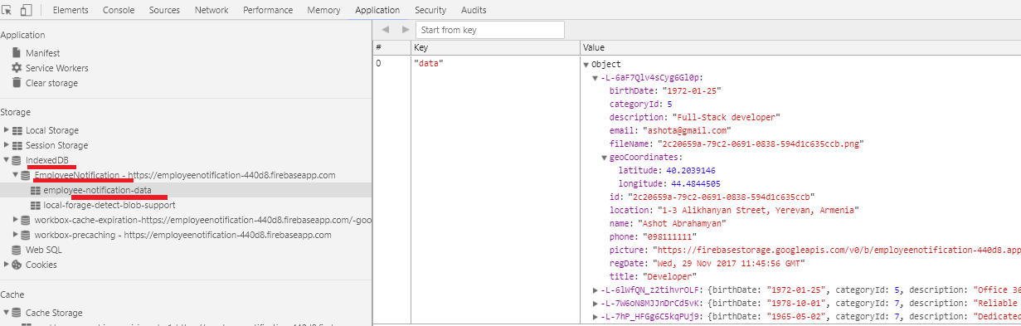

Figure 25

EmployeeNotification instance keeps applicants' data. 'SyncUsers' instance keeps the applicants' data needs to be synchronized.

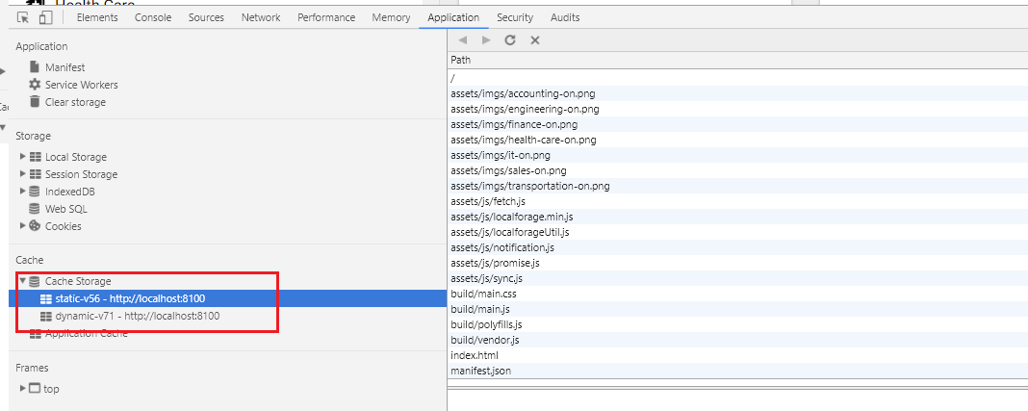

Figure 26

Our app's static and dynamic caching in Chrome dev tool.

Workbox is a collection of libraries and build tools that make it easy to store your website's files locally, on your users' devices.

I am going to implement caching using Workbox. I use workbox-cli which is a CLI tool to generate a service and a

file manifest making use of the workbox-sw module.

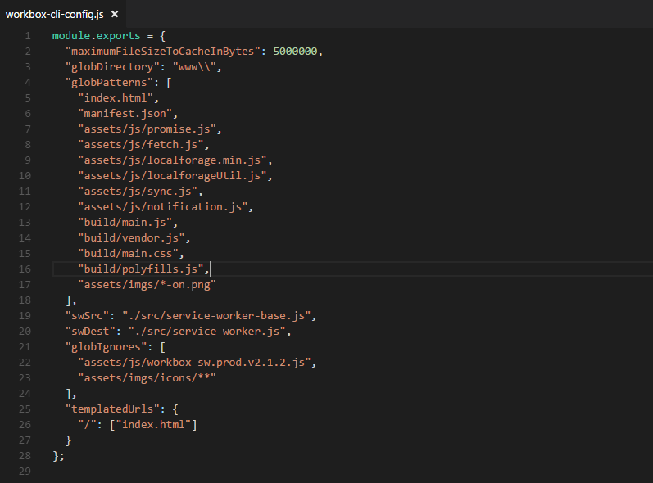

Figure 27

This is our app's workbox-cli-config file where we define entries to be pre-cached and ignored and other properties.

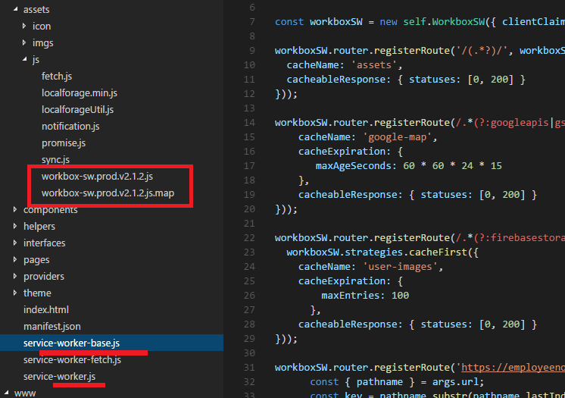

Figure 28

package.json script section defines "generate-sw": "workbox inject:manifest" command. Running it, service-worker.js file is generated based on service-worker-base.js.

If you decide to change something in service-worker.js file then you have to run generate-sw command to generate new service-worker.js file.

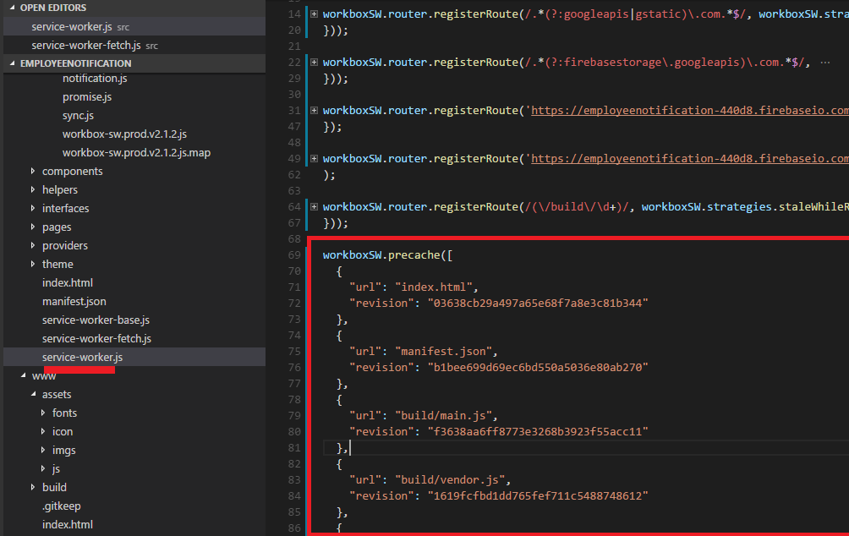

Figure 29

workboxSW.precache([]) - precached entries section is generated based on workbox-cli-config.js. Other sections, dynamic ones

will be programmed by us using workbox routing.

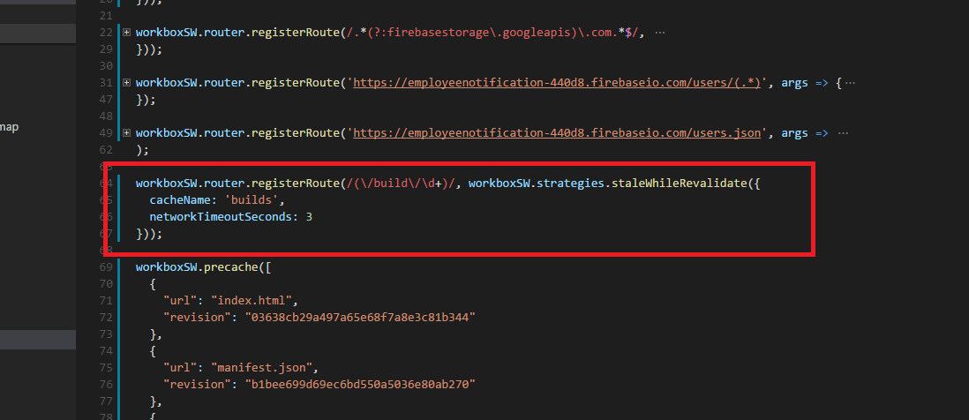

Figure 30

Route matching build chunks makes use of staleWhileRevaliate strategy. Resources are requested from both the cache and the network in parallel,

then responds with the cached version. The cache is replaced with whatever returns from the network. The cache name is "builds".

One important property is networkTimoutSeconds one which is 3 seconds. If we do not define the property and

network is very slow then it will take longer to get the response. After 3 seconds the response will be returned from the cache.

Unfortunately fetch does not support timeout property natively now.

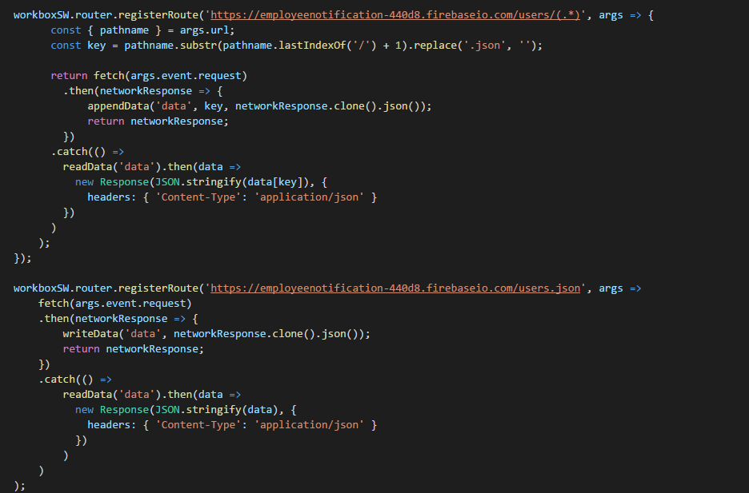

Figure 31

We match all applicants and an applicant route. Workbox does not work with IndexedDB directly so we just put almost the same code what

we defined in fetch implementation of service worker (Figures 20, 21).

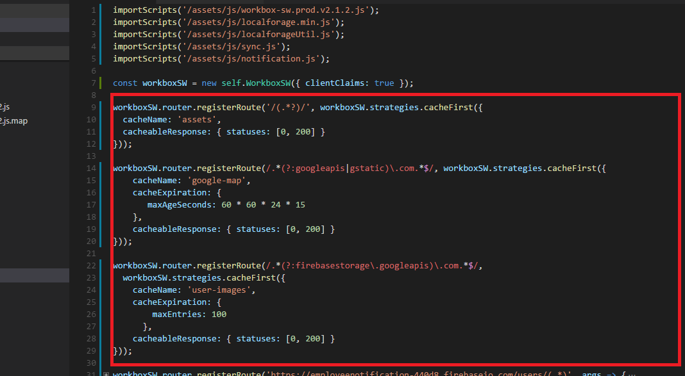

Figure 32

For the rest we use cahceFirst strategy. First, we define cachExpiration -> maxProperty for user-images cache.

CacheExpiration is used to remove entries form a cache based on criteria. 'maxEntries' is the maximum number of entries to cache.

Entries will be expired using a latest recently used policy once the cache reaches the threshold. 'maxAgeSeconds' is the maximum

age of entry before it's treated as staled and removed. There an issue with maxAgeSeconds I experienced which is not documented.

Say we defined maxAgeEntry 5 minutes. You went offline and the items were delivered form the cache. Everything works fine until 5 minutes passed.

After 5 minutes the cache is removed based on maxAgeEntry. The application is crashed as files have gone.

maxAgeEntry does not take into consideration that the app is offline.

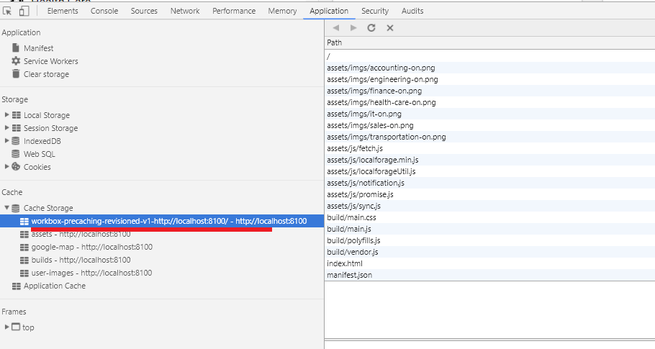

Figure 33

Precached assets in Cache Storage chrome dev tool.

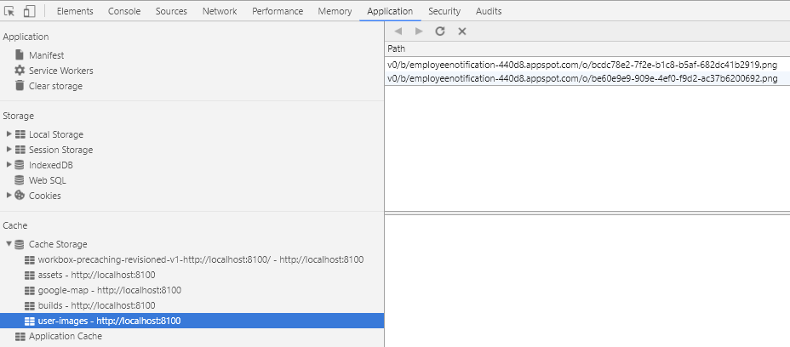

Figure 34

user-mages dynamic caching.

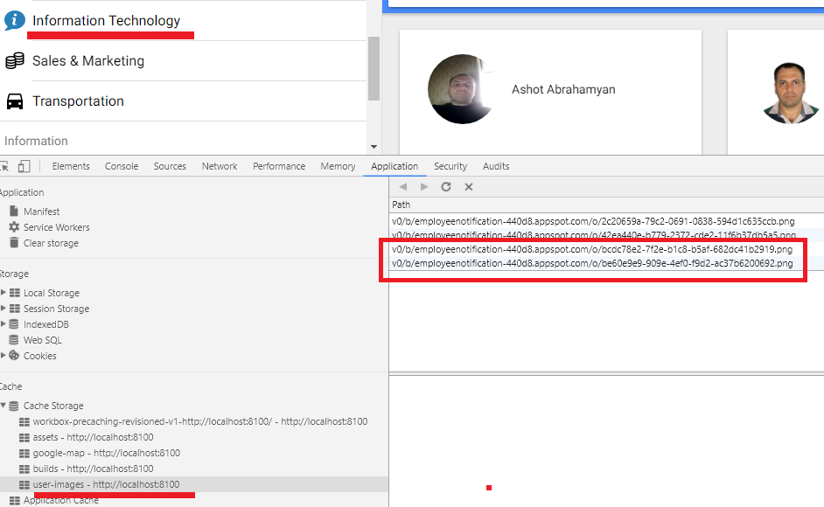

Figure 35

If you navigate to a category that has not been navigated before you will see that applicants' pictures will be added to "user-images" cache dynamically.

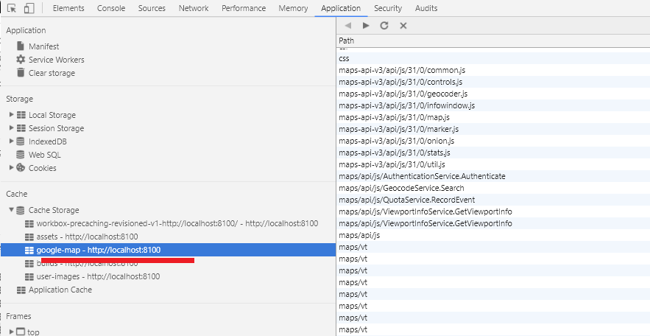

Figure 36

google-map cached assets.

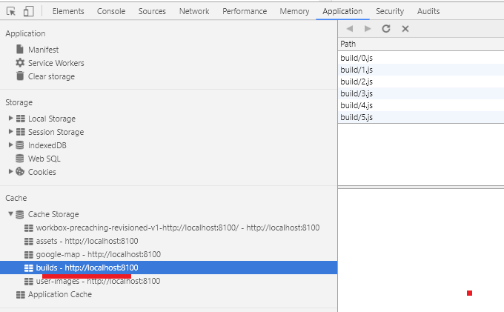

Figure 37

"builds" build chunks cached.

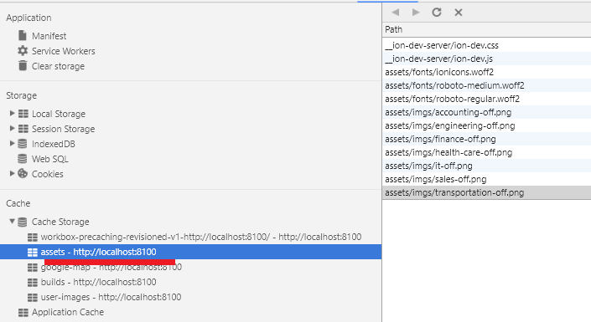

Figure 38

"assets" cached.

I have an issue with workbox caching. To tell the truth I do not know if it is an issue or the right behavior.

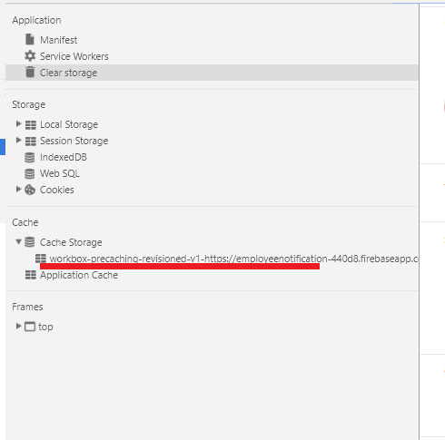

Figure 39

When you run the application for the first time only static cache is generated. Dynamic cache is only generated on second page refresh.

This is annoying. if you go to offline right after running the application for the first time then the app will not work as

expected as dynamically cached assets will not be there.

We hosted the application on Firebase using Cloud Functions for Firebase. We could have our node/express server installed but

it is easier to user Firebase instead of ours. Cloud functions for Firebase lets you automatically run backend code in response to events triggered

by Firebase features and HTTPS requests. Your code is stored in Google's cloud and runs in a managed environment.

<https://firebase.google.com/docs/functions/get-started> link explain how to write and deploy functions. Definitely check video tutorial in that link.

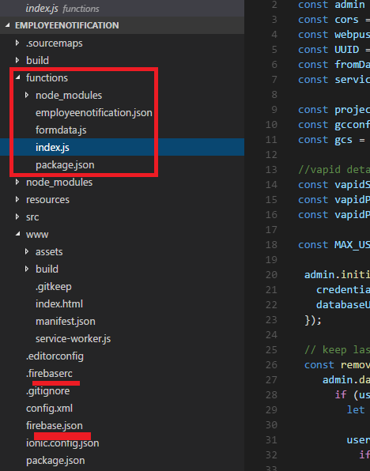

Figure 40

You will see "functions" folder generated and some firebase files after the successful installation.

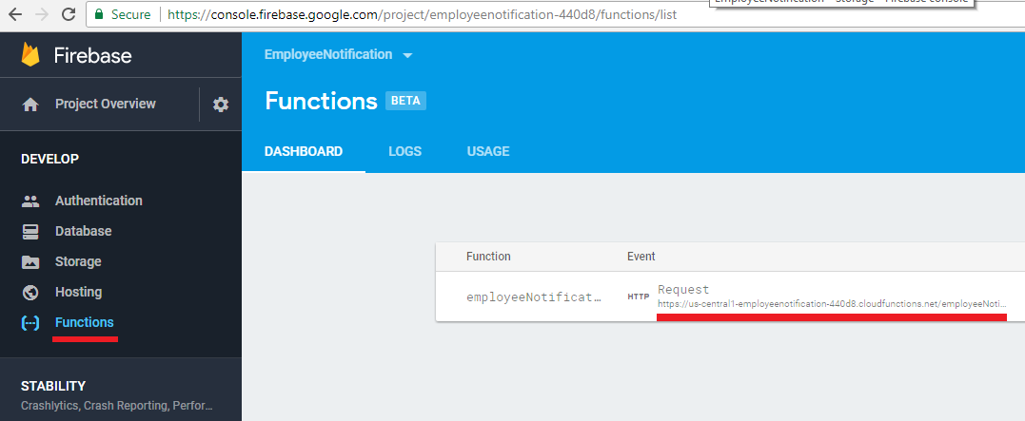

Figure 41

This is Employee Notification firebase functions page and the endpoint is <https://us-central1-employeenotification-440d8.cloudfunctions.net/employeeNotification>

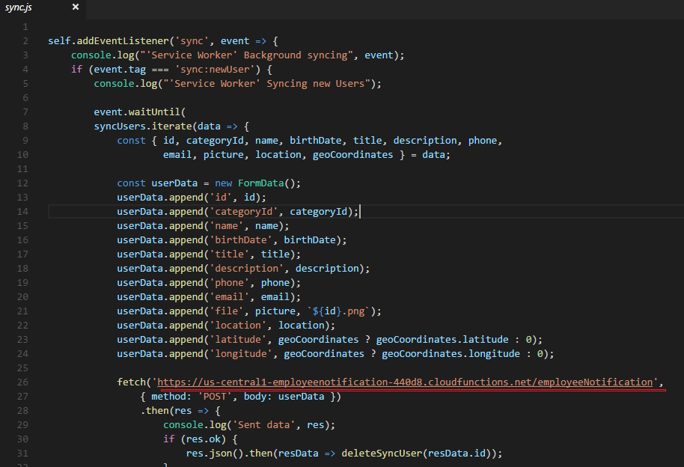

Figure 42

We fetch that endpoint with an applicant 's form values.

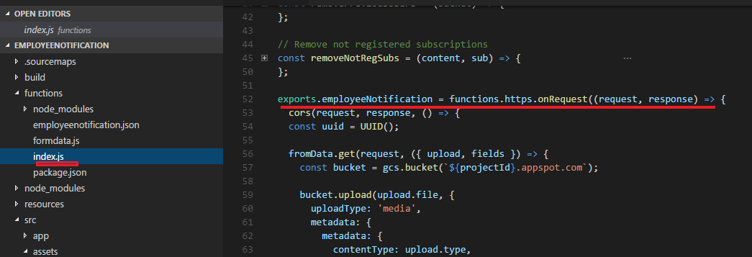

Figure 43

Request is passed to Firebase onRequest handler.

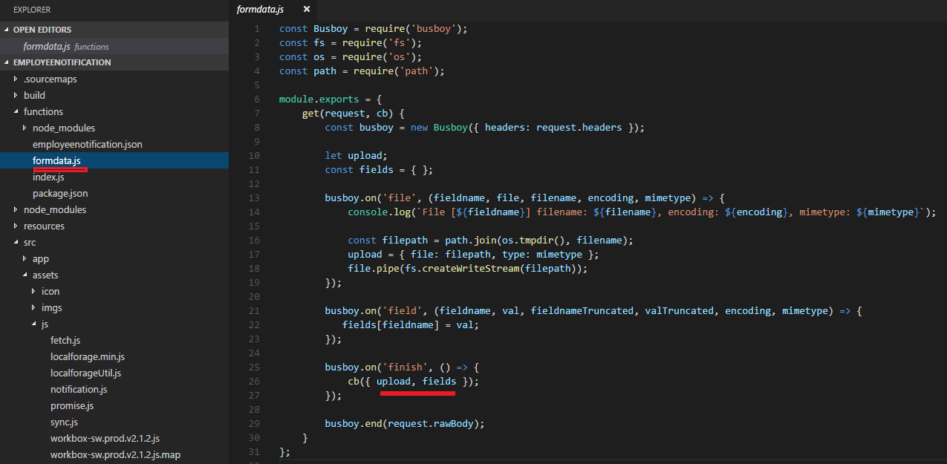

Figure 44

We obtain form data and uploaded picture using famous Busboy npm package.

In order to install applicants' information into database we have to initialize the app store to access the Firebase database.

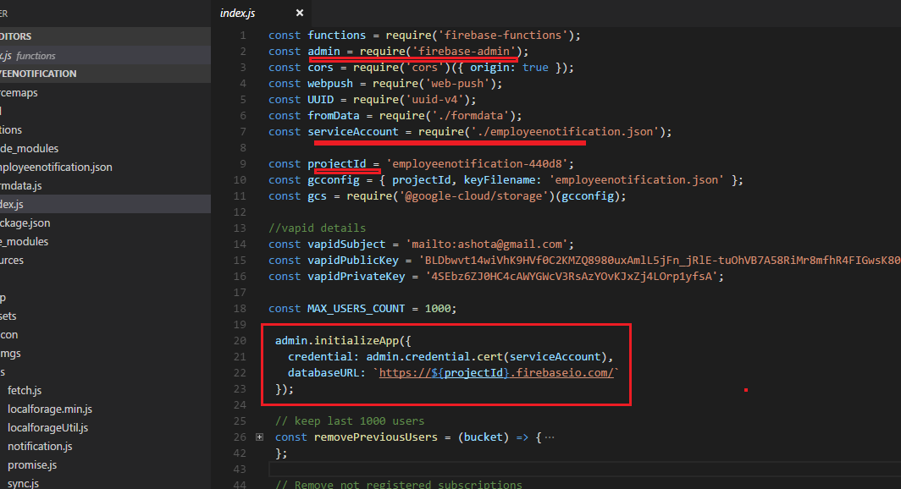

Figure 45

To initialize the app, we need two things. We need tell where our database lives and key file.

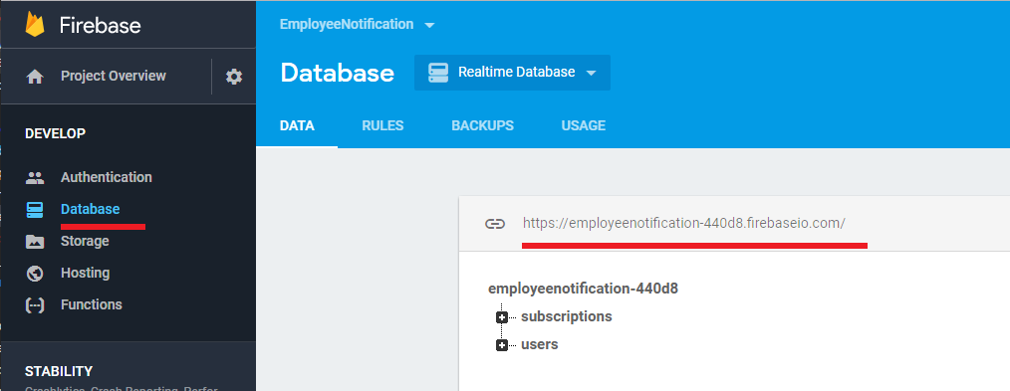

Figure 46

It is simple to get the database location.

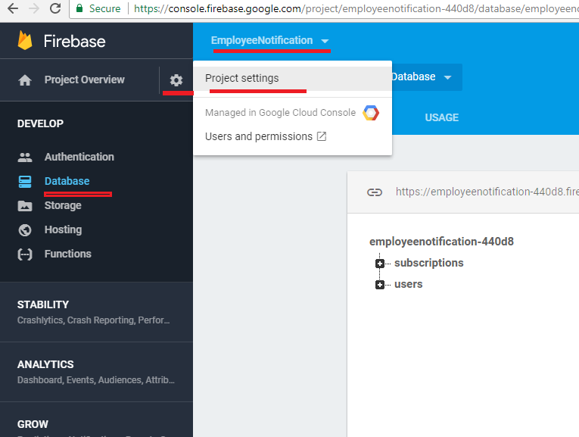

Figure 47

In order to retrieve key file, you should click settings gear then go to Project settings page.

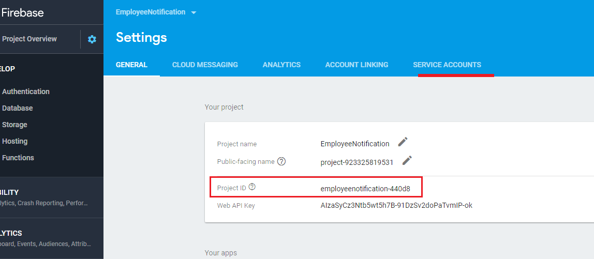

Figure 48

You see Project ID that is also used in application (Figure 45). Click "SERVICE ACCOUNTS" link.

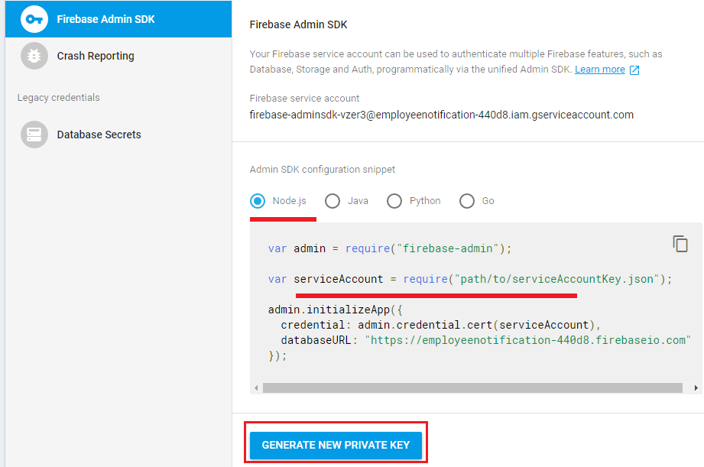

Figure 49

Click GENERATE NEW PRIVATE KEY button.

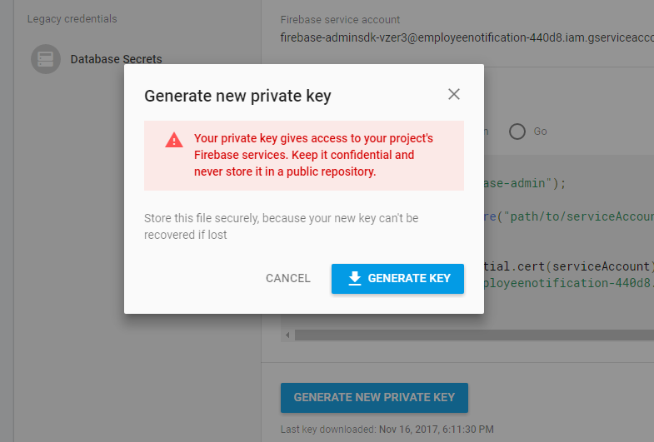

Figure 50

Generate a key and download it. It is a JSON file.

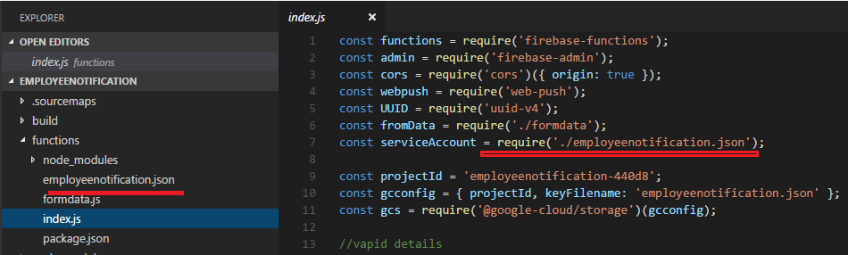

Figure 51

I renamed the file I downloaded to "employeenotification.json" and point to the right location for serviceAccount.

Note, this file will be git ignored and will not be in the source code.

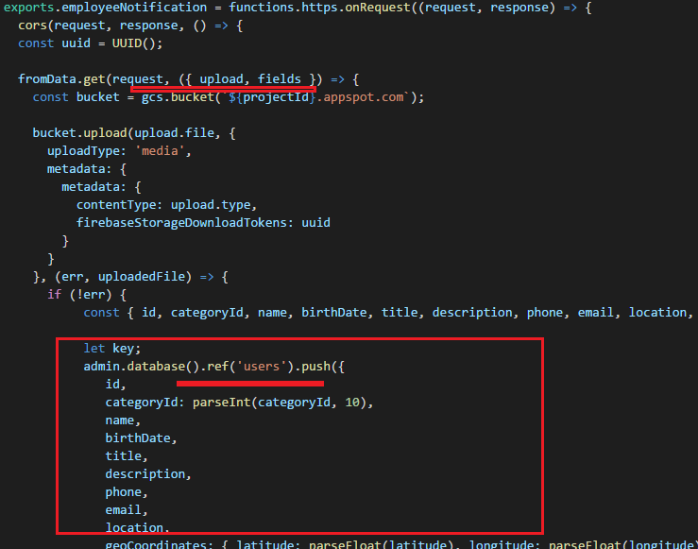

Figure 52

We got the access and can insert applicants' data.

To send secure push messages from client to server we use VAPID <https://blog.mozilla.org/services/2016/04/04/using-vapid-with-webpush/>

VAPID uses two keys private and public. We use public key in our JavaScript code on the client and private keys on the server. This way we protect

our server and make sure that we only send messages from our application server.

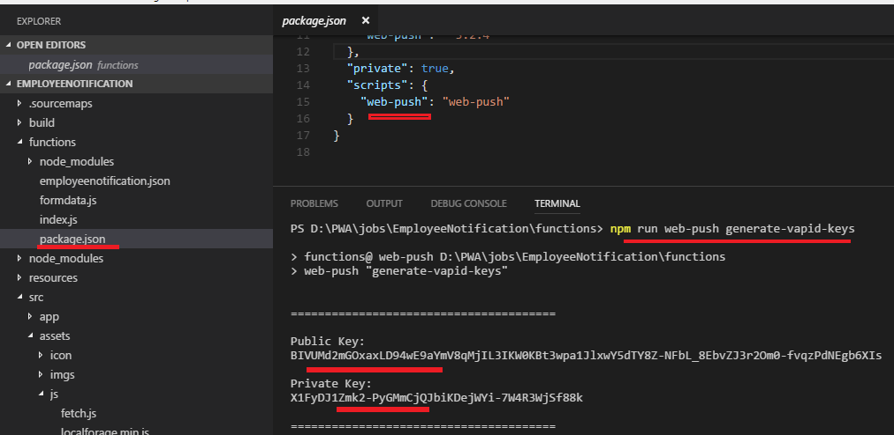

Figure 53

We installed web-push package and run "npm run web-push generate-vapid-keys" command. Both public and private keys generated.

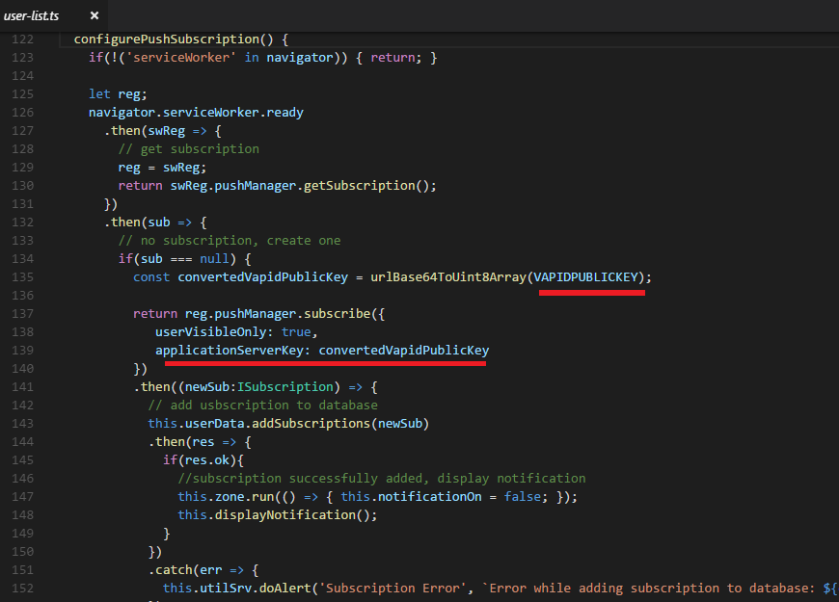

Figure 54

Vapid public key used in client code to add subscriptions to database.

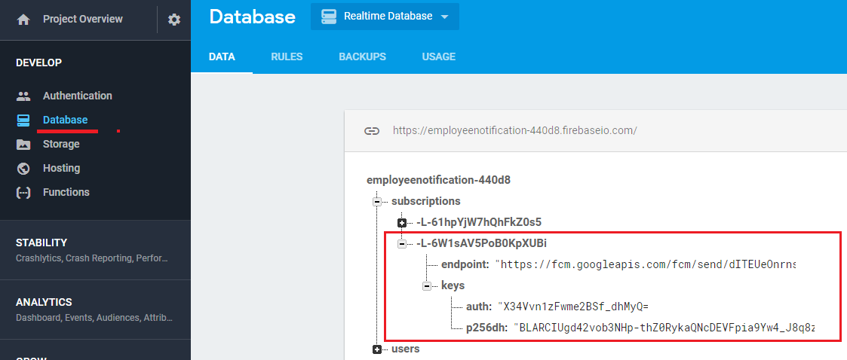

Figure 55

Subscription added to database. "endpoint" is one of Google's server that we can send push messages.

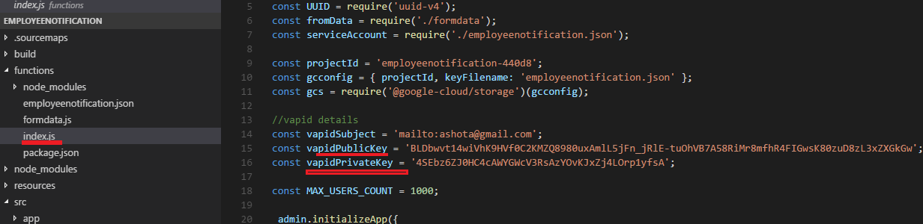

Figure 56

On Firebase side we define both vapid public and private keys.

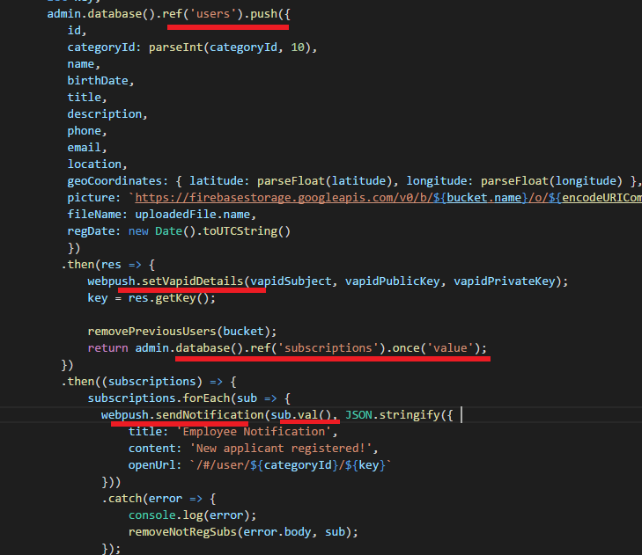

Figure 57

Once the applicant is added to database we set vapid details to push. Then iterate over subscriptions and send notifications.

sub.val() is the subscription object; endpoint, keys (auth, p256dh) Figure 55.

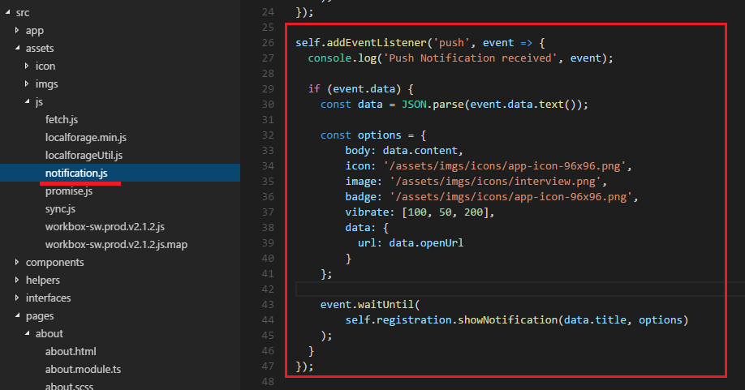

Figure 58

On the client side we listen to push, receive data and show notification.

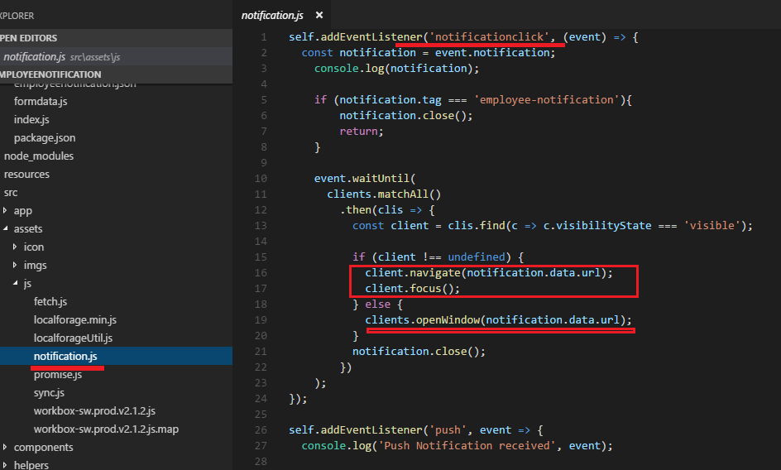

Figure 59

When notification is clicked we consider two options. We navigate to applicant's details page if the app window is open

or open the application and navigate to the applicant's details page.

It is time to save applicant's picture on the server. First, we install @google-cloud/storage npm package.

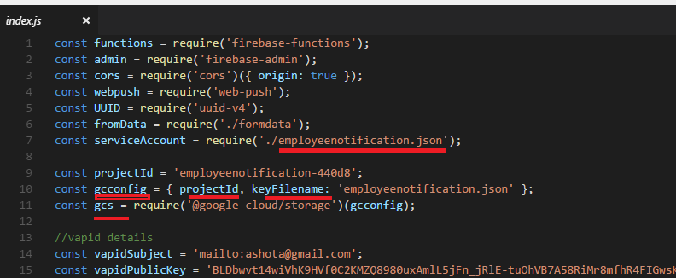

Figure 60

We define google cloud config which is gcconfig with takes two properties the projectId (Figure 48) and

keyFileName which is eployeenotification.json we already added to our project.

We also define gcs by passing the gcconfig. gcs which initializes google cloud storage to access.

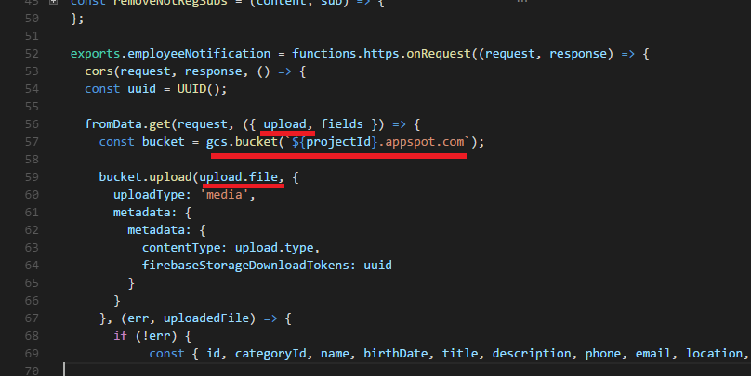

Figure 61

formData callback returns uploaded file (Figure 44). We need to obtain the bucket name to upload files.

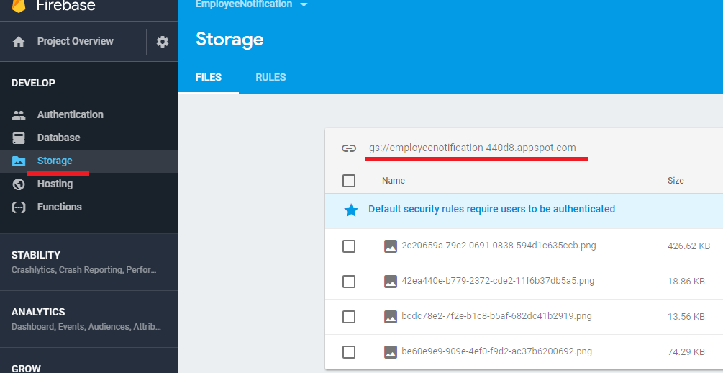

Figure 62

Bucket name can be found under the Storage. You could also see our applicants' pictures already uploaded there.

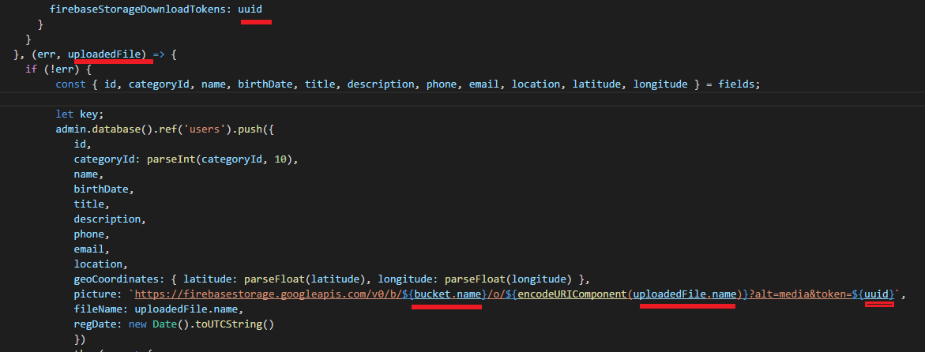

Figure 63

By knowing how Firebase creates links we can do it ourselves to generate picture link.

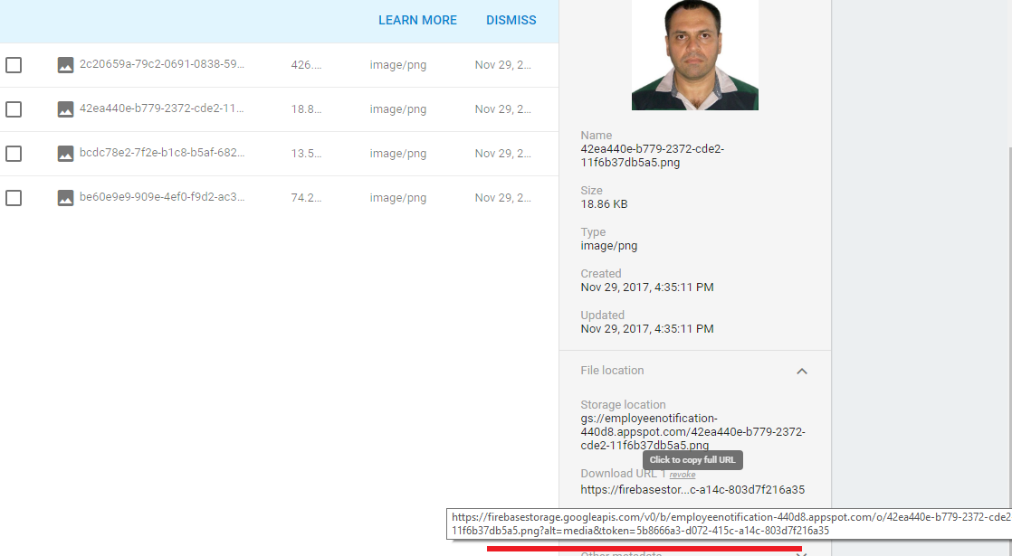

Figure 64

Unloaded applicant's picture link.

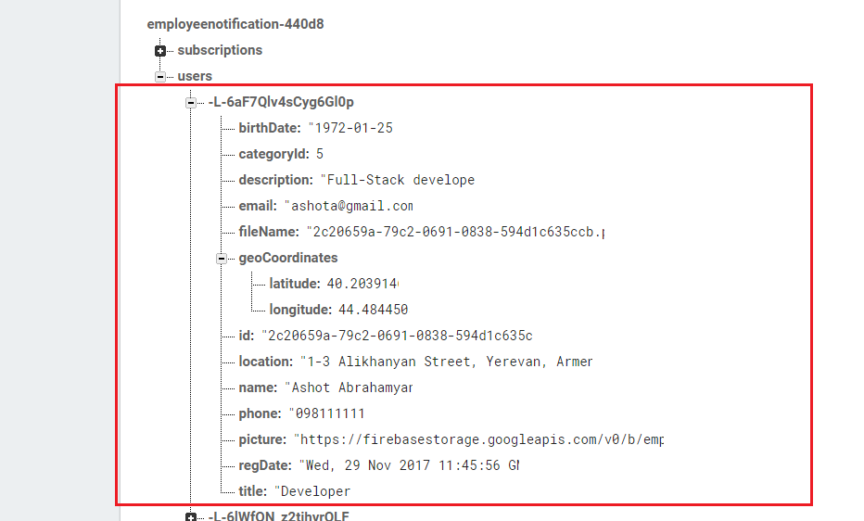

Figure 65

Applicant's fields in database.

There is one thing that should take into consideration regarding subscriptions. Users may subscribe and unsubscribe

multiple times or uninstall the application and install again. This means that that all existing subscriptions are useless because they

install completely new service worker. We somehow should remove useless subscriptions.

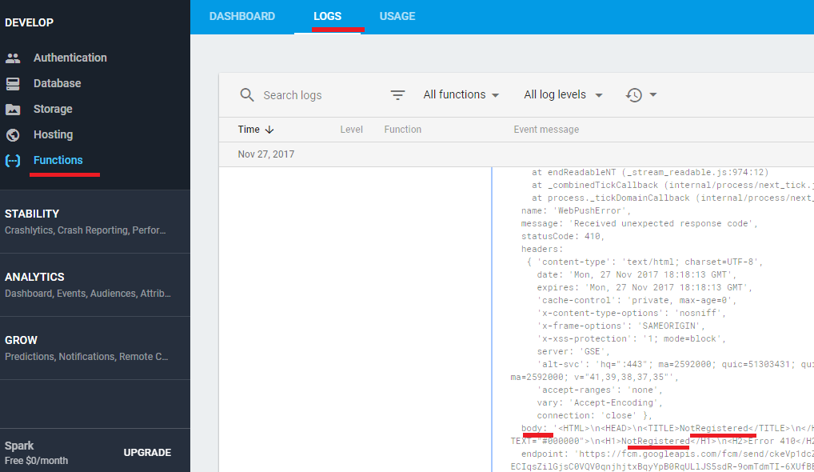

Figure 65

I tried to figure out how to do it by looking into the functions logs file. It seems that case we just get an exception with 'NotRegistered' word in body.

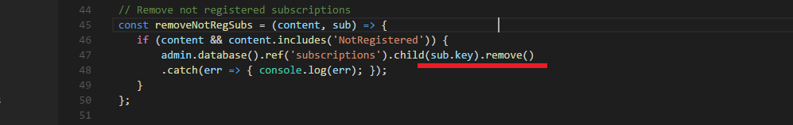

Figure 66

If we find 'NotRegistered' in the error we remove the subscription.

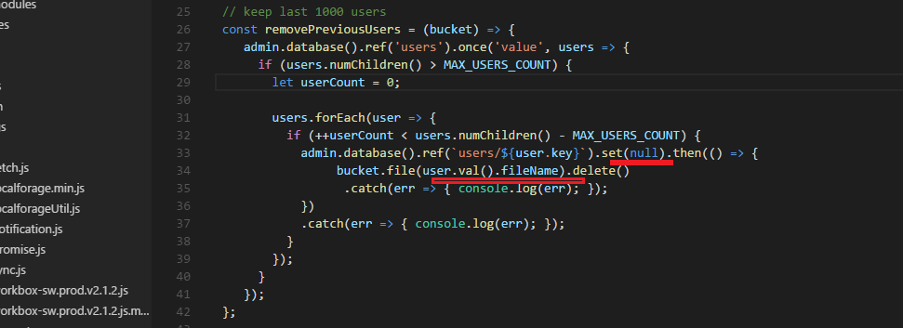

Figure 67

Another function is removePreviousUsers function. We remove previous users from database and bucket if they are more than 1000.