Logging

Docker logs cover two parts

* Logs/details displayed inside container in bash
* Logs created by docker daemon on host machine

## Logs from inside container

We can get info inside container bas using docker logs <<container id/name>> command

Container as shown below we can see output logged to container shell. This command shows all existing output and comes out

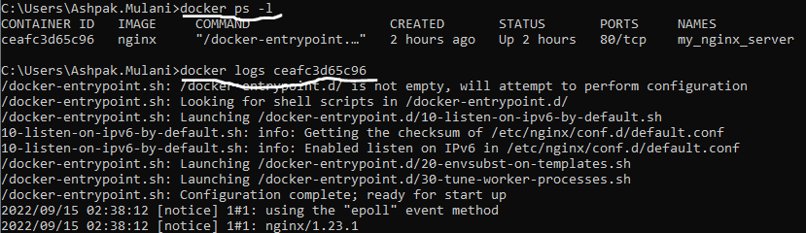

If we have to continue checking output then we can use -f (follow) option and if we also want time stamp then we can use -t option

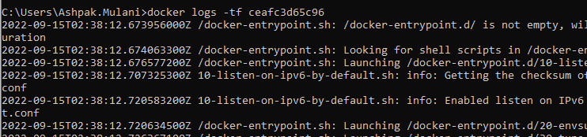

We can also add timestamp filter and get logs after given date

docker logs <<container id/name>> -t - -since 22-12-20

## Logs on host machine

Docker demon on host machine creates logs for container activities on host machine as well. Location for logs is dependent on host operating system. On windows logs are created in ‘programData’ folder. If we run ‘docker inspect <<dockerID>>’ command it gives us big json file as outcome we can find ‘LogPath’ key in it to find where logs are stored on host machine.

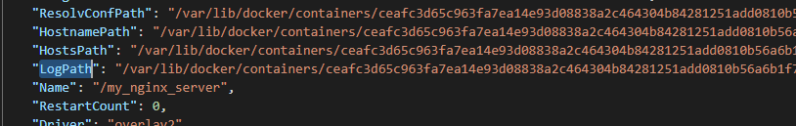

Or docker command itself supports format option for this inspect command,

