# Pipelines

Pipelines can be created using UI or Jenkinsfile

In Jenkinsfile we can create pipeline using

* Declarative pipeline
* Scripted pipeline

# Declarative Pipeline

Declarative pipeline can be defined in Jenkinfile as below.

We can define multiple stages (green box in UI) and steps into each stage.

Inside each step we can define actins using Jenkins supported command or using shell script commands.

pipeline {

    agent any

    stages {

        stage('Build') {

            steps {

                echo 'Building..'

            }

        }

        stage('Test') {

            steps {

                echo 'Testing..'

            }

        }

        stage('Deploy') {

            steps {

                echo 'Deploying....'

            }

        }

    }

}

Sample script to pull java project from SCM git and compile it

pipeline {

   // running pipeline using any agent

    agent any

    // start defining stage in pipeline. In this sample pipeline

    // we will have 'clean up', 'clone repo', 'build' and 'test' stages

    stages {

        stage("Clean Up"){

            steps {

                // in this stage remove all existing dirs from root of pipeline

                // before we start.

                deleteDir()

            }

        }

        stage("Clone Repo"){

            steps {

                // get or git clone code locally in root

                sh "git clone https://github.com/jenkins-docs/simple-java-maven-app.git"

            }

        }

        stage("Build"){

            steps {

                // go to cloned git directory

                dir("simple-java-maven-app") {

                    // maven command to clean existing compiled app 'clean'

                    // and install recompiles app and create executable or jar from java code

                    sh "mvn clean install"

                }

            }

        }

        stage("Test"){

            steps {

                dir("simple-java-maven-app") {

                    // maven command to run unit test cases

                    sh "mvn test"

                }

            }

        }

    }

}

Jenkins file code can be directly added to pipeline confg or can be referred from SCM.

Usually Jenkins file is kept in git/SCM repository then we don’t have to use ‘git clone’ stage in jenkinsfile.

## Jenkins with Git

We can configure and connect to git repo while creating pipeline, by providing repo URL, credentials and jenkinsfile path. (These steps are not required for public repo)

1. Git URL and mention branch

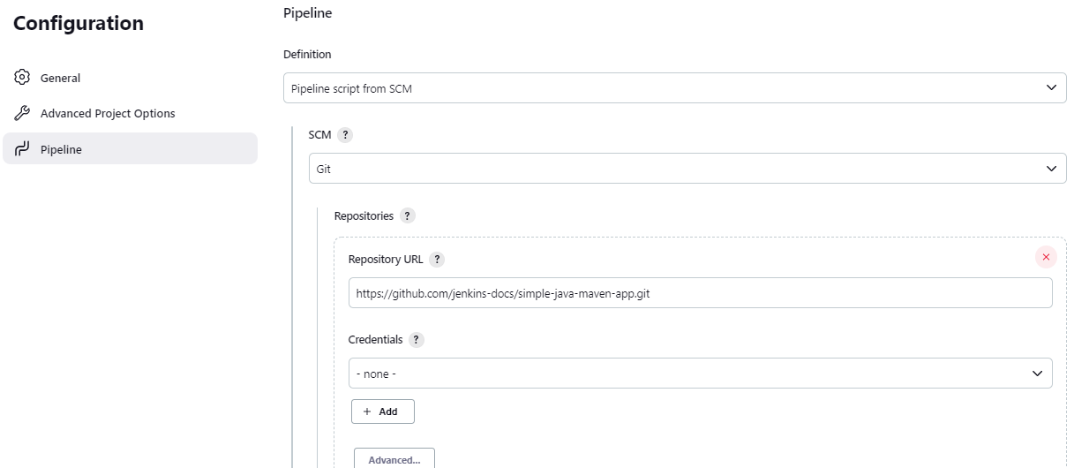

1. Store git credentials in store (more details covered later

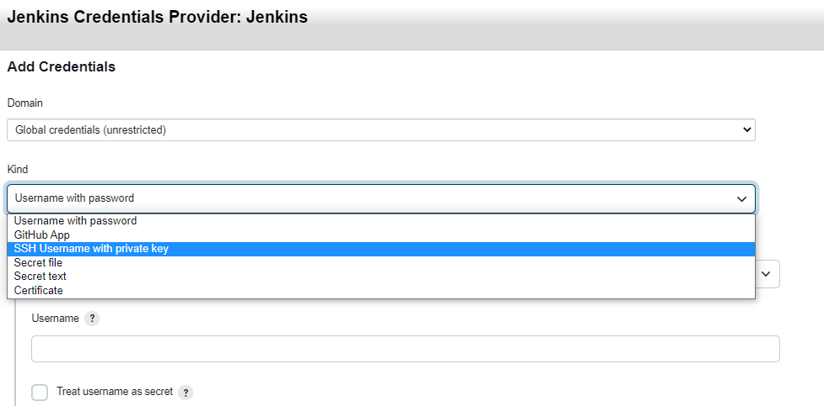

1. Provide jenkinsfile path in git repo

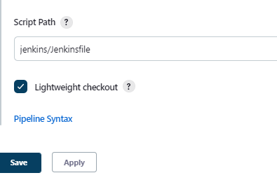

While configuring SCM as source in pipeline we can configure how option to trigger build.

Most common are

* Periodic: build process runs only on specified time in a day rather than on every code change on branch
* Hook: build process runs every time code is push to specific branch in repo
* Poll SCM: build process polls repo every specified interval of minutes and triggers if there are any changes.

