Mediator Pattern

When there is a need of having some central authority to control communication between components in unified way rather than component talking to each other directly then mediator pattern is used.

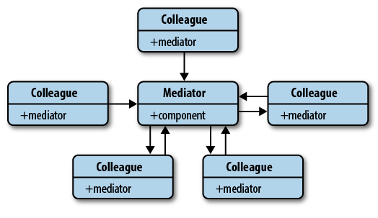

Without mediator implementation things can look like below if all objects and functions starts interacting with each other without central authority and it will ne very difficult to manage and understand code.

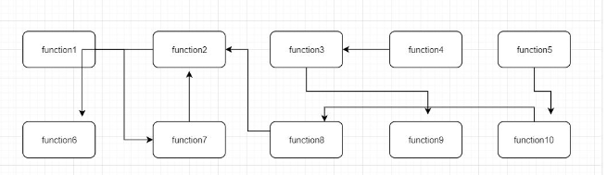

With mediator pattern each function interact with central module and central module forward or receive those communication to-from respective modules. This can be easy to manage and removing tight coupling between objects.

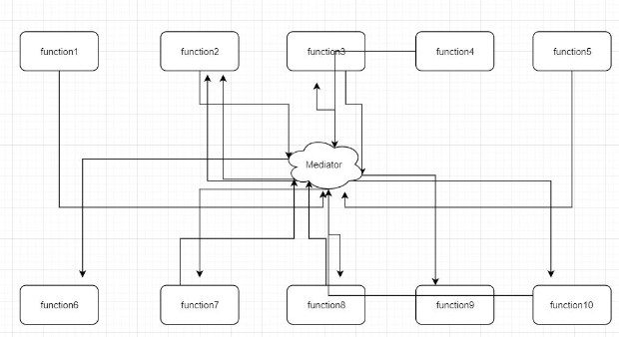

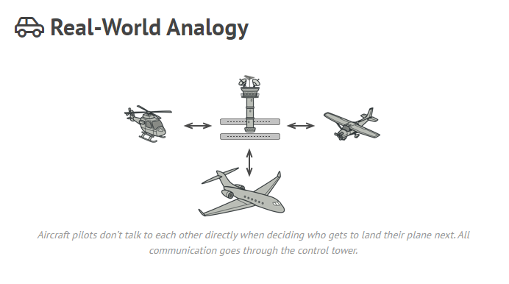

Check code sample in repo