*********

# Python basics

DataClass

Introduced in python 3.7 It is a decorator @dataclass used to define classes which are intended to store data. When you mainly use class to store/represent data objects or store states rather than having multiple operations and methods then dataclass is used.

It automatically defines following methods for us when used it as a decorator on class

__init__(): Initialize the objects and assigns provided values to class attributes

__repr__(): provides string representation of a class object

__eq__(): Implements equality comparison between two objects

If we have normal class then nanaging and updating properfites in different methods become tedious over time.

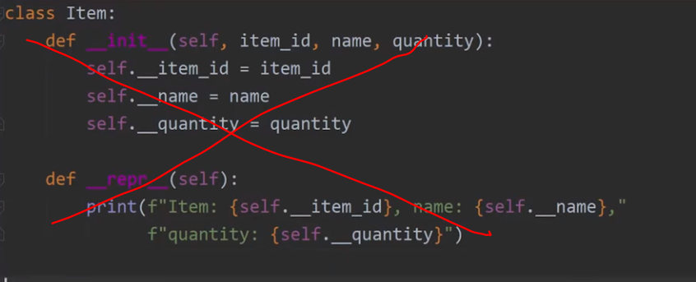

Data class makes them easy by managing lots of things in background just by using @dataclass as decorator to class. It also provides lots more functionality. It also helps with inheriting classes.

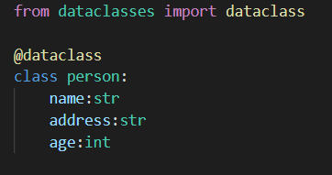

# Pydantic

Dataclass in built-into python buy pydantic is external library which provides more functionalities over data class, so lots of projects use pydatantic instead of dataclas

Pydantic mainly provides data validation, type enforcing etc.. and its interation with other things like fastapi, langchain etc maks it favorite amongs the devs for certain usecases

