 | SIES Graduate School of Technology  Sri Chandrasekarendra Saraswati Vidyapuram  Sector V, Nerul, Navi Mumbai - 400706

Name: Ashwin kumaar Roll No: 123A8008
Name: Aditya Jaiswal Roll No: 123A8003
Class/Div: BE-AIDS
MINI PROJECT
Supply Chain Inventory Optimization Using Game Theory
AIM:
To develop an interactive supply-chain simulation that compares fixed inventory decisions, repeated-game coordination and Bayesian decisions under uncertain demand.
PROBLEM STATEMENT:
Manufacturers, suppliers and retailers must balance stock availability, operating costs and profit. Independent decisions can cause shortages, excess inventory and amplified orders. This project models these interactions and compares three decision policies on identical demand to study their financial and service trade-offs.
OBJECTIVES:
• Model manufacturer, supplier and retailer as independent players.
• Generate reproducible uncertain demand or accept manual demand observations.
• Validate costs, stock, capacity, rounds and probability inputs.
• Implement baseline, repeated-game and Bayesian decision policies.
• Measure player profit, fill rate, service level and inventory costs.
• Study cooperation, discounted payoff and Bayesian belief updates.
• Compare models on identical demand and inspect pure Nash equilibria.
• Provide dashboards, replay, saved history and downloadable results.
THEORY:
Supply Chain Inventory Optimization uses inventory accounting and game theory to study decisions made by a manufacturer, supplier and retailer over multiple rounds. Each player chooses production or replenishment before current customer demand is revealed.
The application uses a React interface, a FastAPI simulation engine, NumPy calculations and SQLite history. It is an educational simulation with transparent decision rules; it does not train a machine-learning prediction model.
• Baseline replenishes stock to a fixed target when inventory reaches the reorder point.
• Repeated play uses cooperation or defection and memory of earlier outcomes.
• Bayesian play chooses the inventory action with the largest belief-weighted expected utility.
• Fill rate is fulfilled units divided by total demanded units.
• Service level is the fraction of rounds with no lost demand.
• Pure Nash equilibria are mutual best responses in a separate two-player payoff matrix.
SIMULATION DATA DESCRIPTION:
Attribute | Type | Description
rounds and seed | Integer | Horizon and reproducible random seed
game_type | Category | Baseline, repeated or Bayesian
strategy and mechanism | Category | Inventory profile and repeated policy
distribution and season | Category | Demand distribution and seasonal factor
demand_mean and demand_std | Numerical | Base demand mean and deviation
priors | Probabilities | LOW, MEDIUM and HIGH beliefs
capacity and storage_capacity | Integer | Production and supplier storage limits
initial inventories | Integer | Opening stock at each stage
prices and production_cost | Numerical | Unit revenues and production expense
holding and shortage costs | Numerical | Remaining-stock and unmet-demand costs
ordering and transport costs | Numerical | Fixed received-order and unit shipment costs
reorder_point and safety_stock | Integer | Replenishment trigger and stock buffer
manual_demand | Integer sequence | Optional observed demand for each round

INPUT VALIDATION AND DATA GENERATION:
Demand is generated using a seeded random number generator, so a configuration can be reproduced. LOW, MEDIUM and HIGH regimes use 0.65, 1.00 and 1.35 times the base mean. Normal, Uniform and Poisson distributions are supported. A regime persists with probability 0.8; otherwise it is drawn from the base prior. The same trajectory is used for every policy comparison.
• Default demonstration: 30 rounds with seed 42; allowed range is 1 to 100 rounds.
• Base demand mean: 100 units; deviation: 20 units for Normal demand.
• Initial LOW, MEDIUM and HIGH probabilities: 0.25, 0.50 and 0.25.
• Negative values, nonfinite inputs and invalid probability sums are rejected.
• Manual demand must contain one nonnegative integer for every round.
• No train-test split or missing-value imputation is required for this simulation.
EXPLORATORY SIMULATION ANALYSIS:
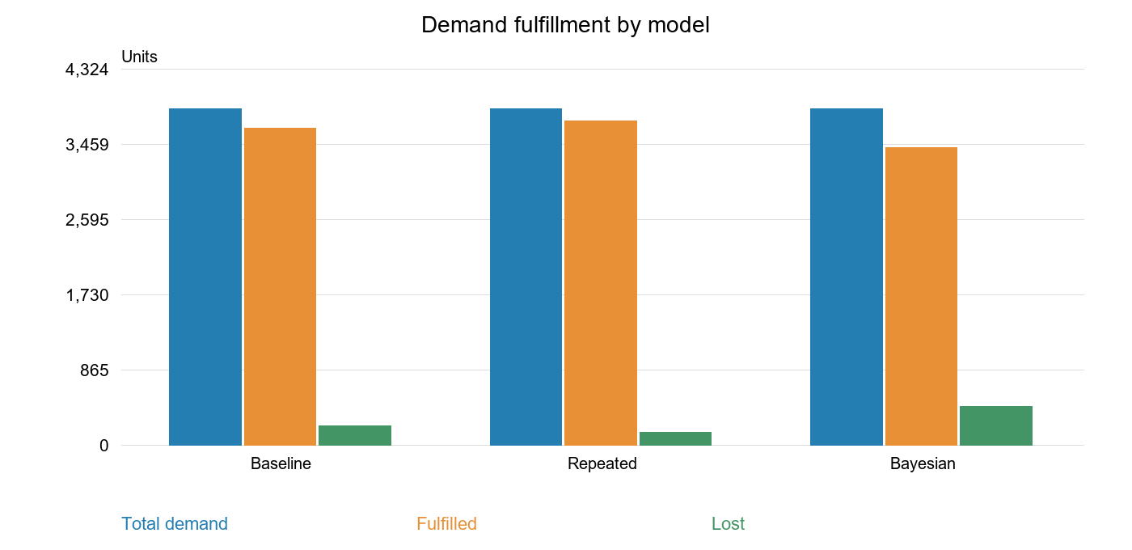
Figure 1: Total demand, fulfilled demand and lost demand by model
The default 30-round comparison produces total demand of 3,861 units for each model. Repeated play fulfills 3,721 units, compared with 3,638 for baseline and 3,420 for Bayesian decisions. These are outcomes for seed 42, not guaranteed rankings.
Model | Fulfilled units / total demand
Baseline | 3638 / 3861
Repeated | 3721 / 3861
Bayesian | 3420 / 3861
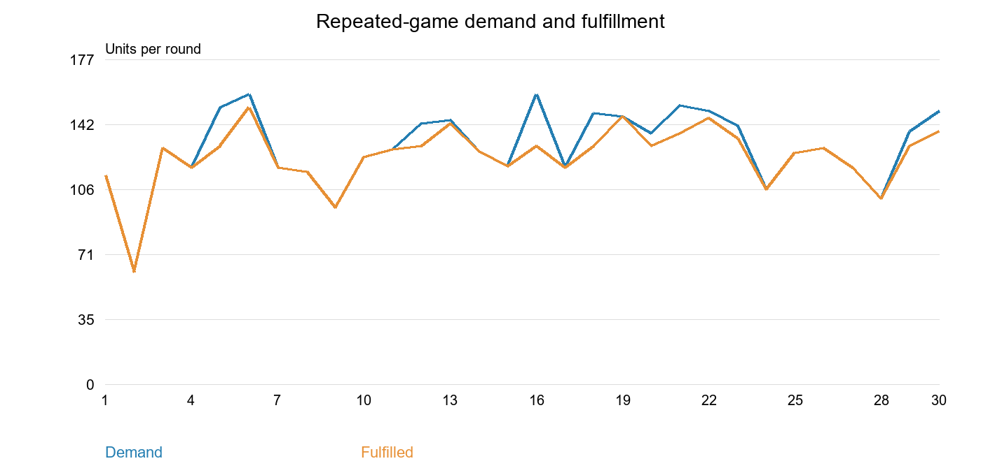
Figure 2: Customer demand and fulfilled units in the repeated-game run
METHODOLOGY:
1. Configure: Choose product, costs, initial inventories, demand, capacity and policy.
2. Generate: Build a seeded demand trajectory; hide current demand from all decisions.
3. Decide: Retailer orders, supplier orders and manufacturer chooses production.
4. Transfer: Bound production and shipments by capacity, stock and storage space.
5. Account: Reveal demand, sell available units and record stock, costs and profit.
6. Learn: Update player memory and forecasts; Bayesian agents update beliefs.
7. Compare: Display results and repeat all three models using the same seed.

CODE:
1. Validated configuration and simulation
from app.models import Config
from app.simulation import simulate

config = Config(rounds=30, seed=42, game_type="repeated")
result = simulate(config)
summary = result["summary"]
print(summary["total_profit"])
print(summary["fill_rate"])
2. Expected utility
from app.game_theory import expected_utility
probabilities = [0.25, 0.50, 0.25]
utilities = [100.0, 200.0, 300.0]
print(expected_utility(probabilities, utilities)) # 200.0
3. Compare models on the same seeded demand
results = {}
for model in ["baseline", "repeated", "bayesian"]:
config = Config(rounds=30, seed=42, game_type=model)
results[model] = simulate(config)
metrics = results[model]["summary"]
print(model, metrics["total_profit"], metrics["fill_rate"])

# Each simulation uses the same seeded demand trajectory.
assert results["baseline"]["summary"]["total_demand"] == 3861
4. Inventory and profit accounting
# Accounting identities checked against actual simulation rows.
for row in result["rounds"]:
for role in ["manufacturer", "supplier", "retailer"]:
player = row[role]
assert player["inventory"] == (
player["beginning_inventory"]
+ player["received"] - player["shipped"]
)
assert row["demand"] == row["fulfilled"] + row["lost"]
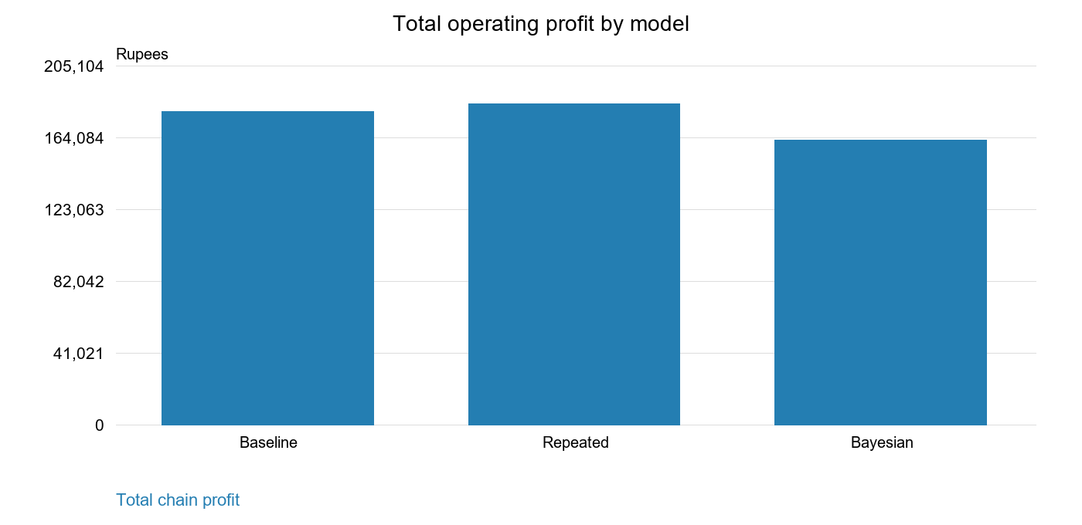
Figure 3: Total operating profit for the three models
MODEL PERFORMANCE:
Model | Profit in Rs. | Fill rate | Stockout rounds
Baseline | 179,005.00 | 94.22% | 13
Repeated | 183,129.00 | 96.37% | 12
Bayesian | 162,480.50 | 88.58% | 20
Repeated play has the highest total profit in this run at Rs. 183,129.00 and a 96.37% fill rate. Baseline earns Rs. 179,005.00; Bayesian play earns Rs. 162,480.50. All models face the same demand. Repeated play holds more stock than baseline, and the supplier earns slightly less despite higher total-chain profit.

OUTPUT:
The following outputs were computed directly by the project simulation engine using the default 30-round configuration and seed 42. The table shows the first fifteen rounds of the repeated-game run.
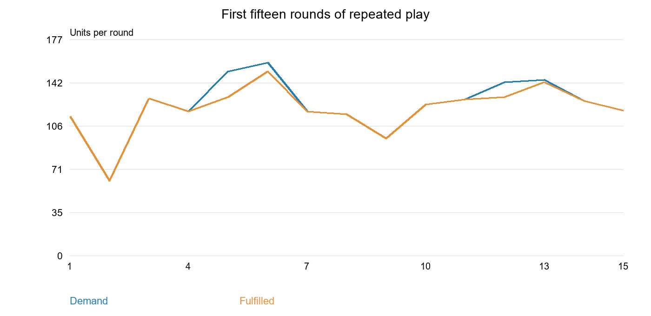
Figure 4: Repeated-game demand and sales for the first fifteen rounds
Round | Customer demand | Fulfilled units
1 | 114 | 114
2 | 61 | 61
3 | 129 | 129
4 | 118 | 118
5 | 151 | 130
6 | 158 | 151
7 | 118 | 118
8 | 116 | 116
9 | 96 | 96
10 | 124 | 124
11 | 128 | 128
12 | 142 | 130
13 | 144 | 142
14 | 127 | 127
15 | 119 | 119
COST AND INVENTORY ANALYSIS:
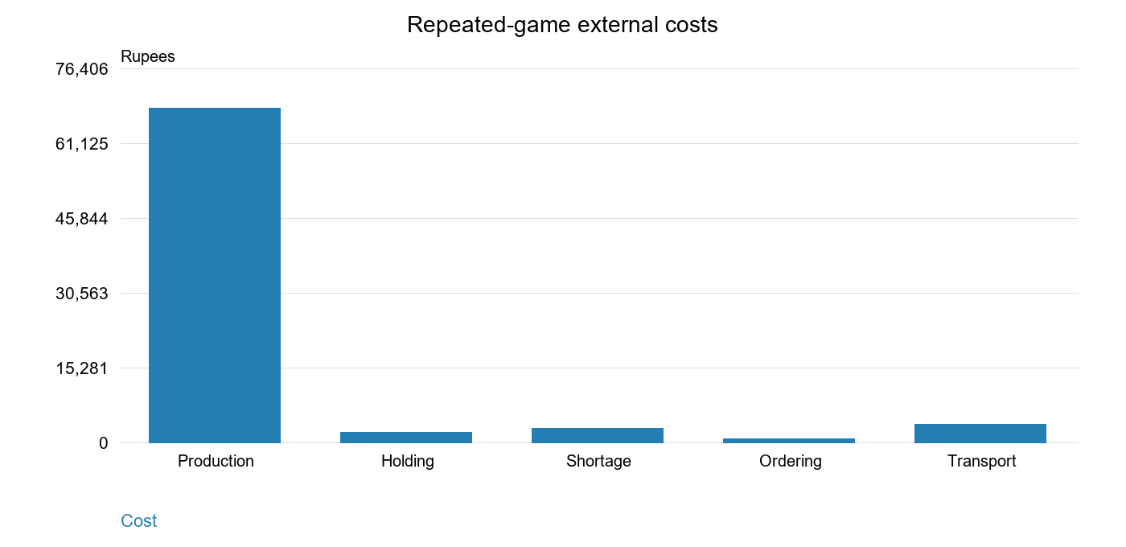
Figure 5: Repeated-game operating cost breakdown
Production is the largest external cost in this run. Internal supplier and wholesale payments cancel when player profits are combined. Holding cost increases when more stock remains after a round. Shortage penalties apply to lost retail demand. Initial inventory is a sunk asset and there is no final salvage value.
Metric | Repeated-game result
Production cost | Rs. 68,220.00
Holding cost | Rs. 1,975.00
Shortage cost | Rs. 2,800.00
Ordering cost | Rs. 725.00
Transport cost | Rs. 3,621.00
Average closing inventory | 79.13 units
Service level | 60.00%
Manufacturing bullwhip ratio | 3.834

SAMPLE SIMULATION:
The sample below uses the default repeated-game configuration with adaptive strategy and mechanism. The interface accepts these inputs, runs the backend engine and displays player-level results, charts and round details.
Product | Everyday essentials
Model | Repeated game
Strategy and mechanism | Adaptive
Rounds and seed | 30 rounds and seed 42
Demand distribution | Normal
Base mean and deviation | 100 and 20 units
Initial M / S / R stock | 150 / 120 / 100 units
Manufacturing capacity | 180 units per round
Supplier storage capacity | 600 units
Production / wholesale price | Rs. 20 / Rs. 32 per unit
Supplier / retail price | Rs. 45 / Rs. 70 per unit
Safety stock / reorder point | 30 / 100 units
Discount factor | 0.95
Total Chain Profit = Rs. 183,129.00
Fulfilled Demand = 3,721 units and Fill Rate = 96.37%
CODE FOR SINGLE SIMULATION:
# Run from the backend directory after installing requirements.
from app.models import Config
from app.simulation import simulate

config = Config(
rounds=30, seed=42, game_type="repeated",
strategy="adaptive", mechanism="adaptive",
demand_mean=100, demand_std=20,
capacity=180, safety_stock=30,
)
result = simulate(config)
s = result["summary"]
print(f"Total profit: {s['total_profit']:.2f}")
print(f"Fulfilled: {s['fulfilled']} units")
print(f"Fill rate: {s['fill_rate']:.2%}")
ADVANTAGES:
• Represents three interacting supply-chain players in a single simulation.
• Validates inputs and preserves inventory and financial accounting.
• Compares three policies using exactly the same demand trajectory.
• Shows profit, availability, cost and inventory trade-offs with charts.
• Supports repeatable experiments across multiple random seeds.
• Stores individual runs in SQLite and exports round CSV or full JSON.
LIMITATIONS:
• Demand is synthetic; outcomes are not validated against a real supply chain.
• Only one product is modeled per run, with fixed prices and immediate deliveries.
• Unmet demand is lost; backorders and final salvage value are not modeled.
• Repeated play uses heuristics and does not prove a dynamic equilibrium.
• Bayesian players share a public signal and evaluate state centers rather than all demand noise.
POSSIBLE IMPROVEMENTS:
• Calibrate demand and cost settings using real operational records.
• Add shipment lead times and outstanding-order tracking.
• Support multiple products and shared production constraints.
• Introduce private demand signals and heterogeneous player beliefs.
• Extend the payoff analysis to mixed or formally solved dynamic equilibria.
• Add multi-user access only when shared deployment is needed.
• Evaluate policy performance across more demand settings and random seeds.
CONCLUSION:
The Supply Chain Inventory Optimization Using Game Theory mini project demonstrates a complete simulation workflow from validated configuration to demand generation, player decisions, inventory updates, financial accounting and visual analysis. In the default 30-round seeded comparison, repeated play earns the highest total-chain profit and fulfills more demand than baseline and Bayesian play. This result is specific to the tested configuration and does not prove that one policy always performs best. The application supports reproducible comparisons, Bayesian belief updates, pure Nash analysis, local history and CSV or JSON exports. Further development can introduce lead times, real demand observations and formally solved dynamic games.

