Project Documentation
Project Title: DC Public Employee Salary Analysis

1. Project Overview

This project analyzes the ‘DC Public Employee Salary’ Dataset obtained from Data.gov (United States Government).

The dataset contains information about government employees in Washington, DC, including their job titles, departments, agencies, and annual salaries.

The purpose of this project is to explore salary distributions, departmental trends, and other factors that influence compensation patterns in public employment.

Through data preprocessing and exploratory data analysis, we aim to extract meaningful insights that can be useful for HR analytics, payroll planning, and government transparency.

2. Tools Used
- Python(Pandas, NumPy, Matplotlib, Seaborn)

3. Dataset
- Source: "C:\Users\USER\OneDrive\Desktop\Data Analytics\Project\Main_Project_Python\DC_Public_Employee_Salary.csv"
- Data contains: FIRST_NAME, LAST_NAME, JOBTITLE, DESCRSHORT, GRADE, COMPRATE, HIREDATE_STRING, GVT_TYPE_OF_APPT, OBJECTID

4. Steps Followed
- Import Python Libraries
- Import Dataset(csv)
- Exploratory Data Analysis (EDA)
- Preprocessing
- Handle Missing Values
- Handling Duplicate Records
- Cleaning Text Columns
- Convert Data Types in to Correct format
- Column Renaming
- Feature Engineering: I added four new columns to enrich the dataset and support deeper analysis
- Verify Final Cleaned Dataset
- View and Export Cleaned Dataset
- Data Visualization (Bar chart, Line chart, Lollipop chart, Correlation Heatmap, Subplot)

5. Key Insights
- Horizontal Bar chart for Highest Paying Job Titles (Average Salary)
- Vertical Bar chart for Top 10 Departments with the Most Employees
- Pie chart for Compensation Band Distribution
- Lollipop chart for Top 10 Grades by Average Salary
- Vertical Bar chart for Top 10 Longest-Serving Employees (Service Years)
- Line chart for Top 10 Job Titles by Employee Count
- Horizontal Bar chart for Top 10 Most Common Grade
- Correlation Heatmap
- Horizontal Bar chart for Top 10 Appointment Types by Median Salary
- Bar chart for Top 10 Hiring Years (Most Employees Hired)
- Multi-Aspect Subplot Visualization
- Future Work and Conclusion

6. Screenshots (few)

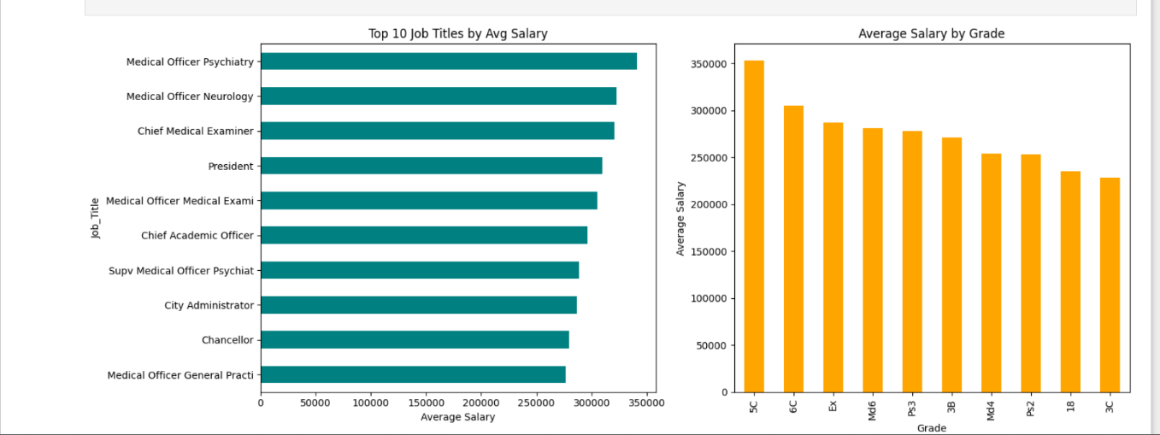
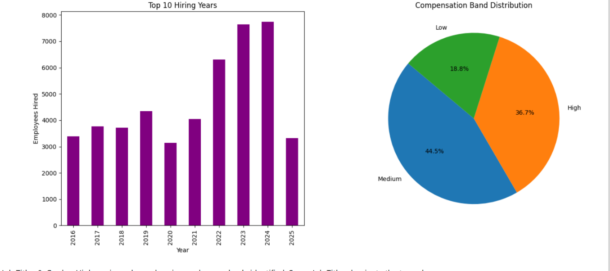

7. Files Included
- "C:\Users\USER\OneDrive\Desktop\Data Analytics\Project\Main_Project_Python\DC_Public_Employee_Salary.csv"– Uncleaned data.
-"C:\Users\USER\OneDrive\Desktop\DataAnalytics\Project\Main_Project_Python\DC_Public_Employee_Salary_cleaned.csv”-Cleaned data

- "C:\Users\USER\OneDrive\Desktop\Data Analytics\Project\Main_Project_Python\DC_Public_Employee_Salary_Project.ipynb"– Python File (Preprocessed and Visualized File)
- ‘README.md’ – Project description

8. How to Use
- Open `DC_Public_Employee_Salary_cleaned’ to view the cleaned data.
- Open `DC_Public_Employee_Salary_Project` in Jupyter Notebook to explore the Data Visualization.

