TEAM 20

**Remote Health Monitoring System**

Project Report

PAMIDI MOHAMMAD ASHRAF: S20210020303

SANDEEP NIDAMANURI: S20210020300

PRAVEEN KUMAR: S20210020313

J MOHIT NAGA VARDHA GANESH: S20210020283

**ABSTRACT:**

Most heart diseases are associated with and reflected by the sound that the heart produces, and one of the easiest and cheapest ways of diagnosing cardiac dysfunction is by Heart auscultation i.e., listening to the heart sound.   
  
 Now if we are talking about traditional auscultation, that requires experience and good listening skills. That is why in this project we thought to build an electronic stethoscope that will be able to get the heart rate of the human body and we can display the data in a Bluetooth-based serial terminal window. And there is an ECG Module to get the electrogram of the heart.

**JUSTIFICATION:**

In this project the heart rate of the subject is been converted into electrical signals. These sound waves of the patient is being recorded through the microphone and this microphone helps the sound waves which enter into the control board.   
  
These sound waves are amplified using amplifier. Those amplified signal is sent to the controller. The controller has the code where we can determine the electrical signal’s heart rate. Arduino uno sends the signal to the Bluetooth where it can be controlled by any android or iOS device where the output can be seen in the respected device.   
  
 The ECG module takes the heart signal and displays it in the serial monitor of the Arduino IDE.

**Functional Block Diagram connecting the sub-modules of the project:**

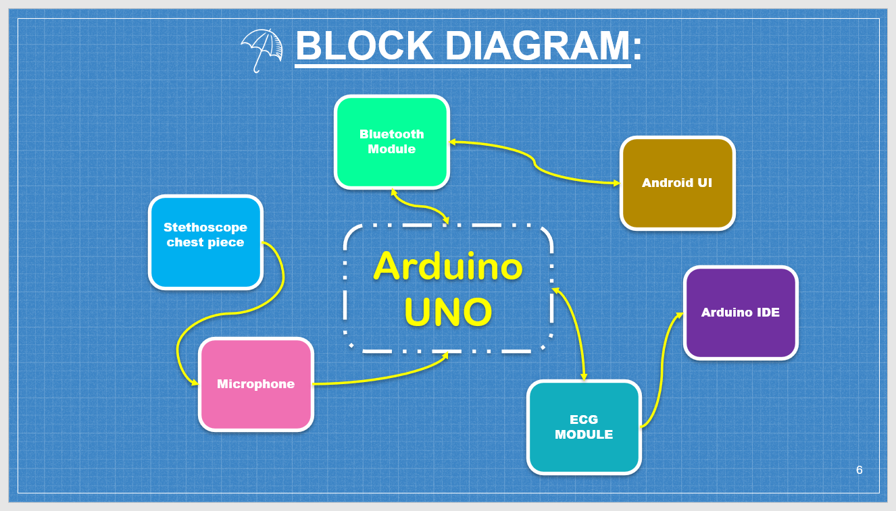

**COMPONENTS:**

HARDWARE

* Arduino UNO
* Bluetooth Module HC-05
* Sound sensor
* Breadboard
* Stethoscope chest piece
* Jumper Wires
* ECG Module

SOFTWARE

* Arduino IDE
* Bluetooth interface
* App/Web interface

**Mid evaluation outputs:**

**ECG Module output:**

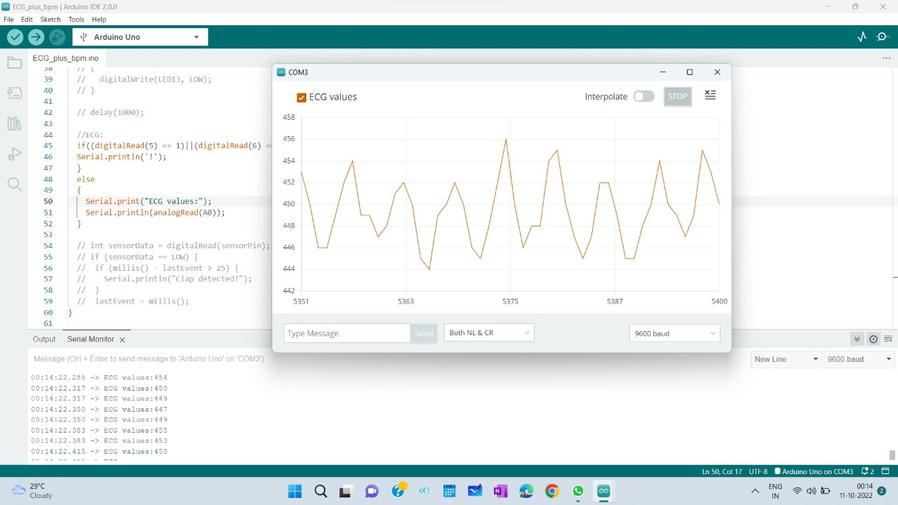

**Heart rate:**

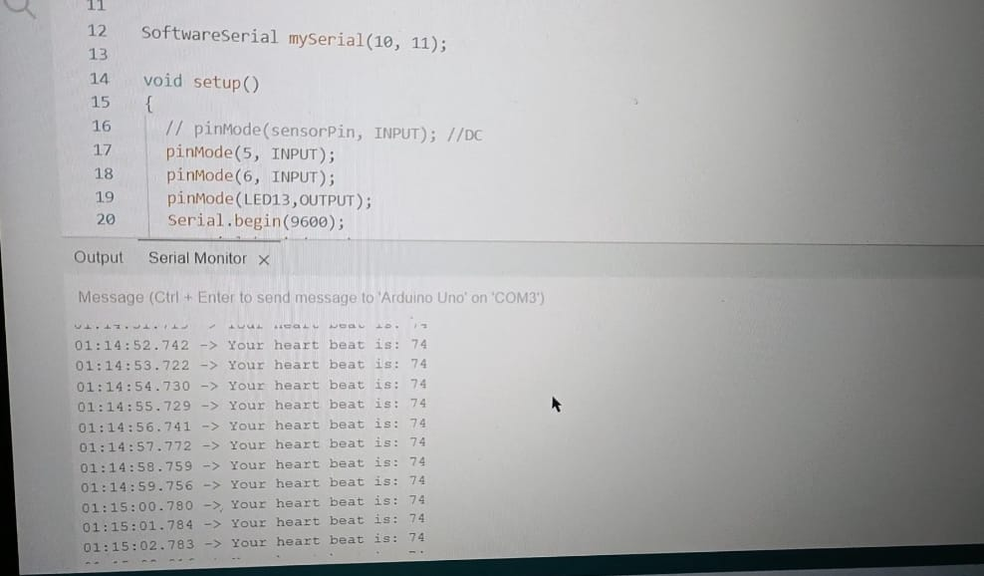

**Phase Wise Implementation:**

* Phase-I: Outputs for pre-evaluation –

Implementing the wireless stethoscope which checks and

gives the heart rate also adding the ECG module to it.

* Phase-II: Outputs for final evaluation –

Implementing the wireless stethoscope which will be capable of user interface.

*ThankYou*