FitZone Gym Management System

Phase 1 — Schema Diagram & Normalization Write-Up

1. Schema Diagram (ERD)
The diagram below shows the 6 required tables, their columns with data types, and the primary key (PK) / foreign key (FK) relationships between them, including the self-referencing mentor_id on trainers.
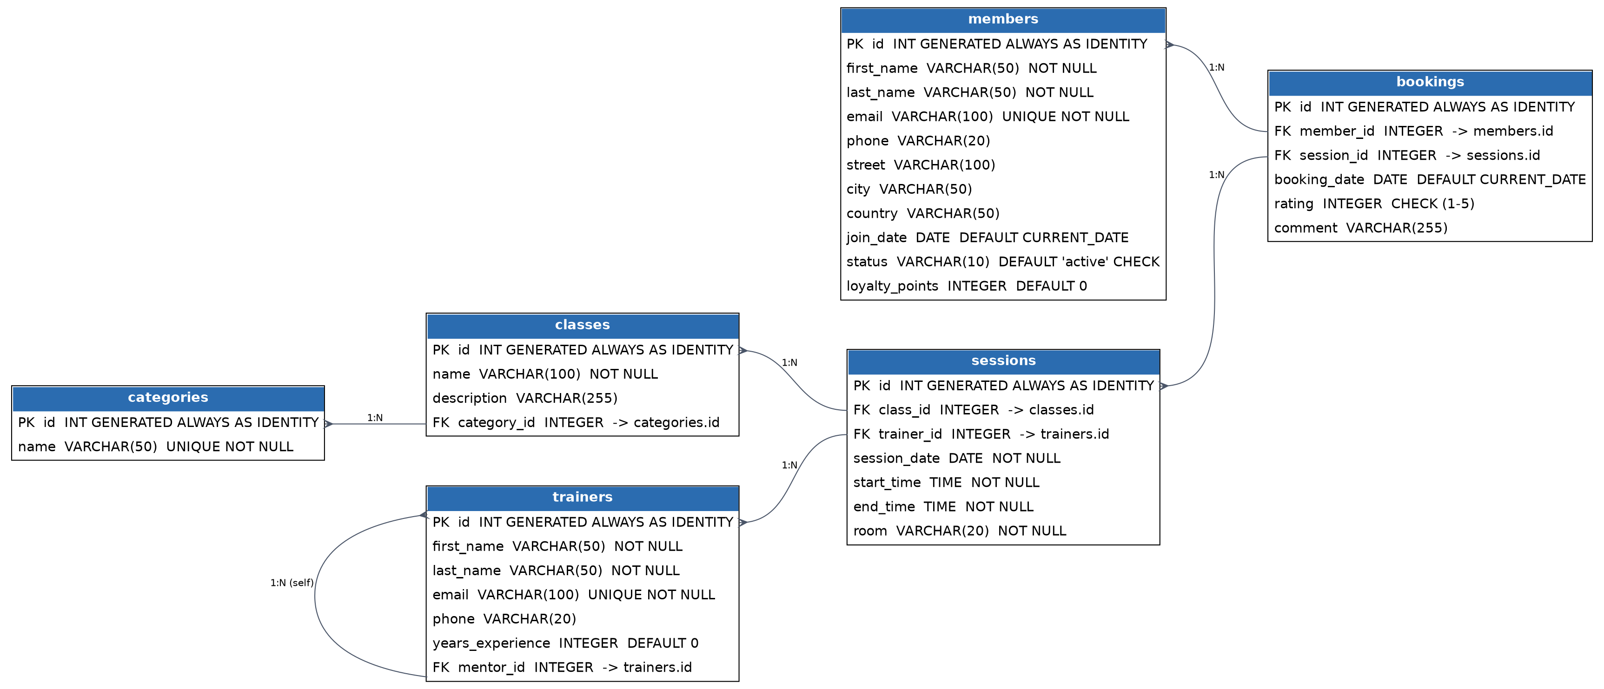

2. The Unnormalized Starting Point
Imagine that before this database was designed, all of FitZone's data lived in one giant spreadsheet-style table, combining member, session, class, trainer and rating information into a single row per booking. A small sample would look like this:
member_name | member_email | member_city | class_name | category | trainer_name | session_date | ratings
Ashraf Muneer | ashraf.muneer@mail.com | Amman | Morning Yoga | Yoga | Sarah Ahmad | 2025-07-01 | 5, 4
Muneer Ali | muneer.ali@mail.com | Irbid | Power Yoga | Yoga | Sarah Ahmad | 2025-07-02 | 5
Yara Khaled | yara.khaled@mail.com | Amman | Yoga Flow | Yoga | Eman Sameer | 2025-07-04 | 4, 3

2.1 Data Duplication
Every row that involves the same member repeats that member's full name, email and city. In the sample above, Ashraf Muneer's email and city are stored twice because he attended two classes. Multiply this across hundreds of bookings and the same trainer name, category name, and class name get copied over and over. This wastes storage and, more importantly, creates multiple independent copies of the same fact that can drift out of sync.

2.2 Update Anomalies
Because a trainer's name is repeated on every row where they teach a session, renaming a trainer (e.g. after a legal name change) means updating every single row that mentions them. Miss even one row and the table now contains two different names for the same trainer — an update anomaly. The same problem applies to category names, class names, and member contact details.

2.3 Insertion Anomalies
In this flat table, a fact can only be recorded if it is attached to a full booking row. This means a brand-new class that has not been scheduled into any session yet, or a category with no classes assigned yet (like Pilates in this project), cannot be represented at all until a booking happens to exist for it. The normalized design fixes this: classes and categories exist as independent rows regardless of whether a session or booking has happened yet.

2.4 Deletion Anomalies
If Muneer Ali's only booking is deleted (for example, a cancelled class), the flat table loses all record that Muneer Ali is a member at all — his contact information disappears along with the booking. In the normalized design, members exist independently of bookings, so deleting a booking never deletes a member.

2.5 Repeating / Multi-Valued Ratings Column
Notice the ratings column in the sample table: Ashraf Muneer's row shows "5, 4" because he has two ratings crammed into a single cell. This violates First Normal Form (1NF), which requires every column to hold a single atomic value. A multi-valued column like this cannot be reliably filtered, averaged, or sorted with standard SQL — you cannot easily compute an average rating per member, because the values are trapped as text inside one cell instead of being separate rows.

2.6 How Normalization Solves This
Splitting the flat table into members, trainers, categories, classes, sessions and bookings removes the duplication (each fact — a member's email, a trainer's name, a category's name — is stored exactly once), removes the update/insertion/deletion anomalies (each entity can be created, changed or removed independently), and resolves the multi-valued ratings problem by giving each rating its own row in bookings, one row per member-session pair. This is exactly what the bookings table in this project does: it links one member to one session per row, and carries that single booking's rating and comment — no repeating groups, no orphaned data.

